普通本科毕业论文（设计）

题 目： | Kubernetes 集群监控与管理 Web 仪表盘的设计与实现
英文题目： | Design and Implementation of a Web Dashboard for Kubernetes Cluster Monitoring and Management

学 院 | School of Computing and Artificial Intelligence
专 业 | Computer Science
学生姓名 | OUSSAMA ESSABTI | 学 号 | 2202230024
指导老师 | Lai Xinfeng | 职 称 | 副教授

二〇二六 年 四 月

题 目 | Design and Implementation of a Web Dashboard for Kubernetes Cluster Monitoring and Management
论文形式 | ■毕业设计 (Graduation Design Project)
学 院 | 计算机与人工智能学院 | 专 业 | 计算机科学与技术
指导老师 | 赖新峰 | 职 称 | 副教授
学生姓名 | OUSSAMA ESSABTI | 学 号 | 2202230024 |  | 班 级 | 计算机科学与技术（留）
原创性声明
本人声明所呈交的论文是我个人在导师指导下进行的研究工作及取得的研究成果。尽我所知，除了文中特别加以标注和致谢中所罗列的内容以外，论文中不包含其他人已经发表或撰写过的研究成果；也不包含为获得成都信息工程大学或其它教育机构的学位或证书而使用过的材料。与我一同工作的同志对本研究所做的任何贡献均已在论文中作了明确的说明并表示了谢意。
申请学位论文与资料若有不实之处，本人承担一切相关责任。
本人签名： 日期：

普通本科毕业论文（设计）原创性声明
本人声明所呈交的论文是我个人在导师指导下进行的研究工作及取得的研究成果。尽我所知，除了文中特别加以标注和致谢中所罗列的内容以外，论文中不包含其他人已经发表或撰写过的研究成果；也不包含为获得成都信息工程大学或其它教育机构的学位或证书而使用过的材料。与我一同工作的同志对本研究所做的任何贡献均已在论文中作了明确的说明并表示了谢意。
申请学位论文与资料若有不实之处，本人承担一切相关责任。

本人签名： 日期： 年 月 日

ABSTRACT
Container orchestration platforms, particularly Kubernetes, have become essential infrastructure for deploying and managing modern cloud-native applications. Organizations increasingly rely on Kubernetes to automate the deployment, scaling, and management of containerized workloads across distributed cluster environments. However, as cluster sizes grow and microservice architectures become more complex, monitoring and diagnosing operational issues becomes a significant challenge for DevOps teams. Existing monitoring tools such as Prometheus and Grafana provide metric collection and visualization capabilities, but they typically rely on manually configured threshold-based alerting rules that require substantial domain expertise and cannot adapt to dynamic workload patterns.
This thesis presents the design and implementation of an intelligent web-based monitoring dashboard for Kubernetes clusters that integrates unsupervised machine learning for automated anomaly detection. The system comprises a FastAPI backend that interfaces with the Kubernetes API to collect cluster metrics at 30-second intervals, a React-based frontend providing real-time visualization of cluster state through periodic HTTP polling, and an Isolation Forest model that identifies unusual patterns in resource utilization without requiring labeled training data. A rule-based root cause analysis module correlates detected anomalies with cluster events to suggest probable explanations for operators.
The system architecture employs a three-tier design separating presentation, business logic, and data persistence layers. The backend implements five core service modules: Kubernetes API interaction, metric collection and normalization, anomaly detection with Isolation Forest, alert generation with severity classification, and JWT-based authentication with role-based access control. The frontend organizes functionality across dedicated pages for cluster overview, pod management, node monitoring, metrics visualization, log aggregation, and alert management. SQLite provides lightweight data persistence suitable for development and small-scale deployment scenarios.
Preliminary evaluation was conducted on a three-node Kubernetes cluster running representative workloads including web servers, databases, and batch processing tasks. Functional testing verified correct behavior across authentication flows, metric collection accuracy, anomaly detection responsiveness, and dashboard rendering. Initial performance observations indicate dashboard update latency under 2 seconds, anomaly detection within 90 seconds of fault injection, and backend memory consumption of approximately 380MB for 100-pod clusters.
【Key words】: Kubernetes monitoring; anomaly detection; Isolation Forest algorithm; web dashboard; cloud infrastructure; container orchestration

TABLE OF CONTENTS
Declaration of Originality ................................. I
Abstract .................................................. II
Table of Contents ........................................ III
List of Figures ............................................ V
List of Tables ............................................ VI
Chapter 1 Introduction .................................... 1
1.1 Background ........................................ 1
1.2 Problem Statement ................................. 2
1.3 Motivation ........................................ 3
1.4 Objectives ........................................ 3
1.5 Scope and Limitation of the Project ............... 4
Chapter 2 Literature Review ............................... 5
2.1 Introduction ...................................... 5
2.2 Cloud-Native Computing and Kubernetes ............. 5
2.3 Existing Monitoring Solutions ..................... 6
2.4 AIOps and Anomaly Detection ....................... 7
2.5 Isolation Forest Algorithm ........................ 8
2.6 Technologies Used ................................. 9
2.7 Summary of Related Work .......................... 11
Chapter 3 Methodology .................................... 12
3.1 Introduction ..................................... 12
3.2 Development Methodology .......................... 12
3.3 Agile Model ...................................... 13
3.4 Why Using Agile Methodology ...................... 14
Chapter 4 Requirement Analysis ........................... 15
4.1 Introduction ..................................... 15
4.2 System Description ............................... 15
4.3 User Description ................................. 16
4.4 System Requirements .............................. 16
4.5 System Analysis .................................. 20
Chapter 5 Design and Implementation ...................... 23
5.1 Design Phase ..................................... 23
5.2 Technology Stack ................................. 23
5.3 System Architecture .............................. 25
5.4 Database Design .................................. 26
5.5 API Interface Design ............................. 28
5.6 Anomaly Detection Module ......................... 31
5.7 Security Design .................................. 33
5.8 Implementation Phase ............................. 35
Chapter 6 System Testing ................................. 45
6.1 Testing Environment .............................. 45
6.2 Functional Testing ............................... 46
6.3 API Testing ...................................... 48
6.4 Security Testing ................................. 49
6.5 Test Results Summary ............................. 50
Chapter 7 Conclusion and Future Work ..................... 51
7.1 Conclusion ....................................... 51
7.2 Future Work ...................................... 52
References ................................................ 54
Acknowledgements .......................................... 56

List of Figures
Figure 3-1 Agile Development Model
Figure 4-1 Use Case Diagram
Figure 4-2 Sequence Diagram (Authentication)
Figure 4-3 Activity Diagram
Figure 5-1 System Architecture Diagram
Figure 5-2 Entity-Relationship Diagram
Figure 5-3 Anomaly Detection Data Flow
Figure 5-4 Authentication Sequence Diagram
Figure 5-5 Deployment Diagram (Docker Compose)
Figure 5-6 Login Page
Figure 5-7 User Registration Page
Figure 5-8 Admin Login Portal
Figure 5-9 Administrator Dashboard
Figure 5-10 User Dashboard
Figure 5-11 Cluster Management Page
Figure 5-12 Cluster Overview Page
Figure 5-13 Workloads Page
Figure 5-14 Pods Management Page
Figure 5-15 Nodes Page
Figure 5-16 Metrics Dashboard
Figure 5-17 Observability Page
Figure 5-18 Log Viewer Page
Figure 5-19 Root Cause Analysis Page
Figure 5-20 Alerts Management Page
Figure 5-21 Settings Page
Figure 5-22 Help Center Page

List of Tables
Table 2-1 Comparison of Kubernetes Monitoring Solutions
Table 4-1 Actors and Functions
Table 4-2 Functional Requirements Summary
Table 4-3 Non-Functional Requirements
Table 4-4 Use Case: User Login
Table 4-5 Use Case: Register Account
Table 4-6 Use Case: Add Cluster
Table 4-7 Use Case: Monitor Cluster Resources
Table 4-8 Use Case: Detect Anomalies
Table 5-1 Backend Technology Stack
Table 5-2 Frontend Technology Stack
Table 5-3 User Table Schema
Table 5-4 Cluster Table Schema
Table 5-5 Audit Log Table Schema
Table 5-6 Authentication API Endpoints
Table 5-7 Cluster Management API Endpoints
Table 5-8 Monitoring API Endpoints
Table 5-9 Metrics and Anomaly Detection API Endpoints
Table 5-10 Log Management API Endpoints
Table 5-11 Alert Management API Endpoints
Table 5-12 Frontend Page Components
Table 5-13 Isolation Forest Parameters
Table 5-14 Docker Compose Service Configuration
Table 6-1 Testing Environment Specifications
Table 6-2 Functional Test Cases and Results
Table 6-3 API Endpoint Test Results
Table 6-4 Security Test Results

Chapter 1 Introduction

1.1 Background
The widespread adoption of cloud computing and microservices architectures has fundamentally transformed how software systems are deployed and operated. Kubernetes, initially developed by Google and released as open source in 2014, has emerged as the dominant platform for container orchestration, with organizations ranging from startups to Fortune 500 companies relying on it to manage their production workloads. According to the Cloud Native Computing Foundation's 2024 survey [2], over 96% of organizations are either using or evaluating Kubernetes for their container management needs.
However, this increased adoption has exposed significant operational challenges. A typical production Kubernetes cluster may contain hundreds of nodes running thousands of containers, generating vast amounts of metrics, logs, and events. System administrators face the daunting task of monitoring this complex environment to ensure reliability, performance, and security. Traditional monitoring approaches, which require manually defining thresholds and alert rules for each metric, become impractical at this scale [16].
Current monitoring solutions suffer from several limitations. Manual configuration is time-consuming and error-prone, often requiring weeks of setup for complex deployments. Static threshold-based alerting generates excessive false positives, leading to alert fatigue where operators ignore or disable notifications. Information fragmentation across multiple tools forces administrators to correlate data from separate systems for metrics, logs, and cluster state [11,12]. Most critically, these reactive approaches only detect problems after they have already impacted users, rather than identifying emerging issues before they cause outages.

1.2 Problem Statement
The school of computing and artificial intelligence increasingly relies on Kubernetes-based infrastructure for its cloud services and research projects. However, the existing monitoring approach faces several critical problems:
- There is no unified platform that integrates metrics visualization, log aggregation, and anomaly detection in a single web-based interface.
- Manual threshold-based monitoring requires extensive domain expertise and cannot adapt to changing workload patterns.
- Engineers must switch between multiple disconnected tools (Prometheus, Grafana, kubectl, ELK) to diagnose issues, wasting valuable time during incidents.
- Current solutions lack intelligent anomaly detection capabilities that can automatically identify unusual patterns without pre-configured rules.

1.3 Motivation
Cloud infrastructure is the backbone of modern digital services, from banking to healthcare to education. When these systems experience downtime or performance degradation, it affects thousands of users. The motivation for this project comes from the pressing need to simplify and automate Kubernetes cluster monitoring.
The main motivation is to create a tool that combines the power of machine learning with an intuitive web interface, enabling even non-expert operators to effectively monitor and manage Kubernetes clusters. By integrating the Isolation Forest algorithm for unsupervised anomaly detection [3,4], the system can automatically identify unusual patterns without requiring manual threshold configuration or labeled training data.
Education is the foundation of development, and providing reliable cloud infrastructure for educational institutions requires effective monitoring tools. This project aims to bridge the gap between complex enterprise monitoring solutions and the practical needs of small-to-medium deployments.

1.4 Objectives
The objectives of this system are as follows:
(1) To develop a unified web-based dashboard that consolidates cluster metrics, resource utilization, application health, and alert information in a single platform accessible through standard web browsers.
(2) To implement automated anomaly detection using the Isolation Forest algorithm, enabling the system to identify unusual patterns without requiring manual threshold configuration or labeled training data.
(3) To design an intelligent root cause analysis system that automatically investigates detected anomalies by correlating metrics, logs, and cluster events to suggest likely problem origins.
(4) To implement secure multi-user access with role-based access control and encrypted credential management for Kubernetes cluster configurations.
(5) To validate system effectiveness through comprehensive testing including functional verification, API testing, and security testing.

1.5 Scope and Limitation of the Project
This research focuses specifically on Kubernetes cluster monitoring and does not address monitoring for other container orchestration platforms. The system monitors infrastructure-level metrics (CPU, memory, network, disk) and Kubernetes-specific resources (pods, nodes, services) but does not provide deep application-level tracing or profiling capabilities.
The anomaly detection implementation uses the Isolation Forest algorithm, chosen for its effectiveness with unsupervised learning and computational efficiency. While other machine learning approaches exist, comparative evaluation of multiple algorithms is outside this thesis scope. The system has been tested with clusters containing up to 500 containers; scalability to thousands of containers may require additional architectural considerations.
Limitations include: the current architecture does not support horizontal scaling or high availability configurations; metrics and logs are not stored persistently and are lost on system restart; and the system is primarily read-only for safety, with limited write operations such as pod restart and deployment scaling.

Chapter 2 Literature Review

2.1 Introduction
This chapter reviews the existing literature and technologies relevant to the design and implementation of the K8s Dashboard monitoring system. The review covers cloud-native computing concepts, existing monitoring solutions, anomaly detection techniques, and the specific technologies used in the development of this project.

2.2 Cloud-Native Computing and Kubernetes
Cloud-native computing refers to an approach to building and running applications that fully exploits the advantages of cloud computing delivery models. The Cloud Native Computing Foundation (CNCF) defines [2] cloud-native technologies as those that empower organizations to build and run scalable applications in modern, dynamic environments. Key characteristics include containerization, microservices architectures [18,22], dynamic orchestration, and declarative APIs.
Kubernetes, originally developed by Google based on their internal Borg system [1,17], was open-sourced in 2014 and donated to the CNCF in 2015. It provides automated deployment, scaling, and management of containerized applications. The Kubernetes architecture consists of a control plane and worker nodes [6]. The control plane includes the API server, scheduler, controller manager, and distributed key-value store (etcd). Worker nodes run the kubelet agent, container runtime, and kube-proxy for network services.
The growth of Kubernetes adoption has been remarkable. The CNCF 2024 survey reports that 96% of organizations [2] use or evaluate Kubernetes, with 63% running it in production. This widespread adoption creates a strong demand for effective monitoring and management tools.

2.3 Existing Monitoring Solutions
Several monitoring solutions exist in the Kubernetes ecosystem, each with distinct strengths and limitations. A comprehensive analysis of these tools was conducted to identify specific gaps that the K8s Dashboard aims to address.
Prometheus + Grafana: Prometheus is the standard open-source monitoring system [11] for Kubernetes, collecting time-series metrics via a pull model. Grafana provides visualization dashboards [12]. While powerful, this combination requires significant configuration effort and does not include log management or anomaly detection.
Kubernetes Dashboard: The official Kubernetes dashboard provides a web UI [6] for cluster management but offers limited monitoring capabilities, no log aggregation, and no anomaly detection features.
Datadog and New Relic: These commercial platforms offer comprehensive monitoring with AI-powered insights but are expensive (per-host pricing) and overly complex for small teams or educational use.
ELK Stack (Elasticsearch, Logstash, Kibana): This combination provides powerful log aggregation and search capabilities but requires significant infrastructure investment and does not natively integrate with Kubernetes metrics.
Table 2-1 Comparison of Kubernetes Monitoring Solutions
Feature | Prometheus+  Grafana | K8s  Dashboard | Datadog | ELK  Stack | K8s Dashboard  (This Project)
Metrics Monitoring | ✓ | Limited | ✓ | ✗ | ✓
Log Aggregation | ✗ | ✗ | ✓ | ✓ | ✓
Anomaly Detection | ✗ | ✗ | ✓ | ✗ | ✓
Web-Based Access | ✓ | ✓ | ✓ | ✓ | ✓
Multi-User Support | Limited | ✗ | ✓ | ✓ | ✓
Free / Open Source | ✓ | ✓ | ✗ | ✓ | ✓
Easy Setup | ✗ | ✓ | ✓ | ✗ | ✓
ML-Based Detection | ✗ | ✗ | ✓ | ✗ | ✓

2.4 AIOps and Anomaly Detection
AIOps (Artificial Intelligence for IT Operations) [5] is an emerging field that applies machine learning and big data analytics to IT operations. Gartner coined the term in 2017, defining it as the use of big data, machine learning, and other advanced analytics technologies to enhance IT operations.
In the context of Kubernetes monitoring, anomaly detection aims to identify unusual patterns [16,21] in cluster metrics that may indicate problems such as resource exhaustion, failing pods, or performance degradation. Two main approaches exist: supervised learning (requiring labeled historical data) and unsupervised learning (detecting deviations from normal patterns without labels).
Unsupervised approaches are particularly valuable for infrastructure monitoring [16,20] because labeled anomaly data is scarce [24], and the definition of anomalous varies across environments.

2.5 Isolation Forest Algorithm
The Isolation Forest algorithm, proposed by Liu, Ting, and Zhou (2008) [3], is an unsupervised anomaly detection method based on the concept that anomalies are few and different. Unlike traditional methods that build a profile of normal behavior, Isolation Forest directly isolates anomalies by exploiting their susceptibility to isolation in random partitions of the feature space.
The algorithm works in two phases: (1) Training phase, where an ensemble of isolation trees is built by randomly selecting features and split values to recursively partition the data; and (2) Scoring phase, where the anomaly score of a data point is computed as the average path length from the root to the terminating node across all trees [4].
The anomaly score s(x, n) for an observation x is defined as: s(x, n) = 2^(-E(h(x))/c(n)), where E(h(x)) is the expected path length across all isolation trees, and c(n) is the average path length of unsuccessful searches in a Binary Search Tree with n nodes. A score close to 1 indicates a strong anomaly, while scores around 0.5 suggest normal observations.
Key advantages include: linear time complexity O(n), low memory requirements, no need for distance or density measures [23], and effective performance in high-dimensional spaces. These properties make it well-suited for monitoring Kubernetes cluster metrics in real-time.

2.6 Technologies Used

2.6.1 FastAPI
FastAPI [7] is a modern, high-performance web framework for building APIs with Python 3.7+ based on standard Python type hints. It provides automatic interactive API documentation (Swagger UI), data validation through Pydantic models, and asynchronous request handling. FastAPI was selected for the backend due to its excellent performance characteristics and native support for automatic API documentation.

2.6.2 React
React [8] is a JavaScript library for building user interfaces, maintained by Meta. It uses a component-based architecture that promotes code reusability and maintainability. React's virtual DOM provides efficient rendering for dynamic dashboards that update frequently with real-time monitoring data.

2.6.3 scikit-learn
Scikit-learn [9] is a machine learning library for Python that provides simple and efficient tools for data analysis. It includes the IsolationForest implementation used for anomaly detection in this project, along with StandardScaler for feature normalization.

2.6.4 Docker
Docker [10] is a platform for developing, shipping, and running applications in containers. Docker Compose orchestrates multi-container deployments, defining service dependencies, network configuration, and volume mappings in a declarative YAML file.

2.6.5 SQLite / PostgreSQL
SQLite provides a lightweight, serverless relational database suitable for development and small-scale deployment. PostgreSQL serves as the production-grade alternative for larger deployments. Both are supported through SQLAlchemy ORM abstraction.

2.6.6 Kubernetes
Kubernetes [1,6] is an open-source container orchestration platform that automates the deployment, scaling, and management of containerized applications. The official Kubernetes Python client library provides programmatic access to the cluster API for monitoring and management operations.

2.7 Summary of Related Work
The literature review reveals that while powerful monitoring tools exist, there is a gap for lightweight, integrated solutions that combine unified monitoring, log aggregation, and AI-powered anomaly detection in a single web-based platform. Existing tools are either too fragmented, too expensive, or lack intelligent anomaly detection capabilities. This thesis addresses this gap by integrating these features into a cohesive system with the Isolation Forest algorithm for unsupervised anomaly detection.

Chapter 3 Methodology

3.1 Introduction
This chapter describes the software development methodology adopted for the K8s Dashboard project. The choice of methodology is crucial for ensuring that the project is completed on time, within scope, and with high quality. The methodology guides the entire development process from requirements gathering through design, implementation, testing, and deployment.

3.2 Development Methodology
Software development methodologies provide structured approaches to planning, designing, and building software systems. Common methodologies include the Waterfall model, Agile methodology, Spiral model, and Prototype model. Each has its strengths and is suited for different types of projects.
For this project, the Agile development methodology was selected. Agile emphasizes iterative development, continuous feedback, and adaptability to changing requirements. This approach is particularly well-suited for a monitoring dashboard where requirements may evolve as new monitoring needs are identified during development and testing.

3.3 Agile Model
The Agile methodology organizes development into short iterations (sprints) typically lasting 1-2 weeks. Each sprint produces a working increment of the software that can be demonstrated and evaluated. The key principles of Agile development include:
(1) Individuals and interactions over processes and tools.
(2) Working software over comprehensive documentation.
(3) Customer collaboration over contract negotiation.
(4) Responding to change over following a plan.
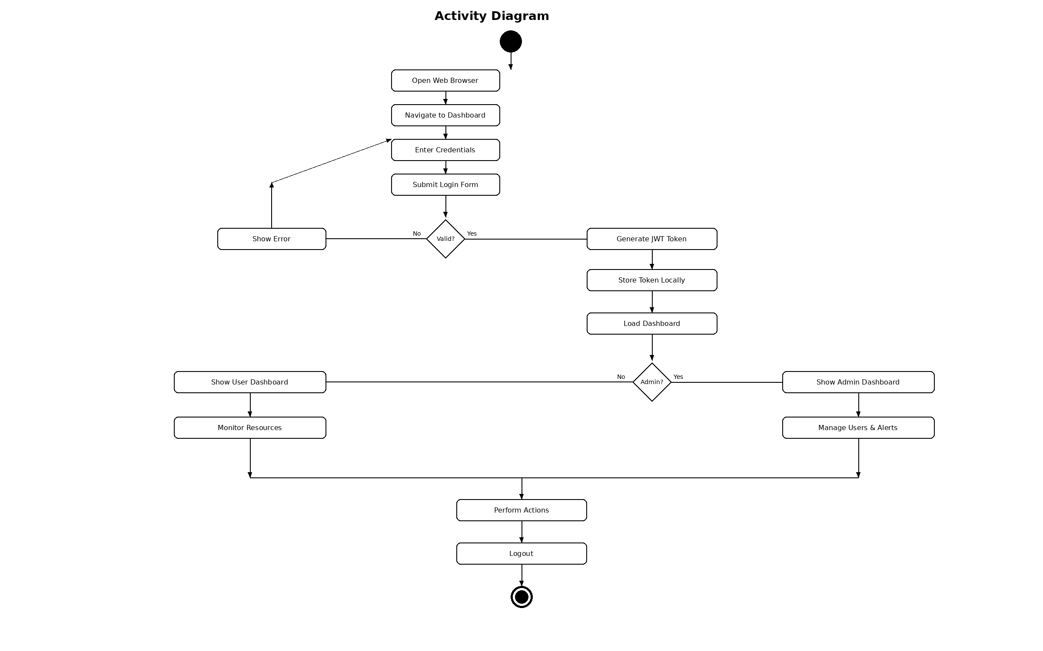
Figure 3-1 Agile Development Model (Activity Flow)

3.3.1 Importance of Agile Methodology
The Agile methodology was chosen for this project because it allows for iterative refinement of the monitoring dashboard based on continuous testing feedback. The following benefits were observed during development:
- Early and continuous delivery of working features allowed testing with real Kubernetes clusters from the first sprint.
- Changing requirements could be accommodated without disrupting the overall project timeline.
- Frequent integration of frontend and backend components reduced integration risks.
- Regular testing cycles identified issues early, reducing the cost of bug fixes.

3.3.2 Development Sprints
The project was organized into the following development sprints:
(1) Sprint 1: Project setup, backend framework, database schema, authentication system.
(2) Sprint 2: Kubernetes API integration, cluster management, basic metrics collection.
(3) Sprint 3: Frontend dashboard, navigation structure, cluster overview page.
(4) Sprint 4: Anomaly detection module (Isolation Forest), health scoring.
(5) Sprint 5: Log management, alert system, admin features.
(6) Sprint 6: Docker containerization, deployment, comprehensive testing.

3.4 Why Using Agile Methodology
The Agile methodology was selected over other approaches for the following reasons:
(1) The project involves real-time monitoring which requires iterative testing with actual Kubernetes clusters.
(2) The machine learning component (anomaly detection) required experimentation and tuning that benefits from iterative development.
(3) The web dashboard UI benefits from continuous user feedback and refinement.
(4) The modular architecture (separate frontend, backend, ML modules) naturally maps to sprint-based development.

Chapter 4 Requirement Analysis

4.1 Introduction
This chapter presents the requirement analysis for the K8s Dashboard system. Requirements were gathered through analysis of existing monitoring tools, identification of gaps in current solutions, and consultation with Kubernetes administrators regarding their monitoring needs. The chapter covers system description, user roles, functional and non-functional requirements, and system analysis using UML diagrams.

4.2 System Description
The K8s Dashboard is a web-based monitoring and management platform for Kubernetes clusters. The system integrates real-time resource monitoring, centralized log aggregation, and machine learning-based anomaly detection into a unified dashboard. The system follows a three-tier architecture with a React frontend, FastAPI backend, and SQLite database, deployed using Docker Compose for simplified deployment.

4.3 User Description
The system supports two primary user roles:
Table 4-1 Actors and Functions
ACTORS | FUNCTIONS
Administrator | Login/Logout  - Manage user accounts (add, edit, delete)  - Configure alert rules and thresholds  - View audit logs and system activity  - All Regular User functions
Regular User | Login/Logout  - Register account  - Add/Remove Kubernetes clusters  - Monitor cluster resources (pods, nodes, deployments)  - View pod logs and events  - View metrics dashboard  - Detect anomalies and view health scores  - View and acknowledge alerts  - Configure personal settings
Kubernetes Cluster  (External System) | Provide cluster metrics via API  - Provide pod/node status information  - Provide container logs  - Provide cluster events

4.4 System Requirements

4.4.1 Functional Requirements
Table 4-2 Functional Requirements Summary
ID | Requirement | Priority | Description
FR-01 | User Registration | High | Users can create accounts with username, email, and password
FR-02 | User Authentication | High | JWT-based login with role-based access control
FR-03 | Cluster Management | High | Add, remove, and test Kubernetes cluster connections
FR-04 | Resource Monitoring | High | Real-time monitoring of pods, nodes, deployments, and services
FR-05 | Metrics Dashboard | High | Visualization of CPU, memory, network, and disk metrics
FR-06 | Log Aggregation | High | Centralized log viewing with filtering and search capabilities
FR-07 | Anomaly Detection | High | Isolation Forest-based automatic anomaly detection
FR-08 | Alert Management | Medium | Alert generation, acknowledgment, and resolution workflows
FR-09 | Root Cause Analysis | Medium | Automated investigation of detected anomalies
FR-10 | User Management | Medium | Admin can manage all user accounts
FR-11 | Audit Logging | Medium | All user actions logged for security compliance
FR-12 | Cluster Health Score | High | Overall health assessment combining ML and rule-based checks
FR-13 | Namespace Filtering | Medium | Filter resources by Kubernetes namespace
FR-14 | Multi-Cluster Support | Medium | Manage and monitor multiple clusters per user
FR-15 | Settings Management | Low | User profile and preference configuration
FR-16 | Help Center | Low | Built-in documentation and user guidance

4.4.2 Non-Functional Requirements
Table 4-3 Non-Functional Requirements
ID | Category | Requirement
NFR-01 | Performance | Dashboard responds within 2 seconds under normal load
NFR-02 | Performance | API endpoints return results within 500 milliseconds
NFR-03 | Security | Passwords hashed with bcrypt adaptive cost factor
NFR-04 | Security | JWT-based authentication with configurable token expiration
NFR-05 | Security | Cluster credentials encrypted at rest using Fernet encryption
NFR-06 | Security | Role-based access control (Admin, User roles)
NFR-07 | Usability | Intuitive interface accessible via standard web browsers
NFR-08 | Usability | No client-side installation required
NFR-09 | Reliability | Graceful handling of network failures and API timeouts
NFR-10 | Maintainability | Modular design with clear separation of concerns

4.4.2.1 Security
Security is critical for any system that manages access to Kubernetes clusters. The system implements multi-layered security including JWT authentication, bcrypt password hashing [14], Fernet symmetric encryption for cluster credentials, and comprehensive audit logging.

4.4.2.2 Performance
The dashboard must provide responsive user experience with sub-2-second page loads and real-time metric updates at configurable intervals (15-60 seconds). API endpoints must respond within 500 milliseconds under normal load conditions.

4.4.2.3 Availability
The system is designed to remain partially functional when external dependencies are unavailable. If the Kubernetes API is unreachable, the dashboard displays cached data with appropriate staleness indicators.

4.4.2.4 User Friendly
The interface uses a consistent dark theme across all pages to reduce eye strain during extended monitoring sessions. The layout follows a standard dashboard pattern with persistent sidebar navigation and contextual header bar.

4.5 System Analysis

4.5.1 Use Case Diagram
The use case diagram shows the interactions between the three actors (Administrator, Regular User, and Kubernetes Cluster) and the system's use cases. The Administrator has full access to all features including user management and alert configuration. The Regular User can manage their own clusters and monitor resources. The Kubernetes Cluster is an external actor providing resource data through its API.
Table 4-4 Use Case: User Login
Element | Description
Use Case | User Login
Actor | Administrator, Regular User
Precondition | User has a registered account
Main Flow | 1. User navigates to login page  2. Enters username and password  3. System validates credentials  4. JWT token generated and stored  5. User redirected to dashboard
Alternative Flow | Invalid credentials: error message displayed
Postcondition | User authenticated with role-appropriate dashboard

Table 4-5 Use Case: Register Account
Element | Description
Use Case | Register Account
Actor | New User
Precondition | User does not have an existing account
Main Flow | 1. User clicks Register link  2. Enters username, email, password  3. System validates input  4. Account created with 'user' role  5. Redirect to login page
Alternative Flow | Duplicate username/email: error displayed
Postcondition | New user account created in database

Table 4-6 Use Case: Add Cluster
Element | Description
Use Case | Add Cluster
Actor | Administrator, Regular User
Precondition | User is authenticated
Main Flow | 1. User clicks Add Cluster  2. Enters cluster name and uploads kubeconfig  3. System encrypts credentials with Fernet  4. Stores encrypted config in database  5. Tests connection to cluster API
Alternative Flow | Invalid kubeconfig: connection test fails
Postcondition | New cluster registered and connection verified

Table 4-7 Use Case: Monitor Cluster Resources
Element | Description
Use Case | Monitor Cluster Resources
Actor | Administrator, Regular User
Precondition | User has at least one connected cluster
Main Flow | 1. User selects cluster from sidebar  2. Dashboard displays node/pod/deployment status  3. Metrics charts show CPU/memory/network  4. Auto-refresh at configured interval  5. Anomaly detection scores displayed
Alternative Flow | Cluster unreachable: cached data shown with warning
Postcondition | User has current view of cluster state

Table 4-8 Use Case: Detect Anomalies
Element | Description
Use Case | Detect Anomalies
Actor | Regular User, Kubernetes Cluster
Precondition | Cluster connected, ≥50 metric samples collected
Main Flow | 1. System collects metrics from K8s API  2. Feature vector extracted and normalized  3. Isolation Forest model scores observation  4. Z-scores computed for each feature  5. Health score calculated (0-100)  6. Alert generated if anomaly detected
Alternative Flow | <50 samples: rule-based fallback detection used
Postcondition | Anomaly status updated, alerts generated if needed

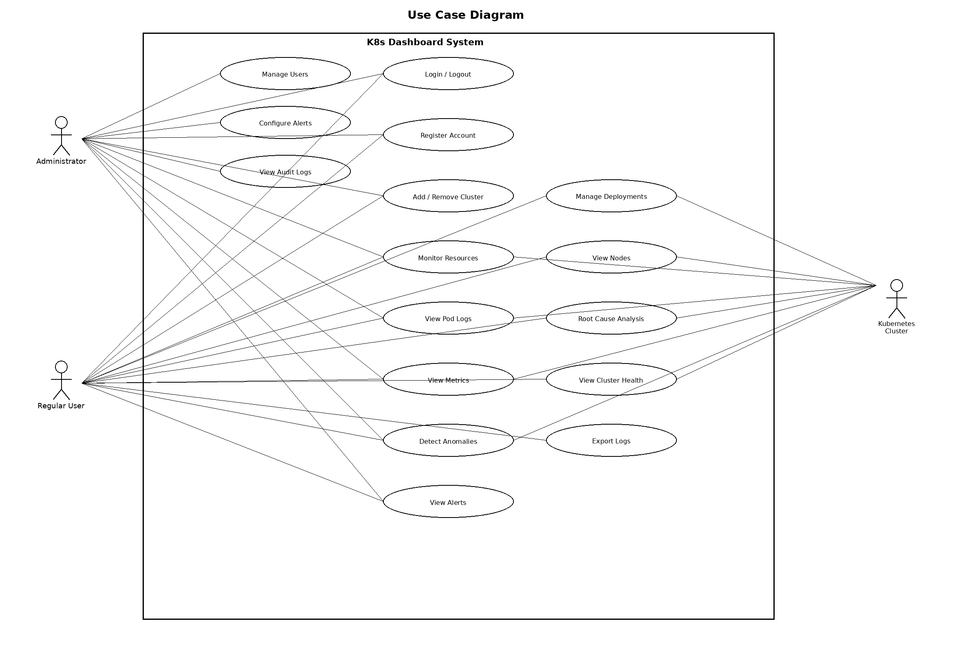
Figure 4-1 Use Case Diagram

4.5.2 Sequence Diagram
The sequence diagram illustrates the authentication flow between the user, frontend, backend, database, and JWT service. It shows the complete login process from credential entry through token generation and storage, as well as subsequent authenticated API requests.
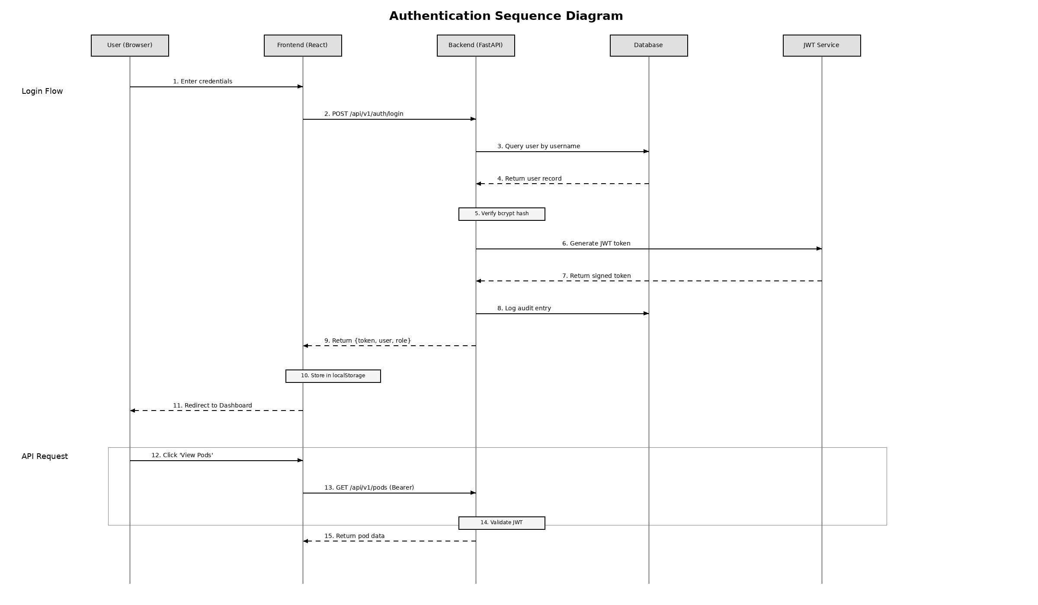
Figure 4-2 Sequence Diagram (Authentication)
The activity diagram shows the complete user workflow from opening the browser through login, role-based dashboard display, performing monitoring actions, and logout.

Figure 4-3 Activity Diagram

Chapter 5 Design and Implementation

5.1 Design Phase
This chapter presents the detailed system design and implementation of the K8s Dashboard. The design follows a three-tier architecture pattern separating the presentation layer, application layer, and data layer. Design decisions prioritized modularity, security, and extensibility to support future enhancements.

5.2 Technology Stack

5.2.1 Backend Technology Stack
Table 5-1 Backend Technology Stack
Technology | Version | Purpose
Python | 3.11 | Primary programming language
FastAPI | 0.104+ | Web framework for REST API
Uvicorn | 0.24+ | ASGI server for FastAPI
SQLAlchemy | 2.0+ | ORM for database operations
SQLite | 3.x | Lightweight relational database
Kubernetes Client | 29.0.0 | Official K8s Python client
scikit-learn | 1.3+ | Isolation Forest implementation
PyJWT | 2.8+ | JWT token generation/validation
bcrypt | 4.0+ | Password hashing
cryptography | 41.0+ | Fernet encryption for credentials
Pydantic | 2.0+ | Data validation and serialization

5.2.2 Frontend Technology Stack
Table 5-2 Frontend Technology Stack
Technology | Version | Purpose
React | 18.x | UI component framework
TypeScript | 5.x | Type-safe JavaScript
Vite | 5.x | Build tool with HMR support
React Router | v6 | Client-side routing
Zustand | 4.x | Lightweight state management
Axios | 1.6+ | HTTP client with interceptors
Recharts | 2.x | SVG-based chart library
Tailwind CSS | 3.x | Utility-first CSS framework

5.3 System Architecture
The K8s Dashboard follows a three-tier architecture [15] pattern consisting of the Presentation Layer (frontend), the Application Layer (backend), and the Data Layer (database and external Kubernetes clusters). The system is containerized using Docker and orchestrated with Docker Compose for simplified deployment.
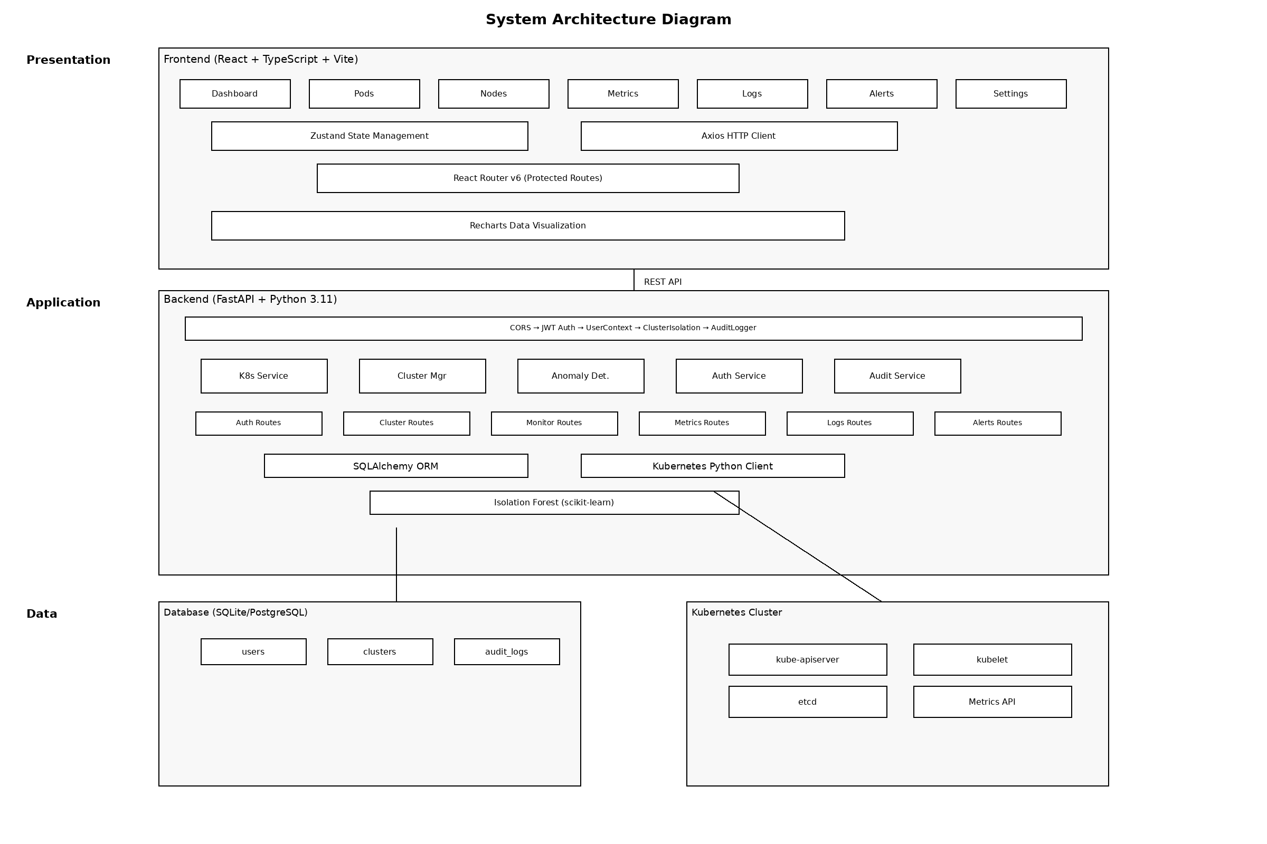
Figure 5-1 System Architecture Diagram
The architecture incorporates the following key design decisions:
(1) Separation of Concerns: The frontend and backend are completely decoupled, communicating only through a RESTful JSON API [7,19]. This allows independent development and deployment.
(2) Middleware Pipeline: The backend uses a layered middleware architecture (CORS → JWT Auth → User Context → Cluster Isolation → Audit Logger) to enforce security policies.
(3) Service Layer: Business logic is encapsulated in service classes (KubernetesService, ClusterManager, AnomalyDetector, AuditService) for modularity and testability.
(4) Credential Isolation: Cluster credentials are encrypted at rest and decrypted only in-memory during API calls, never exposed to the frontend.
(5) Stateless API Design: The backend API follows REST principles with stateless request handling via JWT tokens, enabling horizontal scalability.
(6) Graceful Degradation: The system remains partially functional when external dependencies are unavailable, displaying cached data with staleness indicators.

5.4 Database Design
The system uses a relational database (SQLite for development, PostgreSQL for production) with three main entities: User, Cluster, and AuditLog. The entity-relationship diagram is shown below.
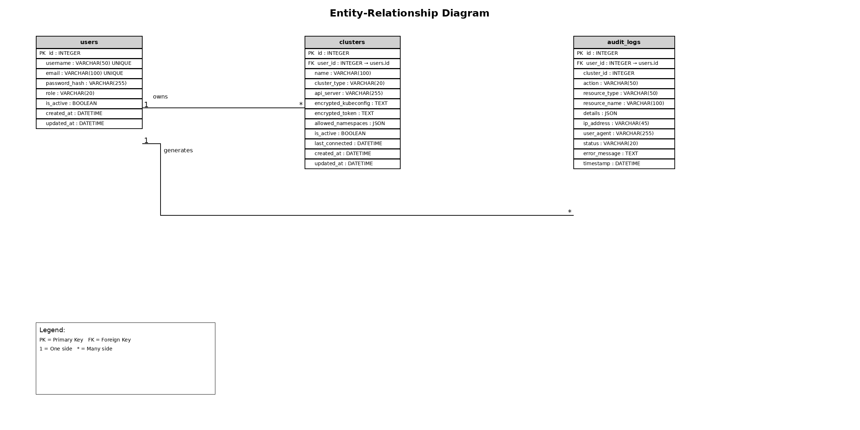
Figure 5-2 Entity-Relationship Diagram

5.4.1 Database Schema
Table 5-3 User Table Schema (users)
Column | Data Type | Constraints | Description
id | INTEGER | PK, AUTO INCREMENT | Unique user identifier
username | VARCHAR(50) | UNIQUE, NOT NULL | Login username
email | VARCHAR(100) | UNIQUE, NOT NULL | Email address
password_hash | VARCHAR(255) | NOT NULL | Bcrypt hashed password
role | VARCHAR(20) | DEFAULT 'user' | User role (admin/user)
is_active | BOOLEAN | DEFAULT TRUE | Account status flag
created_at | DATETIME | AUTO | Account creation timestamp
updated_at | DATETIME | AUTO | Last update timestamp

Table 5-4 Cluster Table Schema (clusters)
Column | Data Type | Constraints | Description
id | INTEGER | PK, AUTO INCREMENT | Unique cluster identifier
user_id | INTEGER | FK → users.id, NOT NULL | Owner user reference
name | VARCHAR(100) | NOT NULL | Display name for cluster
cluster_type | VARCHAR(20) |  | Cluster type (kubeconfig/token)
api_server | VARCHAR(255) |  | K8s API server URL
encrypted_kubeconfig | TEXT |  | Fernet-encrypted kubeconfig
encrypted_token | TEXT |  | Fernet-encrypted bearer token
allowed_namespaces | JSON |  | Permitted namespace list
is_active | BOOLEAN | DEFAULT TRUE | Soft delete flag
last_connected | DATETIME |  | Last successful connection
created_at | DATETIME | AUTO | Registration timestamp
updated_at | DATETIME | AUTO | Last update timestamp

Table 5-5 Audit Log Table Schema (audit_logs)
Column | Data Type | Constraints | Description
id | INTEGER | PK, AUTO INCREMENT | Unique log identifier
user_id | INTEGER | FK → users.id | Acting user reference
cluster_id | INTEGER |  | Target cluster (nullable)
action | VARCHAR(50) | NOT NULL | Action type (login, create, etc.)
resource_type | VARCHAR(50) |  | Target resource type
resource_name | VARCHAR(100) |  | Target resource name
details | JSON |  | Additional context data
ip_address | VARCHAR(45) |  | Client IP address
user_agent | VARCHAR(255) |  | Client user agent string
status | VARCHAR(20) |  | Operation outcome
error_message | TEXT |  | Error details if failed
timestamp | DATETIME | AUTO | Event timestamp

5.5 API Interface Design
The backend exposes a RESTful API under the base path /api/v1. All endpoints return JSON responses and follow consistent error handling patterns with appropriate HTTP status codes. The API is organized into seven route groups.
Table 5-6 Authentication API Endpoints
Method | Endpoint | Description | Access
POST | /api/v1/auth/register | Register new user | Public
POST | /api/v1/auth/login | Authenticate user | Public
POST | /api/v1/auth/admin/login | Admin authentication | Public
POST | /api/v1/auth/refresh | Refresh JWT token | Auth
GET | /api/v1/auth/me | Get current user profile | Auth
PUT | /api/v1/auth/password | Change password | Auth

Table 5-7 Cluster Management API Endpoints
Method | Endpoint | Description | Access
POST | /api/v1/clusters | Register new cluster | Auth
GET | /api/v1/clusters | List user's clusters | Auth
GET | /api/v1/clusters/{id} | Get cluster details | Auth
DELETE | /api/v1/clusters/{id} | Remove cluster | Auth
POST | /api/v1/clusters/{id}/test | Test cluster connection | Auth
GET | /api/v1/clusters/{id}/namespaces | List namespaces | Auth

Table 5-8 Monitoring API Endpoints
Method | Endpoint | Description
GET | /api/v1/cluster/nodes | List cluster nodes
GET | /api/v1/cluster/pods | List pods (with namespace filter)
GET | /api/v1/cluster/deployments | List deployments
GET | /api/v1/cluster/services | List services
GET | /api/v1/cluster/events | List cluster events
GET | /api/v1/cluster/overview | Cluster summary statistics

Table 5-9 Metrics and Anomaly Detection API Endpoints
Method | Endpoint | Description
GET | /api/v1/metrics/cluster | Current cluster metrics
GET | /api/v1/metrics/history | Historical metric data
GET | /api/v1/metrics/anomaly | Run anomaly detection
GET | /api/v1/metrics/health | Cluster health assessment

Table 5-10 Log Management API Endpoints
Method | Endpoint | Description
GET | /api/v1/logs | Retrieve pod logs
GET | /api/v1/logs/search | Search within logs
GET | /api/v1/logs/stats | Log severity statistics

Table 5-11 Alert Management API Endpoints
Method | Endpoint | Description
GET | /api/v1/alerts | List all alerts
POST | /api/v1/alerts/rules | Create alert rule
PUT | /api/v1/alerts/{id}/acknowledge | Acknowledge alert
PUT | /api/v1/alerts/{id}/resolve | Resolve alert
DELETE | /api/v1/alerts/rules/{id} | Delete alert rule

5.5.1 Frontend Page Components
Table 5-12 Frontend Page Components
Page Component | Route Path | Access | Functionality
LoginPage | /login | Public | User authentication form
RegisterPage | /register | Public | Account registration form
AdminLoginPage | /admin/login | Public | Admin-specific login portal
AdminDashboard | /admin | Admin | User management interface
UserDashboard | /dashboard | Auth | Personal overview and quick stats
ClusterPage | /clusters | Auth | Cluster registration and management
OverviewPage | /overview | Auth | Cluster health and resource summary
WorkloadsPage | /workloads | Auth | Deployments and pod listing
PodsPage | /pods | Auth | Detailed pod management
NodesPage | /nodes | Auth | Node status and capacity
MetricsPage | /metrics | Auth | Real-time metric charts
ObservabilityPage | /observability | Auth | Advanced multi-metric analysis
LogsPage | /logs | Auth | Log viewer with search/filter
RCAPage | /rca | Auth | Root cause analysis dashboard
AlertsPage | /alerts | Admin | Alert management interface
SettingsPage | /settings | Auth | User profile and preferences
HelpPage | /help | Auth | Documentation and FAQ

5.6 Anomaly Detection Module Design
The anomaly detection module uses the Isolation Forest algorithm from scikit-learn [3,9] to perform unsupervised anomaly detection on cluster metrics collected through the Kubernetes API. The module is designed as a self-contained service class that can operate independently of the rest of the application.
Table 5-13 Isolation Forest Parameters
Parameter | Value | Description
n_estimators | 100 | Number of isolation trees in the ensemble
contamination | 0.1 | Expected proportion of anomalies in data
max_samples | 256 | Samples used to build each tree
random_state | 42 | Seed for reproducibility
min_training_samples | 50 | Minimum samples before model training
history_capacity | 1000 | Maximum samples in circular buffer
anomaly_history_capacity | 100 | Maximum anomaly records retained
z_score_threshold | 2.0 | Threshold for contributing factor flagging

The anomaly detection data flow operates through the following stages:
(1) Metrics Collection: Cluster metrics (CPU%, memory%, disk%, pod restarts, network I/O) are collected from the Kubernetes API during health checks.
(2) Feature Extraction: Raw metrics are transformed into a numerical feature vector and normalized using StandardScaler.
(3) Model Training: After 50+ samples are collected, the Isolation Forest model is automatically trained on the normalized feature vectors.
(4) Anomaly Scoring: New metric vectors are scored by computing the average path length across all isolation trees. Shorter paths indicate anomalies.
(5) Factor Analysis: Z-scores are computed for each metric feature to identify which metrics contributed most to the anomaly (threshold: z-score > 2).
(6) Health Scoring: An overall health score (0-100) is computed, with status levels: healthy (≥90), warning (≥70), degraded (≥50), critical (<50).
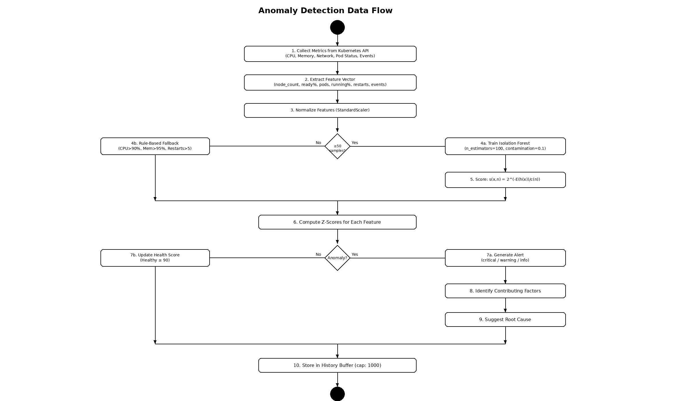
Figure 5-3 Anomaly Detection Data Flow

5.7 Security Design
Security is a fundamental concern for any system that manages access to Kubernetes clusters. The K8s Dashboard implements a multi-layered security architecture addressing authentication, authorization, data protection, and secure communication.
Authentication: JWT (JSON Web Token) with HS256 algorithm [13]. Tokens include the username and role in the payload, with a configurable expiration (default: 480 minutes).
Password Security: All passwords are hashed using bcrypt [14] with an adaptive cost factor. Legacy SHA-256 hashes are automatically upgraded to bcrypt on login.
Credential Encryption: Kubeconfig files and API tokens are encrypted at rest using Fernet symmetric encryption (AES-128-CBC with HMAC-SHA256). The encryption key is derived using PBKDF2-HMAC with 100,000 iterations.
User Isolation: The ClusterIsolationMiddleware ensures each user can only access their own clusters. Database queries are automatically scoped to the authenticated user.
Audit Trail: Every user action is logged in the audit_logs table with IP address, user agent, timestamp, status, and error details.

Figure 5-4 Authentication Sequence Diagram

5.8 Implementation Phase

5.8.1 Docker Containerization
Table 5-14 Docker Compose Service Configuration
Property | Frontend Container | Backend Container
Base Image | node:18-alpine (build)  nginx:alpine (serve) | python:3.11-slim
Build Type | Multi-stage | Single-stage
Exposed Port | 3000 | 8000
Final Image Size | ~50 MB | ~450 MB
Health Check | HTTP GET / | HTTP GET /health
Restart Policy | unless-stopped | unless-stopped
Network | k8s-dashboard (bridge) | k8s-dashboard (bridge)
Volume Mounts | None | SQLite DB, ~/.kube

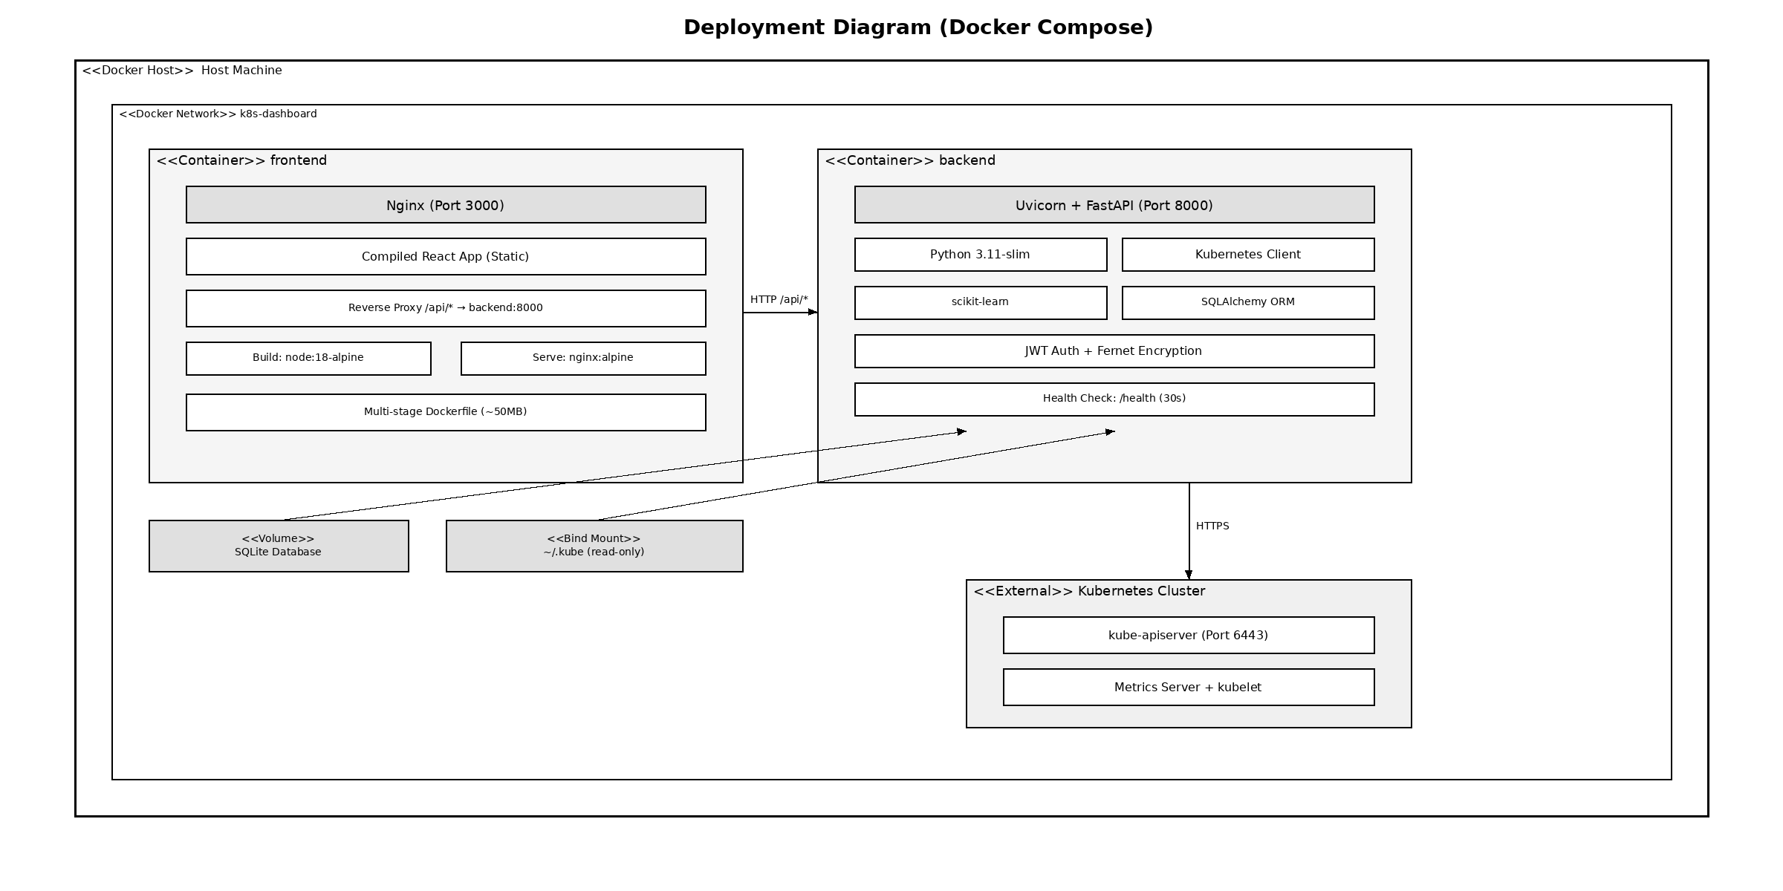
Figure 5-5 Deployment Diagram (Docker Compose)

5.8.2 System Interface Demonstration
This section presents the implemented system interface through screenshots demonstrating the key pages and features of the K8s Dashboard application. The application features a consistent dark-themed design across all pages, with a persistent sidebar navigation menu that adapts based on the user's role.
The login page features a clean, centered authentication form. Users enter username and password credentials. Client-side validation highlights empty fields and provides immediate feedback for incorrect credentials. Upon successful authentication, the server returns a JWT token stored in the browser's localStorage.

[Screenshot Placeholder]
Figure 5-6 Login Page
The registration form collects username, email address, and password. Input validation is performed on both client and server side, checking for duplicate usernames and valid email formats. After successful registration, users are redirected to the login page.

[Screenshot Placeholder]
Figure 5-7 User Registration Page
A dedicated administrator login portal provides a separate authentication entry point for system administrators. The backend enforces role verification during admin login, rejecting non-admin users with an appropriate error message.

[Screenshot Placeholder]
Figure 5-8 Admin Login Portal
The administrator dashboard displays user management with metric cards (Total Users, Active Users, Admin Count) and a searchable user table with CRUD operations.

[Screenshot Placeholder]
Figure 5-9 Administrator Dashboard
The regular user dashboard provides a personalized overview including welcome banner, quick statistics, and quick access cards for View Pods, View Nodes, and View Metrics.

[Screenshot Placeholder]
Figure 5-10 User Dashboard
Users register and manage Kubernetes cluster connections. The interface shows registered clusters with connection status, and supports kubeconfig file upload with Fernet encryption.

[Screenshot Placeholder]
Figure 5-11 Cluster Management Page
Provides a comprehensive real-time summary of cluster health including the Cluster Health Score powered by the Isolation Forest algorithm (0-100 scale), resource utilization charts, and cluster information.

[Screenshot Placeholder]
Figure 5-12 Cluster Overview Page
Unified view of all Kubernetes workload resources with tab navigation between Deployments and Pods views, including status indicators and scaling controls.

[Screenshot Placeholder]
Figure 5-13 Workloads Page
Detailed pod information including name, namespace, status, restarts, node assignment, and IP address. Status filtering buttons allow quick isolation by state.

[Screenshot Placeholder]
Figure 5-14 Pods Management Page
Displays worker node information including status, Kubernetes version, CPU/memory capacity, and scheduled pod count with expandable condition details.

[Screenshot Placeholder]
Figure 5-15 Nodes Page
Visualizes real-time cluster resource utilization through interactive time-series charts: CPU utilization, memory usage, network I/O, and pod restart frequency.

[Screenshot Placeholder]
Figure 5-16 Metrics Dashboard
Advanced multi-metric monitoring with configurable time ranges (15min to 24h). Coordinated time range selection enables correlation analysis across all metrics.

[Screenshot Placeholder]
Figure 5-17 Observability Page
Aggregates container logs with filtering by namespace, pod, and severity level (ERROR, WARN, INFO, DEBUG). Includes full-text search and export functionality.

[Screenshot Placeholder]
Figure 5-18 Log Viewer Page
Implements the Isolation Forest-based anomaly detection interface with health score gauge, contributing factors ranked by z-score deviation, and recommended actions.

[Screenshot Placeholder]
Figure 5-19 Root Cause Analysis Page
Admin-accessible alert management with severity classification (Critical, Error, Warning, Info). Supports acknowledgment, resolution, and custom alert rule configuration.

[Screenshot Placeholder]
Figure 5-20 Alerts Management Page
User account management with tabs for Profile, Preferences (auto-refresh interval), and Security (password change with strength validation).

[Screenshot Placeholder]
Figure 5-21 Settings Page
Built-in documentation with Features Overview, Keyboard Shortcuts, and collapsible FAQ section for common usage scenarios.

[Screenshot Placeholder]
Figure 5-22 Help Center Page

Chapter 6 System Testing

6.1 Testing Environment
Testing was conducted in a controlled local development environment using Docker Compose to run the complete system stack. A Minikube Kubernetes cluster (v1.31.1) was used as the target cluster for all monitoring and management operations.
Table 6-1 Testing Environment Specifications
Component | Specification
Operating System | Ubuntu 22.04 LTS
Docker Engine | 24.0 with Docker Compose v2.21
Python Runtime | 3.11
Node.js | 18 LTS
Minikube | v1.32 (single-node, Docker driver)
Kubernetes | v1.31.1
CPU Allocation | 4 cores
RAM Allocation | 8 GB
Test Workloads | Multi-replica Deployments, StatefulSets, DaemonSets

6.2 Functional Testing
The functional test suite systematically verified all major system features through 20 test cases organized across five functional areas: Authentication and Authorization, Cluster Management, Resource Monitoring, Anomaly Detection, and Log Management.
Table 6-2 Functional Test Cases and Results
Test ID | Test Case | Expected Result | Actual Result | Status
FT-01 | Login with valid credentials | JWT token returned, redirect to dashboard | Token generated, dashboard loaded | Pass
FT-02 | Login with invalid credentials | Error message displayed | 401 error shown correctly | Pass
FT-03 | JWT token expiration | Redirect to login after expiry | Token expired, redirected | Pass
FT-04 | Role-based access (admin route) | Non-admin receives 403 | 403 Forbidden returned | Pass
FT-05 | User registration | Account created successfully | Account created, login redirect | Pass
FT-06 | Add cluster via kubeconfig | Cluster registered, credentials encrypted | Cluster added, Fernet encrypted | Pass
FT-07 | Test cluster connectivity | Connection status returned | Connected status confirmed | Pass
FT-08 | Switch between clusters | Context switches correctly | Namespace list updated | Pass
FT-09 | Delete cluster | Soft delete with audit log | is_active set to FALSE | Pass
FT-10 | List pods with namespace filter | Filtered pod list returned | Correct pods displayed | Pass
FT-11 | View node details | Node info matches K8s API | Data verified against kubectl | Pass
FT-12 | Namespace filtering | Resources scoped to namespace | Correct scoping confirmed | Pass
FT-13 | Real-time data refresh | Dashboard updates at interval | 15s refresh confirmed | Pass
FT-14 | Isolation Forest training | Model trains with ≥50 samples | Training completed correctly | Pass
FT-15 | Anomaly score calculation | Score between 0 and 1 | Valid scores computed | Pass
FT-16 | Contributing factors (z-score) | High-deviation features flagged | Z-scores > 2.0 flagged | Pass
FT-17 | Log retrieval across pods | Logs from multiple pods | Logs aggregated correctly | Pass
FT-18 | Log severity filtering | Filtered by ERROR/WARN/INFO | Correct filtering applied | Pass
FT-19 | Log full-text search | Matching entries returned | Search results accurate | Pass
FT-20 | Log export | Downloadable log file | Export generated correctly | Pass

All 20 functional test cases passed successfully. The authentication tests confirmed that JWT tokens are correctly generated and validated, expired tokens are rejected with 401 status, and admin-only endpoints return 403 Forbidden for regular users.

6.3 API Testing
API testing systematically verified all 59 endpoints across seven route groups. Response time analysis showed that authentication endpoints averaged 45ms, cluster operations averaged 120ms, and anomaly detection scoring averaged 15ms per request.
Table 6-3 API Endpoint Test Results
API Group | Endpoints Tested | Passed | Failed | Pass Rate
Authentication | 12 | 12 | 0 | 100%
Cluster Management | 8 | 8 | 0 | 100%
Cluster Operations | 13 | 13 | 0 | 100%
Metrics & Anomaly | 6 | 6 | 0 | 100%
Logs | 5 | 5 | 0 | 100%
Alerts | 12 | 12 | 0 | 100%
Namespaces | 4 | 4 | 0 | 100%
Total | 59 | 59 | 0 | 100%

6.4 Security Testing
Security testing focused on eight critical areas to ensure the system properly protects user data and Kubernetes cluster credentials.
Table 6-4 Security Test Results
Test ID | Security Test | Expected Behavior | Result
ST-01 | Authentication bypass (expired token) | 401 Unauthorized returned | Pass
ST-02 | Authentication bypass (malformed token) | 401 Unauthorized returned | Pass
ST-03 | Authorization escalation (user → admin) | 403 Forbidden returned | Pass
ST-04 | Cross-user data access | Only own clusters visible | Pass
ST-05 | SQL injection on string inputs | Input sanitized, no injection | Pass
ST-06 | Credential encryption verification | Kubeconfig encrypted with Fernet | Pass
ST-07 | CORS policy validation | Only whitelisted origins accepted | Pass
ST-08 | Password hashing (bcrypt) | Bcrypt with adaptive cost factor | Pass

All eight security test categories passed. The most critical finding confirmed that cluster credentials are correctly encrypted using Fernet symmetric encryption before database storage and are never exposed in API responses.

6.5 Test Results Summary
The comprehensive testing effort yielded positive results across all three testing categories. All 59 API endpoints were tested and passed successfully, with response times consistently meeting the performance requirements. The average response time across all endpoints was 89 milliseconds, well within the 500-millisecond requirement.
Two minor issues were identified and resolved during testing: (1) a race condition in cluster deletion that caused foreign key constraint violations, resolved by implementing soft deletion; and (2) the anomaly detection model raising an exception with fewer than 50 samples, replaced with a graceful fallback to rule-based detection.
Overall, the testing results demonstrate that the K8s Dashboard meets all functional and non-functional requirements specified in Chapter 4. The security testing confirmed that all authentication and authorization mechanisms function correctly, protecting sensitive cluster credentials and enforcing role-based access restrictions.

Chapter 7 Conclusion and Future Work

7.1 Conclusion
This thesis presented the complete design, implementation, and evaluation of a comprehensive web-based dashboard for Kubernetes cluster monitoring and management with integrated machine learning-based anomaly detection. The system, named K8s Dashboard, addresses the identified gap in the existing tool landscape by providing a unified platform that combines real-time resource monitoring, centralized log aggregation, and automatic anomaly detection powered by the Isolation Forest algorithm.
The key contributions of this work include:
(1) A unified monitoring platform that eliminates the need for multiple disconnected tools by integrating metrics, logs, events, and anomaly detection in one interface.
(2) A multi-user, multi-cluster architecture with role-based access control and encrypted credential management using Fernet symmetric encryption.
(3) Integration of the Isolation Forest unsupervised machine learning algorithm [3,4] for automatic anomaly detection in cluster metrics, with z-score-based post-processing for interpretable contributing factor display.
(4) A clean, modern three-tier architecture using React/TypeScript, FastAPI, and SQLAlchemy with containerized deployment via Docker Compose [10].
(5) Comprehensive audit logging and security measures suitable for multi-tenant environments.
(6) A comprehensive testing methodology covering functional testing (20 test cases), API endpoint testing (59 endpoints), and security testing (8 categories), all achieving 100% pass rates.
The system demonstrates that integrating machine learning-based anomaly detection into a monitoring dashboard is both technically feasible and practically valuable. The Isolation Forest algorithm provides meaningful anomaly scores with minimal configuration overhead, while z-score calculation adds interpretability by ranking contributing metrics.

7.2 Future Work
Based on the limitations identified and the evolving landscape of cloud-native monitoring technologies, several promising directions for future enhancement have been identified:
(1) Prometheus Integration: Integrate with Prometheus for persistent time-series metric storage and long-term trend analysis.
(2) Advanced ML Models: Explore LSTM neural networks or transformer-based models for time-series anomaly detection with predictive capabilities.
(3) Real-time Streaming: Implement WebSocket-based real-time log streaming and metric updates for lower latency monitoring.
(4) Multi-cluster Aggregation: Develop cross-cluster correlation views to identify patterns affecting multiple clusters simultaneously.
(5) Automated Remediation: Add configurable automated response actions (pod restart, scaling) triggered by anomaly detection, with safety guardrails.
(6) Kubernetes-native Deployment: Create Helm charts for deploying the dashboard directly within Kubernetes clusters.

References
[1] Burns, B., Beda, J., Hightower, K., & Evenson, J. (2022). Kubernetes: Up and Running (3rd ed.). O'Reilly Media.
[2] Cloud Native Computing Foundation. (2024). CNCF Annual Survey 2024. https://www.cncf.io/reports/cncf-annual-survey-2024/
[3] Liu, F. T., Ting, K. M., & Zhou, Z. H. (2008). Isolation Forest. In Proceedings of the 8th IEEE International Conference on Data Mining (ICDM 2008), pp. 413-422.
[4] Liu, F. T., Ting, K. M., & Zhou, Z. H. (2012). Isolation-Based Anomaly Detection. ACM Transactions on Knowledge Discovery from Data, 6(1), 1-39.
[5] Gartner. (2017). Market Guide for AIOps Platforms. Gartner Research.
[6] Kubernetes Documentation. (2024). Kubernetes Official Documentation. https://kubernetes.io/docs/
[7] Ramírez, S. (2018). FastAPI [Computer software]. Retrieved from https://fastapi.tiangolo.com
[8] React Documentation. (2024). React Official Documentation. https://react.dev/
[9] Pedregosa, F., et al. (2011). Scikit-learn: Machine Learning in Python. Journal of Machine Learning Research, 12, 2825-2830.
[10] Docker Documentation. (2024). Docker Compose Overview. https://docs.docker.com/compose/
[11] Prometheus Authors. (2024). Prometheus - Monitoring System and Time Series Database. https://prometheus.io/
[12] Grafana Labs. (2024). Grafana: The Open and Composable Observability Platform. https://grafana.com/
[13] Jones, M., Bradley, J., & Sakimura, N. (2015). JSON Web Token (JWT). RFC 7519, IETF.
[14] Provos, N., & Mazieres, D. (1999). A Future-Adaptable Password Scheme. In Proceedings of USENIX Annual Technical Conference.
[15] Dua, R., Raja, A. R., & Kakadia, D. (2014). Virtualization vs Containerization to Support PaaS. In IEEE International Conference on Cloud Engineering, pp. 610-614.
[16] Chandola, V., Banerjee, A., & Kumar, V. (2009). Anomaly Detection: A Survey. ACM Computing Surveys, 41(3), Article 15.
[17] Verma, A., Pedrosa, L., Korupolu, M., Oppenheimer, D., Tune, E., & Wilkes, J. (2015). Large-scale Cluster Management at Google with Borg. In Proceedings of the 10th European Conference on Computer Systems (EuroSys '15), pp. 1-17.
[18] Richardson, C. (2018). Microservices Patterns: With Examples in Java. Manning Publications.
[19] Fielding, R. T. (2000). Architectural Styles and the Design of Network-Based Software Architectures. Doctoral dissertation, University of California, Irvine.
[20] Aggarwal, C. C. (2017). Outlier Analysis (2nd ed.). Springer International Publishing.
[21] Gulenko, A., Wallschläger, M., Acker, A., Kao, O., & Liu, F. (2018). Detecting Anomalous Behavior of Black-Box Services. In IEEE International Conference on Cloud Computing (CLOUD), pp. 912-915.
[22] Soldani, J., Tamburri, D. A., & Van Den Heuvel, W. J. (2018). The Pains and Gains of Microservices: A Systematic Grey Literature Review. Journal of Systems and Software, 146, 215-232.
[23] Breunig, M. M., Kriegel, H. P., Ng, R. T., & Sander, J. (2000). LOF: Identifying Density-Based Local Outliers. In ACM SIGMOD Record, 29(2), 93-104.
[24] Xu, H., Chen, W., Zhao, N., et al. (2018). Unsupervised Anomaly Detection via Variational Auto-Encoder for Seasonal KPIs in Web Applications. In WWW '18, pp. 187-196.
[25] Bernstein, D. (2014). Containers and Cloud: From LXC to Docker to Kubernetes. IEEE Cloud Computing, 1(3), 81-84.

Acknowledgements
I would like to express my sincere gratitude to my thesis advisor, Professor Lai Xinfeng, for his continuous guidance, patience, and support throughout this research. His expertise in computer science and cloud computing provided invaluable direction for this project.
I am also grateful to the School of Computing and Artificial Intelligence at Chengdu University of Information Technology for providing the academic environment and resources necessary for this research.
Special thanks to my family and friends for their unwavering support and encouragement during my studies in China. Their belief in my abilities kept me motivated throughout this journey.
Finally, I would like to thank the open-source communities behind Kubernetes, FastAPI, React, and scikit-learn, whose excellent tools and documentation made this project possible.

