

* **HTML**
* **CSS**
* **Javascript**
* **Bootstrap**
* **React Js**
* **Node Js**
* **React Js intermediate (Web Developer)**
* **I have my own project which I will present to you as a summary. It contains all the techniques that help in developing the site in an advanced manner and with safe protection. You will like it.**

***2020 /2021***

***2023/2024***

**COMPUTER SCIENCE LICENSE**

**BACHELOR**

**EDUCATION**

**EXPERIENCE**

**oussama.remmas@gmail.com**

* **ARABIC**
* **ENGLISH**
* **French**

**LANGUAGES**

**SKILLS**

**+213698833491**

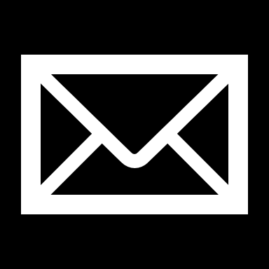

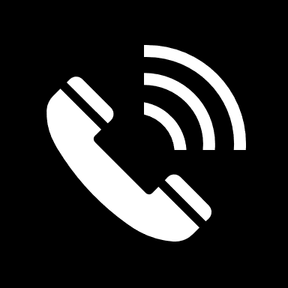

**REMMAS**

**OUSSAMA**

