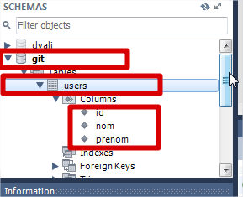

Script to create Database and also the table users :

CREATE DATABASE IF NOT EXISTS `git` /\*!40100 DEFAULT CHARACTER SET utf8 \*/;

USE `git`;

DROP TABLE IF EXISTS `users`;

CREATE TABLE `users` (

`id` int(11) NOT NULL,

`nom` varchar(45) DEFAULT NULL,

`prenom` varchar(45) DEFAULT NULL

) ENGINE=InnoDB DEFAULT CHARSET=utf8;

After the database, now we can create our project by following the next steps:

1. Create a project with Activator tools : tape the command activator new 
2. Choose a play-scala project : 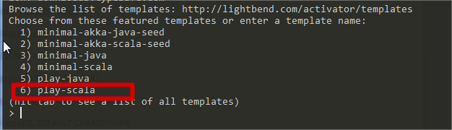
3. Tape 6, and give a name to your project for example : CrudApplication (the name of my project)
4. Now you can browse your file’s project : 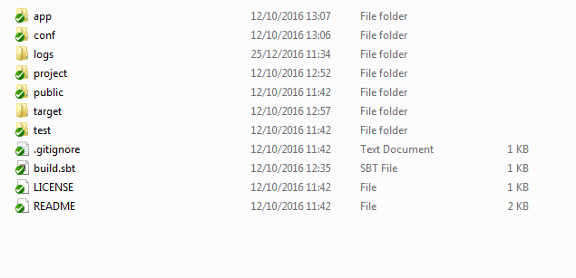
5. Change the file database.conf : you can find this file in the folder conf

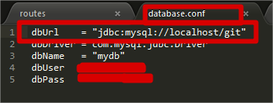

1. Browse the folder \app\controllers and open the file AsyncController.scala : 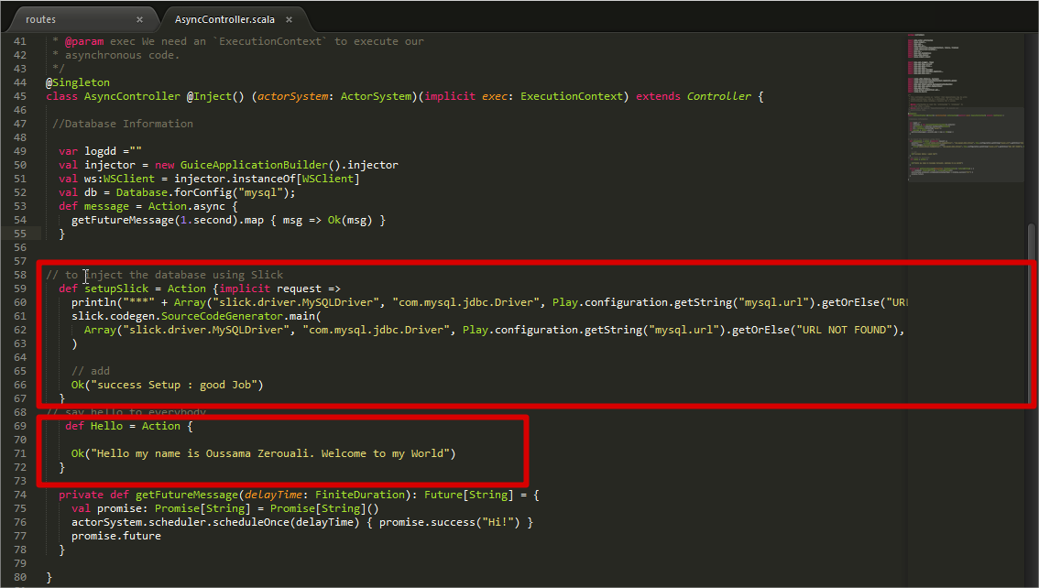
2. For the SetupSlick method add this code :

// to inject the database using Slick

def setupSlick = Action {implicit request =>

println("\*\*\*" + Array("slick.driver.MySQLDriver", "com.mysql.jdbc.Driver", Play.configuration.getString("mysql.url").getOrElse("URL NOT FOUND"), Play.current.path + "/app", "model", Play.configuration.getString("mysql.properties.user").getOrElse("UserName NOT FOUND"), Play.configuration.getString("mysql.properties.password").getOrElse("password NOT FOUND")).toList)

slick.codegen.SourceCodeGenerator.main(

Array("slick.driver.MySQLDriver", "com.mysql.jdbc.Driver", Play.configuration.getString("mysql.url").getOrElse("URL NOT FOUND"), Play.current.path + "/app", "model", Play.configuration.getString("mysql.properties.user").getOrElse("UserName NOT FOUND"), Play.configuration.getString("mysql.properties.password").getOrElse("password NOT FOUND"))

)

// add

Ok("success Setup : good Job")

}

1. After that go directly to the folder app and create a new file with the name model and after that create a scala file : Tables.scala 
2. Now you can add your first method in the routes file : you can find your routes file in the folder conf, after you can update the way for your SetupSlick method :

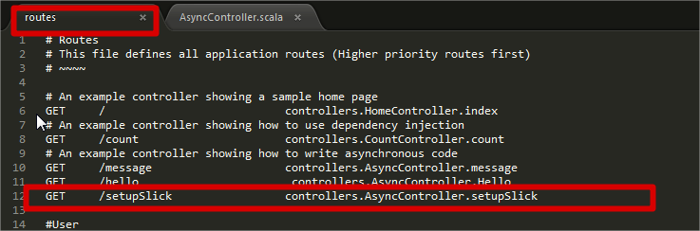

1. Now it’s the time to test your method with a REST API Client, I use POSTMAN to test my code for every method and every function :

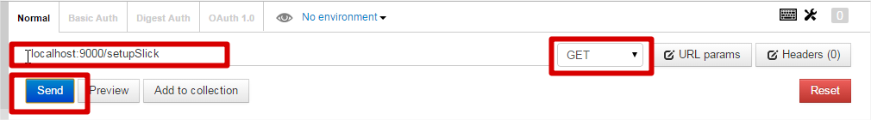

1. Go to the folder app/model and open the file : Tables.scala, you will find all the change on your file :

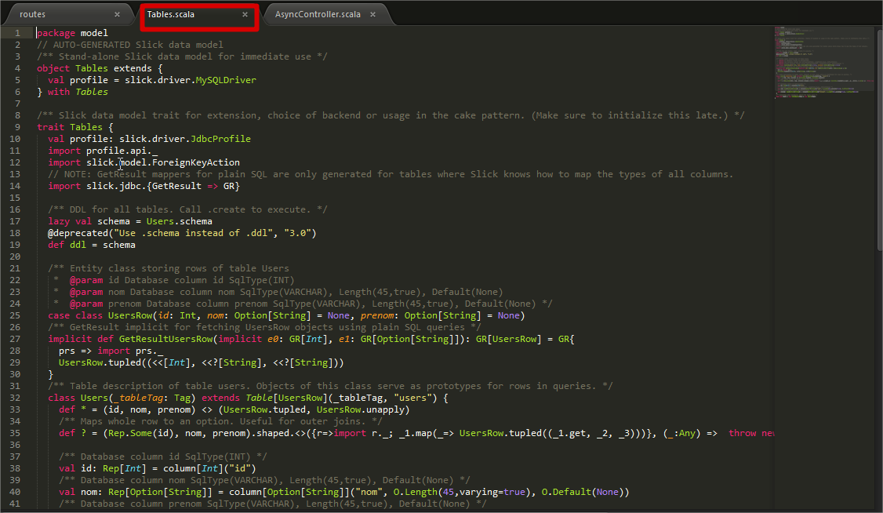

1. Now you can create your model file :

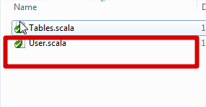

1. Create your controller in the folder app/controllers, UserREST.scala :

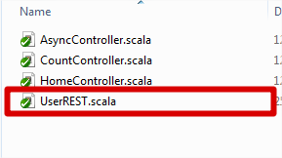

1. Add all your function in the file User.scala and the controller file UserREST.scala, after go to the routes file to give the name and the for each action that you want to execute with the REST API :

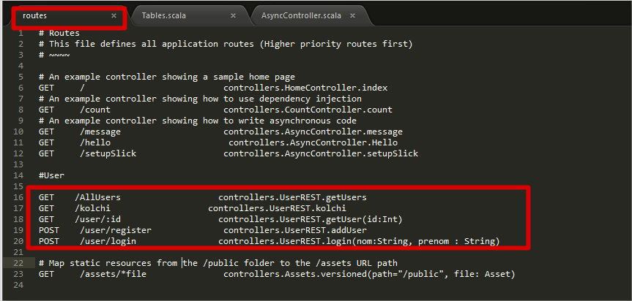

1. Now you must compile the project to verify if that all the code is okay, or there is some errors to correct, you can compile the project by taping the command : compile
2. If all is okay, so you can now start your project by taping the command run in the console :

