Understanding Linear Regression: Simple and Multiple
Part 1: Theory, formulas and a worked example

About this document
These are my study notes on linear regression. The goal of Part 1 is to understand the simple and the multiple regression model, to collect all the key mathematical formulas, and to see how they work on real data through a small example.
Part 2 will use R to run the same example and connect the code to the theory below.

1. What is a regression model?
A regression model explains a response variable $Y$ using other variables $X_{1},…,X_{p}$. In its general form:
$$Y=β_{0}+β_{1}X_{1}+β_{2}X_{2}+…+β_{p}X_{p}+ε$$
- $Y$ is the response (the target).
- $β_{0}+β_{1}X_{1}+…+β_{p}X_{p}$ is the part we can explain with the predictors.
- $ε$ is the random part (the random errors).
Real example. Price (k€) = $β_{0}+β_{1}⋅{\text{size (m}}^{2}\text{)}+β_{2}⋅\text{floor}+ε$. If $β_{1}=4$, each extra m² adds about 4 k€ to the price. The intercept $β_{0}$ corresponds to a column of 1s in the data.
The word “linear” means that the model is linear in the coefficients $β$, not necessarily in $X$. Linear regression is a supervised machine learning algorithm. For example, we can predict a house price from its surface, or predict the morning temperature from the amount of sun.
Two terms are important:
- Target: what we want to predict (for example, the house price).
- Features: what we use to predict it (for example, the size of the house).

2. Simple linear regression

2.1 The true model
With one feature, the true model is:
$$Y=β_{0}+β_{1}X+ε$$
- $β_{0}$ is the intercept: the value of $Y$ when $X=0$ (the base price).
- $β_{1}$ is the slope: the predicted change in $Y$ for a one-unit increase in $X$.
- $ε$ is the random error.

2.2 The estimated model
In practice we do not know the exact values of $β_{0}$ and $β_{1}$. We estimate them from data, which gives the fitted equation:
$$\hat{Y}={\hat{β}}_{0}+{\hat{β}}_{1}X$$
Here ${\hat{β}}_{0}$ and ${\hat{β}}_{1}$ are the estimates of $β_{0}$ and $β_{1}$, calculated from the observed data.
Example 1. Suppose the estimates are ${\hat{β}}_{0}=108$ and ${\hat{β}}_{1}=1.85$. For a house of 50 m²:
$$\hat{Y}=108+1.85×50=200.5$$
The model predicts about €200,000. This fitted equation is not the same as the illustrative equation in Section 1. It only shows what a fitted model might look like after analysing real observations. With real data, we cannot tell whether the estimated coefficients equal the unknown true coefficients.

3. How the model finds the best line
Given observed data, how do we calculate ${\hat{β}}_{0}$ and ${\hat{β}}_{1}$? We use OLS (Ordinary Least Squares). Let us follow it step by step on a small example. Imagine we observe five houses:
Table 1. Observed sizes and prices of the five houses
House | Size $X$ (m²) | Observed price $Y$ (€ thousands)
A | 30 | 150
B | 40 | 180
C | 50 | 210
D | 60 | 220
E | 70 | 290
We want to find the line that best describes the relationship between size and price.

Step 1: Calculate the means
$$\overset{‾}{X}=\frac{1}{n}\sum_{i=1}^{n}{X_{i}} \overset{‾}{Y}=\frac{1}{n}\sum_{i=1}^{n}{Y_{i}}$$
Here $n=5$, so:
$$\overset{‾}{X}=\frac{30+40+50+60+70}{5}=50$$
$$\overset{‾}{Y}=\frac{150+180+210+220+290}{5}=210$$
The average house size is 50 m² and the average observed price is €210,000.

Step 2: Calculate the slope
The slope tells us the predicted change in $Y$ for one unit of $X$. The formula is:
$${\hat{β}}_{1}=\frac{\sum_{i=1}^{n}{\left(X_{i}−\overset{‾}{X}\right)}\left(Y_{i}−\overset{‾}{Y}\right)}{\sum_{i=1}^{n}{{\left(X_{i}−\overset{‾}{X}\right)}^{2}}}$$
For our example:
Table 2. Intermediate calculations for the slope
House | $$X_{i}−\overset{‾}{X}$$ | $$Y_{i}−\overset{‾}{Y}$$ | Product | $${\left(X_{i}−\overset{‾}{X}\right)}^{2}$$
A | −20 | −60 | 1,200 | 400
B | −10 | −30 | 300 | 100
C | 0 | 0 | 0 | 0
D | 10 | 10 | 100 | 100
E | 20 | 80 | 1,600 | 400
Total |  |  | 3,200 | 1,000
Therefore:
$${\hat{β}}_{1}=\frac{3,200}{1,000}=3.2$$
Each extra m² adds about 3.2 k€ (€3,200) to the predicted price.

Step 3: Calculate the intercept
The formula is:
$${\hat{β}}_{0}=\overset{‾}{Y}−{\hat{β}}_{1}\overset{‾}{X}$$
Substituting our values:
$${\hat{β}}_{0}=210−3.2×50=50$$
The intercept is 50 in thousands of euros. It is the base price, the predicted value of $Y$ when $X=0$.

Final equation
$$\hat{Y}=50+3.2X$$
OLS calculates the intercept and the slope from the observed values of $X$ and $Y$. We do not choose the estimated coefficients by hand.

4. Residuals and the least squares criterion
The line usually does not pass through every point, so we need a measure of how far the predictions are from the observed values.
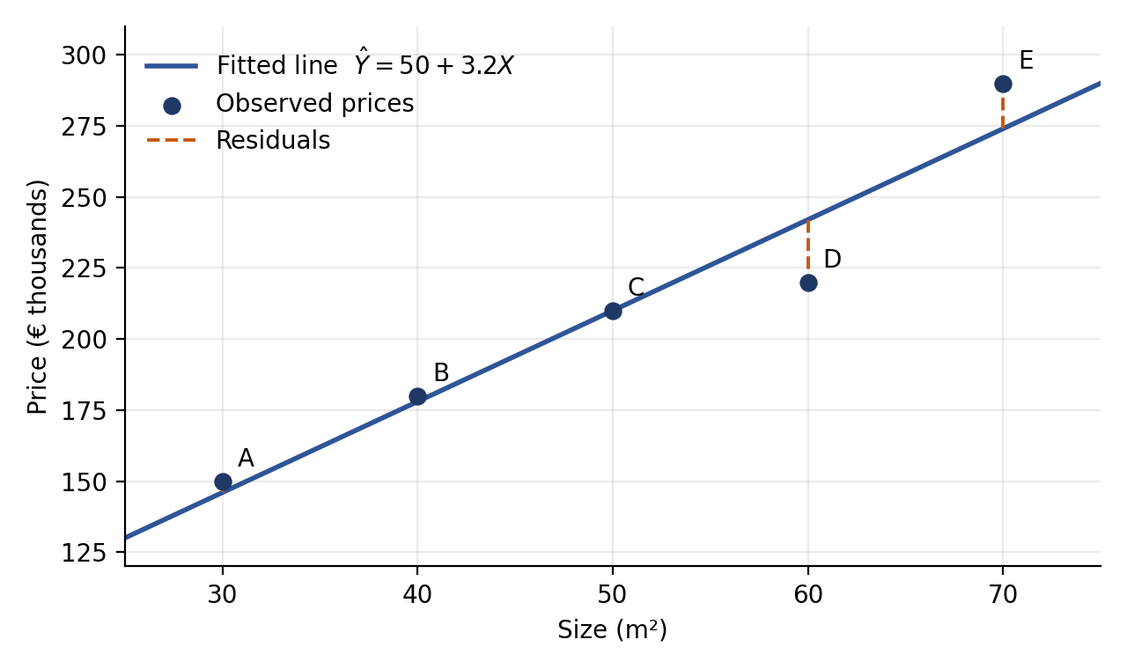
Figure 1. The fitted line and the residuals (dashed) for the five houses
For each point, we calculate the difference between the real value $Y_{i}$ and the estimated value ${\hat{Y}}_{i}$. This difference is called the residual:
$$e_{i}=Y_{i}−{\hat{Y}}_{i}$$
For our five houses:
Table 3. Actual values, predictions and residuals
House | Actual $Y_{i}$ | Predicted ${\hat{Y}}_{i}$ | Residual $e_{i}$
A | 150 | 146 | 4
B | 180 | 178 | 2
C | 210 | 210 | 0
D | 220 | 242 | −22
E | 290 | 274 | 16
We then calculate the RSS (Residual Sum of Squares), also called the SSE (Sum of Squared Errors):
$$RSS=\sum_{i=1}^{n}{{\left(Y_{i}−{\hat{Y}}_{i}\right)}^{2}}$$
For our example:
$$RSS=4^{2}+2^{2}+0^{2}+{\left(−22\right)}^{2}+{16}^{2}$$
$$RSS=16+4+0+484+256=760$$
The important idea: squaring makes every error non-negative, and large errors contribute more heavily.

5. What OLS does
OLS means Ordinary Least Squares. To see the idea, imagine three observations with $X=1,2,3$ and observed prices of €10,000, €20,000 and €30,000. We try three different equations to predict the prices:
Table 4. Three candidate models
Model | Equation | Predictions | RSS
A | $$\hat{Y}=5,000+8,000X$$ | €13,000, €21,000, €29,000 | 11,000,000
B | $$\hat{Y}=0+10,000X$$ | €10,000, €20,000, €30,000 | 0
C | $$\hat{Y}=2,000+9,000X$$ | €11,000, €20,000, €29,000 | 2,000,000
Which model is the best? Model B, because its predictions are exactly equal to the observed prices, so its RSS is 0.
OLS chooses the coefficients that minimize the RSS:
$$\left({\hat{β}}_{0},{\hat{β}}_{1}\right)=arg\min_{β_{0},β_{1}}\sum_{i=1}^{n}{{\left(Y_{i}−β_{0}−β_{1}X_{i}\right)}^{2}}$$
The notation $argmin$ means “the values of the parameters that make this expression as small as possible”.

6. How we measure prediction errors
RSS is useful, but it grows with the number of observations and it uses squared units. Two other metrics are common in machine learning, so we look at three in total.

6.1 Mean Squared Error (MSE)
$$MSE=\frac{1}{n}\sum_{i=1}^{n}{{\left(Y_{i}−{\hat{Y}}_{i}\right)}^{2}}$$
For our five houses:
$$MSE=\frac{760}{5}=152$$
Its units are squared thousands of euros. A smaller MSE means a better fit on the data being evaluated.

6.2 Root Mean Squared Error (RMSE)
$$RMSE=\sqrt{MSE}$$
$$RMSE=\sqrt{152}≈12.33$$
Because the target is measured in thousands of euros, the RMSE is about €12,330. It expresses the typical scale of the prediction error, although it is not the average absolute error.

6.3 Mean Absolute Error (MAE)
$$MAE=\frac{1}{n}\sum_{i=1}^{n}{\left|Y_{i}−{\hat{Y}}_{i}\right|}$$
$$MAE=\frac{4+2+0+22+16}{5}=8.8$$
The MAE is €8,800 for this example. It measures the average absolute error and is less sensitive to large errors than the squared-error metrics.
Table 5. Error metrics for the five-house example
Metric | Value | Unit | Sensitive to large errors?
RSS | 760 | (k€)² | Yes
MSE | 152 | (k€)² | Yes
RMSE | 12.33 | k€ | Yes
MAE | 8.8 | k€ | Less

7. Multiple linear regression

7.1 The model
Linear regression can work with several predictors at the same time. The general multiple linear regression equation is:
$$Y_{i}=β_{0}+β_{1}X_{i1}+…+β_{p}X_{ip}+ε_{i}$$
For example, to predict the price of a house we can use:
- $X_{1}$: size
- $X_{2}$: number of bedrooms
- $X_{3}$: distance from the city centre
The equation becomes:
$$Y_{i}=β_{0}+β_{1}X_{i1}+β_{2}X_{i2}+β_{3}X_{i3}+ε_{i}$$

7.2 Matrix form
The matrix form of the model is:
$$y=Xβ+ε$$
- $y$: the target (vector of observed values).
- $X$: the design matrix, containing all the predictors and a column of 1s for the intercept.
- $β$: the vector of unknown coefficients.
- $ε$: the vector of errors.

7.3 The OLS estimator
The OLS estimator is:
$$\hat{β}={\left(X^{⊤}X\right)}^{−1}X^{⊤}y$$
- $X^{⊤}$ means the transpose of $X$.
- $X^{⊤}X$ summarizes the relationships among the columns of the design matrix.
- ${\left(X^{⊤}X\right)}^{−1}$ is the inverse matrix, provided it exists.
- Multiplying by $X^{⊤}y$ gives the estimated coefficients.
This formula is the matrix version of the slope and intercept formulas from Section 3.

7.4 Estimated error variance
The variance of the errors is estimated with:
$${\hat{σ}}^{2}=\frac{RSS}{n−p−1}$$
where $n$ is the number of observations and $p$ is the number of predictors. The denominator $n−p−1$ is the number of degrees of freedom, because $p+1$ coefficients were estimated from the data.

8. Main assumptions of the model
1. Linearity in the coefficients. The response is a linear combination of the coefficients $β$, as explained in Section 1.
2. Errors have mean zero, conditional on the predictors.
$$E\left(ε∣X\right)=0$$
This is important for unbiased coefficient estimation. If an important factor is omitted and is related to both the predictors and the target, the estimates can be biased.
3. Constant error variance (homoscedasticity).
$$Var\left(ε∣X\right)=σ^{2}$$
The error variance is constant across predictor values. If it changes, we have heteroscedasticity. The OLS coefficients may still be useful, but the conventional standard errors can be unreliable.

9. Summary of the main formulas
Table 6. Key formulas of Part 1
Quantity | Formula
Simple regression model | $$Y=β_{0}+β_{1}X+ε$$
Fitted equation | $$\hat{Y}={\hat{β}}_{0}+{\hat{β}}_{1}X$$
Slope | $${\hat{β}}_{1}=∑\left(X_{i}−\overset{‾}{X}\right)\left(Y_{i}−\overset{‾}{Y}\right)/∑{\left(X_{i}−\overset{‾}{X}\right)}^{2}$$
Intercept | $${\hat{β}}_{0}=\overset{‾}{Y}−{\hat{β}}_{1}\overset{‾}{X}$$
Residual | $$e_{i}=Y_{i}−{\hat{Y}}_{i}$$
RSS | $$∑{\left(Y_{i}−{\hat{Y}}_{i}\right)}^{2}$$
MSE | $$RSS/n$$
RMSE | $$\sqrt{MSE}$$
MAE | $$\frac{1}{n}∑|Y_{i}−{\hat{Y}}_{i}|$$
Matrix model | $$y=Xβ+ε$$
OLS estimator | $$\hat{β}={\left(X^{⊤}X\right)}^{−1}X^{⊤}y$$
Error variance | $${\hat{σ}}^{2}=RSS/\left(n−p−1\right)$$

Part 2
In Part 2, I will do some R command and work with data set and do a linear regression model , with this I will do some relation betweeen R and mathematics concept

