Linear Regression in R: Following the Course Code
Part 2: Simulation, real data and the link with the mathematics

About this document
In Part 1, I studied the theory of simple and multiple linear regression. In Part 2, I work with the R code used in the course. This code is short but dense: one line of R often hides a matrix formula. So for each block of code, I explain what it does and which formula of Part 1 it corresponds to.
The document has two parts:
- Part A: a simulation. We generate our own data, so we know the true coefficients $β$. This lets us check that the OLS formulas really work.
- Part B: real data. We analyse the mtcars data set, from the first exploration to a multiple regression model, with variable selection and a check of multicollinearity. At the end, there is a short look at two other data sets (Salaries and iris).
All the code and all the outputs were run in R 4.3.3. The seeds are fixed with set.seed(), so the same numbers can be reproduced. Section numbers such as “Section 7.3 of Part 1” refer to the first document.

Part A: A simulation to check the OLS formulas

A.1 Why simulate data?
In real life, the true coefficients $β$ are unknown. In a simulation, we choose them ourselves, we generate $y$ from the model, and then we see if the estimation method finds them again. The model is the matrix form of Section 7.2 of Part 1:
$$y=Xβ+ε ε∼N\left(0,σ^{2}I\right)$$
The notation $ε∼N\left(0,σ^{2}I\right)$ means that the errors are normal with mean 0, all with the same variance $σ^{2}$, and independent from each other (the identity matrix $I$ has zeros outside the diagonal). This contains the assumptions of Section 8 of Part 1: mean zero and constant variance.

A.2 Setting the parameters
n <- 50 # sample size
p <- 5 # number of variables
sigma <- 1 # standard deviation of the errors
set.seed(1) # fix the seed for reproducible random numbers
beta0 <- 0 # the intercept is fixed to 0
beta <- runif(p, -5, 5) # beta ~ U(-5, 5)
Table 1. Parameters of the simulation
R object | Math | Meaning
n | $$n$$ | Number of observations (50)
p | $$p$$ | Number of predictors (5)
sigma | $$σ$$ | Standard deviation of the errors (1)
beta0 | $$β_{0}$$ | True intercept (0)
beta | $$β_{1},…,β_{5}$$ | True slopes, drawn from a uniform distribution between −5 and 5
The function set.seed(1) fixes the starting point of the random number generator. Without it, we would get different numbers at each run. With seed 1, the true slopes are:
[1] -2.3449134 -1.2787610 0.7285336 4.0820779 -2.9831807

A.3 Simulating the matrix X
library(MASS)
X <- mvrnorm(n, mu = rep(0, p), Sigma = diag(p)) # X ~ Np(mu, Sigma)
dim(X)
cov(X)
apply(X, MARGIN = 2, FUN = mean)
apply(X, MARGIN = 2, FUN = sd)
The function mvrnorm() of the package MASS generates a multivariate normal sample. Here the mean vector is 0 (rep(0, p)) and the covariance matrix is the identity diag(p): the 5 variables are independent, with mean 0 and standard deviation 1. (The commented lines in the course code do the same with rnorm().) The function dim(X) returns 50 5, so $X$ has 50 rows and 5 columns.
The sample covariance matrix cov(X) is close to the identity matrix, but not exactly, because the sample is finite:
Table 2. Sample covariance matrix of X (rounded to 3 decimals)
 | $$X_{1}$$ | $$X_{2}$$ | $$X_{3}$$ | $$X_{4}$$ | $$X_{5}$$
$$X_{1}$$ | 1.181 | 0.033 | −0.220 | −0.076 | 0.006
$$X_{2}$$ | 0.033 | 0.997 | 0.007 | −0.041 | −0.006
$$X_{3}$$ | −0.220 | 0.007 | 0.878 | 0.054 | 0.240
$$X_{4}$$ | −0.076 | −0.041 | 0.054 | 0.640 | 0.031
$$X_{5}$$ | 0.006 | −0.006 | 0.240 | 0.031 | 0.895
The means of the columns are between −0.20 and 0.11, and the standard deviations between 0.80 and 1.09.

A.4 Errors and response
eps <- rnorm(n, 0, sigma) # eps ~ N(0, sigma^2)
hist(eps)
y <- drop(beta0 + X %*% beta) + eps # y = X * beta + eps
hist(y)
shapiro.test(y)
The operator %*% is the matrix product, so X %*% beta is $Xβ$. The function drop() transforms the result, a matrix with one column, into a simple vector.
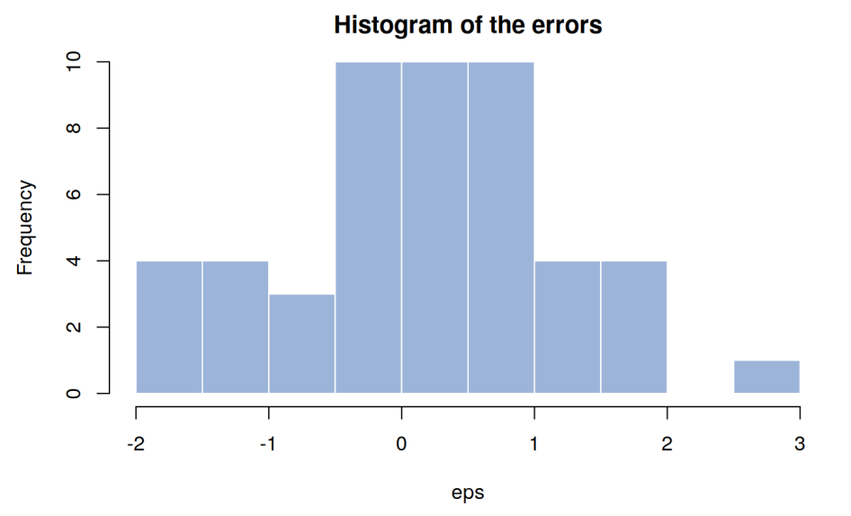
Figure 1. Histogram of the simulated errors
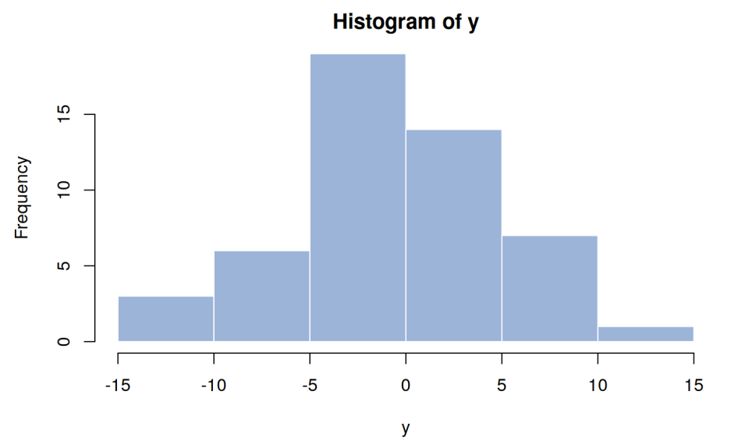
Figure 2. Histogram of the simulated response y
The Shapiro-Wilk test checks the normality. Its null hypothesis $H_{0}$ is that the data come from a normal distribution. We get $W=0.98657$ and a p-value of $0.8362$. A $W$ close to 1 and a large p-value mean that there is no evidence against normality. This is expected here: $y$ is built from normal variables.

A.5 The true covariance matrix of the estimator
The OLS estimator of Section 7.3 of Part 1 is $\hat{β}={\left(X^{⊤}X\right)}^{−1}X^{⊤}y$. Since $\text{Var}\left(y\right)=σ^{2}I$, its covariance matrix is:
$$\text{Var}\left(\hat{β}\right)=σ^{2}{\left(X^{⊤}X\right)}^{−1}$$
The diagonal of this matrix contains the variance of each coefficient. In the simulation, we know $σ$, so we can compute the true value. In the following code, Xtilde is the design matrix with the column of 1s for the intercept.
Xtilde <- cbind(1, X)
betatrue <- c(beta0, beta)
covartrue <- (sigma^2) * solve(crossprod(Xtilde)) # sigma^2 * (Xt X)^(-1)
varbetatrue <- diag(covartrue)
The R functions used in these lines are the building blocks of the whole course code:
Table 3. Main R functions of the course code
R function | What it does | Math
cbind(1, X) | Adds a column of 1s to X | $$\tilde{X}=\left[1,X\right]$$
t(A) | Transpose | $$A^{⊤}$$
A %*% B | Matrix product | $$AB$$
crossprod(A) | Same as t(A) %*% A, but faster | $$A^{⊤}A$$
crossprod(A, b) | Same as t(A) %*% b | $$A^{⊤}b$$
solve(A) | Inverse of a matrix | $$A^{−1}$$
solve(A, b) | Solves the system $Ax=b$ | $$A^{−1}b$$
diag(M) | Diagonal of a matrix (or identity matrix if given a number)
drop(M) | Transforms a one-column matrix into a vector
apply(X, 2, f) | Applies the function f to each column of X

A.6 Fitting the model with lm()
olm <- lm(y ~ X)
summ.olm <- summary(olm)
summ.olm
Coefficients:
Estimate Std. Error t value Pr(>|t|)
(Intercept) 0.1543 0.1465 1.054 0.298
X1 -2.3666 0.1359 -17.419 < 2e-16 ***
X2 -1.0711 0.1438 -7.450 2.51e-09 ***
X3 0.8957 0.1633 5.485 1.91e-06 ***
X4 4.1873 0.1804 23.213 < 2e-16 ***
X5 -2.8192 0.1578 -17.864 < 2e-16 ***
Residual standard error: 1.003 on 44 degrees of freedom
Multiple R-squared: 0.969, Adjusted R-squared: 0.9655
F-statistic: 275.2 on 5 and 44 DF, p-value: < 2.2e-16
How to read this output:
- Estimate is the vector $\hat{β}$.
- Std. Error is the square root of the diagonal of ${\hat{σ}}^{2}{\left(X^{⊤}X\right)}^{−1}$.
- t value is the Estimate divided by its Std. Error, and Pr(>|t|) is the p-value of the test $H_{0}:β_{j}=0$.
- Residual standard error is $\hat{σ}=1.003$, very close to the true $σ=1$. The degrees of freedom are $n−p−1=50−5−1=44$.
The object summ.olm is a list. The command str(summ.olm) shows its content, and we can extract any part of it, for example summ.olm$coefficients or summ.olm$sigma.

A.7 Doing the same computation by hand
Now we compute the same quantities with the matrix formulas, without lm():
# betahat = (Xt X)^(-1) Xt y
betaest <- drop(solve(crossprod(Xtilde), crossprod(Xtilde, y)))
# sigmahat^2 = (y - X betahat)t (y - X betahat) / (n - (p + 1))
sigma2est <- drop(crossprod(y - Xtilde %*% betaest) / (n - (p + 1)))
# var(betahat) = sigmahat^2 * (Xt X)^(-1)
varbetaest <- diag(sigma2est * solve(crossprod(Xtilde)))
Table 4. Each line of code and its formula
R code | Formula
solve(crossprod(Xtilde), crossprod(Xtilde, y)) | $$\hat{β}={\left({\tilde{X}}^{⊤}\tilde{X}\right)}^{−1}{\tilde{X}}^{⊤}y$$
crossprod(y - Xtilde %*% betaest) | $$RSS={\left(y−\tilde{X}\hat{β}\right)}^{⊤}\left(y−\tilde{X}\hat{β}\right)=∑e_{i}^{2}$$
/ (n - (p + 1)) | divide by the degrees of freedom $n−p−1$
sigma2est * solve(crossprod(Xtilde)) | $${\hat{σ}}^{2}{\left({\tilde{X}}^{⊤}\tilde{X}\right)}^{−1}$$
The line with crossprod(y - Xtilde %*% betaest) is the RSS of Section 4 of Part 1, written as a product of a vector by itself. The result is exactly the same as lm():
Table 5. True coefficients, estimates and standard errors
Coefficient | True $β$ | Estimate (by hand = lm()) | Std. Error (by hand = lm())
$β_{0}$ (Intercept) | 0.0000 | 0.1543 | 0.1465
$β_{1}$ (X1) | −2.3449 | −2.3666 | 0.1359
$β_{2}$ (X2) | −1.2788 | −1.0711 | 0.1438
$β_{3}$ (X3) | 0.7285 | 0.8957 | 0.1633
$β_{4}$ (X4) | 4.0821 | 4.1873 | 0.1804
$β_{5}$ (X5) | −2.9832 | −2.8192 | 0.1578
The manual value of ${\hat{σ}}^{2}$ is $1.0064$, so $\hat{σ}=1.0032$, the same as the output of lm(). The estimates are close to the true values: the largest difference is 0.21, about 1.5 standard errors.

A.8 Repeating the experiment 10,000 times
One sample gives one value of $\hat{β}$. But $\hat{β}$ is a random vector: with another sample of errors, we would get other values. To study its behaviour, we keep $X$ and $β$ fixed, we generate new errors 10,000 times, and we estimate the model each time:
betasim <- varbetasim <- NULL
set.seed(2)
for(i in 1:10000) {
eps <- rnorm(n, 0, sigma)
y <- drop(beta0 + X %*% beta) + eps
betaest <- drop(solve(crossprod(Xtilde), crossprod(Xtilde, y)))
sigma2est <- drop(crossprod(y - Xtilde %*% betaest) / (n - (p + 1)))
varbetaest <- diag(sigma2est * solve(crossprod(Xtilde)))
betasim <- rbind(betasim, betaest)
varbetasim <- rbind(varbetasim, varbetaest)
}
At each turn, rbind() adds a new row to the results. This works, but it is slow for large loops. The commented lines of the course code show a faster way: create the empty matrix first with matrix(NA, nrow = 10000, ncol = 6) and fill row i at each turn.
We then compare three things, for each coefficient:
Table 6. Results of the 10,000 simulations
Coefficient | True $β_{j}$ | Mean of ${\hat{β}}_{j}$ | True variance | Variance of ${\hat{β}}_{j}$ (simulated) | Mean of estimated variance
$$β_{0}$$ | 0.0000 | 0.0004 | 0.0213 | 0.0219 | 0.0213
$$β_{1}$$ | −2.3449 | −2.3438 | 0.0183 | 0.0185 | 0.0183
$$β_{2}$$ | −1.2788 | −1.2784 | 0.0205 | 0.0206 | 0.0205
$$β_{3}$$ | 0.7285 | 0.7286 | 0.0265 | 0.0265 | 0.0265
$$β_{4}$$ | 4.0821 | 4.0798 | 0.0323 | 0.0319 | 0.0323
$$β_{5}$$ | −2.9832 | −2.9874 | 0.0247 | 0.0248 | 0.0247
Three results come out of this table:
- The estimator is unbiased. The mean of ${\hat{β}}_{j}$ over the 10,000 samples is almost equal to the true $β_{j}$: $E\left(\hat{β}\right)=β$.
- The variance formula is correct. The simulated variance of ${\hat{β}}_{j}$ is almost equal to the diagonal of $σ^{2}{\left(X^{⊤}X\right)}^{−1}$ of Section A.5.
- The variance estimator is unbiased too. The mean of the estimated variances ${\hat{σ}}^{2}{\left(X^{⊤}X\right)}^{−1}$ is almost equal to the true variance. This is the reason why we divide the RSS by $n−p−1$ and not by $n$.
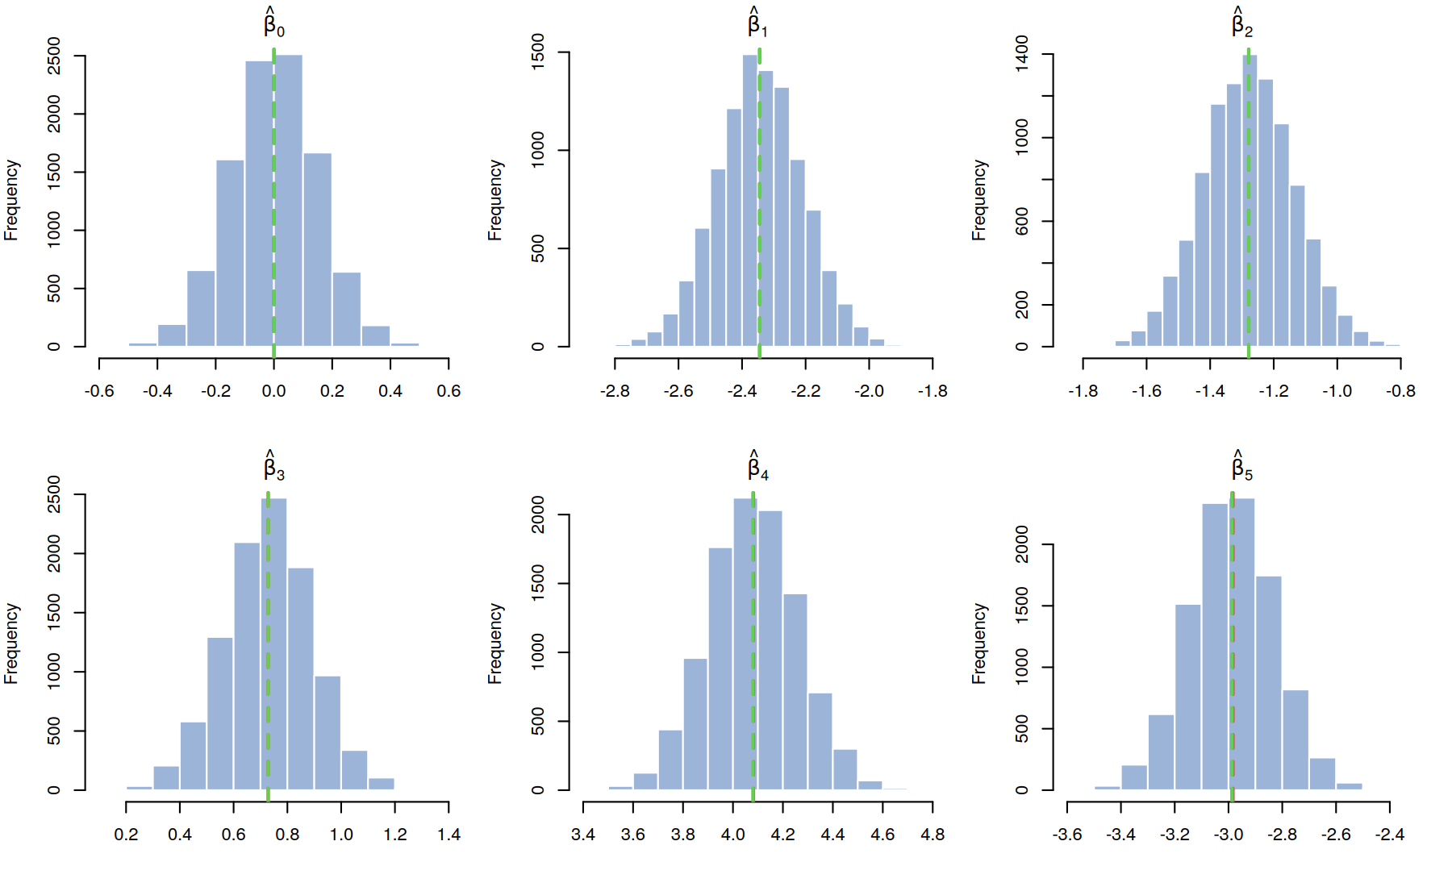
Figure 3. Distribution of the 6 estimated coefficients over 10,000 simulations. Red dashed line: true value. Green dashed line: mean of the estimates.
Each histogram has a bell shape centred on the true value, so the red and the green lines are almost on top of each other. This is the picture of an unbiased estimator.

A.9 The hat matrix
The fitted values of the model are $\hat{y}=\tilde{X}\hat{β}$. If we replace $\hat{β}$ by its formula, we get:
$$\hat{y}=\tilde{X}{\left({\tilde{X}}^{⊤}\tilde{X}\right)}^{−1}{\tilde{X}}^{⊤}y=Hy \text{with} H=\tilde{X}{\left({\tilde{X}}^{⊤}\tilde{X}\right)}^{−1}{\tilde{X}}^{⊤}$$
The matrix $H$ is called the hat matrix, because it “puts a hat” on $y$.
H <- Xtilde %*% solve(crossprod(Xtilde)) %*% t(Xtilde)
sum(diag(H))
plot(y, drop(H %*% y))
abline(0, 1, lty = 3, col = 2)
The sum of the diagonal of $H$ (the trace) is equal to 6, which is $p+1$, the number of estimated coefficients. This is where the degrees of freedom $n−p−1=n−\text{trace}\left(H\right)$ come from. The diagonal elements $h_{ii}$ are called the leverages: they measure how much each observation $y_{i}$ influences its own fitted value.
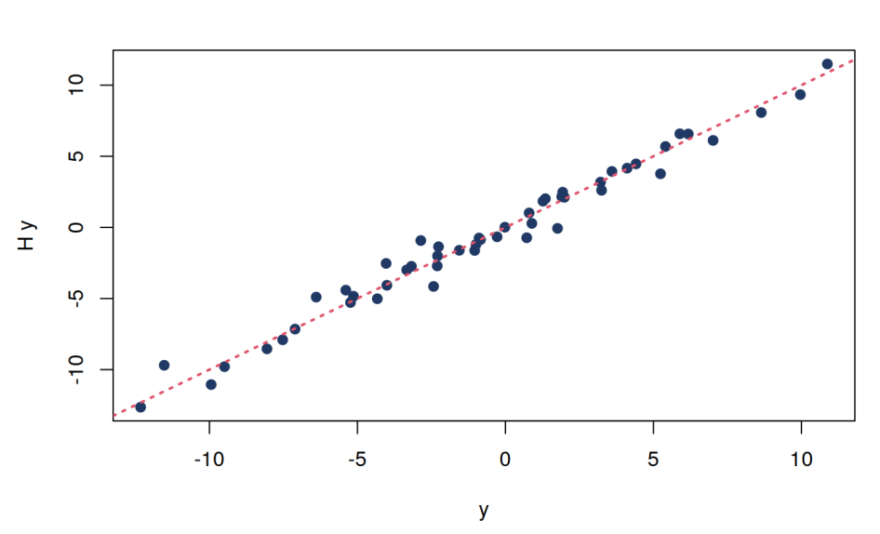
Figure 4. Observed values y against fitted values Hy (dotted line: y = x)
The points are close to the line $y=x$, because the model explains most of the variation (the R-squared was 0.969 for the first sample). In this code, y is the last sample generated by the loop of Section A.8.

Part B: Real data with the mtcars data set

B.1 The data set
The mtcars data set is included in R. It contains information on 32 car models, extracted from road tests published by the US magazine Motor Trend in 1974: the fuel consumption and ten variables describing the design and the performance of the cars.
Table 7. Variables of mtcars
Variable | Description
mpg | Fuel consumption in miles per US gallon (higher = more efficient). This is the target.
cyl | Number of cylinders
disp | Engine displacement (cubic inches)
hp | Gross horsepower
drat | Rear axle ratio
wt | Weight (thousands of pounds)
qsec | Time for a quarter mile (seconds); lower = better acceleration
vs | Engine shape: 0 = V-shaped, 1 = straight
am | Transmission: 0 = automatic, 1 = manual
gear | Number of forward gears
carb | Number of carburetors
Although all the variables are stored as numbers in R, vs and am are binary categorical variables, and cyl, gear and carb can be treated as discrete or categorical variables.

B.2 First exploration
data(mtcars)
str(mtcars)
summary(mtcars)
table(mtcars$vs)
table(mtcars$am)
table(mtcars$cyl)
table(mtcars$gear)
table(mtcars$carb)
The function str() shows that we have 32 observations of 11 variables, all numeric. The function summary() gives, for each variable, the minimum, the quartiles, the median, the mean and the maximum. For example, mpg goes from 10.4 to 33.9, with a mean of 20.09. The function table() counts how many times each value appears:
Table 8. Number of cars for each value of the discrete variables
Variable | Value: number of cars
vs | 0: 18, 1: 14
am | 0: 19, 1: 13
cyl | 4: 11, 6: 7, 8: 14
gear | 3: 15, 4: 12, 5: 5
carb | 1: 7, 2: 10, 3: 3, 4: 10, 6: 1, 8: 1

B.3 Is mpg normally distributed?
hist(mtcars$mpg, main = "Miles/(US) gallon")
shapiro.test(mtcars$mpg)
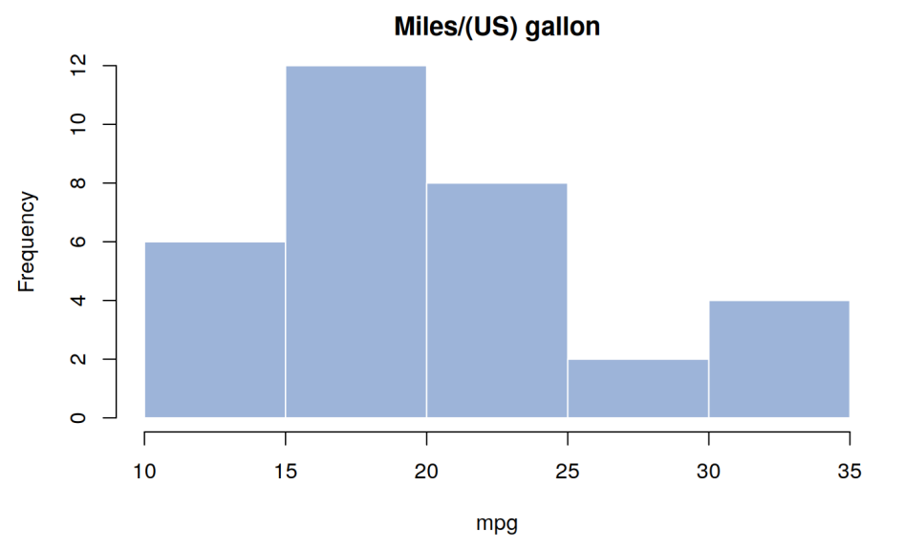
Figure 5. Histogram of the fuel consumption mpg
Shapiro-Wilk normality test
data: mtcars$mpg
W = 0.94756, p-value = 0.1229
The null hypothesis $H_{0}$ is that mpg follows a normal distribution, and the alternative $H_{1}$ is that it does not. The statistic $W=0.948$ is close to 1, and the p-value $0.1229$ is larger than 0.05, so we do not reject $H_{0}$: there is no evidence against normality.
In a regression model, the normality assumption concerns the errors, not directly the response. So this check is only a first indication. We will look at the residuals again in Section B.8.

B.4 Does mpg depend on the categorical variables?

Analysis of deviance
anova(glm(mpg ~ factor(cyl), data = mtcars), test = "Chisq")
Df Deviance Resid. Df Resid. Dev Pr(>Chi)
NULL 31 1126.05
factor(cyl) 2 824.78 29 301.26 < 2.2e-16 ***
For a Gaussian model, the deviance is simply a sum of squares, so this output is directly connected to Part 1:
- The line NULL is the model without any predictor. Its residual deviance, $1126.05$, is the total variability of mpg: $TSS=∑{\left(Y_{i}−\overset{‾}{Y}\right)}^{2}$.
- The variable cyl explains $824.78$ of this variability.
- The remaining $301.26$ is the RSS of the model with cyl. It is the variability not explained by the cylinders, which comes from other sources (weight, power, and so on).
The decomposition is $1126.05=824.78+301.26$, that is $TSS=\text{explained}+RSS$. The cylinders explain $824.78/1126.05=73.2\%$ of the variability of mpg. The p-value tests the null hypothesis that the variable has no effect; here it is smaller than 0.05, so we reject it. The same analysis for the other discrete variables gives:
Table 9. Share of the variability of mpg explained by each variable (total = 1126.05)
Variable | Df | Explained deviance | Residual deviance (RSS) | Explained share | p-value
cyl | 2 | 824.78 | 301.26 | 73.2% | < 2.2e-16
vs | 1 | 496.53 | 629.52 | 44.1% | 1.148e-06
am | 1 | 405.15 | 720.90 | 36.0% | 4.023e-05
gear | 2 | 483.24 | 642.80 | 42.9% | 1.844e-05
carb | 5 | 500.56 | 625.49 | 44.5% | 0.0008809
All the p-values are far below 0.05, so each of these variables is associated with mpg. Be careful when comparing the shares: a variable with many levels (like carb, with 5 degrees of freedom) can explain more only because it uses more parameters.

The t-test for two groups
t.test(mpg ~ factor(vs, labels = c("V", "S")), data = mtcars)
t = -4.6671, df = 22.716, p-value = 0.0001098
95 percent confidence interval:
-11.462508 -4.418445
sample estimates:
mean in group V mean in group S
16.61667 24.55714
For a variable with two groups, we use a t-test (here the Welch version, which is the default in R). For a variable with three groups or more, we use the analysis of variance (as above for cyl). The p-value is $0.0001$, so we reject the hypothesis that the two means are equal: cars with a V-shaped engine do about 16.6 mpg on average, and cars with a straight engine about 24.6 mpg. The p-values of the t-test and of the anova() for vs are not identical because the tests are different, but both are far below 0.05.

B.5 Relations between the numeric variables
pairs(mtcars[, c("mpg", "disp", "hp", "drat", "wt", "qsec")],
main = "mtcars data", gap = 1/2)
cor(mtcars[, c("mpg", "disp", "hp", "drat", "wt", "qsec")])
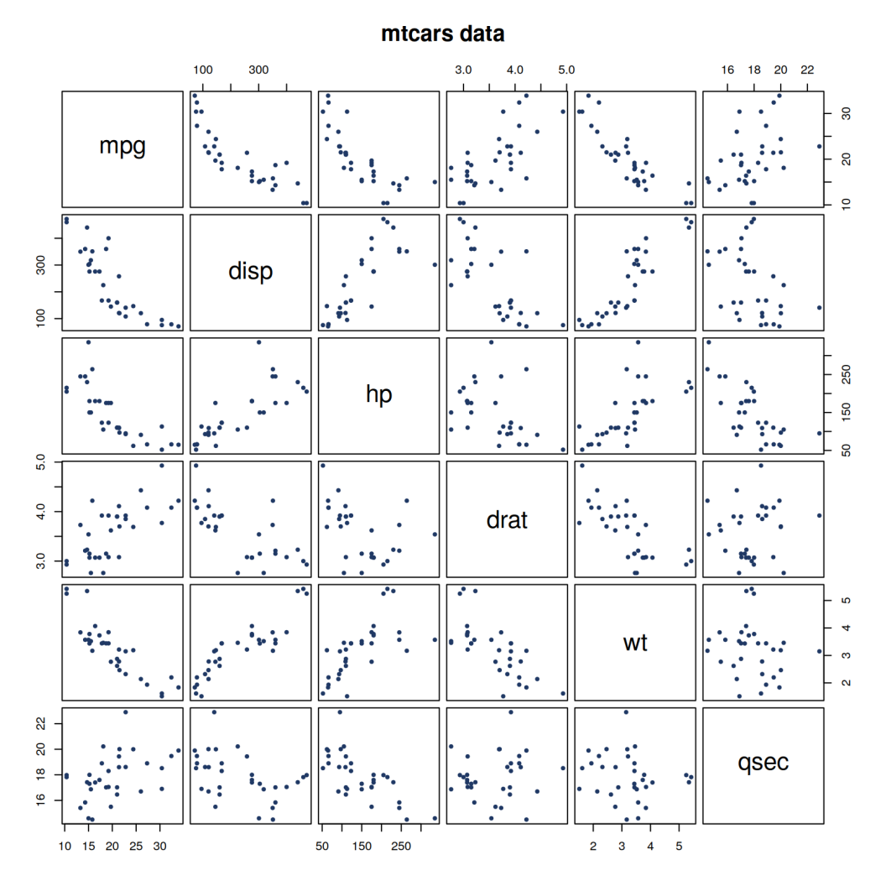
Figure 6. Scatter plots of all the pairs of numeric variables
The plot pairs() shows all the scatter plots at once. The function cor() gives the same information with numbers: the correlation coefficient $r$, which is always between $−1$ and $+1$.
Table 10. Correlation matrix of the numeric variables
 | mpg | disp | hp | drat | wt | qsec
mpg | 1.000 | −0.848 | −0.776 | 0.681 | −0.868 | 0.419
disp | −0.848 | 1.000 | 0.791 | −0.710 | 0.888 | −0.434
hp | −0.776 | 0.791 | 1.000 | −0.449 | 0.659 | −0.708
drat | 0.681 | −0.710 | −0.449 | 1.000 | −0.712 | 0.091
wt | −0.868 | 0.888 | 0.659 | −0.712 | 1.000 | −0.175
qsec | 0.419 | −0.434 | −0.708 | 0.091 | −0.175 | 1.000
Two things to notice:
- mpg is strongly and negatively correlated with wt ($−0.868$), disp ($−0.848$) and hp ($−0.776$): heavy and powerful cars use more fuel.
- The predictors are also strongly correlated with each other, for example disp and wt ($0.888$). This will cause a problem of multicollinearity in Section B.9.

B.6 Preparing the variables for the model
mtcars$vs <- factor(mtcars$vs, labels = c("V", "S"))
mtcars$am <- factor(mtcars$am, labels = c("automatic", "manual"))
mtcars$cyl <- ordered(mtcars$cyl)
mtcars$gear <- ordered(mtcars$gear)
mtcars$carb <- ordered(mtcars$carb)
summary(mtcars)
We tell R which variables are categorical. This changes the design matrix $X$, because a categorical variable cannot be used as a number. R creates new numeric columns for it:
- A factor with 2 levels (vs, am) gives one column of 0 and 1. For example vsS is equal to 1 for a straight engine, and ammanual is equal to 1 for a manual transmission.
- An ordered factor with $k$ levels (cyl, gear, carb) gives $k−1$ columns, named .L (linear), .Q (quadratic), .C (cubic), ^4, ^5.
Counting the columns, we get $p=2+1+1+1+1+1+1+1+2+5=16$ predictors (cyl 2, disp, hp, drat, wt, qsec, vs, am, gear 2, carb 5). With the intercept, the matrix $X$ has 17 columns for only $n=32$ observations.

B.7 Multiple linear regression with all the variables
olm <- lm(mpg ~ ., data = mtcars)
summary(olm)
plot(olm)
The formula mpg ~ . means: explain mpg with all the other variables.
Table 11. Coefficients of the full model
Coefficient | Estimate | Std. Error | t value | p-value
(Intercept) | 26.5717 | 19.5662 | 1.358 | 0.1945
cyl.L | −0.2377 | 5.0626 | −0.047 | 0.9632
cyl.Q | 2.0254 | 2.1495 | 0.942 | 0.3610
disp | 0.0356 | 0.0319 | 1.114 | 0.2827
hp | −0.0705 | 0.0394 | −1.788 | 0.0939
drat | 1.1828 | 2.4835 | 0.476 | 0.6407
wt | −4.5298 | 2.5388 | −1.784 | 0.0946
qsec | 0.3678 | 0.9354 | 0.393 | 0.6997
vsS | 1.9309 | 2.8713 | 0.672 | 0.5115
ammanual | 1.2121 | 3.2136 | 0.377 | 0.7113
gear.L | 1.7879 | 2.6420 | 0.677 | 0.5089
gear.Q | 0.1224 | 2.4090 | 0.051 | 0.9602
carb.L | 6.0616 | 6.7282 | 0.901 | 0.3819
carb.Q | 1.7883 | 2.8004 | 0.639 | 0.5327
carb.C | 0.4238 | 2.5739 | 0.165 | 0.8714
carb^4 | 0.9332 | 2.4504 | 0.381 | 0.7087
carb^5 | −2.4641 | 2.9045 | −0.848 | 0.4096
Residual standard error: 2.833 on 15 degrees of freedom
Multiple R-squared: 0.8931, Adjusted R-squared: 0.779
F-statistic: 7.83 on 16 and 15 DF, p-value: 0.000124
The numbers of the last lines are connected to Part 1:
- The degrees of freedom are $n−p−1=32−16−1=15$.
- The residual standard error is $\hat{σ}=\sqrt{RSS/15}=\sqrt{120.40/15}=\sqrt{8.027}=2.833$. (The value $RSS=120.40$ appears later in the output of stepAIC.)
- The R-squared compares the RSS with the total variability of Section B.4: $R^{2}=1−RSS/TSS=1−120.40/1126.05=0.893$.
The result looks surprising: the model explains 89% of the variability, but no coefficient is significant at the 5% level. The reason is that we have too many predictors (16) for only 32 cars, and that these predictors are correlated with each other. With so many parameters, the model is also unstable: when we draw the diagnostic plots with plot(olm), R gives a warning, because the observations 30 and 31 (Ferrari Dino and Maserati Bora) have a leverage equal to 1. This means $h_{ii}=1$ in the hat matrix of Section A.9: the model fits these two cars perfectly by itself, which is a sign of overfitting.

B.8 Selecting the variables with stepAIC
The idea is to keep only the variables that are really useful. The function stepAIC() of the package MASS compares the models with the AIC (Akaike Information Criterion). For a linear model, the criterion used by stepAIC() is:
$$AIC=nlog\left(\frac{RSS}{n}\right)+2k$$
where $k$ is the number of estimated coefficients ($p+1$). The first term decreases when the RSS decreases (better fit), and the second term increases with the number of coefficients (penalty for complexity). A smaller AIC is better. For the full model, $32×log\left(120.40/32\right)+2×17=76.40$, exactly the value printed by R.
olm_step <- MASS::stepAIC(olm, direction = "both")
summary(olm_step)
With direction = "both", at each step R tries to remove each variable and to add back each removed variable, and it keeps the change with the lowest AIC. It stops when no change improves the AIC.
Table 12. Steps of the selection
Step | Variable removed | AIC after the step
Start (all variables) |  | 76.40
1 | carb | 69.83
2 | gear | 67.00
3 | drat | 65.23
4 | disp | 63.51
5 | qsec | 62.06
6 | vs | 61.65
End | no more improvement | 61.65
The final model is mpg ~ cyl + hp + wt + am:
Table 13. Coefficients of the final model
Coefficient | Estimate | Std. Error | t value | p-value
(Intercept) | 31.9767 | 3.0634 | 10.438 | 8.61e-11
cyl.L | −1.5300 | 1.6152 | −0.947 | 0.35225
cyl.Q | 1.5918 | 0.8808 | 1.807 | 0.08231
hp | −0.0321 | 0.0137 | −2.345 | 0.02693
wt | −2.4968 | 0.8856 | −2.819 | 0.00908
ammanual | 1.8092 | 1.3963 | 1.296 | 0.20646
Now hp and wt are significant at the 5% level. Each additional 1,000 lbs reduces the predicted mpg by about 2.5, for cars with the same cylinders, power and transmission. We can compare the two models with the quantities of Part 1:
Table 14. Full model against final model
Quantity | Full model | Final model
Number of predictors $p$ | 16 | 5
Degrees of freedom $n−p−1$ | 15 | 26
RSS | 120.40 | 151.03
$$\hat{σ}=\sqrt{RSS/\left(n−p−1\right)}$$ | 2.833 | 2.410
$$R^{2}$$ | 0.8931 | 0.8659
Adjusted $R^{2}$ | 0.7790 | 0.8401
AIC (as used by stepAIC) | 76.40 | 61.65
The RSS of the final model is larger, which is normal: when we remove predictors, the fit on the data cannot get better. But $\hat{σ}$ is smaller, because we divide by 26 degrees of freedom instead of 15, and the adjusted $R^{2}$, which penalizes the number of predictors, is higher. So the simpler model is the better one.
Finally, we look at the diagnostic plots of the final model with plot(olm_step):
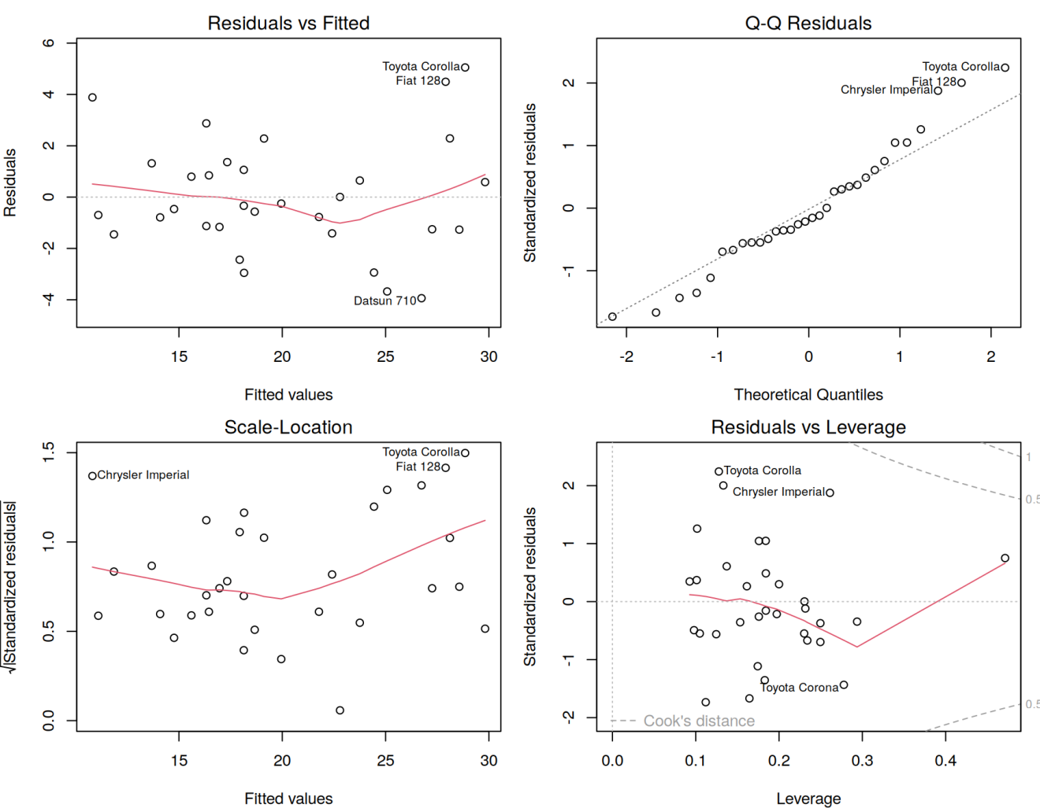
Figure 7. Diagnostic plots of the final model
- Residuals vs Fitted (top left): the residuals are around 0, with only a slight curve. This relates to the assumptions of mean zero and linearity.
- Q-Q Residuals (top right): the points follow the line quite well, so the normality of the errors is acceptable.
- Scale-Location (bottom left): the spread of the residuals increases a little with the fitted values, but not strongly. This is the check of constant variance.
- Residuals vs Leverage (bottom right): no point is beyond the dashed lines of the Cook’s distance, so no observation is too influential. The largest leverage is 0.47, and the sum of all the leverages is 6, the number of coefficients, as in Section A.9.
One caution: the variable selection was done on only 32 cars, so the selected model depends on this sample. It is a good exploratory tool, but not a proof that these are the “true” variables.

B.9 Multicollinearity and the VIF
When the predictors are strongly correlated, the matrix $X^{⊤}X$ is almost not invertible and the variances of the coefficients become very large. This is what we saw in Table 11, with huge standard errors. The Variance Inflation Factor measures it. For a predictor $X_{j}$:
$$VIF_{j}=\frac{1}{1−R_{j}^{2}}$$
where $R_{j}^{2}$ is the R-squared of the regression of $X_{j}$ on all the other predictors. If $X_{j}$ is perfectly independent of the others, $R_{j}^{2}=0$ and $VIF_{j}=1$. The variance of ${\hat{β}}_{j}$ is multiplied by $VIF_{j}$.
library(car)
vif(olm)
vif(olm_step)
Our model contains factors with several columns, so vif() returns the Generalized VIF (GVIF). We read the last column, $GVIF^{1/\left(2⋅Df\right)}$, which is on the scale of the square root of a standard VIF. The rules of thumb of the course are:
- above 3.16 (VIF above 10): severe multicollinearity;
- above 2.24 (VIF above 5): moderate or high correlation;
- above 2.00 (VIF above 4): worth monitoring.
Table 15. GVIF of the full model and of the final model
Model | Variable | GVIF | Df | $$GVIF^{1/\left(2⋅Df\right)}$$ | Diagnosis
Full | cyl | 128.12 | 2 | 3.36 | Severe
Full | disp | 60.37 | 1 | 7.77 | Severe
Full | hp | 28.22 | 1 | 5.31 | Severe
Full | drat | 6.81 | 1 | 2.61 | Moderate
Full | wt | 23.83 | 1 | 4.88 | Severe
Full | qsec | 10.79 | 1 | 3.28 | Severe
Full | vs | 8.09 | 1 | 2.84 | Moderate
Full | am | 9.93 | 1 | 3.15 | Moderate
Full | gear | 50.85 | 2 | 2.67 | Moderate
Full | carb | 503.21 | 5 | 1.86 | Acceptable
Final | cyl | 5.82 | 2 | 1.55 | Acceptable
Final | hp | 4.70 | 1 | 2.17 | To monitor
Final | wt | 4.01 | 1 | 2.00 | To monitor
Final | am | 2.59 | 1 | 1.61 | Acceptable
In the full model, most variables have a severe or moderate multicollinearity, which explains the huge standard errors of Table 11. In the final model, all the values are at most 2.17, so the problem is mostly solved. The variable selection of Section B.8 therefore also reduced the multicollinearity.

B.10 Two other data sets in the course code
The last lines of the course code explore two other data sets, in the same way as mtcars.
The Salaries data set (package carData) contains 397 university professors with 6 variables: rank (3 levels), discipline (2 levels), yrs.since.phd, yrs.service, sex and salary. The code only uses str(), summary() and table() to explore it. For example, there are 67 assistant professors, 64 associate professors and 266 full professors, and the salary goes from 57,800 to 231,545 with a mean of 113,706.
The iris data set contains 150 flowers of 3 species (setosa, versicolor, virginica) with 4 numeric measurements. The code tests the length of the sepals:
shapiro.test(iris$Sepal.Length)
iris2 <- subset(iris, Species != 'setosa')
iris2$Species <- droplevels(iris2$Species)
t.test(Sepal.Length ~ Species, data = iris2)
anova(glm(Sepal.Length ~ Species, data = iris), test = "Chisq")
Table 16. Results on the iris data
Test | Result | Conclusion
Shapiro-Wilk on Sepal.Length | $W=0.97609$, p-value $=0.01018$ | Normality is rejected at 5%, but only slightly ($W$ is close to 1)
t-test, versicolor against virginica | $t=−5.6292$, p-value $=1.866×{10}^{−7}$; means 5.936 and 6.588 | The two species have different mean sepal lengths
Analysis of deviance, 3 species | Total 102.168, explained 63.212, residual 38.956; p-value $<2.2×{10}^{−16}$ | The species explain $63.212/102.168=61.9\%$ of the variability
The function subset() removes the species setosa, because the t-test compares exactly two groups, and droplevels() removes the now-empty level from the factor. For three species, we use the analysis of deviance instead of the t-test, as in Section B.4.

Summary: from the formulas to the R code
Table 17. Mathematical concepts and their R code in the course
Concept | Formula | R code
Model in matrix form | $$y=Xβ+ε$$ | y <- drop(beta0 + X %*% beta) + eps
OLS estimator | $$\hat{β}={\left(X^{⊤}X\right)}^{−1}X^{⊤}y$$ | solve(crossprod(Xtilde), crossprod(Xtilde, y))
Same thing with the function |  | lm(y ~ X) or lm(mpg ~ ., data = mtcars)
Residual sum of squares | $$RSS=∑e_{i}^{2}$$ | crossprod(y - Xtilde %*% betaest)
Error variance | $${\hat{σ}}^{2}=RSS/\left(n−p−1\right)$$ | sigma2est or summary(olm)$sigma^2
Covariance of the estimator | $$σ^{2}{\left(X^{⊤}X\right)}^{−1}$$ | sigma2est * solve(crossprod(Xtilde))
Variance of each coefficient | diagonal of the matrix above | diag(...)
Hat matrix | $$H=X{\left(X^{⊤}X\right)}^{−1}X^{⊤}$$ | Xtilde %*% solve(crossprod(Xtilde)) %*% t(Xtilde)
Degrees of freedom of the model | $$\text{trace}\left(H\right)=p+1$$ | sum(diag(H))
Total variability | $$TSS=∑{\left(Y_{i}−\overset{‾}{Y}\right)}^{2}$$ | line NULL of anova(glm(...))
R-squared | $$R^{2}=1−RSS/TSS$$ | summary(olm)$r.squared
Model selection | $$AIC=nlog\left(RSS/n\right)+2k$$ | MASS::stepAIC(olm)
Multicollinearity | $$VIF_{j}=1/\left(1−R_{j}^{2}\right)$$ | car::vif(olm)

Conclusion
The code of the course is not a black box. Each line corresponds to a formula of Part 1, and the simulation of Part A proves it: the matrix estimator ${\left(X^{⊤}X\right)}^{−1}X^{⊤}y$ is unbiased, its variance is $σ^{2}{\left(X^{⊤}X\right)}^{−1}$, and lm() gives exactly the same numbers as the matrix computation.
With the real data of Part B, we also saw the limits of the method. Adding all the variables improved the R-squared, but gave an unstable model with severe multicollinearity. The selection with the AIC gave a simpler model with a smaller $\hat{σ}$, no serious multicollinearity and acceptable diagnostic plots.

