
ARCHITECTURE BASELINE / MVP + PRODUCTION PATH
Technical Architecture Guide
GroundPulse Research Agent
From a ground-segment research question to a reproducible evidence package — without inventing telemetry or operational conclusions.
STATUS  Baseline Architecture / Proposed MVP | VERSION  v1.0 · 14 August 2026 | OWNER  Oussama Rahmani · GroundPulse AI

Guide posture
This is not a marketing deck and does not claim that every integration is live. It is an engineering baseline that defines what must be true before GroundPulse releases a research package to a user, partner, or review panel.

INTERNAL · PRODUCT & ENGINEERING · EVIDENCE-FIRST SYSTEMS

DOCUMENT CONTROL
Document Control and Reading Map
This document consolidates the supplied submission guide, research paper, hackathon narrative, and roadmap into one architecture reference. It deliberately distinguishes product intent, required engineering controls, and claims that should only be made after measurement and recorded evidence.
Field | Value
Reference | GroundPulse Technical Architecture Guide
Domain | Evidence-backed satellite and ground-segment research preparation
Audience | Platform engineering, data engineering, security, research, product, and technical reviewers
Architecture status | Proposed MVP baseline; not evidence of live production integrations or station operations
Scope | Research-job intake, validation, package generation, observability, security, and delivery roadmap
Consolidated material | Supplied DevPost guide, research paper, hackathon submission, and roadmap PDF

Reading Map
Section | Executive purpose
01. Mission and product boundary | Defines the problem, promise, and claims the system must never make.
02. Evidence governance | Defines no-fabrication controls, evidence labels, and publication gating.
03. Reference architecture | Describes components, runtime flow, and durable research artifacts.
04. Job lifecycle and contracts | Constrains agent behavior through state, tool, and data contracts.
05. Security and interfaces | Sets trust boundaries, identity controls, and API responsibilities.
06. Reliability and quality | Defines observability, release verification, and measurable quality goals.
07–08. Delivery and risk | Converts the design into milestones, proof points, and managed risks.
Appendices | Provides request/package boundaries, terminology, and sources.

MISSION & PRODUCT BOUNDARY
01 — Mission and Product Boundary
GroundPulse is a system for producing traceable research packages, not a general answer engine. It turns a natural-language research request into a controlled workflow that discovers approved sources, normalizes evidence, assesses fitness, and releases a report that does not exceed what the evidence can support.
Operating assumption
Data absence is a meaningful result. It must appear to the user as an explicit evidence gap, rather than being hidden behind language that merely sounds confident.

Problem Statement
Ground-segment questions commonly require orbital context, observation records, space-weather context, and source-use terms. These inputs differ in timestamp conventions, units, spatial coverage, quality flags, and metadata completeness. The risk is not only slow manual research; it is converting unrecorded assumptions into operational-sounding conclusions.
Product Promise
GroundPulse produces a readable research brief and a structured manifest. Every released claim is tied to evidence, a reproducible derivation, an explicit proposal, or an unavailable-data record. The target design uses approved read-only adapters, including public orbital-element resources, the SatNOGS Network, and NOAA space-weather products when each source is approved by policy. [3] [4] [5]
MVP Boundary: In Scope and Explicitly Out of Scope
In scope | Explicitly out of scope
Discovering suitable sources, checking coverage and metadata, and producing a cautious research brief. | Operating a ground station, issuing spacecraft commands, or controlling RF equipment.
Presenting orbital elements, observation metadata, and space-weather context when sourced and validated. | Inferring RF health, station uptime, equipment failure, or anomalies from public metadata alone.
Recording missing periods, regions, or fields as UNAVAILABLE. | Interpolating missing measurements or presenting predictive-maintenance inference as fact.
Maintaining a job, evidence, and package trail with stable identifiers. | Serving as the operational system of record for a satellite mission.

Architecture Principles
Principle | Engineering interpretation
Evidence before language | Generated language cannot reach publication until the underlying evidence has passed an explicit gate.
Determinism around probabilistic logic | Tool selection and synthesis are bound by contracts, state, and replayable controls.
Explicit uncertainty | Gaps, limitations, and source conditions are schema fields, not optional prose at the end of a report.
Least authority | Every adapter is read-only and uses a narrowly scoped identity; the agent has no operational authority by default.
Replayable research | Each request retains parameters, source version, retrieval time, validation rules, and package version.
Human escalation by design | Policy ambiguity and exhausted retries enter NEEDS_REVIEW rather than becoming guesses.

EVIDENCE GOVERNANCE
02 — Evidence Governance and No-Fabrication Controls
The GroundPulse rule is not “make the model honest.” It is “make an unsupported release structurally invalid.” The system separates fact collection, evidence acceptance, and language generation. Plausibility is insufficient: every statement needs an inspectable evidence status.
No-fabrication rule
GroundPulse must not release a measurement, operational conclusion, or causal explanation unless its manifest links that statement to documented evidence or a reproducible transformation. When evidence is unavailable, the correct output is UNAVAILABLE with a reason for the gap.

Claim Taxonomy
Label | When it is allowed | Minimum supporting record
SOURCE-BACKED | A retrieved record from an approved source directly supports the statement. | evidence_id, source reference, retrieval time, and relevant source fields.
DERIVED | A result is calculated solely from accepted evidence. | Formula or transform_version, input evidence_ids, and explicit units.
PROPOSED | A hypothesis, recommended investigation, or unverified design choice is presented. | Explicitly tentative language, rationale, owner, or follow-up path.
UNAVAILABLE | No suitable source exists, coverage is insufficient, or validation fails. | Gap name, reason for non-acceptance, and measurement/source needed to close it.

Source-Fitness Matrix
validate_provenance issues an independent decision for each evidence item. It is not a general verdict on a provider: a source may be accepted for one time window and rejected for another, or remain partial because critical metadata is missing.
Dimension | Validation question | Example failed result
Temporal coverage | Does the record span the requested start and end window? | A TLE or time series does not cover the research interval.
Spatial / subject coverage | Does the record concern the satellite, location, or observation type requested? | The record belongs to another satellite or lacks required location context.
Metadata completeness | Are identifiers, units, timestamps, and relevant quality information present? | A value has no unit or a record lacks an auditable retrieval time.
Terms and licensing | Does the source permit the intended use and attribution? | Terms are absent from adapter policy or cannot be evaluated.
Freshness and quality | Is the evidence sufficiently current and within accepted quality conditions? | The record is stale or marked preliminary/incomplete by the source.

Publication Gate
Stage | Mandatory control | Auditable output
Normalize | Convert source responses to a common schema without losing the raw reference. | raw_ref, normalized fields, retrieval timestamp, adapter version.
Validate | Evaluate all fitness dimensions and assign ACCEPTED, PARTIAL, or REJECTED. | Fit assessment and gap list.
Compose | Use ACCEPTED evidence only; PARTIAL evidence requires an explicit limitation. | Draft claims linked to evidence IDs.
Verify | Programmatically check that every claim has a valid label plus evidence or an unavailable reason. | Publication-gate pass/fail record.
Persist | Freeze report, manifest, policy version, and transform rules as one package. | Immutable package URI and content hash.

Critical distinction
The target is zero untraceable claims in tested and released packages. This is not a blanket promise that an LLM can never hallucinate; it is an architectural guard that blocks publication when the required provenance is incomplete.

REFERENCE ARCHITECTURE
03 — Reference Architecture and Runtime Flow
The architecture separates user experience, job creation, asynchronous execution, agent behavior, evidence validation, and package persistence. The separation shortens front-end response time, prevents duplicate work, and makes each consequential decision observable.
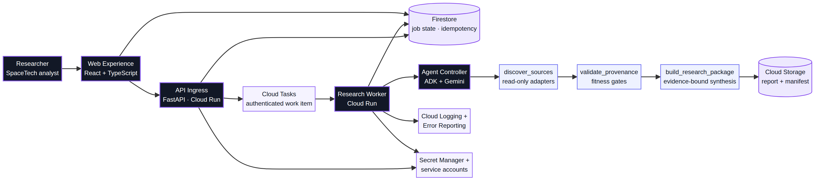
Figure 1 — Reference architecture: separation of intake, asynchronous work, validation, and durable package storage.
Component Responsibilities
Component | Responsibility | Key control
Web Experience | Accepts a request, presents job progress, and opens a completed package without exposing source secrets. | Uses job_id only; never receives worker-execution authority.
FastAPI / Cloud Run API | Validates request schema, creates a job and idempotency key, then enqueues work. | User authentication, request validation, and consistent first state write.
Firestore | Stores job state, structured tool results, idempotency keys, and audit metadata. | Constrained transitions and append-oriented history.
Cloud Tasks | Separates job creation from work execution and applies a bounded retry policy. | Authenticated HTTPS task; aligned with Cloud Run task guidance. [1]
Cloud Run Worker | Runs state logic, invokes the agent and tools, and writes events and artifacts. | Verifies task identity and state version before any side effect.
ADK + model runtime | Plans inside constraints, selects allowed tools, and composes structured evidence. | No final language without Claim/Evidence contract; ADK supports structured paths combining deterministic and adaptive logic. [2]
Cloud Storage | Stores the report, manifest, and permitted snapshots required for replay. | Stable package name, content hash, and retention policy.
Logging & Error Reporting | Correlates user request, job, tool, and evidence with an operational trace. | Secret redaction and data minimization before logging.

End-to-End Job Flow
Step | Action | Evidence retained
1. Accept request | API validates satellite, location, time window, and requested outputs, then normalizes input. | request_version, normalized_request, actor_id, idempotency_key.
2. Create state | A durable job is created in QUEUED before work is placed on the queue. | job_id, state=QUEUED, timestamps.
3. Constrained plan | The agent selects only approved adapters and tools with explicit validation conditions. | plan_version, selected_adapters, policy_version.
4. Discover | discover_sources calls read-only adapters and records raw plus normalized responses. | Candidate evidence and retrieval metadata.
5. Validate | validate_provenance applies the fitness matrix and produces accepted evidence or gaps. | Fit assessments and gap list.
6. Build package | build_research_package receives accepted evidence only. | Claims, citations, limitations, manifest draft.
7. Gate release | An independent validator checks claim-to-evidence relationships and policy labels. | Gate result and validation report.
8. Persist and present | The immutable package is written and the job is set to COMPLETED. | Artifact URI, content hash, completion time.

JOB LIFECYCLE & CONTRACTS
04 — Job Lifecycle and Data Contracts
A state machine makes agent behavior safe to operate. A model may assist with planning or composition, but it does not have authority to alter state or publish an artifact. A trusted service enforces transitions and records transition reason and policy version.
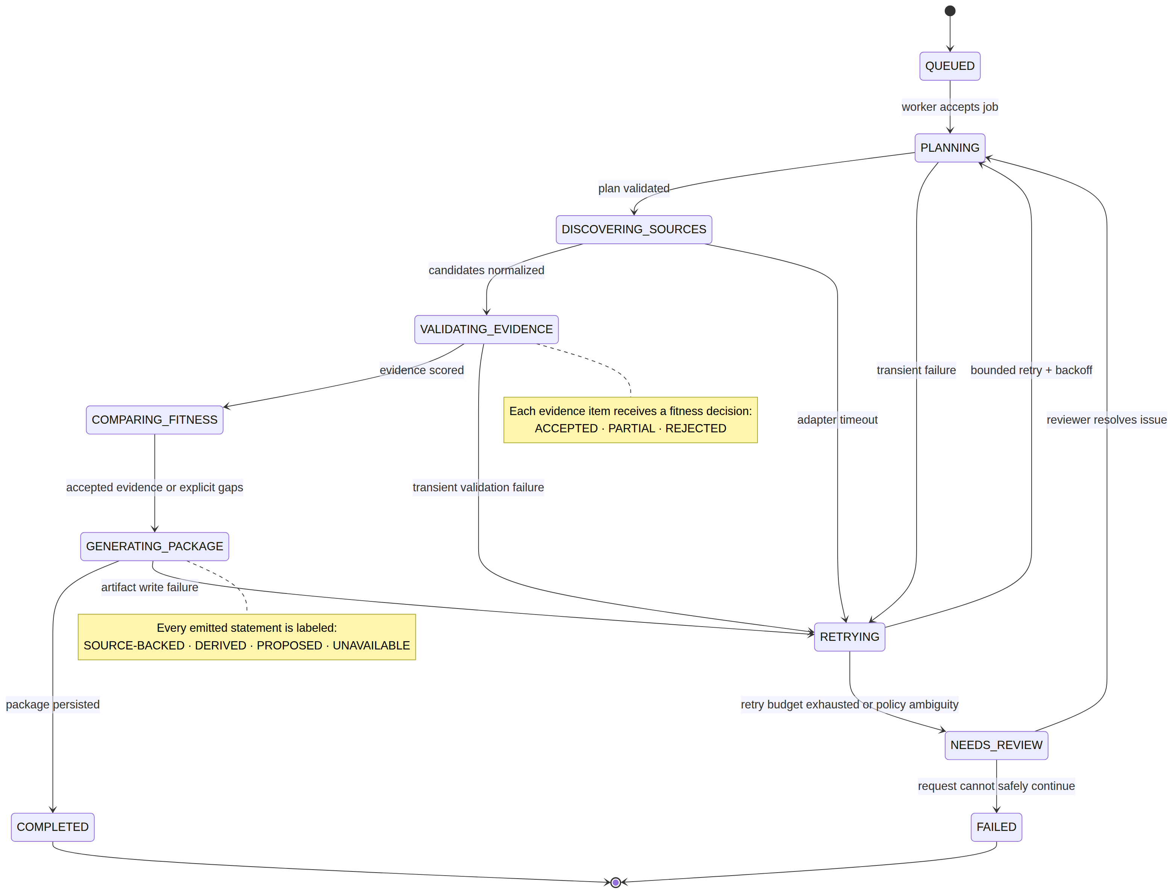
Figure 2 — Reference job-state machine with recovery and human-review paths.
Job States and Exit Criteria
State | Meaning | Exit criterion
QUEUED | A valid request is waiting to be executed. | Job record and task message are durable.
PLANNING | A constrained plan specifies permitted sources, tools, and expected outputs. | All tools are allow-listed and each objective has a validation condition.
DISCOVERING_SOURCES | Candidate evidence is collected through adapters. | Every adapter result has raw_ref and retrieval time, or a classified error.
VALIDATING_EVIDENCE | Fitness is calculated for each evidence item. | No evidence item lacks a status and reason.
COMPARING_FITNESS | Accepted evidence is selected and partial-evidence limitations are recorded. | accepted list and gap_list are stable.
GENERATING_PACKAGE | Report and manifest are composed with claim linkage. | Every claim passes schema and policy validation.
COMPLETED | A frozen, readable package exists. | Artifact hash, URI, and gate result are PASS.
RETRYING / NEEDS_REVIEW / FAILED | Failure and ambiguity paths outside the happy path. | A classified reason, retry count, and follow-up owner where applicable.

Three Tool Contracts
Tool | Input contract | Allowed output | Prohibited action
discover_sources | Normalized request, allow-list, adapter configuration. | CandidateSource[] with query, retrieval time, and raw_ref. | Making final facts or setting job state to COMPLETED.
validate_provenance | CandidateSource[], evidence policy, required fields. | FitAssessment[], gap_list, and source manifest. | Promoting incomplete evidence to SOURCE-BACKED.
build_research_package | Accepted evidence, partial evidence with limitations, template. | ReportDraft, Claim[], citations, and JSON manifest. | Calling a new external source or creating an unproven claim.

Structured Entities
Entity | Essential fields | Reason it exists
ResearchJob | job_id, request_version, state, idempotency_key, policy_version. | Isolates every run and links input to output.
EvidenceItem | evidence_id, source_id, raw_ref, retrieved_at, normalized_payload, adapter_version. | Prevents loss of origin or uncontextualized interpretation.
FitAssessment | evidence_id, status, criteria[], limitations[], reviewer_hint. | Turns “is this usable?” into an inspectable decision.
Claim | claim_id, text, label, evidence_ids[], transform_version, limitation_ids[]. | Forces one or more relationships between language and evidence.
ResearchPackage | report_uri, manifest_uri, content_hash, generated_at, gate_result. | Provides a durable unit of delivery and review.

EXAMPLE MANIFEST
{
"package_id": "gp_2026_08_14_01",
"job_id": "job_7f39...",
"policy_version": "evidence-policy/1.0",
"claims": [{
"claim_id": "c-014", "label": "DERIVED",
"evidence_ids": ["ev-101", "ev-102"],
"transform_version": "pass-window/1.2",
"limitation_ids": ["gap-03"]
}],
"publication_gate": {"status": "PASS", "validator": "manifest/1.0"},
"content_hash": "sha256:<immutable-content-hash>"
}

Idempotency rule
The API derives a key from the actor, request class, and normalized request. If the same request arrives before the first one completes, the API returns the existing job rather than starting duplicate research or creating a second package.

INTERFACES & SECURITY
05 — Interfaces, Security, and Trust Isolation
Security focuses on minimizing authority and protecting research provenance from manipulation. Content received from the web or an external source is never treated as an instruction. It enters as data and passes schema, normalization, and validation before it can influence report composition.
Proposed MVP API Contract
Interface | Purpose | Safe response
POST /v1/research-jobs | Accept a normalized research question and create a job. | 202 Accepted with job_id and QUEUED; never waits for the report.
GET /v1/research-jobs/{job_id} | Present state, current stage, and non-sensitive progress information. | 200 with state, progress marker, and review hint where applicable.
GET /v1/research-jobs/{job_id}/package | Read a completed package for an authorized user. | 200 for a completed package or 409 if publication has not passed.
POST /v1/research-jobs/{job_id}/review | Record an authorized reviewer decision at NEEDS_REVIEW. | 200 with decision, reviewer ID, and immutable audit comment.

Trust Model
Asset or path | Primary threat | Proposed control
User interface | Malformed requests or cross-tenant authorization bypass. | User authentication, job ownership authorization, schema validation, and rate limits.
Cloud Tasks → Worker | A forged job sent to an internal worker. | Private service, HTTPS, OIDC, and a service account with Cloud Run Invoker only. [1]
Source adapters | Schema drift, contaminated data, or instructions embedded in source text. | Read-only allow-list, size limit, validation schema, and treating all upstream content as data.
Credentials | API secrets appear in logs or report artifacts. | Secret Manager, least-privilege service accounts, log redaction, and no secrets in model context.
Final package | Report modification after verification or mixed evidence versions. | Manifest hash, object versioning/immutability, and a report bound to package_id.
Operational logs | Sensitive data or unnecessary complete prompts retained. | Event classification, sampling, TTL, and structured correlation fields over raw text.

Source Policy
The approved-source list is a versioned, reviewable artifact: source_id, owner, data type, permitted use, licensing or terms URL, freshness fields, and adapter version. SatNOGS documents a REST API and states that its API data are distributed under CC BY-SA; the package template should preserve appropriate attribution whenever that source is used. [3] NOAA and CelesTrak inputs should each be treated as independent products with evolving terms, metadata, and update cadence, not as implicit static facts. [4] [5]
Separation of authority
The API identity creates jobs and writes only the minimum initial state. The worker identity processes an authenticated task only. A source-read identity has no operational authority. A reviewer identity does not run workers. This separation makes incident scope narrower and reviewable.

RELIABILITY & QUALITY
06 — Reliability, Observability, and Quality Assurance
The system requires two forms of proof: that the operational path worked and that the produced package was governed by evidence. A log line saying a job completed is not enough; it must also be possible to show that every released claim passed the publication gate.
Core Observability Events
Dimension | Measure | Purpose
Operational health | queue_age, worker_latency, retries, terminal_failures. | Detect backlog, degraded sources, and weak retry policy.
Evidence quality | accepted/partial/rejected ratio, gap frequency, schema failures. | Detect a weak source or an unmet research requirement.
Package integrity | claims by label, orphan-claim count, publication-gate failures. | Ensure no-fabrication controls remain effective.
Cost | tokens by stage, adapter calls, runtime seconds, artifact bytes. | Manage a measurable unit cost rather than a stale estimate.
Security | authorization denials, redaction hits, invalid task identity. | Detect trust-boundary bypass attempts or data exposure.

Proposed Quality Objectives — Not Published Results
Metric | Definition | MVP target
Traceability coverage | Share of claims with a valid label and relationship to evidence or a documented gap. | 100% in test and release packages; failure blocks publication.
Publication-gate pass rate | Packages that pass validator checks before being frozen. | ≥99% in staging after intentionally injected failures are excluded.
Duplicate execution rate | Duplicate attempts that create multiple artifacts for one idempotency key. | 0 in resilience and load test scenarios.
Time to visible state | Time from accepted request to QUEUED visible to the user. | Establish by measurement; do not assume.
Evidence-gap fidelity | Human reviews confirming UNAVAILABLE is correct and not hiding accessible evidence. | Start with a reviewed sample before automating evaluation.

Release Verification
Level | Verification examples | Acceptance condition
Unit | Timestamp normalization, idempotency-key calculation, label-to-evidence rules. | Every critical edge case has a deterministic test.
Contract | Adapters conform to source schema and handle changed fields. | An adapter version does not advance until documented fixtures pass.
Integration | API → queue → worker → storage using a source fixture. | Closing the browser does not lose a job; the package remains retrievable.
Policy / red-team | Request missing data, place malicious text in source content, use partial evidence. | System returns UNAVAILABLE or NEEDS_REVIEW, never an unsupported claim.
Human audit | Sample packages link each claim to source, transformation, and limitation. | Findings feed the next policy version.

Non-negotiable test
Test a request that requires a fact public data cannot establish, such as station operational status or RF health. The accepted result is not a better guess; it is a clear refusal that names the authorized measurement source needed.

DELIVERY ROADMAP
07 — Delivery Roadmap: Proof of Concept to Reviewable MVP
The recommended sequence establishes trust before expanding surface area. Do not prioritize a polished interface or live demo until one narrow path proves that provenance, validation, unavailable-data behavior, and a structured package work together.
Milestone | Deliverables | Verification gate | Move-forward decision
M0 — Contract and policy | One persona, request form, evidence policy, package template, and gap definition. | A test question cannot produce a report without labels. | Freeze evidence-policy/1.0.
M1 — Source adapters | Read-only connectors and normalized metadata for CelesTrak, SatNOGS, NOAA, or equivalent fixtures. | Every response carries provenance, retrieval time, and a documented fixture. | Enable one live source after terms review.
M2 — Agent and tools | Constrained plan, three tools, structured results. | Local request returns sources, gaps, and a manifest draft. | Reject any claim lacking evidence ID.
M3 — Async jobs | Firestore state, Cloud Tasks, Cloud Run worker, retry policy. | Browser close or worker restart does not lose a submitted job. | Run staging with core telemetry.
M4 — Package and gate | Readable report, JSON manifest, immutable storage, validator. | Every report has limitations, gate result, and inspectable package. | Review sample packages before user access.
M5 — Proof and demo | Tests, diagrams, audit trace, demo script, recording. | Independent reviewer runs one workflow and inspects evidence without help. | Readiness decision for submission or closed pilot.

Open Decisions Before Production
Decision | Why it matters | Suggested owner / next action
Retention policy | Queries and evidence may have different data-handling and audit requirements. | Security + Product: define classification, TTL, and deletion rights.
Source allow-list | Every source adds licensing, drift, reliability, and support risk. | Research + Data: use an adapter scorecard before admission.
NEEDS_REVIEW thresholds | Too many escalations harm experience; too few damage trust. | Product + Operations: create samples and review volume.
Model versioning | Model behavior changes can alter tool decisions or report language. | Platform: pin version, evaluation suite, and rollback plan.
Data region and identity | Determines compliance, latency, and multi-tenant design. | Security + Platform: conduct threat model and residency decision.
SLO and cost targets | Hackathon estimates should not be treated as production facts. | Operations: baseline telemetry, then publish target budgets and latency.

Four-Minute Auditable Demo
Time | Scene | Proof shown
0:00–0:30 | A real, bounded research question and the analyst need it addresses. | Clear problem definition and product boundary.
0:30–1:10 | Submit request; show QUEUED and named state stages. | job_id, constrained plan summary, and trace correlation ID.
1:10–2:15 | Open one accepted source, one partial result, and one rejection. | Fitness matrix and provenance record.
2:15–3:05 | Open report and manifest, then trace a claim to evidence. | Visible SOURCE-BACKED, DERIVED, and UNAVAILABLE labels.
3:05–4:00 | Highlight a data gap the system refused to invent; show storage/log trace. | Proof that refusal is a successful policy outcome, not a silent failure.

RISK REGISTER
08 — Operating Risks and Mitigations
GroundPulse reliability depends on source availability, data-schema integrity, and controlled generative behavior. These are ongoing engineering risks, not presentation footnotes, and should be managed through explicit controls and indicators.
Risk | Impact | Architectural mitigation | Early signal
Source outage or throttling | Incomplete package or delayed job. | Timeouts, backoff, demo-only cached fixtures, and UNAVAILABLE outcome. | Adapter errors or increasing queue age.
Schema drift | Incorrect normalization or loss of a critical field. | Contract tests, adapter versioning, and source suspension on failure. | Validation/schema-failure rate.
Model manipulation by source content | Tool decision or language violating policy. | Treat source as data, use schema extraction, and never pass raw instructions to execution tools. | Policy-gate failures or anomalous tool paths.
Claim beyond evidence capability | Loss of researcher trust or a misleading decision. | Claim labels, manifest gate, and sampled human audit. | Orphan claims or audit findings.
Uncontrolled cost | Budget overrun or poor scalability. | Per-stage telemetry, request caps, and budget alerts. | Token/runtime cost per job.
Secret or sensitive-data exposure | Security or compliance incident. | Secret Manager, least privilege, redaction, and retention policy. | Secret-scan hit or logging-policy alert.

Trust condition
System success should not be measured by the number of reports produced. It should be measured by the share of packages an independent reviewer can trace, understand, and replay without access to undocumented context.

APPENDIX A
Appendix A — Research Request and Package Boundary
Minimum Valid Request
Field | Example | Validation
subject | NOAA-19 | Satellite or research subject has a normalizable identifier.
location | Budapest, 47.5N, 19.0E | Named location plus coordinates, or coordinates with clear datum.
time_window | 2026-08-14T00:00Z / 2026-08-21T00:00Z | Start precedes end; UTC or an explicitly convertible time zone.
research_questions | Orbital context; observations; space weather; limitations. | Question types are supported by the policy and source catalog.
output_profile | research_brief_v1 | Approved template requires citations and limitations.

Final Package Boundary
Package component | Content | Required
Executive brief | Scope, evidence-backed findings, and limitations in readable form. | Yes
Evidence register | Evidence list with source, retrieval time, and fitness status. | Yes
Claim ledger | Every claim with evidence label plus source/transform IDs. | Yes
Data gaps | Every UNAVAILABLE item, reason, and proposed closure path. | Yes
Reproducibility manifest | Policy, adapters, template versions, and content hash. | Yes
Raw snapshots | Permitted raw response snapshots under source terms and retention policy. | Policy-dependent

APPENDIX B
Appendix B — Glossary
Term | Operational definition
Evidence item | A retrieved unit of data with a raw reference, retrieval time, and defined normalization.
Provenance | The origin chain of an item: source, query, time, adapter, and transformation.
Fit assessment | A decision about an evidence item for a specific question, not a universal judgment on its provider.
Manifest | A structured file tying report, request, evidence, policy, versions, and content hash together.
Idempotency | A guarantee that repeating the same request does not produce duplicate side effects or packages.
Graceful refusal | A result that states unavailability or the need for review rather than manufacturing an answer.
Publication gate | An independent check blocking package persistence when claim/evidence contracts are violated.

REFERENCES
References and Design Sources
The external references below support the platform capabilities and source characteristics used in this design. Product-specific structure, scope, and roadmap content have been reorganized from materials supplied by the project owner.
[1] Google Cloud. Executing asynchronous tasks — Cloud Run + Cloud Tasks.
[2] Google. Agent Development Kit (ADK) — graph workflows and production agent framework.
[3] SatNOGS Network. API documentation and data license.
[4] NOAA Space Weather Prediction Center. Products and Data.
[5] CelesTrak. NORAD General Perturbations (GP) Element Sets.
[S1] GroundPulse_DevPost_Guide.docx — supplied project material.
[S2] GroundPulse_Research_Paper.docx — supplied project material.
[S3] GroundPulse_Hackathon_Submission.docx — supplied project material.
[S4] groundpulse_research_agent_roadmap.pdf — supplied project material.
Closing note
The next edition of this guide becomes materially stronger when it incorporates adapter contracts, approved retention policy, evaluation results, and measured staging telemetry. At that point, this baseline can evolve into a managed, living architecture record.

