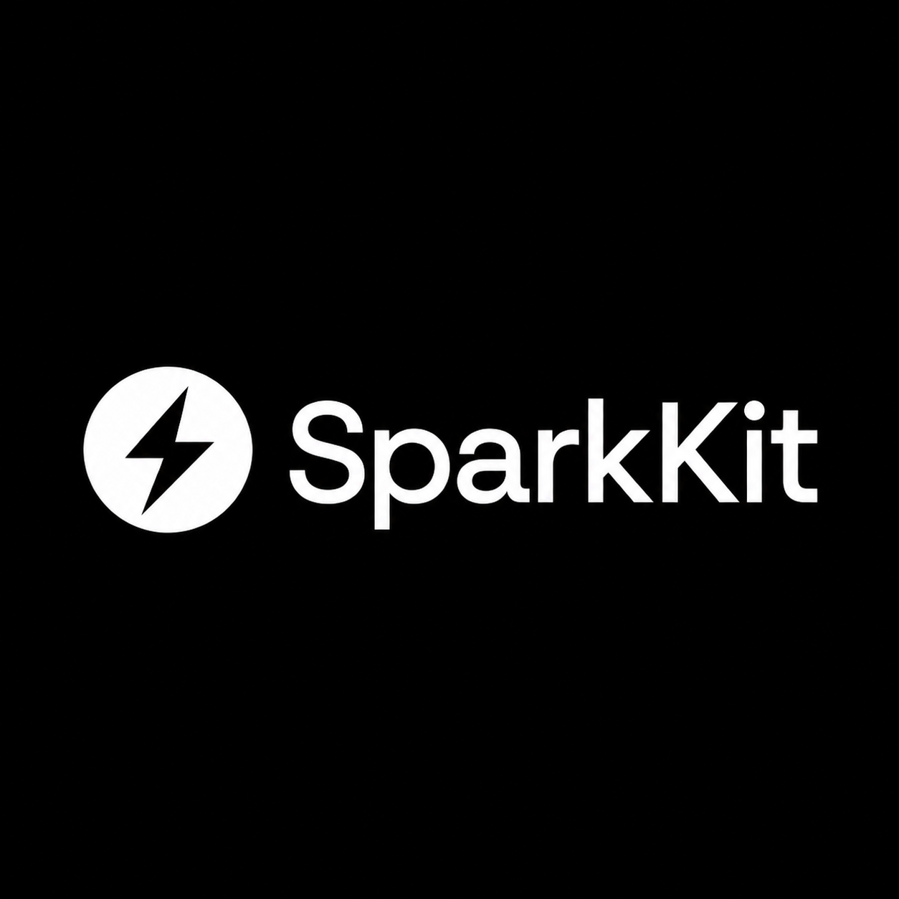
VISION BRIEF
Sparkbase + SparkKit
The open foundation and managed cloud for small software built by humans and AI agents.
CORE PROMISE Build with SparkKit. Run it on Sparkbase.
SparkKit gives developers code they own. Sparkbase turns that code into secure, shareable, continuously operated software.
Strategic vision | August 2026 | Early-stage working document

01 / EXECUTIVE VISION

Small software deserves a real operating system
AI has made software dramatically easier to create. It has not made identity, permissions, data isolation, deployment, secrets, backups, monitoring, or safe updates disappear. Those operational requirements arrive immediately after the first useful prototype.
Sparkbase and SparkKit exist to close that gap. Together, they create a path from generated code to dependable software without forcing every small team to become a cloud infrastructure team.
NORTH STAR Make secure software as easy to deploy and share as a document - while preserving source ownership and portability.

The thesis
- Every team has workflows too specific for mass-market SaaS and too important for fragile scripts.
- AI agents reduce the cost of creating purpose-built applications, expanding the volume of small software.
- The new bottleneck is trusted operation: deployment, access, data, observability, maintenance, and governance.
- A coherent application standard plus an opinionated cloud can remove that bottleneck.

What success looks like
A developer or agent connects a repository and receives a secure application URL, managed PostgreSQL, authentication, organization permissions, secrets, previews, logs, backups, and safe deployment workflows. Colleagues can use the application without understanding its infrastructure.

02 / PRODUCT SYSTEM

Two products, one reinforcing system
SparkKit | Sparkbase
Open-source application foundation | Managed cloud and operational layer
Portable TypeScript and owned source | Deploy, share, secure, observe, and recover
Auth, organizations, roles, tenant-safe data | Domains, databases, secrets, backups, previews
Works locally and on infrastructure of choice | Convenience that must earn adoption
Optimized for developers and coding agents | Optimized for teams using the resulting software

The relationship
SparkKit must remain genuinely useful without Sparkbase. That independence creates trust, community adoption, and a durable standard. Sparkbase wins by making deployment and operations dramatically easier - not by weakening self-hosting or locking away essential capabilities.

A simple brand architecture
- SparkKit: the toolkit, reference application, generator, conventions, and open ecosystem.
- Sparkbase: the company and future managed cloud for running SparkKit applications.
- Message: Build with SparkKit. Run it on Sparkbase.

03 / INITIAL MARKET WEDGE

Start with technical teams building real internal tools
The first customer should not be everyone who can describe an app. The strongest early user is a small technical team already using AI coding agents, already creating focused applications, and already frustrated by repeating cloud setup and maintenance.

High-value starting use cases
- Operations dashboards and approval workflows
- Customer and partner portals
- Document processing and research workspaces
- Specialized CRM extensions and reporting applications
- Team-specific automation interfaces with organization permissions

The first commercial promise
PRODUCT WEDGE Connect a SparkKit repository and receive one secure, shareable application URL in minutes.

The ideal first-run experience
- Connect a GitHub repository or generate a SparkKit application.
- Sparkbase detects the application contract and required services.
- A preview environment is created with database, secrets, HTTPS, and authentication.
- The owner invites colleagues through organization-aware access controls.
- Every change is tested, previewed, deployed, monitored, and recoverable.

04 / BUSINESS AND DEFENSIBILITY

Sell operational confidence, not raw infrastructure
Sparkbase can run on established cloud infrastructure at the beginning. The customer is not paying for commodity compute alone; they are paying to remove decisions, integration work, security gaps, and ongoing maintenance from every small application.

Business model
- Free: one developer, a small number of applications, community support, and clear usage limits.
- Pro: custom domains, backups, higher limits, more applications, and longer log retention.
- Team: members, roles, audit history, shared secrets, preview policies, and deployment approvals.
- Business: SSO, private networking, policy controls, support, and compliance features.
- Usage: transparent compute, database, storage, bandwidth, and optional agent operations.

The long-term moat
Generic clouds understand containers and processes. Sparkbase can understand the application itself because SparkKit defines its identity model, tenant boundary, migrations, configuration, tests, and deployment contract.
- Know which routes require authentication and which changes affect permissions.
- Detect unsafe database migrations and cross-tenant data risks before deployment.
- Generate the right preview environment and quality gates automatically.
- Give operational agents a constrained, auditable interface for diagnosis and remediation.
COMPOUNDING ADVANTAGE Every well-operated SparkKit application improves the platform's understanding of how small software should be deployed and maintained.

05 / ROADMAP

Prove the workflow before expanding the platform
Phase 1 Complete the open foundation
Finish the SaaS vertical slice, error states, smoke tests, generator, and one reliable Docker deployment.
Phase 2 Validate the cloud wedge
Repository connection, automated deployment, managed PostgreSQL, secrets, HTTPS, logs, invitations, and rollback.
Phase 3 Find repeat usage
Work with 10-20 technical teams; measure deployment time, weekly activity, second-app creation, retention, and willingness to pay.
Phase 4 Become agent-native
Offer CLI, API, and MCP surfaces for controlled environment creation, deployment, diagnosis, and rollback.
Phase 5 Automate operations
Policy-aware previews, safe migrations, dependency maintenance, cost controls, failure diagnosis, and approved remediation.

Evidence that matters
- Real applications deployed and used weekly by real teams
- Minutes from repository connection to a secure shareable URL
- Users creating a second application without founder assistance
- Documented retention, deployment reliability, support load, and willingness to pay
- No claims of traction, savings, or reliability without measured evidence

06 / STRATEGIC FOCUS

The company is Sparkbase. The standard is SparkKit.
SparkKit creates trust, portability, distribution, and a shared language for humans and agents. Sparkbase turns that standard into a valuable managed experience. The immediate goal is not to build every cloud feature; it is to make one small application reliably deployable, shareable, and maintainable with almost no operational ceremony.
STRATEGIC RECOMMENDATION Finish the SparkKit proof, then move quickly to the smallest working Sparkbase deployment flow and place it in front of real teams.

Principles to protect
- Source ownership and portability are non-negotiable.
- Security and tenant isolation remain product features, not documentation footnotes.
- Agent actions are permissioned, observable, budgeted, and reversible.
- Managed services earn adoption through convenience and reliability.
- Proof comes before promises: shipped code, working deployments, and measured usage.
BUILD WITH SPARKKIT. RUN IT ON SPARKBASE.
Open foundation. Optional managed cloud. Software that remains yours.

