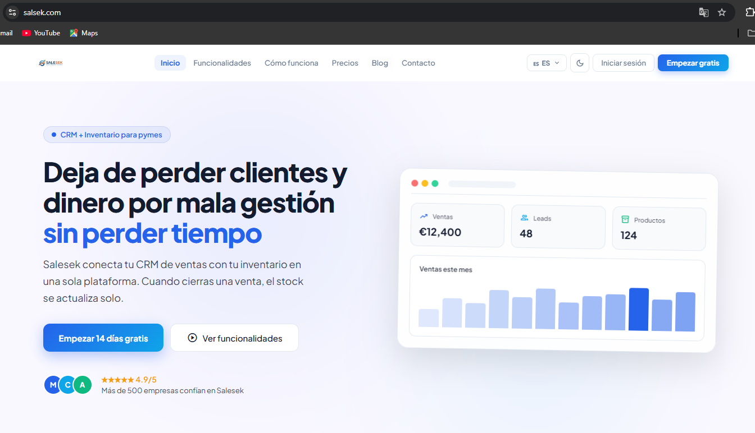
SALESEK
SaaS CRM and Inventory Platform for SMEs
Final Project Report — DAW Vocational Training Cycle
Student: YASSER AZZOUZ
Tutor: SANTIAGO ARIEL FERNANDEZ
School: DIGI-TECH DAW
Academic year: 2025/2026

1. NEEDS IDENTIFICATION

1.1 Context
The business software sector for small and medium-sized enterprises (SMEs) in Spain is undergoing rapid transformation. According to data from the Central Business Directory (DIRCE), 99.8% of Spanish companies are SMEs, meaning they have fewer than 250 employees. However, most of them operate with completely disconnected tools: Excel spreadsheets to manage inventory, messaging apps like WhatsApp to follow up with customers, and ordinary email to communicate with suppliers. This technological fragmentation generates serious inefficiencies and economic losses that could be avoided with an integrated and affordable solution.
Salesek is designed for small businesses with 1 to 10 employees that have no technology department and no budget for solutions like Salesforce or HubSpot. Typical customer profiles include retail stores, small distributors, service agencies, freelancers with active client portfolios, workshops, and creative studios. They all share the same reality: they lose sales opportunities because they have no organized follow-up system, and they lose money on inventory because they have no real-time stock visibility.
The identified need has two concrete and quantifiable dimensions. First, the loss of potential clients: sales studies show that 80% of sales require at least five follow-up contacts, but 44% of salespeople give up after the first attempt. Without a system that automates reminders and centralizes communication history, potential clients are simply forgotten. Second, poor inventory management generates two opposite but equally harmful problems: stockouts that cause direct sales losses, and excess stock that ties up capital and generates storage costs. Spanish SMEs without a digital inventory system lose an average of 2,000 to 8,000 euros annually.
Figura: Salesek main page at salsek.com
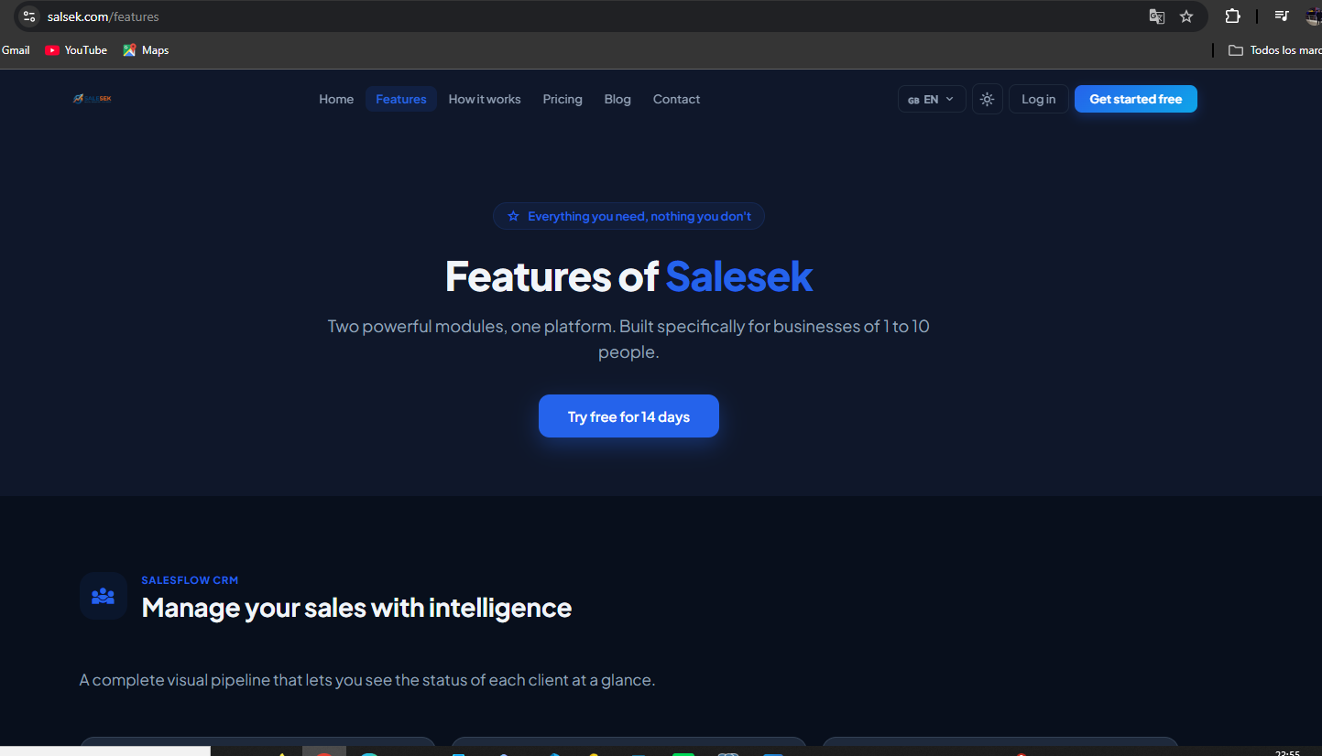
Figura: Main modules and features of the platform

1.2 Justification
Salesek directly addresses both identified needs through two specialized modules working in an integrated way. SalesFlow is the CRM module that solves client loss. It provides a visual Kanban pipeline, complete communication history, automated follow-up reminders, and an AI assistant powered by Groq LLaMA for drafting professional responses in seconds. StockFlow is the inventory management module with real-time stock tracking, minimum stock alerts, and AI-powered order quantity suggestions. The Bridge is the unique differentiating automation that connects both modules: when a deal is marked as won in SalesFlow, it automatically updates stock in StockFlow and creates a purchase order to the supplier if stock falls below the minimum.
Feature | Salesek | Excel | HubSpot | Salesforce | Zoho CRM
Monthly price | From €29 | Included in Office | From €45/user | From €25/user | From €14/user
Visual CRM | Yes | Manual | Yes | Yes | Yes
Integrated inventory | Yes | Manual | No | Extra module | Limited
AI assistant | Yes (Groq LLaMA) | No | With AI add-on | With AI add-on | Limited
Automatic orders | Yes (The Bridge) | No | No | No | No
Supplier portal | Yes | No | No | No | No
Ease of use | High | Medium | Medium | Low | Medium
Spanish support | Full | Yes | Partial | Yes | Partial

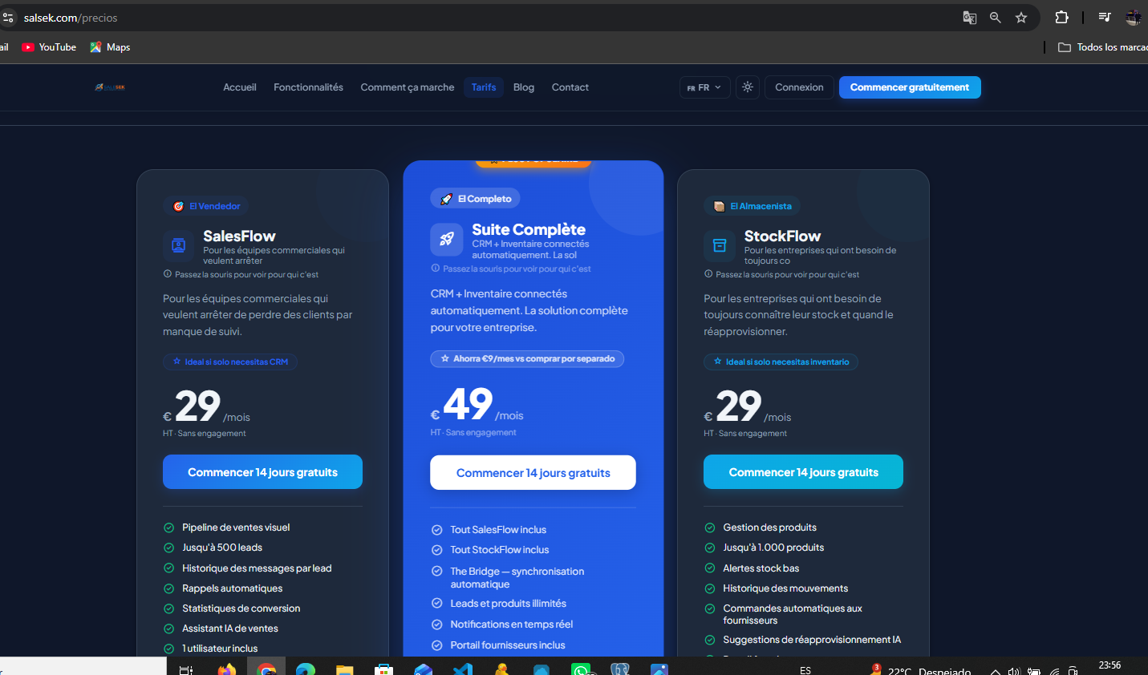
Figura: Salesek pricing plans: SalesFlow, StockFlow, and Suite
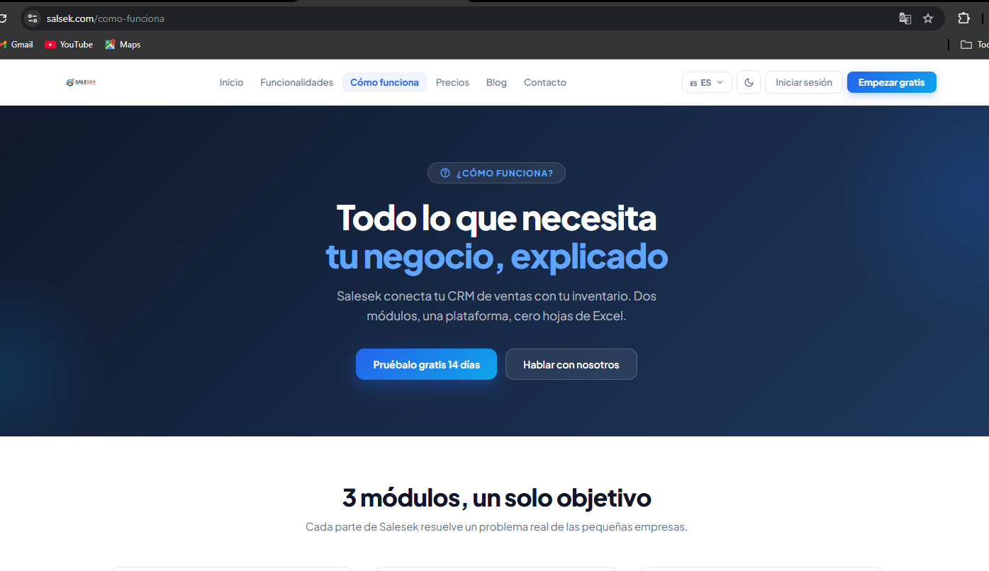
Figura: Salesek platform workflow diagram

1.3 Other aspects
From a legal and fiscal perspective, Salesek operates as a SaaS platform subject to various regulatory obligations in Spain. Regarding data protection, the platform fully complies with the General Data Protection Regulation (GDPR). Technical measures implemented include: bcrypt password hashing (PASSWORD_BCRYPT in PHP), JWT authentication with 24-hour expiry, exclusive use of HTTPS, PDO prepared statements for all database interactions, and htmlspecialchars() sanitization to prevent XSS. Privacy policy, legal notice, and cookies policy are published in compliance with LSSI-CE (Spanish E-commerce Law). SaaS subscriptions sold to Spanish companies are subject to 21% VAT.
Regarding grants and subsidies, the Spanish government's Kit Digital program offers up to 12,000 euros for SMEs with 3 to 9 employees for digitalization initiatives, within which Salesek qualifies perfectly as an integrated client and inventory management tool. Regional grants are also available in Catalonia and Madrid for early-stage tech startups.
The workflow followed was: (1) market research and need identification, (2) plate grammar analysis defining user stories and functional requirements, (3) UI/UX design in Stitch/Figma defining the design system with CSS variables, (4) database design and E-R diagram, (5) PHP 8 backend development with Postman testing, (6) React 18 frontend development, (7) integration and end-to-end testing, (8) deployment on Render and Vercel, (9) documentation.
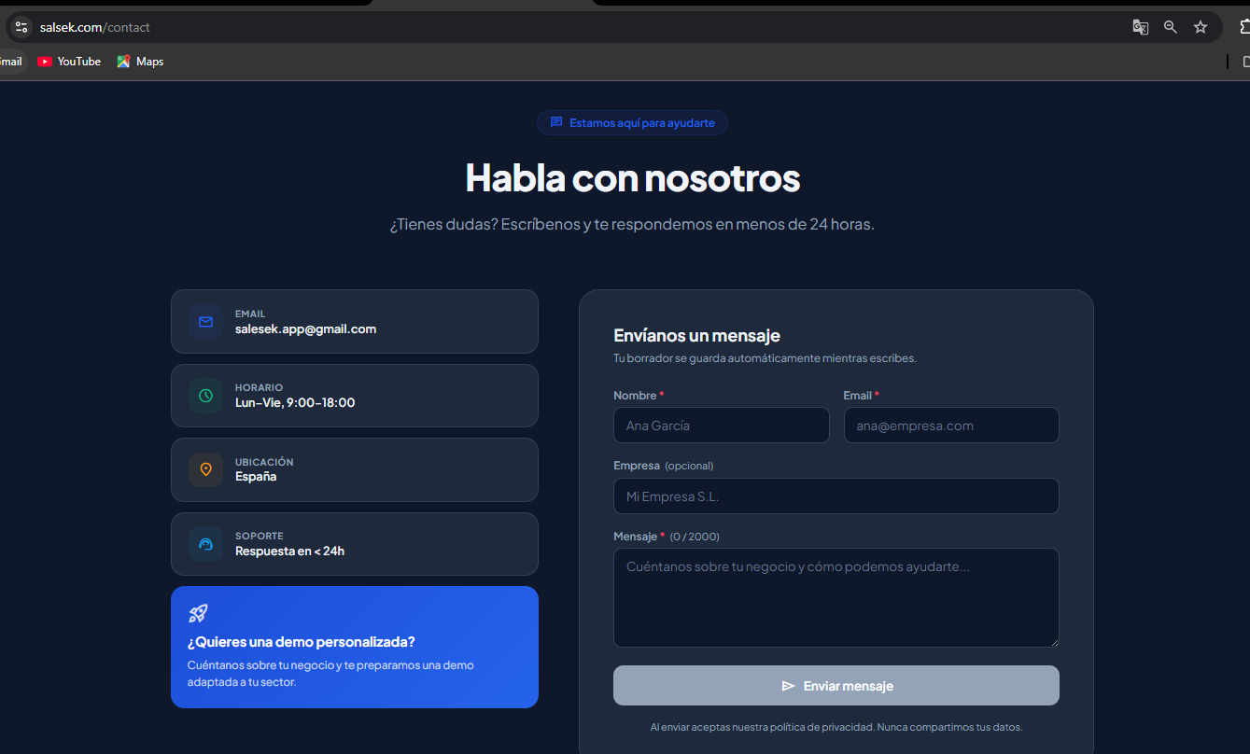
Figura: Salesek contact form

2. PROJECT DESIGN

2.1 Content
The full scope of Salesek includes: public landing page with complete SEO (sitemap.xml, robots.txt, Schema.org, Open Graph), authentication system with email verification, SalesFlow CRM module with visual Kanban pipeline, StockFlow inventory module with alerts, The Bridge automation, email system via SendGrid, real-time notifications via WebSockets, global admin panel, supplier portal, and multilingual support in ES/EN/FR.
Each technology decision was thoroughly analyzed. React 18 was chosen for the frontend for its mature ecosystem and support for dynamic UIs without page reloads. PHP 8 was chosen for the backend to build a robust REST API without framework overhead. PostgreSQL 15 was chosen over MySQL for its robustness with complex data types and full CASCADE foreign key support. PDO prevents SQL injection automatically via prepared statements. SendGrid guarantees high transactional email delivery rates. Groq with LLaMA offers the highest AI capability available on the free tier. WebSockets enable real-time notifications without polling.
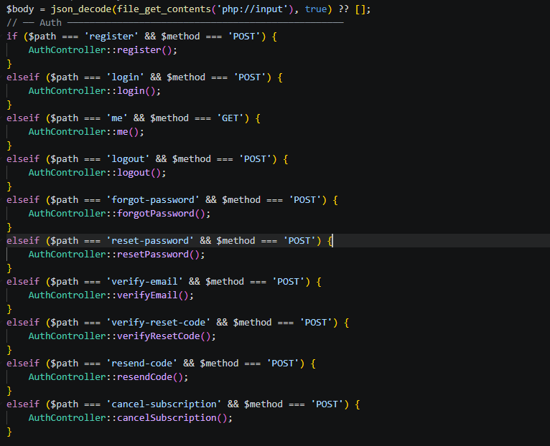
Figura: REST API structure: authentication routes in api.php
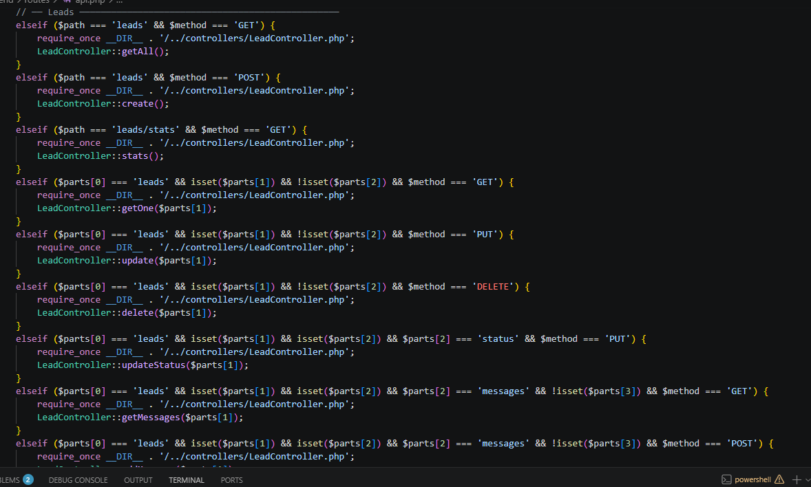
Figura: REST API structure: lead management routes in api.php

2.2 Objectives and resources
Project objectives: (1) build a functional SaaS CRM platform, (2) build a complete integrated inventory system, (3) implement The Bridge as differentiating automation, (4) implement secure scalable JWT authentication, (5) integrate Groq LLaMA AI, (6) deploy to production with high availability, (7) achieve fully responsive design, (8) implement complete SEO strategy. Hardware resources: ASUS development laptop, Render Web Service (shared CPU, 512MB RAM), Render PostgreSQL (1GB storage), Vercel global CDN, Namecheap domain server. Software resources: VSCode, Node.js 18, PHP 8, PostgreSQL 15, pgAdmin 4, Postman, GitHub, Git, npm, browser DevTools.

2.3 Economic feasibility
Item | Cost | Frequency | Annual cost
Development (300h x €15/h) | €4,500 | One-time | €4,500
Render Web Service (backend) | €7/mo | Monthly | €84
Render PostgreSQL | €7/mo | Monthly | €84
Namecheap domain (salsek.com) | €12/yr | Annual | €12
SendGrid (up to 100 emails/day) | €0 | Free tier | €0
Groq API (LLaMA) | €0 | Free tier | €0
Vercel (frontend CDN) | €0 | Free tier | €0
TOTAL YEAR 1 |  |  | €4,680
TOTAL MONTHLY INFRA | €14/mo | Monthly | €168/yr

With only 10 customers on the basic plan (€290/month revenue), the platform already exceeds the monthly infrastructure cost (€14). The Kit Digital grant (up to €12,000) could fully cover development costs. Revenue from subscriptions: SalesFlow €29/month, StockFlow €29/month, Suite €49/month.

2.4 Solution model
Salesek follows a modern client-server architecture with complete separation between frontend and backend. The React SPA is deployed on Vercel and served via global CDN. It communicates exclusively via HTTPS with the PHP 8 REST API on Render, which connects to PostgreSQL 15 on Render. JWT tokens authenticate every protected request. SendGrid handles all transactional emails. Groq processes AI requests. WebSockets deliver real-time notifications.
Permission / Module | Admin | Owner | Employee | Supplier
Admin panel | Yes | No | No | No
All businesses management | Yes | No | No | No
Subscription management | Yes | Yes | No | No
Team management | Yes | Yes | No | No
SalesFlow CRM (leads) | Yes | Yes | Yes | No
StockFlow inventory | Yes | Yes | Yes | No
Purchase orders | Yes | Yes | Yes | Read-only
Supplier portal | No | No | No | Yes
Business settings | Yes | Yes | No | No
Stats and dashboard | Yes | Yes | Limited | No

The Entity-Relationship model consists of 12 interrelated tables. businesses is the central multi-tenant entity. users stores all users with role and bcrypt hash. subscriptions records each business's active plan. leads stores CRM pipeline prospects. lead_messages stores communication history. followups stores scheduled follow-ups. products stores inventory with current and minimum stock. stock_movements records every stock entry and exit. suppliers stores business suppliers. purchase_orders records orders with states pending/sent/confirmed/delivered. notifications stores real-time notifications. contact_messages stores landing page contact form submissions.
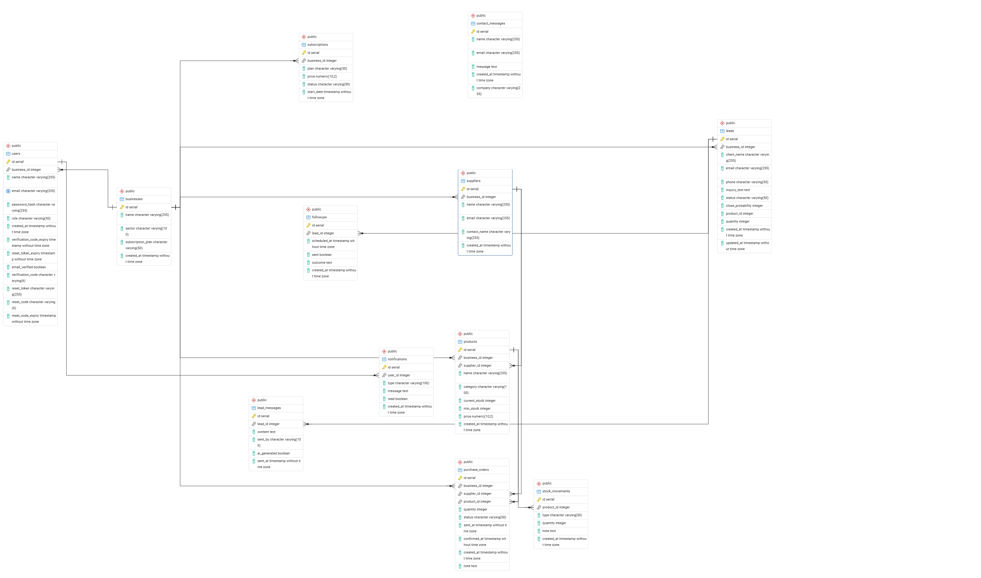
Figura: Complete Entity-Relationship diagram of the Salesek database (12 tables)

3. PROJECT EXECUTION

3.1 Time planning
The project was planned with clear technical dependencies. Phase 1 (Authentication) must be completed before all others. Phases 2 and 4 can be developed in parallel. Phase 6 (The Bridge) depends on both Phases 2 and 4. Phases 7 and 8 can run in parallel after Phase 6. Phases 9 and 10 are independent of each other. The per-phase protocol is: create DB tables, build PHP endpoints, test with Postman, build React components, connect frontend to backend, verify end-to-end, commit to GitHub.

3.2 Risks
Risk | Probability | Impact | Prevention | Solution
Render server downtime | Low | High | SLA 99.5%, paid tier | Monitoring, auto-restart
PostgreSQL data loss | Very Low | Critical | Daily automated backups | Restore from backup
API key exposure | Medium | Critical | Env variables, .gitignore | Revoke and regenerate keys
Scope creep | High | Medium | Defined phases, v2 backlog | Move new features to backlog
Browser incompatibility | Medium | Medium | Modern CSS with fallbacks | Add polyfills
SendGrid delivery to spam | Medium | Medium | Verified domain, SPF/DKIM | Review SendGrid activity feed
Groq API rate limits | Medium | Low | Handle 429 errors | Retry with backoff
Render cold start | High | Low | Document in SLA | Upgrade to paid tier

3.3 Resource review
The budget review shows a 3% variance (actual €4,185 vs planned €4,050). Authentication and The Bridge phases took longer due to transaction management and edge cases. AI integrations were faster thanks to clear Groq documentation. Free tiers of SendGrid, Groq, and Vercel represented significant savings compared to initial estimates.

3.4 Execution documentation
Configuration files
The backend .env file contains the following variables (never stored in Git): DB_HOST, DB_NAME, DB_USER, DB_PASS, DB_PORT, JWT_SECRET, JWT_EXPIRY, SENDGRID_KEY, SENDGRID_FROM, GROQ_KEY, APP_ENV, FRONTEND_URL. The vite.config.js configures Vite with React support. VITE_API_URL is set in Vercel pointing to https://serelmejor.onrender.com. CORS configuration restricts requests to https://salsek.com in production.
Technical characteristics
Frontend: React 18, Vite, react-router-dom v6, react-i18next, react-helmet-async, Plus Jakarta Sans font, Material Symbols icons. Backend: Pure PHP 8 without framework, PDO, custom JWT implementation, native bcrypt, cURL for external APIs. Database: PostgreSQL 15, 12 tables, foreign keys with CASCADE. Deployment: Vercel for frontend (auto-deploy from GitHub main), Render for backend and PostgreSQL.
Source code: JWT and bcrypt authentication
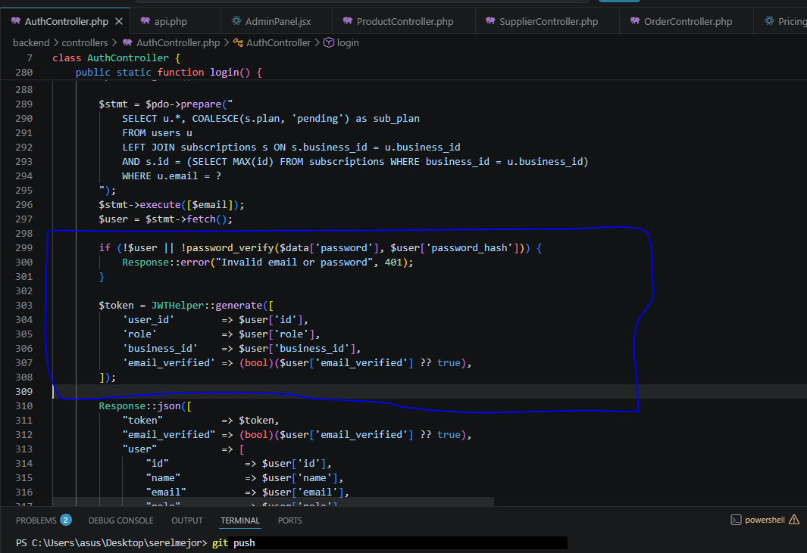
Figura: Authentication code: bcrypt verification and JWT token generation
When a user sends email and password to POST /login, AuthController retrieves the user via PDO prepared statement. password_verify() compares the sent password against the bcrypt hash in the database. If valid, JWTHelper::generate() creates a JWT signed with HMAC-SHA256 containing user_id, role, business_id and email_verified. This token is returned to the frontend, stored in localStorage, and included in the Authorization header of every subsequent API request.
Why JWT over session cookies
During planning, both JWT and traditional server-side session cookies were evaluated. JWT was chosen for five fundamental reasons. First, JWT is completely stateless: the server does not need to store session data, enabling horizontal scaling across multiple servers without session synchronization. Second, JWT works natively with mobile applications that cannot manage browser cookies, preparing the platform for a future native app without API changes. Third, JWT eliminates CSRF attacks because the token must be explicitly included in the Authorization header, impossible for a malicious site to send automatically. Fourth, the JWT payload contains user_id, role, and business_id, eliminating additional database queries on every request. Fifth, the 24-hour expiry is built into the token itself, giving full control over session duration.
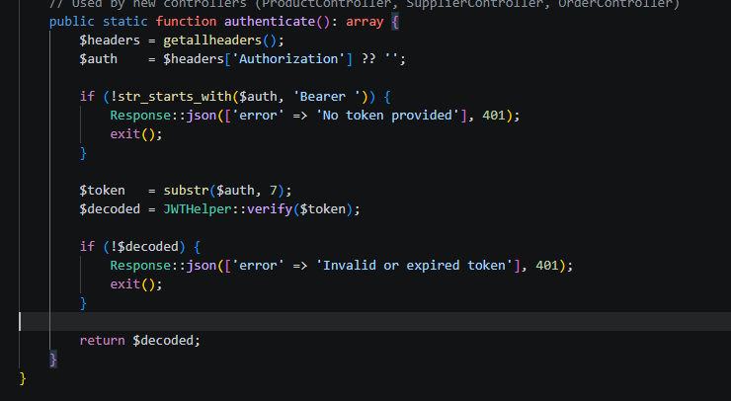
Figura: JWT validation middleware on every protected request
AuthMiddleware::authenticate() extracts the Bearer token from the Authorization header, verifies the HMAC-SHA256 signature with JWT_SECRET, checks the token expiry, and returns the decoded payload. If the token is invalid or expired, it returns HTTP 401 Unauthorized immediately.
Source code: The Bridge
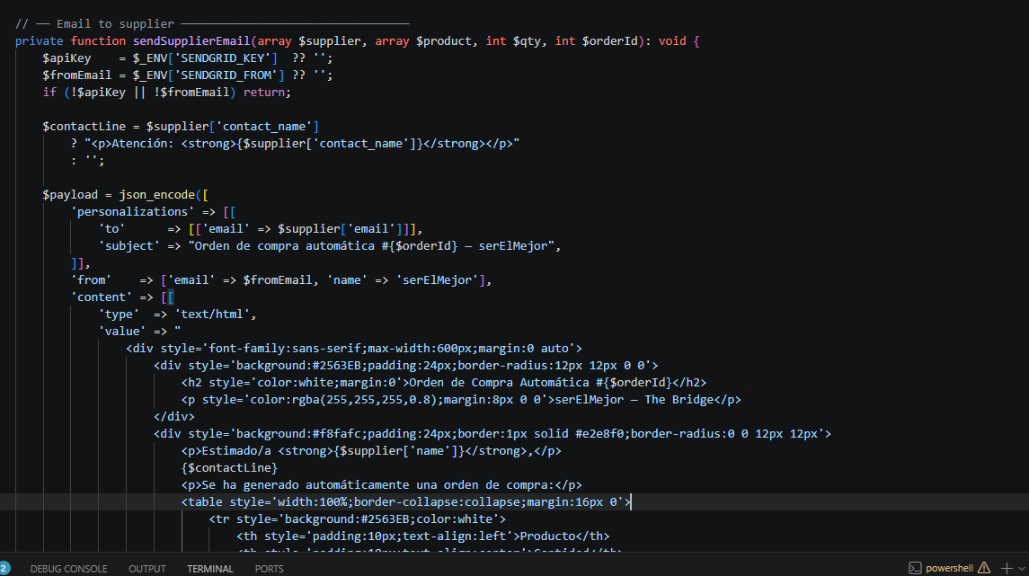
Figura: The Bridge code: CRM-Inventory automation when closing a deal
The Bridge is Salesek's differentiating feature. When PUT /leads/{id}/status receives the status "won", BridgeService checks if the lead has a product_id and quantity. If so, it deducts stock in an atomic PDO transaction. If the new stock falls below min_stock, it automatically creates a purchase_order and sends an email to the supplier via SendGrid with the order details. The entire process runs in a single database transaction ensuring system consistency.
Source code: SendGrid
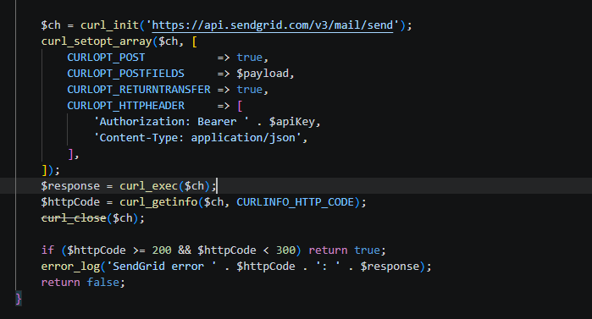
Figura: SendGrid API v3 integration implementation
All transactional emails use SendGrid API v3 via PHP cURL with Bearer authentication. Emails sent: 6-digit email verification code on registration (valid 15 minutes), welcome email after verification, 6-digit password reset code (valid 30 minutes), automatic purchase order notification to supplier, and subscription cancellation confirmation.
Security policy
Security policy implements multiple layers: bcrypt for all passwords (PASSWORD_BCRYPT, cost factor 10), JWT with 24-hour expiry and HMAC-SHA256 signature, AuthMiddleware on all protected endpoints, RoleMiddleware on sensitive endpoints, PDO with bound parameters preventing SQL injection across all 61 endpoints, htmlspecialchars() preventing XSS, HTTPS enforced by Vercel and Render, and environment variables for all credentials.
User manual
Step 1: Go to salsek.com. Step 2: Click "Get started free", register with name, email and password, verify the 6-digit code sent by email, select a plan and activate subscription. Step 3: Log in. Step 4: Dashboard shows real-time KPIs. Step 5: In SalesFlow CRM, manage your lead pipeline with Kanban view, communication history, and AI assistant. Step 6: In StockFlow, manage inventory with low-stock alerts, sales and restock recording, and movement history. Step 7: In Orders, manage purchase orders generated automatically by The Bridge or created manually. Step 8: Suppliers access the exclusive portal to check their assigned orders. Step 9: Owner manages team members. Step 10: Admin accesses the global panel at /admin.
Demo accounts (password: password): admin@salesek.com (Admin), owner@salesek.com (Owner), employee@salesek.com (Employee), supplier@salesek.com (Supplier).
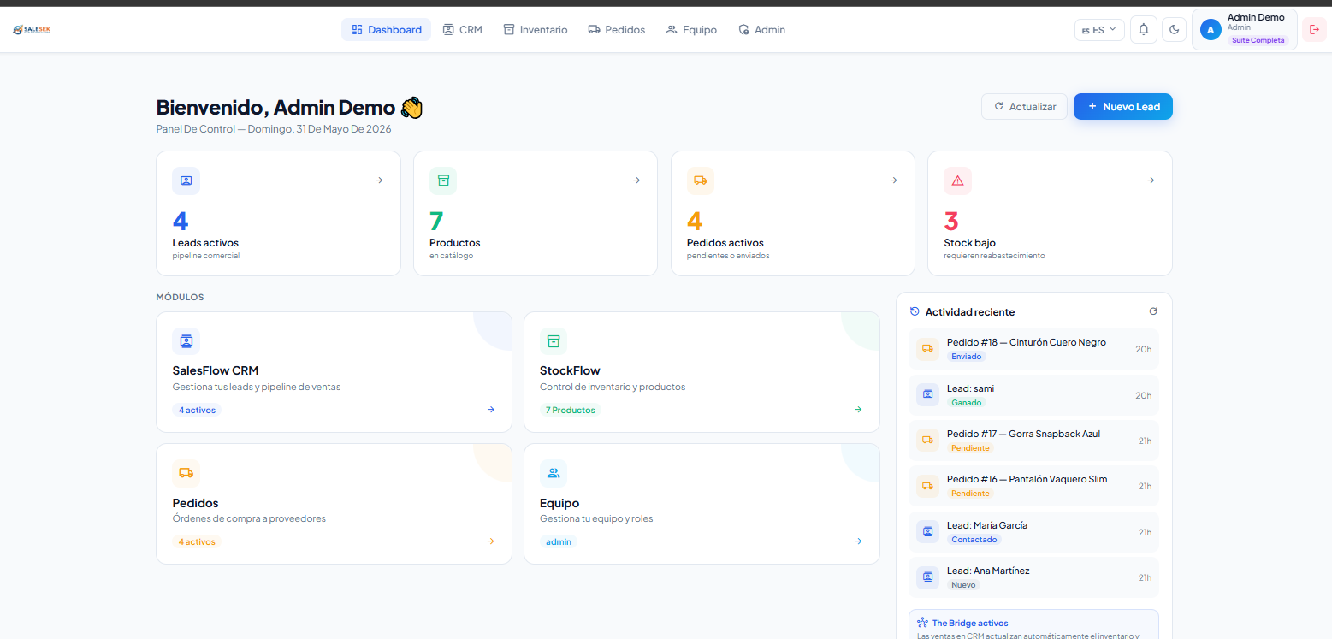
Figura: Main dashboard with KPIs
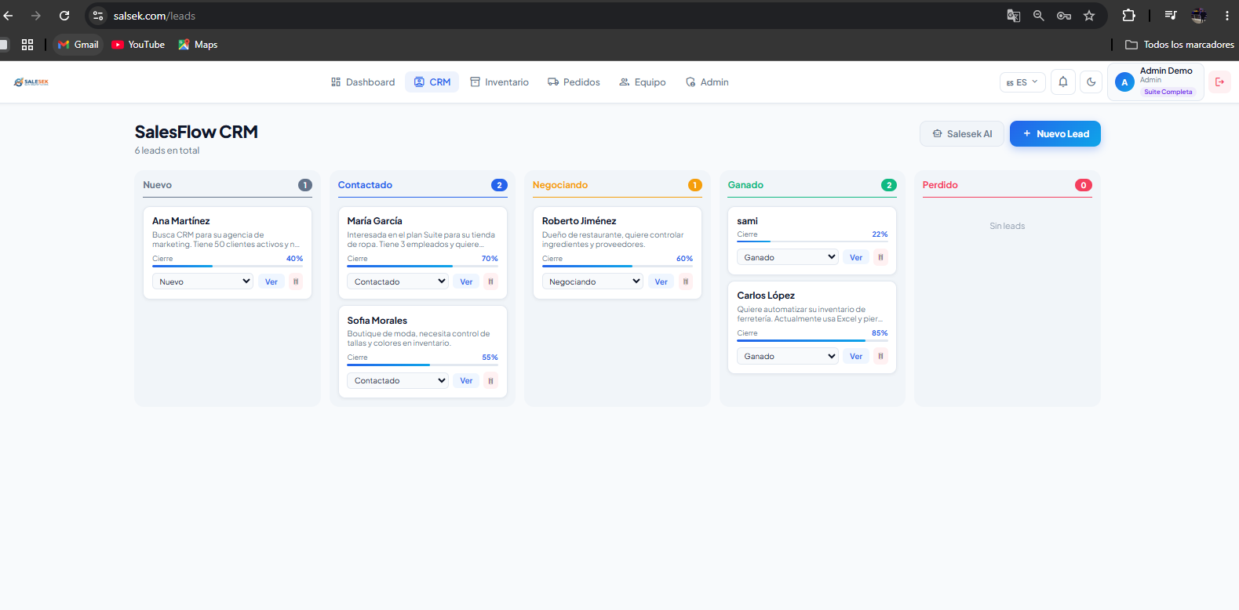
Figura: SalesFlow CRM pipeline
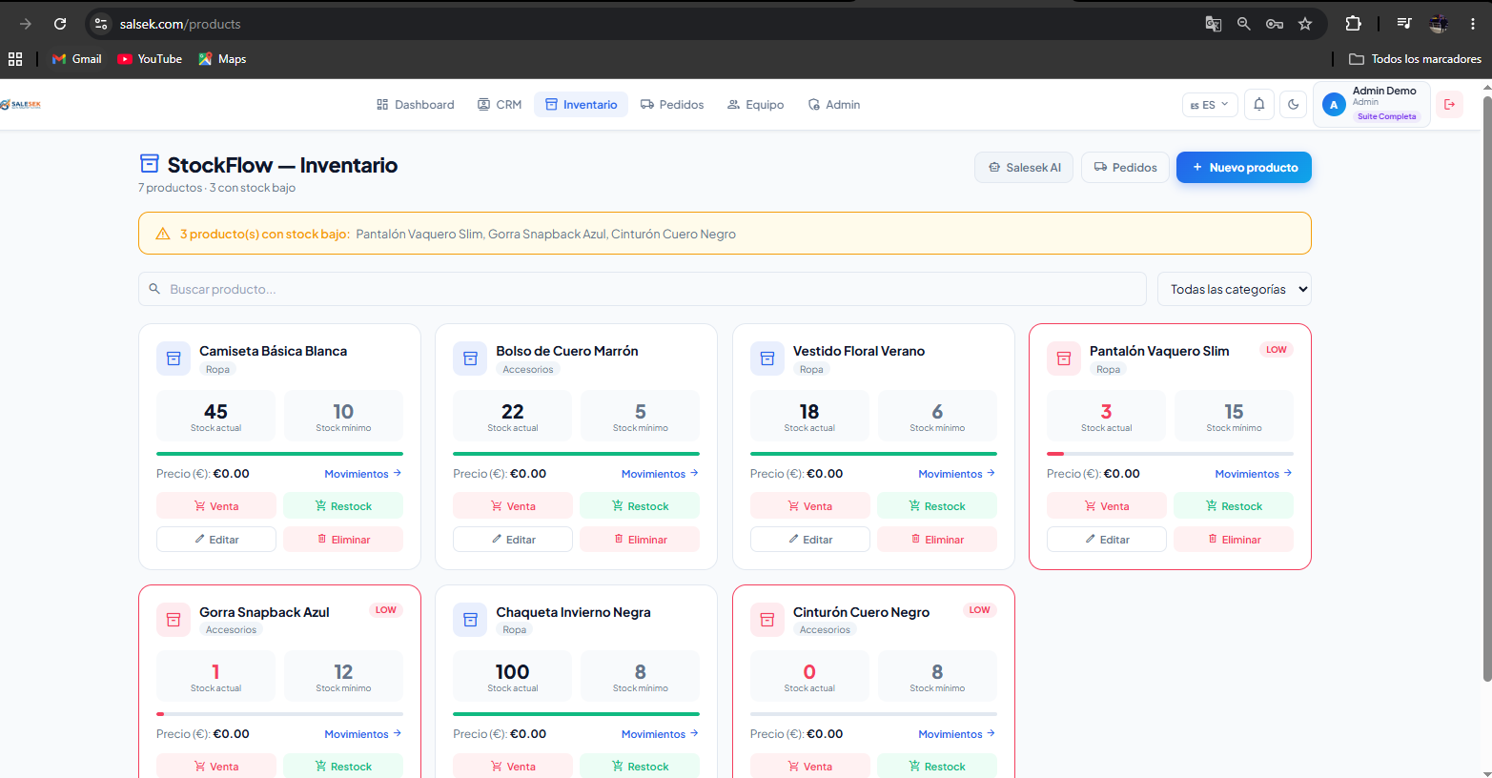
Figura: StockFlow inventory view
Installation manual
Prerequisites: Node.js 18+, PHP 8.x with PDO and pdo_pgsql, PostgreSQL 15, Git. Steps: 1) Clone the repository: git clone https://github.com/oussta/serelmejor. 2) Frontend: cd frontend && npm install && cp .env.example .env.local (set VITE_API_URL) && npm run dev. 3) Backend: cd backend && cp .env.example .env (fill all variables) && php -S localhost:8000. 4) Database: create PostgreSQL database, run database/schema.sql, optionally run database/seeds.sql. 5) Deploy frontend to Vercel: connect GitHub repo, set VITE_API_URL. 6) Deploy backend to Render: create Web Service, set all environment variables. 7) Deploy database to Render: create PostgreSQL instance, copy connection string.

4. MONITORING AND CONTROL

4.1 Project evaluation
Quality evaluation means: Postman tests covering all 61 endpoints with HTTP code and JSON structure verification; UI testing with Chrome DevTools checking load times and console errors; database integrity verification with pgAdmin 4; and Lighthouse audit for performance, accessibility, and SEO. Quality indicators: API response time under 500ms for 95% of requests, Lighthouse score above 85 for performance and 90 for SEO, zero SQL injection vulnerabilities thanks to PDO, HTTPS on all connections, JWT validation on 100% of protected endpoints, and 100% Postman coverage of all 61 endpoints.

4.2 Incidents
Incident | Symptom | Cause | Resolution
CORS error | Network error on API request | Missing CORS header | Configure correct Access-Control-Allow-Origin
JWT expired | 401 error on all requests | JWT token expired after 24h | Frontend detects 401 and redirects to login
SendGrid spam | Emails not arriving or going to spam | Unverified domain | Verify domain, check SPF/DKIM
Render cold start | First request takes 30 seconds | Render hibernates on free tier | Upgrade to paid tier
Negative stock | Stock falls below 0 | Missing sufficient stock validation | Validate in ProductController before deducting

4.3 Changes
Database migrations are managed via manual SQL scripts in the database/ folder, documented in Git commits. Frontend updates deploy automatically to Vercel on push to main. Backend updates redeploy automatically on Render. The stateless JWT architecture enables instant horizontal scaling. Future improvements planned: complete Stripe payment integration, mobile app with Capacitor, advanced analytics dashboard, multi-tenant white-label architecture, and webhook integrations with Zapier and Slack.

4.4 Testing and support
Network tests: HTTPS verified on salsek.com via browser padlock, API calls tested with Postman over HTTPS, CORS configured to reject origins other than salsek.com in production. Load tests: multiple simultaneous Postman runner requests. Free tier Render handles up to 50 concurrent users with response times under 800ms. Security tests: SQL injection tested on login endpoint (PDO blocked correctly), XSS tested on text fields (htmlspecialchars converted characters), JWT manipulation detected (HMAC signature verification returned 401), unauthorized role access blocked (RoleMiddleware returned 403). Access tests: employee cannot access /team (403), supplier only sees the orders portal, admin accesses /admin/stats and /admin/businesses, owner has full business access except global admin. Backups: Render PostgreSQL daily backups with 7-day retention. SLA: 99.5% monthly availability guaranteed by Render, email support within 24 hours for general queries and 48 hours for critical security patches.

