**Cerinta 1**

PROIECT SGDG

HÂRNAGEA ANDREI-ALEXANDRU

GESTIONAREA UNOR GALERII DE ARTĂ

GRUPA 242

**Am creat o bază de date pentru a facilita memorarea galeriilor de artă. O galerie are loc într-un singur oraș, este îndrumată de un singur coordonator și are mai mulți sponsori, care oferă donații. În cadrul unei galerii au loc mai multe evenimente. La un eveniment se prezintă exponate, care pot avea unul sau mai mulți autori. Pentru un evenument se pot angaja mai multe echipe staff, care un mai mulți angajați.**

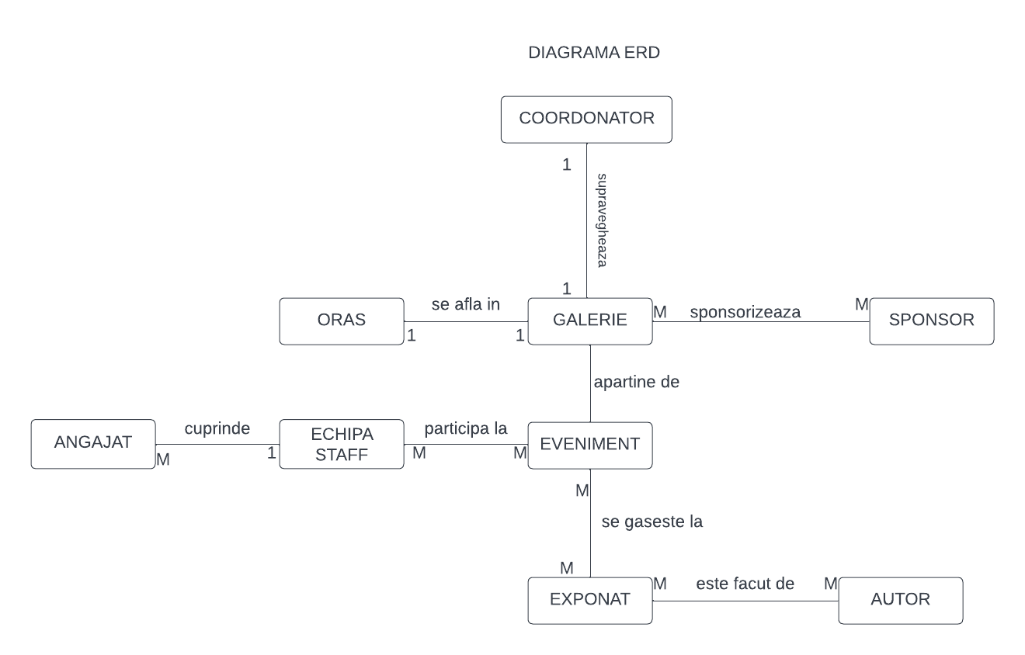**Cerinta 2**

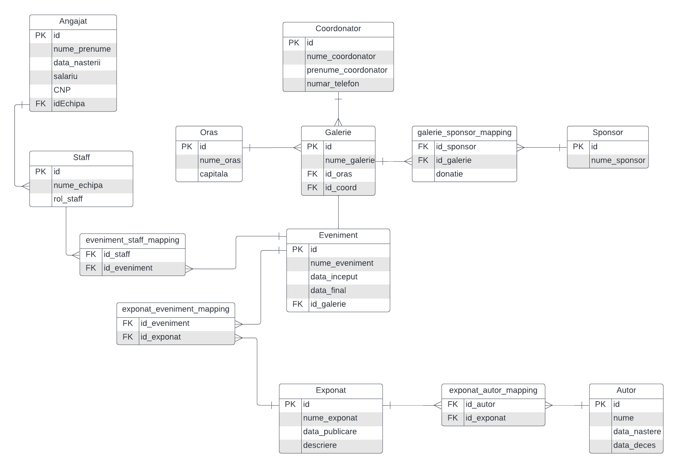**Cerinta 3**

**Cerinta 4**

Crearea tabelelor

CREATE TABLE AUTOR (

id_autor NUMBER PRIMARY KEY,

nume_autor varchar2(255) NOT NULL,

data_nastere DATE NOT NULL,

data_deces DATE

);

CREATE TABLE EXPONAT (

id_exponat NUMBER PRIMARY KEY,

nume_exponat varchar2(255) NOT NULL,

data_publicare date,

descriere varchar2(255)

);

CREATE TABLE COORDONATOR (

id_coord NUMBER PRIMARY KEY,

nume_sponsor varchar2(255) NOT NULL,

prenume_sponsor varchar2(255) NOT NULL,

numar_telefon varchar2(255) NOT NULL

);

CREATE TABLE ORAS(

id_oras NUMBER PRIMARY KEY,

nume_oras varchar2(255) NOT NULL,

capitala NUMBER NOT NULL

);

CREATE TABLE GALERIE(

id_galerie NUMBER PRIMARY KEY,

id_oras NUMBER,

id_coord NUMBER,

nume_galerie varchar2(255) NOT NULL,

FOREIGN KEY (id_oras) REFERENCES ORAS(id_oras) ON DELETE SET NULL,

FOREIGN KEY (id_coord) REFERENCES COORDONATOR(id_coord) ON DELETE SET NULL

);

CREATE TABLE EVENIMENT (

id_eveniment NUMBER PRIMARY KEY,

id_galerie NUMBER,

nume_eveniment VARCHAR2(255) NOT NULL,

data_inceput date NOT NULL,

data_final date NOT NULL,

FOREIGN KEY (id_galerie) REFERENCES GALERIE(id_galerie) ON DELETE SET NULL

);

CREATE TABLE SPONSOR(

id_sponsor NUMBER PRIMARY KEY,

nume_sponsor VARCHAR2(255) NOT NULL

);

CREATE TABLE STAFF(

id_staff NUMBER PRIMARY KEY,

nume_echipa VARCHAR2(255),

rol_staff VARCHAR2(255)

);

CREATE TABLE ANGAJAT(

id_angajat NUMBER PRIMARY KEY,

nume_anagajat VARCHAR2(255) NOT NULL,

prenume_anagajat VARCHAR2(255) NOT NULL,

data_nastere DATE NOT NULL,

salariu NUMBER NOT NULL,

CNP VARCHAR2(255) NOT NULL,

id_staff NUMBER,

FOREIGN KEY (id_staff) REFERENCES STAFF(id_staff) ON DELETE SET NULL

);

CREATE TABLE EVENIMENT_STAFF_MAPPING(

id_staff NUMBER,

id_eveniment NUMBER,

PRIMARY KEY(id_staff,id_eveniment),

FOREIGN KEY (id_staff) REFERENCES STAFF(id_staff) ON DELETE SET NULL,

FOREIGN KEY (id_eveniment) REFERENCES EVENIMENT(id_eveniment) ON DELETE SET NULL

);

CREATE TABLE EXPONAT_AUTOR_MAPPING(

id_autor NUMBER,

id_exponat NUMBER,

PRIMARY KEY(id_autor,id_exponat),

FOREIGN KEY (id_autor) REFERENCES AUTOR(id_autor) ON DELETE SET NULL,

FOREIGN KEY (id_exponat) REFERENCES EXPONAT(id_exponat) ON DELETE SET NULL

);

CREATE TABLE GALERIE_SPONSOR_MAPPING(

id_galerie NUMBER,

id_sponsor NUMBER,

donatie NUMBER not null,

PRIMARY KEY (id_galerie, id_sponsor),

FOREIGN KEY (id_galerie) REFERENCES GALERIE(id_galerie) ON DELETE SET NULL,

FOREIGN KEY (id_sponsor) REFERENCES SPONSOR(id_sponsor) ON DELETE SET NULL

);

CREATE TABLE EXPONAT_EVENIMENT_MAPPING(

id_eveniment NUMBER,

id_exponat NUMBER,

PRIMARY KEY(id_eveniment,id_exponat),

FOREIGN KEY (id_eveniment) REFERENCES EVENIMENT(id_eveniment) ON DELETE SET NULL,

FOREIGN KEY (id_exponat) REFERENCES EXPONAT(id_exponat) ON DELETE SET NULL

);

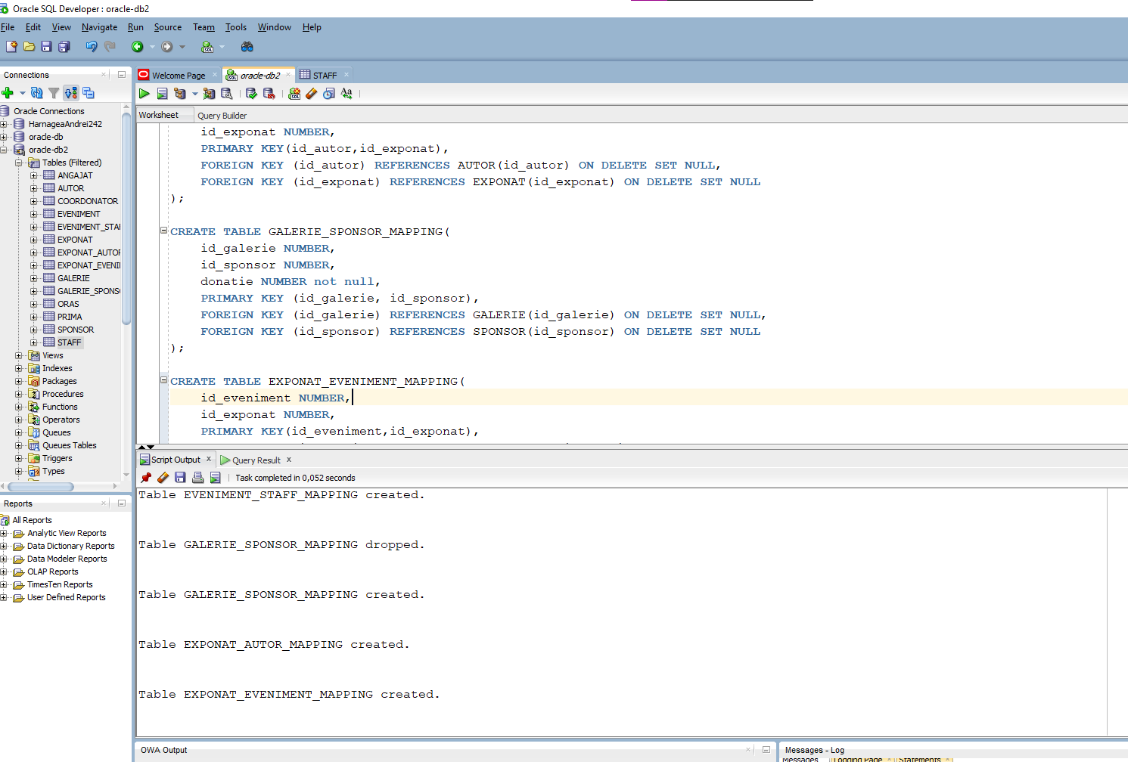

**Cerinta 5**

insert into SPONSOR (id_sponsor, nume_sponsor) values (1, 'Skimia');

insert into SPONSOR (id_sponsor, nume_sponsor) values (2, 'Plajo');

insert into SPONSOR (id_sponsor, nume_sponsor) values (3, 'Voolia');

insert into SPONSOR (id_sponsor, nume_sponsor) values (4, 'Topicblab');

insert into SPONSOR (id_sponsor, nume_sponsor) values (5, 'Riffwire');

select * from sponsor

insert into AUTOR (id_autor, nume_autor, data_nastere, data_deces) values (1, 'Van Gogh', '13-09-1951', '06-10-1984');

insert into AUTOR (id_autor, nume_autor, data_nastere, data_deces) values (2, 'Picasso', '28-11-1991', NULL);

insert into AUTOR (id_autor, nume_autor, data_nastere, data_deces) values (3, 'Castelli', '18-06-1985', '19-12-2009');

insert into AUTOR (id_autor, nume_autor, data_nastere, data_deces) values (4, 'Carolynn', '29-08-1989', NULL);

insert into AUTOR (id_autor, nume_autor, data_nastere, data_deces) values (5, 'Da Vinci', '05-03-1975', '13-10-2018');

insert into AUTOR (id_autor, nume_autor, data_nastere, data_deces) values (6, 'Chell', '17-07-1960', NULL);

SELECT * FROM AUTOR

insert into COORDONATOR (id_coord, nume_coordonator, prenume_coordonator, numar_telefon) values (1, 'des Remedios', 'Milty', '661 355 2788');

insert into COORDONATOR (id_coord, nume_coordonator, prenume_coordonator, numar_telefon) values (2, 'Howsden', 'Hannis', '851 662 1805');

insert into COORDONATOR (id_coord, nume_coordonator, prenume_coordonator, numar_telefon) values (3, 'Byforth', 'Hy', '302 853 4191');

insert into COORDONATOR (id_coord, nume_coordonator, prenume_coordonator, numar_telefon) values (4, 'Folley', 'Xerxes', '888 630 2960');

insert into COORDONATOR (id_coord, nume_coordonator, prenume_coordonator, numar_telefon) values (5, 'Broadis', 'Renado', '215 129 8433');

SELECT * FROM COORDONATOR

insert into STAFF (id_staff, nume_echipa, rol_staff) values (1, 'Fotografii', 'fotografie');

insert into STAFF (id_staff, nume_echipa, rol_staff) values (2, 'Bucatarii', 'catering');

insert into STAFF (id_staff, nume_echipa, rol_staff) values (3, 'Luminatii', 'lumini');

insert into STAFF (id_staff, nume_echipa, rol_staff) values (4, 'Masinele', 'transport');

insert into STAFF (id_staff, nume_echipa, rol_staff) values (5, 'Gardienii', 'body-guards');

SELECT * FROM STAFF

insert into ANGAJAT (id_angajat, nume_angajat, prenume_angajat, data_nastere, salariu, CNP, id_staff) values (1, 'Rudderham', 'Alli', '19-08-2001', 1567, '561017087225946895', 1);

insert into ANGAJAT (id_angajat, nume_angajat, prenume_angajat, data_nastere, salariu, CNP, id_staff) values (2, 'Jurges', 'Lynette', '21-12-1982', 2270, '3561813473931435', 1);

insert into ANGAJAT (id_angajat, nume_angajat, prenume_angajat, data_nastere, salariu, CNP, id_staff) values (3, 'McCulley', 'Hendrick', '21-11-1979', 2780, '4026616165983581', 1);

insert into ANGAJAT (id_angajat, nume_angajat, prenume_angajat, data_nastere, salariu, CNP, id_staff) values (4, 'Neumann', 'Aloysius', '05-09-1998', 4882, '3570830634142362', 2);

insert into ANGAJAT (id_angajat, nume_angajat, prenume_angajat, data_nastere, salariu, CNP, id_staff) values (5, 'Murfin', 'Constantin', '29-09-1980', 2748, '5303845895843085', 2);

insert into ANGAJAT (id_angajat, nume_angajat, prenume_angajat, data_nastere, salariu, CNP, id_staff) values (6, 'Colville', 'Solly', '07-01-1971', 2176, '63040369063298219', 2);

insert into ANGAJAT (id_angajat, nume_angajat, prenume_angajat, data_nastere, salariu, CNP, id_staff) values (7, 'McGettrick', 'Jeddy', '11-03-1976', 4400, '5602245404939466', 2);

insert into ANGAJAT (id_angajat, nume_angajat, prenume_angajat, data_nastere, salariu, CNP, id_staff) values (8, 'Christescu', 'Steven', '23-01-1967', 4565, '36532667146898', 2);

insert into ANGAJAT (id_angajat, nume_angajat, prenume_angajat, data_nastere, salariu, CNP, id_staff) values (9, 'Farrens', 'Vasili', '04-04-1967', 2156, '3539528611653019', 3);

insert into ANGAJAT (id_angajat, nume_angajat, prenume_angajat, data_nastere, salariu, CNP, id_staff) values (10, 'Christescu', 'Hobey', '09-06-1984', 3580, '560223844255436250', 3);

insert into ANGAJAT (id_angajat, nume_angajat, prenume_angajat, data_nastere, salariu, CNP, id_staff) values (11, 'Myall', 'Denni', '18-11-1970', 2161, '3564352220627936', 3);

insert into ANGAJAT (id_angajat, nume_angajat, prenume_angajat, data_nastere, salariu, CNP, id_staff) values (12, 'Greenlies', 'Eugen', '24-01-1999', 3629, '5610695640397392', 4);

insert into ANGAJAT (id_angajat, nume_angajat, prenume_angajat, data_nastere, salariu, CNP, id_staff) values (13, 'Neeson', 'Weider', '07-01-1988', 2207, '3576378139687378', 4);

insert into ANGAJAT (id_angajat, nume_angajat, prenume_angajat, data_nastere, salariu, CNP, id_staff) values (14, 'Comini', 'Deny', '16-03-1981', 4107, '5602233476673742', 4);

insert into ANGAJAT (id_angajat, nume_angajat, prenume_angajat, data_nastere, salariu, CNP, id_staff) values (15, 'Burrell', 'Felicle', '28-10-1985', 2193, '3549037879008427', 4);

insert into ANGAJAT (id_angajat, nume_angajat, prenume_angajat, data_nastere, salariu, CNP, id_staff) values (16, 'Badland', 'Lek', '11-01-1972', 3288, '3574996911389939', 5);

insert into ANGAJAT (id_angajat, nume_angajat, prenume_angajat, data_nastere, salariu, CNP, id_staff) values (17, 'Canete', 'Bebe', '04-11-1985', 2671, '633424762069417930', 5);

insert into ANGAJAT (id_angajat, nume_angajat, prenume_angajat, data_nastere, salariu, CNP, id_staff) values (18, 'Christofle', 'Tremayne', '05-01-2001', 3694, '4508859506024551', 3);

insert into ANGAJAT (id_angajat, nume_angajat, prenume_angajat, data_nastere, salariu, CNP, id_staff) values (19, 'Heeron', 'Mechelle', '11-07-1997', 2452, '4844780974268905', null);

insert into ANGAJAT (id_angajat, nume_angajat, prenume_angajat, data_nastere, salariu, CNP, id_staff) values (20, 'Spaight', 'Lilah', '27-05-1997', 4107, '3578494216089996', null);

SELECT * FROM ANGAJAT

SELECT * FROM AUTOR

insert into EXPONAT (id_EXPONAT, nume_exponat, data_publicare, descriere) values (1, 'OXYCODONE', '30/9/2013', 'Digitized explicit parallelism');

insert into EXPONAT (id_EXPONAT, nume_exponat, data_publicare, descriere) values (2, 'Starry Night', '6/7/2007', 'Synergistic heuristic adapter');

insert into EXPONAT (id_EXPONAT, nume_exponat, data_publicare, descriere) values (3, 'MORUS', '2/7/1999', 'Right-sized mobile service-desk');

insert into EXPONAT (id_EXPONAT, nume_exponat, data_publicare, descriere) values (4, 'Plus', '7/5/2002', 'User-centric zero tolerance parallelism');

insert into EXPONAT (id_EXPONAT, nume_exponat, data_publicare, descriere) values (5, 'anti', '5/12/2022', 'Front-line content-based success');

insert into EXPONAT (id_EXPONAT, nume_exponat, data_publicare, descriere) values (6, 'Metronidazole', null, 'Total empowering strategy');

insert into EXPONAT (id_EXPONAT, nume_exponat, data_publicare, descriere) values (7, 'PROMETHAZINE', '7/12/2001', 'Enhanced tertiary process improvement');

insert into EXPONAT (id_EXPONAT, nume_exponat, data_publicare, descriere) values (8, 'Anti Itch', null, 'Total fresh-thinking project');

insert into EXPONAT (id_EXPONAT, nume_exponat, data_publicare, descriere) values (9, 'Peisaj', '28/2/2002', 'Ergonomic global intranet');

insert into EXPONAT (id_EXPONAT, nume_exponat, data_publicare, descriere) values (10, 'PrePost', '10/10/2008', 'Switchable composite array');

insert into EXPONAT (id_EXPONAT, nume_exponat, data_publicare, descriere) values (11, 'Cedar Elm', '12/3/1998', 'Persevering fresh-thinking throughput');

insert into EXPONAT (id_EXPONAT, nume_exponat, data_publicare, descriere) values (12, 'Sleep Aid', '24/6/1995', null);

insert into EXPONAT (id_EXPONAT, nume_exponat, data_publicare, descriere) values (13, 'HONIBE', '11/11/2007', null);

insert into EXPONAT (id_EXPONAT, nume_exponat, data_publicare, descriere) values (14, 'METHYLIN', null, 'Expanded local neural-net');

insert into EXPONAT (id_EXPONAT, nume_exponat, data_publicare, descriere) values (15, 'Volcano', '26/8/2008', null);

insert into ORAS (id_oras, nume_oras, capitala) values (1, 'Paris', 1);

insert into ORAS (id_oras, nume_oras, capitala) values (2, 'Porto Ferreira', 0);

insert into ORAS (id_oras, nume_oras, capitala) values (3, 'New York', 0);

insert into ORAS (id_oras, nume_oras, capitala) values (4, 'Tr Vinh', 0);

insert into ORAS (id_oras, nume_oras, capitala) values (5, 'Bucuresti', 1);

insert into galerie (id_galerie, id_oras, id_coord, nume_galerie) values (1, 1, 1, 'Primavera');

insert into galerie (id_galerie, id_oras, id_coord, nume_galerie) values (2, 2, 2, 'The Best');

insert into galerie (id_galerie, id_oras, id_coord, nume_galerie) values (3, 3, 3, 'Aperture');

insert into galerie (id_galerie, id_oras, id_coord, nume_galerie) values (4, 4, 4, 'Salt Mines');

insert into galerie (id_galerie, id_oras, id_coord, nume_galerie) values (5, 5, 5, 'Mechanical');

insert into galerie (id_galerie, id_oras, id_coord, nume_galerie) values (6, 1, 5, 'Quirkcy');

insert into galerie (id_galerie, id_oras, id_coord, nume_galerie) values (7, 5, 4, 'Blck Mesa');

insert into EVENIMENT (id_eveniment, id_galerie, nume_eveniment, data_inceput, data_final) values (1, 1, 'Latlux', '12/06/2014', '24/07/2014');

insert into EVENIMENT (id_eveniment, id_galerie, nume_eveniment, data_inceput, data_final) values (2, 1, 'Quo Lux', '24/03/2012', '11/04/2012');

insert into EVENIMENT (id_eveniment, id_galerie, nume_eveniment, data_inceput, data_final) values (3, 2, 'Prodder', '22/02/2012', '16/03/2012');

insert into EVENIMENT (id_eveniment, id_galerie, nume_eveniment, data_inceput, data_final) values (4, 2, 'Flowdesk', '02/08/2014', '24/08/2014');

insert into EVENIMENT (id_eveniment, id_galerie, nume_eveniment, data_inceput, data_final) values (5, 2, 'Greenlam', '02/02/2018', '12/02/2018');

insert into EVENIMENT (id_eveniment, id_galerie, nume_eveniment, data_inceput, data_final) values (6, 3, 'Latlux', '31/07/2013', '12/08/2013');

insert into EVENIMENT (id_eveniment, id_galerie, nume_eveniment, data_inceput, data_final) values (7, 3, 'Fix San', '07/07/2020', '29/10/2020');

insert into EVENIMENT (id_eveniment, id_galerie, nume_eveniment, data_inceput, data_final) values (8, 4, 'Ventosanzap', '06/01/2019', '11/01/2019');

insert into EVENIMENT (id_eveniment, id_galerie, nume_eveniment, data_inceput, data_final) values (9, 4, 'Job', '19/06/2021', '01/07/2021');

insert into EVENIMENT (id_eveniment, id_galerie, nume_eveniment, data_inceput, data_final) values (10, 4, 'Stim', '20/01/2016', '15/02/2016');

insert into EVENIMENT (id_eveniment, id_galerie, nume_eveniment, data_inceput, data_final) values (11, 4, 'Konklab', '29/06/2018', '09/07/2019');

insert into EVENIMENT (id_eveniment, id_galerie, nume_eveniment, data_inceput, data_final) values (12, 5, 'Domainer', '03/01/2015', '06/04/2015');

insert into EVENIMENT (id_eveniment, id_galerie, nume_eveniment, data_inceput, data_final) values (13, 5, 'Fix San', '4/08/2014', '13/08/2014');

insert into EVENIMENT (id_eveniment, id_galerie, nume_eveniment, data_inceput, data_final) values (14, 6, 'Namfix', '12/06/2015', '27/09/2015');

insert into EVENIMENT (id_eveniment, id_galerie, nume_eveniment, data_inceput, data_final) values (15, 7, 'Subin', '09/09/2015', '27/12/2015');

insert into EVENIMENT (id_eveniment, id_galerie, nume_eveniment, data_inceput, data_final) values (16, 7, 'Y-Solowarm', '09/04/2019', '29/07/2019');

insert into EVENIMENT (id_eveniment, id_galerie, nume_eveniment, data_inceput, data_final) values (17, 7, 'Pannier', '30/07/2021', '31/08/2021');

INSERT INTO GALERIE_SPONSOR_MAPPING (id_galerie, id_sponsor, donatie) values (1, 1, 10000);

INSERT INTO GALERIE_SPONSOR_MAPPING (id_galerie, id_sponsor, donatie) values (1, 2, 7000);

INSERT INTO GALERIE_SPONSOR_MAPPING (id_galerie, id_sponsor, donatie) values (2, 1, 14000);

INSERT INTO GALERIE_SPONSOR_MAPPING (id_galerie, id_sponsor, donatie) values (2, 3, 20000);

INSERT INTO GALERIE_SPONSOR_MAPPING (id_galerie, id_sponsor, donatie) values (2, 4, 5000);

INSERT INTO GALERIE_SPONSOR_MAPPING (id_galerie, id_sponsor, donatie) values (3, 5, 2000);

INSERT INTO GALERIE_SPONSOR_MAPPING (id_galerie, id_sponsor, donatie) values (3, 1, 5700);

INSERT INTO GALERIE_SPONSOR_MAPPING (id_galerie, id_sponsor, donatie) values (4, 1, 8000);

INSERT INTO GALERIE_SPONSOR_MAPPING (id_galerie, id_sponsor, donatie) values (5, 2, 9000);

INSERT INTO GALERIE_SPONSOR_MAPPING (id_galerie, id_sponsor, donatie) values (5, 1, 400);

INSERT INTO GALERIE_SPONSOR_MAPPING (id_galerie, id_sponsor, donatie) values (6, 3, 6000);

INSERT INTO GALERIE_SPONSOR_MAPPING (id_galerie, id_sponsor, donatie) values (6, 4, 900);

INSERT INTO GALERIE_SPONSOR_MAPPING (id_galerie, id_sponsor, donatie) values (6, 5, 6000);

INSERT INTO GALERIE_SPONSOR_MAPPING (id_galerie, id_sponsor, donatie) values (6, 3, 4000);

INSERT INTO GALERIE_SPONSOR_MAPPING (id_galerie, id_sponsor, donatie) values (1, 3, 1000);

insert into EXPONAT_EVENIMENT_MAPPING (id_eveniment, id_EXPONAT) values (7, 4);

insert into EXPONAT_EVENIMENT_MAPPING (id_eveniment, id_EXPONAT) values (1, 11);

insert into EXPONAT_EVENIMENT_MAPPING (id_eveniment, id_EXPONAT) values (5, 1);

insert into EXPONAT_EVENIMENT_MAPPING (id_eveniment, id_EXPONAT) values (5, 6);

insert into EXPONAT_EVENIMENT_MAPPING (id_eveniment, id_EXPONAT) values (6, 6);

insert into EXPONAT_EVENIMENT_MAPPING (id_eveniment, id_EXPONAT) values (7, 4);

insert into EXPONAT_EVENIMENT_MAPPING (id_eveniment, id_EXPONAT) values (13, 11);

insert into EXPONAT_EVENIMENT_MAPPING (id_eveniment, id_EXPONAT) values (6, 5);

insert into EXPONAT_EVENIMENT_MAPPING (id_eveniment, id_EXPONAT) values (2, 13);

insert into EXPONAT_EVENIMENT_MAPPING (id_eveniment, id_EXPONAT) values (14, 4);

insert into EXPONAT_EVENIMENT_MAPPING (id_eveniment, id_EXPONAT) values (13, 2);

insert into EXPONAT_EVENIMENT_MAPPING (id_eveniment, id_EXPONAT) values (5, 2);

insert into EXPONAT_EVENIMENT_MAPPING (id_eveniment, id_EXPONAT) values (17, 3);

insert into EXPONAT_EVENIMENT_MAPPING (id_eveniment, id_EXPONAT) values (7, 5);

insert into EXPONAT_EVENIMENT_MAPPING (id_eveniment, id_EXPONAT) values (13, 7);

insert into EXPONAT_EVENIMENT_MAPPING (id_eveniment, id_EXPONAT) values (7, 4);

insert into EXPONAT_EVENIMENT_MAPPING (id_eveniment, id_EXPONAT) values (3, 8);

insert into EXPONAT_EVENIMENT_MAPPING (id_eveniment, id_EXPONAT) values (8, 7);

insert into EXPONAT_EVENIMENT_MAPPING (id_eveniment, id_EXPONAT) values (12, 9);

insert into EXPONAT_EVENIMENT_MAPPING (id_eveniment, id_EXPONAT) values (5, 13);

insert into EXPONAT_EVENIMENT_MAPPING (id_eveniment, id_EXPONAT) values (4, 3);

insert into EXPONAT_EVENIMENT_MAPPING (id_eveniment, id_EXPONAT) values (4, 10);

insert into EXPONAT_EVENIMENT_MAPPING (id_eveniment, id_EXPONAT) values (2, 6);

insert into EXPONAT_EVENIMENT_MAPPING (id_eveniment, id_EXPONAT) values (11, 6);

insert into EXPONAT_EVENIMENT_MAPPING (id_eveniment, id_EXPONAT) values (4, 12);

insert into EXPONAT_EVENIMENT_MAPPING (id_eveniment, id_EXPONAT) values (14, 1);

insert into EXPONAT_EVENIMENT_MAPPING (id_eveniment, id_EXPONAT) values (1, 8);

insert into EXPONAT_EVENIMENT_MAPPING (id_eveniment, id_EXPONAT) values (15, 13);

insert into EXPONAT_EVENIMENT_MAPPING (id_eveniment, id_EXPONAT) values (2, 1);

insert into EXPONAT_EVENIMENT_MAPPING (id_eveniment, id_EXPONAT) values (15, 6);

insert into EXPONAT_EVENIMENT_MAPPING (id_eveniment, id_EXPONAT) values (14, 11);

insert into EXPONAT_EVENIMENT_MAPPING (id_eveniment, id_EXPONAT) values (12, 14);

insert into EXPONAT_EVENIMENT_MAPPING (id_eveniment, id_EXPONAT) values (2, 4);

insert into EXPONAT_EVENIMENT_MAPPING (id_eveniment, id_EXPONAT) values (12, 3);

insert into EXPONAT_EVENIMENT_MAPPING (id_eveniment, id_EXPONAT) values (8, 1);

insert into EXPONAT_EVENIMENT_MAPPING (id_eveniment, id_EXPONAT) values (10, 4);

insert into EXPONAT_EVENIMENT_MAPPING (id_eveniment, id_EXPONAT) values (14, 5);

insert into EXPONAT_EVENIMENT_MAPPING (id_eveniment, id_EXPONAT) values (4, 6);

insert into EXPONAT_EVENIMENT_MAPPING (id_eveniment, id_EXPONAT) values (6, 11);

insert into EXPONAT_EVENIMENT_MAPPING (id_eveniment, id_EXPONAT) values (3, 2);

insert into EXPONAT_EVENIMENT_MAPPING (id_eveniment, id_EXPONAT) values (2, 10);

insert into EXPONAT_EVENIMENT_MAPPING (id_eveniment, id_EXPONAT) values (7, 1);

insert into EXPONAT_EVENIMENT_MAPPING (id_eveniment, id_EXPONAT) values (13, 8);

insert into EXPONAT_EVENIMENT_MAPPING (id_eveniment, id_EXPONAT) values (14, 9);

insert into EXPONAT_EVENIMENT_MAPPING (id_eveniment, id_EXPONAT) values (13, 9);

insert into EXPONAT_EVENIMENT_MAPPING (id_eveniment, id_EXPONAT) values (14, 5);

insert into EXPONAT_EVENIMENT_MAPPING (id_eveniment, id_EXPONAT) values (9, 8);

insert into EXPONAT_EVENIMENT_MAPPING (id_eveniment, id_EXPONAT) values (6, 11);

insert into EXPONAT_EVENIMENT_MAPPING (id_eveniment, id_EXPONAT) values (17, 2);

insert into EXPONAT_EVENIMENT_MAPPING (id_eveniment, id_EXPONAT) values (16, 13);

insert into EXPONAT_AUTOR_MAPPING(id_autor, id_exponat) values (1,1);

insert into EXPONAT_AUTOR_MAPPING(id_autor, id_exponat) values (2,5);

insert into EXPONAT_AUTOR_MAPPING(id_autor, id_exponat) values (3,6);

insert into EXPONAT_AUTOR_MAPPING(id_autor, id_exponat) values (4,6);

insert into EXPONAT_AUTOR_MAPPING(id_autor, id_exponat) values (5,2);

insert into EXPONAT_AUTOR_MAPPING(id_autor, id_exponat) values (6,3);

insert into EXPONAT_AUTOR_MAPPING(id_autor, id_exponat) values (7,1);

insert into EXPONAT_AUTOR_MAPPING(id_autor, id_exponat) values (8,4);

insert into EXPONAT_AUTOR_MAPPING(id_autor, id_exponat) values (9,4);

insert into EXPONAT_AUTOR_MAPPING(id_autor, id_exponat) values (10,2);

insert into EXPONAT_AUTOR_MAPPING(id_autor, id_exponat) values (2,11);

insert into EXPONAT_AUTOR_MAPPING(id_autor, id_exponat) values (2,12);

insert into EXPONAT_AUTOR_MAPPING(id_autor, id_exponat) values (3,12);

insert into EXPONAT_AUTOR_MAPPING(id_autor, id_exponat) values (4,12);

insert into EXPONAT_AUTOR_MAPPING(id_autor, id_exponat) values (4,13);

insert into EXPONAT_AUTOR_MAPPING(id_autor, id_exponat) values (6,13);

insert into EXPONAT_AUTOR_MAPPING(id_autor, id_exponat) values (5,14);

insert into EXPONAT_AUTOR_MAPPING(id_autor, id_exponat) values (2,14);

insert into EXPONAT_AUTOR_MAPPING(id_autor, id_exponat) values (5,15);

insert into EXPONAT_AUTOR_MAPPING(id_autor, id_exponat) values (3,15);

insert into EVENIMENT_STAFF_MAPPING (id_eveniment, id_staff) values (1, 2);

insert into EVENIMENT_STAFF_MAPPING (id_eveniment, id_staff) values (1, 4);

insert into EVENIMENT_STAFF_MAPPING (id_eveniment, id_staff) values (10, 3);

insert into EVENIMENT_STAFF_MAPPING (id_eveniment, id_staff) values (11, 1);

insert into EVENIMENT_STAFF_MAPPING (id_eveniment, id_staff) values (11, 2);

insert into EVENIMENT_STAFF_MAPPING (id_eveniment, id_staff) values (12, 1);

insert into EVENIMENT_STAFF_MAPPING (id_eveniment, id_staff) values (12, 1);

insert into EVENIMENT_STAFF_MAPPING (id_eveniment, id_staff) values (13, 2);

insert into EVENIMENT_STAFF_MAPPING (id_eveniment, id_staff) values (13, 3);

insert into EVENIMENT_STAFF_MAPPING (id_eveniment, id_staff) values (14, 1);

insert into EVENIMENT_STAFF_MAPPING (id_eveniment, id_staff) values (14, 2);

insert into EVENIMENT_STAFF_MAPPING (id_eveniment, id_staff) values (14, 3);

insert into EVENIMENT_STAFF_MAPPING (id_eveniment, id_staff) values (14, 4);

insert into EVENIMENT_STAFF_MAPPING (id_eveniment, id_staff) values (15, 2);

insert into EVENIMENT_STAFF_MAPPING (id_eveniment, id_staff) values (15, 3);

insert into EVENIMENT_STAFF_MAPPING (id_eveniment, id_staff) values (15, 4);

insert into EVENIMENT_STAFF_MAPPING (id_eveniment, id_staff) values (17, 1);

insert into EVENIMENT_STAFF_MAPPING (id_eveniment, id_staff) values (17, 4);

insert into EVENIMENT_STAFF_MAPPING (id_eveniment, id_staff) values (17, 5);

insert into EVENIMENT_STAFF_MAPPING (id_eveniment, id_staff) values (2, 3);

insert into EVENIMENT_STAFF_MAPPING (id_eveniment, id_staff) values (3, 2);

insert into EVENIMENT_STAFF_MAPPING (id_eveniment, id_staff) values (4, 1);

insert into EVENIMENT_STAFF_MAPPING (id_eveniment, id_staff) values (4, 2);

insert into EVENIMENT_STAFF_MAPPING (id_eveniment, id_staff) values (4, 4);

insert into EVENIMENT_STAFF_MAPPING (id_eveniment, id_staff) values (4, 5);

insert into EVENIMENT_STAFF_MAPPING (id_eveniment, id_staff) values (5, 1);

insert into EVENIMENT_STAFF_MAPPING (id_eveniment, id_staff) values (5, 2);

insert into EVENIMENT_STAFF_MAPPING (id_eveniment, id_staff) values (5, 4);

insert into EVENIMENT_STAFF_MAPPING (id_eveniment, id_staff) values (6, 3);

insert into EVENIMENT_STAFF_MAPPING (id_eveniment, id_staff) values (6, 5);

insert into EVENIMENT_STAFF_MAPPING (id_eveniment, id_staff) values (7, 1);

insert into EVENIMENT_STAFF_MAPPING (id_eveniment, id_staff) values (8, 1);

insert into EVENIMENT_STAFF_MAPPING (id_eveniment, id_staff) values (8, 4);

insert into EVENIMENT_STAFF_MAPPING (id_eveniment, id_staff) values (9, 1);

insert into EVENIMENT_STAFF_MAPPING (id_eveniment, id_staff) values (9, 3);

insert into EVENIMENT_STAFF_MAPPING (id_eveniment, id_staff) values (9, 4);

insert into EVENIMENT_STAFF_MAPPING (id_eveniment, id_staff) values (9, 5);

**Cerinta 6**

--Pentru o galerie sa se afiseze echipele staff care paticipa la un eveniment

CREATE OR REPLACE PROCEDURE CERINTA6 (numegale GALERIE.nume_galerie%type)

AS

TYPE tab_indx IS TABLE OF EVENIMENT%ROWTYPE INDEX BY PLS_INTEGER;

evenimente tab_indx;

TYPE lista_nested IS TABLE OF STAFF%rowtype;

aux_staff lista_nested := lista_nested();

nr NUMBER;

nr_staffs NUMBER;

BEGIN

SELECT e.id_eveniment,e.id_galerie, e.nume_eveniment, e.data_inceput, e.data_final

BULK COLLECT INTO evenimente

FROM EVENIMENT e, GALERIE g

WHERE e.id_galerie = g.id_galerie AND UPPER(g.nume_galerie) LIKE UPPER(numegale) ;

SELECT COUNT(*)

INTO nr

FROM EVENIMENT e, GALERIE g

WHERE e.id_galerie = g.id_galerie AND UPPER(g.nume_galerie) LIKE UPPER(numegale)

GROUP BY g.id_galerie;

DBMS_OUTPUT.PUT_LINE('Nr evenimente la galeria '|| numegale || ' ' || nr);

FOR i in evenimente.first..evenimente.last LOOP

SELECT s.id_staff, s.nume_echipa, s.rol_staff

BULK COLLECT INTO aux_staff

FROM EVENIMENT_STAFF_MAPPING esm, EVENIMENT e, STAFF s

WHERE s.id_staff = esm.id_staff AND esm.id_eveniment = e.id_eveniment AND e.id_eveniment = evenimente(i).id_eveniment;

--DBMS_OUTPUT.PUT_LINE(aux_staff.count);

nr_staffs := aux_staff.count;

IF nr_staffs = 0 THEN

DBMS_OUTPUT.PUT_LINE('Evenimentul nu are staffs!');

END IF;

IF nr_staffs >0 THEN

DBMS_OUTPUT.PUT_LINE('Evenimentul ' || evenimente(i).nume_eveniment || ' a angajat ' || nr_staffs || ' echipe');

FOR j in aux_staff .first..aux_staff.last LOOP

DBMS_OUTPUT.PUT_LINE(aux_staff(j).nume_echipa);

END LOOP;

END IF;

END LOOP;

END;

/

BEGIN

CERINTA6('Primavera');

END;

/

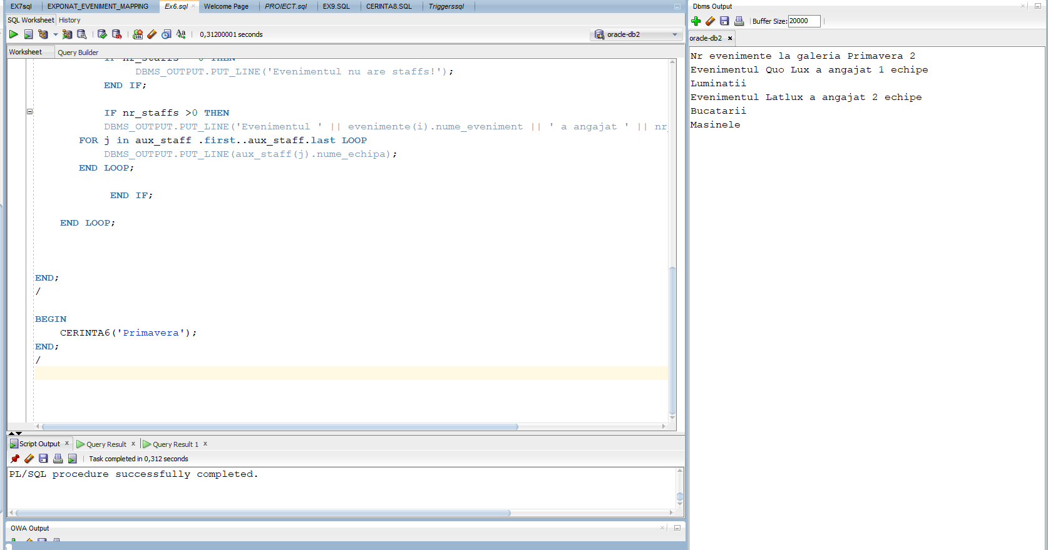

**Cerinta 7**

--Sa se afiseze galeriile, evenimentele acelei galerii si exponatele ce apar la

--galerie a unui oras

CREATE OR REPLACE PROCEDURE CERINTA7(numeor ORAS.nume_oras%type)

AS

CURSOR GALERII IS

SELECT *

FROM galerie

WHERE id_oras = (

SELECT id_oras

FROM ORAS

WHERE upper(nume_oras) LIKE upper(numeor)

);

CURSOR events(galerieid GALERIE.id_galerie%type) IS

SELECT nume_eveniment, id_eveniment

FROM EVENIMENT

WHERE id_galerie = galerieid ;

CURSOR arts(idev EVENIMENT.id_eveniment%type) IS

SELECT nume_exponat || ' About: '|| descriere

FROM EXPONAT_EVENIMENT_MAPPING eem

INNER JOIN EXPONAT E

ON E.id_exponat = eem.id_exponat

WHERE eem.id_eveniment = idev;

den eveniment.nume_eveniment%TYPE;

evid eveniment.nume_eveniment%TYPE;

text VARCHAR2(250);

BEGIN

for i in galerii

LOOP

DBMS_OUTPUT.PUT_LINE('Galeria ' || i.nume_galerie);

for j in events(i.id_galerie) LOOP

DBMS_OUTPUT.PUT_LINE('Eveniment ' || j.nume_eveniment);

OPEN arts(j.id_eveniment);

LOOP

FETCH arts INTO text;

EXIT WHEN arts%NOTFOUND;

DBMS_OUTPUT.PUT_LINE(' ' || text);

END LOOP;

CLOSE arts;

END LOOP;

DBMS_OUTPUT.PUT_LINE('____________________');

END LOOP;

END;

/

BEGIN

CERINTA7('Bucuresti');

END;

/

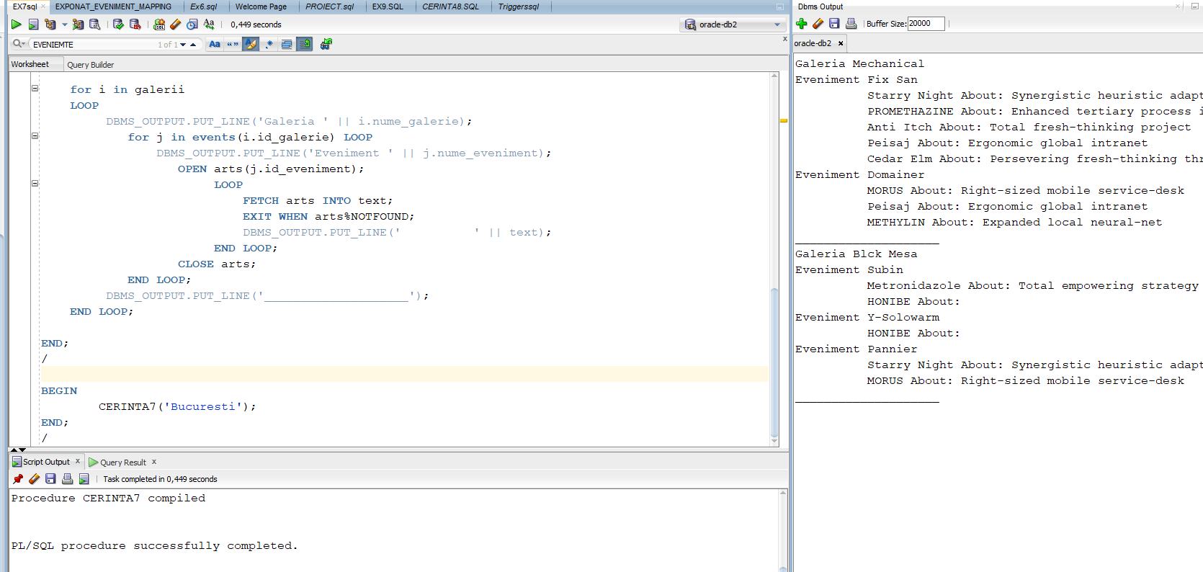

**CERINTA 8**

--pentru fiecare galerie sa sa calculeze profitul acesta fiind diferenta dintre donatiile primite si suma salariilor staffului

CREATE OR REPLACE FUNCTION CERINTA8(numegal galerie.nume_galerie%type) RETURN NUMBER

IS

donatii NUMBER;

datorii NUMBER;

profit NUMBER;

TYPE tabl_indx IS TABLE OF GALERIE%ROWTYPE INDEX BY PLS_INTEGER;

aux tabl_indx;

TYPE tabl_indx_sps IS TABLE OF GALERIE_SPONSOR_MAPPING%ROWTYPE INDEX BY PLS_INTEGER;

aux_sps tabl_indx_sps;

TYPE tabl_indx_ang IS TABLE OF ANGAJAT%ROWTYPE INDEX BY PLS_INTEGER;

aux_ang tabl_indx_ang;

NO_DATA_FOUND_GAL EXCEPTION;

NO_DATA_FOUND_DATORIE EXCEPTION;

TOO_MANY_ROWS EXCEPTION;

BEGIN

donatii:=0;

datorii:=0;

SELECT *

BULK COLLECT INTO aux

from GALERIE

WHERE numegal = galerie.nume_galerie;

IF SQL%NOTFOUND THEN

RAISE NO_DATA_FOUND_GAL;

END IF;

IF aux.count>1 THEN

RAISE TOO_MANY_ROWS;

END IF;

--DONATIILE

SELECT gsm.id_galerie, gsm.id_sponsor, gsm.donatie

BULK COLLECT INTO aux_sps

FROM GALERIE g

INNER JOIN GALERIE_SPONSOR_MAPPING gsm ON g.id_galerie = gsm.id_galerie

WHERE UPPER(g.nume_galerie) LIKE UPPER(numegal);

IF SQL%NOTFOUND THEN

RAISE NO_DATA_FOUND_DATORIE;

END IF;

SELECT sum(donatie)

INTO DONATII

FROM GALERIE g

INNER JOIN GALERIE_SPONSOR_MAPPING gsm ON g.id_galerie = gsm.id_galerie

WHERE UPPER(g.nume_galerie) LIKE UPPER(numegal)

group by nume_galerie;

--Salariile

SELECT an.id_angajat,an.nume_angajat, an.prenume_angajat, an.data_nastere, an.salariu, an.cnp, an.id_staff

BULK COLLECT INTO aux_ang

FROM GALERIE g

INNER JOIN EVENIMENT ev ON g.id_galerie = ev.id_galerie

INNER JOIN EVENIMENT_STAFF_MAPPING ESM ON esm.id_eveniment = ev.id_eveniment

INNER join STAFF s on s.id_staff = esm.id_staff

INNER join angajat an on an.id_STAFF = s.id_staff

WHERE UPPER(g.nume_galerie) LIKE UPPER(numegal);

IF SQL%NOTFOUND THEN

datorii:=0;

ELSE

SELECT sum(salariu)

INTO DATORII

FROM GALERIE g

INNER JOIN EVENIMENT ev ON g.id_galerie = ev.id_galerie

INNER JOIN EVENIMENT_STAFF_MAPPING ESM ON esm.id_eveniment = ev.id_eveniment

inner join STAFF s on s.id_staff = esm.id_staff

inner join angajat an on an.id_angajat = s.id_staff

WHERE UPPER(g.nume_galerie) LIKE UPPER(numegal)

GROUP BY nume_galerie;

END IF;

profit:= donatii-datorii;

IF PROFIT < 0 THEN

RAISE NO_DATA_FOUND_DATORIE;

END IF;

DBMS_OUTPUT.PUT_LINE(profit);

return profit;

EXCEPTION

WHEN NO_DATA_FOUND_GAL THEN

DBMS_OUTPUT.PUT_LINE('Nu exista aceasta galerie!');

RETURN -1000;

WHEN NO_DATA_FOUND_DATORIE THEN

DBMS_OUTPUT.PUT_LINE('Nu a realizat niciun profit!');

RETURN -1000;

WHEN TOO_MANY_ROWS THEN

DBMS_OUTPUT.PUT_LINE('Exista mai multe galerii cu acest nume!');

RETURN -1000;

WHEN OTHERS THEN

DBMS_OUTPUT.PUT_LINE('Alta eroare!');

RETURN -1000;

END;

/

DECLARE

aux NUMBER;

BEGIN

aux := CERINTA8('Primavera');

DBMS_OUTPUT.PUT_LINE(aux);

aux := CERINTA8('Bjork');

aux := CERINTA8('Datorie');

aux := CERINTA8('Quirkcy');

END;

/

insert into galerie (id_galerie, id_oras, id_coord, nume_galerie) values (9, 1, 1, 'Quirkcy');

insert into galerie (id_galerie, id_oras, id_coord, nume_galerie) values (8, 1, 1, 'Datorie');

insert into EVENIMENT (id_eveniment, id_galerie, nume_eveniment, data_inceput, data_final) values (18, 8, 'Nomooney', '12/06/2014', '24/07/2014');

insert into EVENIMENT_STAFF_MAPPING (id_eveniment, id_staff) values (18, 2);

SELECT * FROM GALERIE

SELECT nume_galerie, sum(salariu) as Datorie FROM GALERIE g

INNER JOIN EVENIMENT ev ON g.id_galerie = ev.id_galerie

INNER JOIN EVENIMENT_STAFF_MAPPING ESM ON esm.id_eveniment = ev.id_eveniment

inner join STAFF s on s.id_staff = esm.id_staff

inner join angajat an on an.id_angajat = s.id_staff

GROUP BY nume_galerie

SELECT nume_galerie, sum(donatie) FROM GALERIE g

INNER JOIN GALERIE_SPONSOR_MAPPING gsm ON g.id_galerie = gsm.id_galerie

group by nume_galerie

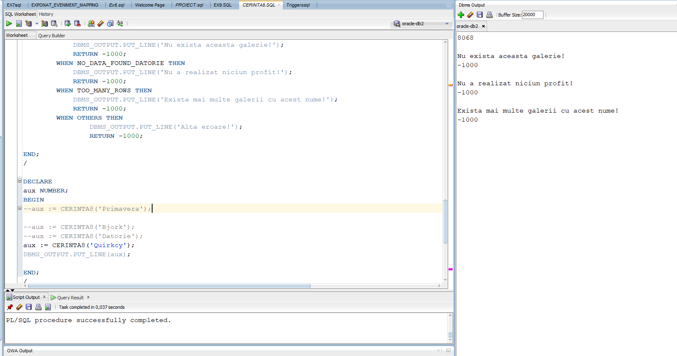

**Cerinta 9**

**--**Sa se afiseze exponatele care se gasesc intr-un oras. Erorile care pot aparea sunt: nu exista orase cu acest nume, nu sunt exponate in oras si sunt mai multe orase cu acelasi nume

CREATE OR REPLACE PROCEDURE CERINT9(numeor oras.nume_oras%type)

AS

TYPE tab_indx_exp IS TABLE OF EXPONAT%ROWTYPE INDEX BY PLS_INTEGER;

exponate tab_indx_exp;

TYPE tab_indx_orase IS TABLE OF ORAS%ROWTYPE INDEX BY PLS_INTEGER;

orase tab_indx_orase;

NO_DATA_FOUND_ORAS EXCEPTION;

NO_DATA_FOUND_EXPONATE EXCEPTION;

TOO_MANY_ROWS EXCEPTION;

BEGIN

SELECT *

BULK COLLECT INTO orase

FROM oras

WHERE UPPER(nume_oras) LIKE UPPER(numeor);

IF SQL%NOTFOUND THEN

RAISE NO_DATA_FOUND_ORAS;

END IF;

IF orase.count >=2 THEN

RAISE TOO_MANY_ROWS;

END IF;

SELECT DISTINCT ex.id_exponat,ex.NUME_EXPONAT, ex.data_publicare, ex.descriere

BULK COLLECT INTO exponate

FROM ORAS o

INNER JOIN GALERIE g on g.id_oras = o.id_oras

inner join EVENIMENT ev on g.id_galerie = ev.id_galerie

inner join EXPONAT_EVENIMENT_MAPPING eem on ev.id_eveniment = eem.id_eveniment

inner join exponat ex on ex.id_exponat = eem.id_exponat

inner join EXPONAT_AUTOR_MAPPING eam on eam.id_exponat=ex.id_exponat

INNER join autor a on eam.id_autor = a.id_autor

WHERE a.data_deces IS NULL AND nume_oras like numeor;

--DBMS_OUTPUT.PUT_LINE(exponate.count);

IF exponate.count = 0 THEN

RAISE NO_DATA_FOUND_EXPONATE;

END IF;

DBMS_OUTPUT.PUT_LINE('In orasul '||numeor || ' sunt exponatele:');

FOR i in exponate.first..exponate.last LOOP

DBMS_OUTPUT.PUT_LINE(exponate(i).nume_exponat);

END LOOP;

EXCEPTION

WHEN NO_DATA_FOUND_ORAS THEN

DBMS_OUTPUT.PUT_LINE('Nu exista acest oras!');

WHEN NO_DATA_FOUND_EXPONATE THEN

DBMS_OUTPUT.PUT_LINE('Nu sunt astfel de exponate in oras!');

WHEN TOO_MANY_ROWS THEN

DBMS_OUTPUT.PUT_LINE('Exista mai multe orase cu acest nume!');

WHEN OTHERS THEN

DBMS_OUTPUT.PUT_LINE('Alta eroare!');

END;

/

BEGIN

--CERINT9('Paris');

--CERINT9('Budapesta');

--CERINT9('Constanta');

CERINT9('Husi');

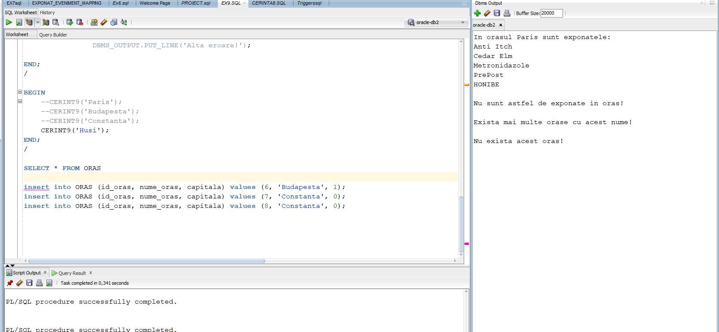END;

**Cerinta 10**

--Am facut un trigger care nu permite inserarea in tabela oras in zilele de vara sau zilele de 13

CREATE OR REPLACE TRIGGER CERINTA10

BEFORE INSERT OR UPDATE OR DELETE ON ORAS

BEGIN

IF(TO_CHAR(SYSDATE,'DD') LIKE '13' OR TO_CHAR(SYSDATE,'MM') LIKE '07' OR TO_CHAR(SYSDATE,'MM') LIKE '08' OR TO_CHAR(SYSDATE,'MM') LIKE '06') THEN

RAISE_APPLICATION_ERROR(-20001, 'Zi cu ghinion, nu se lucreaza!');

END IF;

END;

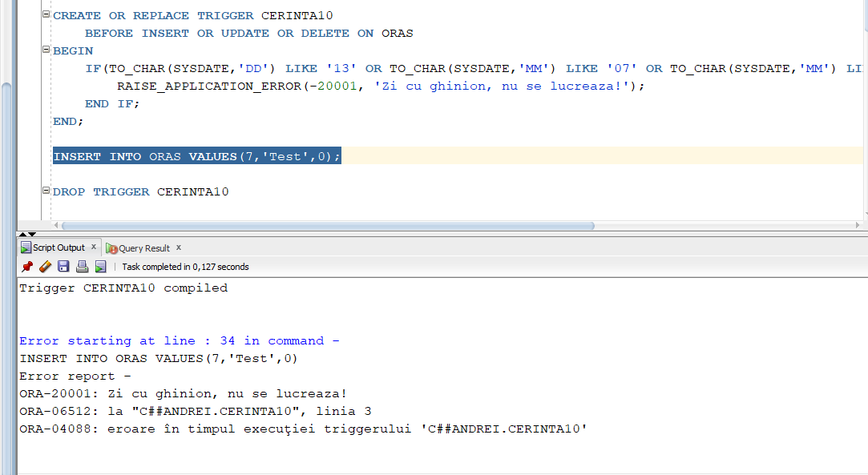

**Cerinta 11**

--Am creat un trigger care nu permite scaderea salariului

CREATE OR REPLACE TRIGGER CERINTA11

AFTER UPDATE OF SALARIU ON ANGAJAT

FOR EACH ROW

BEGIN

IF(:NEW.salariu < :OLD.salariu) THEN

RAISE_APPLICATION_ERROR (-20001, 'Salariul nu poate fi mai mic decat cel vechi!');

END IF;

END;

/

UPDATE ANGAJAT

SET SALARIU = 1

WHERE id_angajat=1;

DROP TRIGGER CERINTA11

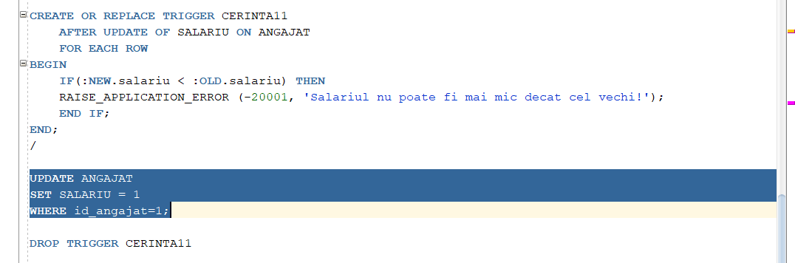

**Cerinta 12**

CREATE TABLE utiliz(

nume_utilizator VARCHAR2(255),

nume_bd VARCHAR(255),

eveniment VARCHAR2(255),

nume_target VARCHAR(255),

data DATE

);

CREATE OR REPLACE TRIGGER CERINTA12

AFTER CREATE OR DROP OR ALTER ON SCHEMA

BEGIN

INSERT INTO utiliz

values(SYS.LOGIN_USER, SYS.DATABASE_NAME,SYS.SYSEVENT,SYS.DICTIONARY_OBJ_NAME, SYSDATE);

END;

/

CREATE TABLE tabela_temp(ind NUMBER(4));

ALTER TABLE tabela_temp ADD(nume VARCHAR2(20));

SELECT * FROM UTILIZ;

DROP TRIGGER CERINTA12;

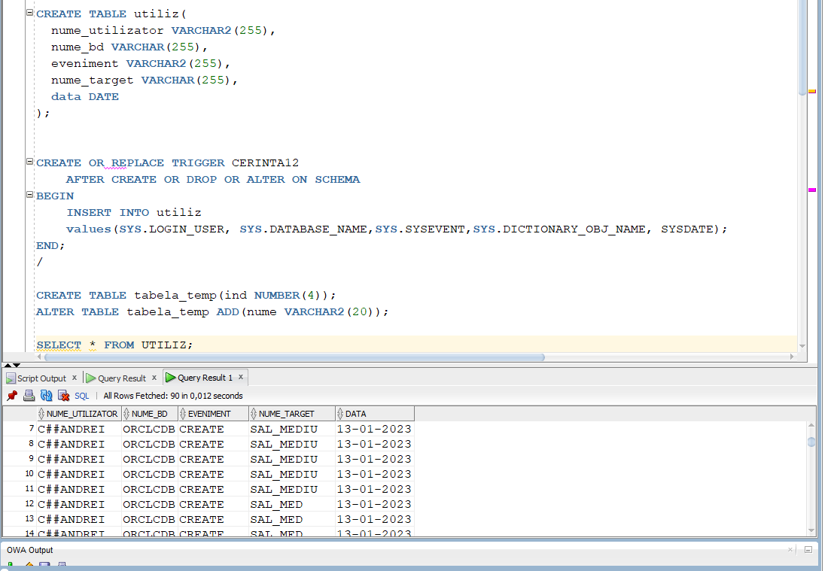

**Cerinta 13**

**CREATE OR REPLACE PACKAGE proiect_complet AS**

**PROCEDURE CERINTA6 (numegale GALERIE.nume_galerie%type);**

**PROCEDURE CERINTA7(numeor ORAS.nume_oras%type);**

**FUNCTION CERINTA8(numegal galerie.nume_galerie%type) RETURN NUMBER;**

**PROCEDURE CERINT9(numeor oras.nume_oras%type);**

**END proiect_complet;**

**/**

**CREATE OR REPLACE PACKAGE BODY proiect_complet**

**AS**

**PROCEDURE CERINTA6 (numegale GALERIE.nume_galerie%type)**

**AS**

**TYPE tab_indx IS TABLE OF EVENIMENT%ROWTYPE INDEX BY PLS_INTEGER;**

**evenimente tab_indx;**

**TYPE lista_nested IS TABLE OF STAFF%rowtype;**

**aux_staff lista_nested := lista_nested();**

**nr NUMBER;**

**nr_staffs NUMBER;**

**BEGIN**

**SELECT e.id_eveniment,e.id_galerie, e.nume_eveniment, e.data_inceput, e.data_final**

**BULK COLLECT INTO evenimente**

**FROM EVENIMENT e, GALERIE g**

**WHERE e.id_galerie = g.id_galerie AND UPPER(g.nume_galerie) LIKE UPPER(numegale) ;**

**SELECT COUNT(*)**

**INTO nr**

**FROM EVENIMENT e, GALERIE g**

**WHERE e.id_galerie = g.id_galerie AND UPPER(g.nume_galerie) LIKE UPPER(numegale)**

**GROUP BY g.id_galerie;**

**DBMS_OUTPUT.PUT_LINE('Nr evenimente la galeria '|| numegale || ' ' || nr);**

**FOR i in evenimente.first..evenimente.last LOOP**

**SELECT s.id_staff, s.nume_echipa, s.rol_staff**

**BULK COLLECT INTO aux_staff**

**FROM EVENIMENT_STAFF_MAPPING esm, EVENIMENT e, STAFF s**

**WHERE s.id_staff = esm.id_staff AND esm.id_eveniment = e.id_eveniment AND e.id_eveniment = evenimente(i).id_eveniment;**

**--DBMS_OUTPUT.PUT_LINE(aux_staff.count);**

**nr_staffs := aux_staff.count;**

**IF nr_staffs = 0 THEN**

**DBMS_OUTPUT.PUT_LINE('Evenimentul nu are staffs!');**

**END IF;**

**IF nr_staffs >0 THEN**

**DBMS_OUTPUT.PUT_LINE('Evenimentul ' || evenimente(i).nume_eveniment || ' a angajat ' || nr_staffs || ' echipe');**

**FOR j in aux_staff .first..aux_staff.last LOOP**

**DBMS_OUTPUT.PUT_LINE(aux_staff(j).nume_echipa);**

**END LOOP;**

**END IF;**

**END LOOP;**

**END CERINTA6;**

**PROCEDURE CERINTA7(numeor ORAS.nume_oras%type)**

**AS**

**CURSOR GALERII IS**

**SELECT \***

**FROM galerie**

**WHERE id_oras = (**

**SELECT id_oras**

**FROM ORAS**

**WHERE upper(nume_oras) LIKE upper(numeor)**

**);**

**CURSOR events(galerieid GALERIE.id_galerie%type) IS**

**SELECT nume_eveniment, id_eveniment**

**FROM EVENIMENT**

**WHERE id_galerie = galerieid ;**

**CURSOR arts(idev EVENIMENT.id_eveniment%type) IS**

**SELECT nume_exponat || ' About: '|| descriere**

**FROM EXPONAT_EVENIMENT_MAPPING eem**

**INNER JOIN EXPONAT E**

**ON E.id_exponat = eem.id_exponat**

**WHERE eem.id_eveniment = idev;**

**den eveniment.nume_eveniment%TYPE;**

**evid eveniment.nume_eveniment%TYPE;**

**text VARCHAR2(250);**

**BEGIN**

**for i in galerii**

**LOOP**

**DBMS_OUTPUT.PUT_LINE('Galeria ' || i.nume_galerie);**

**for j in events(i.id_galerie) LOOP**

**DBMS_OUTPUT.PUT_LINE('Eveniment ' || j.nume_eveniment);**

**OPEN arts(j.id_eveniment);**

**LOOP**

**FETCH arts INTO text;**

**EXIT WHEN arts%NOTFOUND;**

**DBMS_OUTPUT.PUT_LINE(' ' || text);**

**END LOOP;**

**CLOSE arts;**

**END LOOP;**

**DBMS_OUTPUT.PUT_LINE('____________________');**

**END LOOP;**

**END CERINTA7;**

**FUNCTION CERINTA8(numegal galerie.nume_galerie%type) RETURN NUMBER**

**IS**

**donatii NUMBER;**

**datorii NUMBER;**

**profit NUMBER;**

**TYPE tabl_indx IS TABLE OF GALERIE%ROWTYPE INDEX BY PLS_INTEGER;**

**aux tabl_indx;**

**TYPE tabl_indx_sps IS TABLE OF GALERIE_SPONSOR_MAPPING%ROWTYPE INDEX BY PLS_INTEGER;**

**aux_sps tabl_indx_sps;**

**TYPE tabl_indx_ang IS TABLE OF ANGAJAT%ROWTYPE INDEX BY PLS_INTEGER;**

**aux_ang tabl_indx_ang;**

**NO_DATA_FOUND_GAL EXCEPTION;**

**NO_DATA_FOUND_DATORIE EXCEPTION;**

**TOO_MANY_ROWS EXCEPTION;**

**BEGIN**

**donatii:=0;**

**datorii:=0;**

**SELECT \***

**BULK COLLECT INTO aux**

**from GALERIE**

**WHERE numegal = galerie.nume_galerie;**

**IF SQL%NOTFOUND THEN**

**RAISE NO_DATA_FOUND_GAL;**

**END IF;**

**IF aux.count>1 THEN**

**RAISE TOO_MANY_ROWS;**

**END IF;**

**--DONATIILE**

**SELECT gsm.id_galerie, gsm.id_sponsor, gsm.donatie**

**BULK COLLECT INTO aux_sps**

**FROM GALERIE g**

**INNER JOIN GALERIE_SPONSOR_MAPPING gsm ON g.id_galerie = gsm.id_galerie**

**WHERE UPPER(g.nume_galerie) LIKE UPPER(numegal);**

**IF SQL%NOTFOUND THEN**

**RAISE NO_DATA_FOUND_DATORIE;**

**END IF;**

**SELECT sum(donatie)**

**INTO DONATII**

**FROM GALERIE g**

**INNER JOIN GALERIE_SPONSOR_MAPPING gsm ON g.id_galerie = gsm.id_galerie**

**WHERE UPPER(g.nume_galerie) LIKE UPPER(numegal)**

**group by nume_galerie;**

**--Salariile**

**SELECT an.id_angajat,an.nume_angajat, an.prenume_angajat, an.data_nastere, an.salariu, an.cnp, an.id_staff**

**BULK COLLECT INTO aux_ang**

**FROM GALERIE g**

**INNER JOIN EVENIMENT ev ON g.id_galerie = ev.id_galerie**

**INNER JOIN EVENIMENT_STAFF_MAPPING ESM ON esm.id_eveniment = ev.id_eveniment**

**INNER join STAFF s on s.id_staff = esm.id_staff**

**INNER join angajat an on an.id_STAFF = s.id_staff**

**WHERE UPPER(g.nume_galerie) LIKE UPPER(numegal);**

**IF SQL%NOTFOUND THEN**

**datorii:=0;**

**ELSE**

**SELECT sum(salariu)**

**INTO DATORII**

**FROM GALERIE g**

**INNER JOIN EVENIMENT ev ON g.id_galerie = ev.id_galerie**

**INNER JOIN EVENIMENT_STAFF_MAPPING ESM ON esm.id_eveniment = ev.id_eveniment**

**inner join STAFF s on s.id_staff = esm.id_staff**

**inner join angajat an on an.id_angajat = s.id_staff**

**WHERE UPPER(g.nume_galerie) LIKE UPPER(numegal)**

**GROUP BY nume_galerie;**

**END IF;**

**profit:= donatii-datorii;**

**IF PROFIT < 0 THEN**

**RAISE NO_DATA_FOUND_DATORIE;**

**END IF;**

**DBMS_OUTPUT.PUT_LINE(profit);**

**return profit;**

**EXCEPTION**

**WHEN NO_DATA_FOUND_GAL THEN**

**DBMS_OUTPUT.PUT_LINE('Nu exista aceasta galerie!');**

**RETURN -1000;**

**WHEN NO_DATA_FOUND_DATORIE THEN**

**DBMS_OUTPUT.PUT_LINE('Nu a realizat niciun profit!');**

**RETURN -1000;**

**WHEN TOO_MANY_ROWS THEN**

**DBMS_OUTPUT.PUT_LINE('Exista mai multe galerii cu acest nume!');**

**RETURN -1000;**

**WHEN OTHERS THEN**

**DBMS_OUTPUT.PUT_LINE('Alta eroare!');**

**RETURN -1000;**

**END CERINTA8;**

**PROCEDURE CERINT9(numeor oras.nume_oras%type)**

**AS**

**TYPE tab_indx_exp IS TABLE OF EXPONAT%ROWTYPE INDEX BY PLS_INTEGER;**

**exponate tab_indx_exp;**

**TYPE tab_indx_orase IS TABLE OF ORAS%ROWTYPE INDEX BY PLS_INTEGER;**

**orase tab_indx_orase;**

**NO_DATA_FOUND_ORAS EXCEPTION;**

**NO_DATA_FOUND_EXPONATE EXCEPTION;**

**TOO_MANY_ROWS EXCEPTION;**

**BEGIN**

**SELECT \***

**BULK COLLECT INTO orase**

**FROM oras**

**WHERE UPPER(nume_oras) LIKE UPPER(numeor);**

**IF SQL%NOTFOUND THEN**

**RAISE NO_DATA_FOUND_ORAS;**

**END IF;**

**IF orase.count >=2 THEN**

**RAISE TOO_MANY_ROWS;**

**END IF;**

**SELECT DISTINCT ex.id_exponat,ex.NUME_EXPONAT, ex.data_publicare, ex.descriere**

**BULK COLLECT INTO exponate**

**FROM ORAS o**

**INNER JOIN GALERIE g on g.id_oras = o.id_oras**

**inner join EVENIMENT ev on g.id_galerie = ev.id_galerie**

**inner join EXPONAT_EVENIMENT_MAPPING eem on ev.id_eveniment = eem.id_eveniment**

**inner join exponat ex on ex.id_exponat = eem.id_exponat**

**inner join EXPONAT_AUTOR_MAPPING eam on eam.id_exponat=ex.id_exponat**

**INNER join autor a on eam.id_autor = a.id_autor**

**WHERE a.data_deces IS NULL AND nume_oras like numeor;**

**--DBMS_OUTPUT.PUT_LINE(exponate.count);**

**IF exponate.count = 0 THEN**

**RAISE NO_DATA_FOUND_EXPONATE;**

**END IF;**

**DBMS_OUTPUT.PUT_LINE('In orasul '||numeor || ' sunt exponatele:');**

**FOR i in exponate.first..exponate.last LOOP**

**DBMS_OUTPUT.PUT_LINE(exponate(i).nume_exponat);**

**END LOOP;**

**EXCEPTION**

**WHEN NO_DATA_FOUND_ORAS THEN**

**DBMS_OUTPUT.PUT_LINE('Nu exista acest oras!');**

**WHEN NO_DATA_FOUND_EXPONATE THEN**

**DBMS_OUTPUT.PUT_LINE('Nu sunt astfel de exponate in oras!');**

**WHEN TOO_MANY_ROWS THEN**

**DBMS_OUTPUT.PUT_LINE('Exista mai multe orase cu acest nume!');**

**WHEN OTHERS THEN**

**DBMS_OUTPUT.PUT_LINE('Alta eroare!');**

**END CERINT9;**

**END proiect_complet;**

**/**

**--testam pachetul**

**EXECUTE proiect_complet.CERINTA6('Primavera');**

**EXECUTE proiect_complet.CERINTA7('Bucuresti');**

**BEGIN**

**DBMS_OUTPUT.PUT_LINE('Cerinta 8: ' || CERINTA8('Primavera'));**

**END;**

**EXECUTE proiect_complet.CERINT9('Paris');**

