

### SOFTWARE INSTALLATION INSTRUCTIONS v1

(For V.7.21 – Updates in Progress)

### 1/26/16

# Table of contents

download and uncompress files 3

install software **Error! Bookmark not defined.**4

install license 6

opening a .piz file 8

# Download and un-compress files

Your software package and license(s) will be sent in an email.

1. Download files from email.
2. There should be two files: a .zip file and a .lic file located in the Downloads folder on your hard drive:

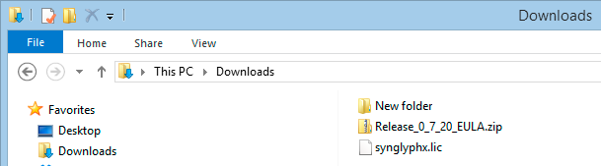

## unzip the file

1. If you received a .piz file instead of a .zip, see the **Opening a .piz File** section of this manual for instructions on changing the file type. Once the file is in .zip format return here.
2. Double-click on the .zip file, and click on **Extract** to un-compress the installation setup file:

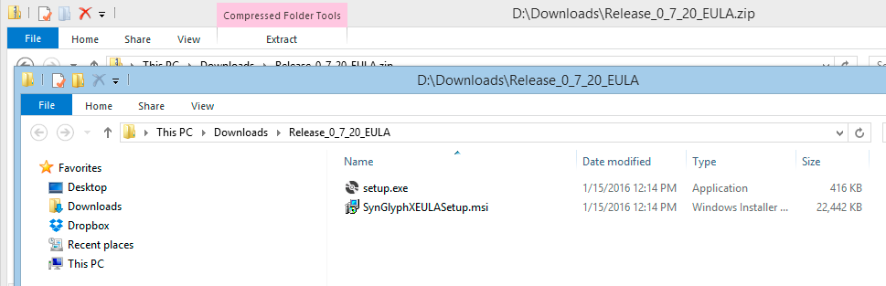

# INSTALL SOFTWARE

1. Double-click the **SynGlyphXEULASetup.msi** file:

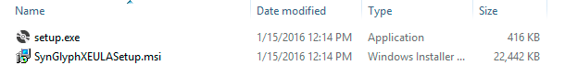

1. Click **Run** to install software:

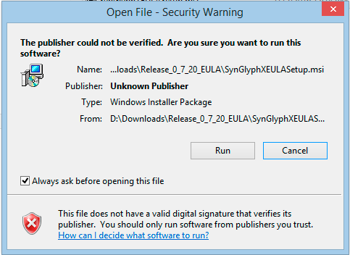

1. Select a new installation folder with **Browse** or leave the default:

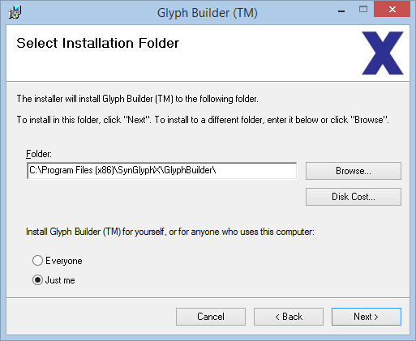

1. Click **Next** to start installation:

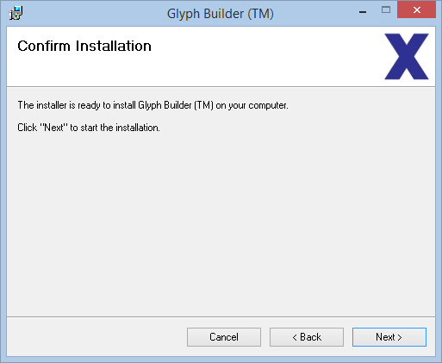

1. Click **I Agree** to the EULA after reading and then **Next** to finish installation:

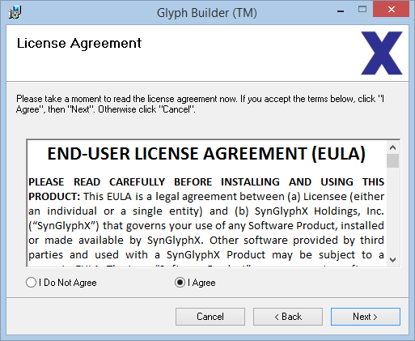

# INSTALL LICENSE

1. Download the license file you received from SynGlyphX to your hard drive that (if you have not already):
2. Double click on any one of the shortcut icons located on desktop to launch the software:

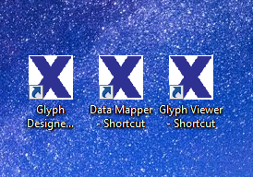

1. The **Licensing Status** dialog box will come up:

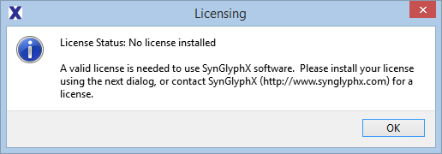

1. Click **OK**
2. Click on the **Install New License File** button located on the lower left on this dialog box:

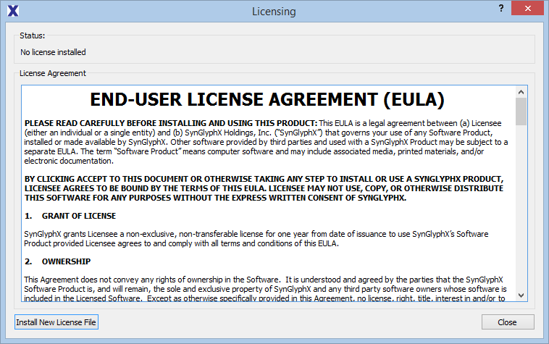

1. Find a license file on your hard drive. Click **Open**, and the software program will launch:

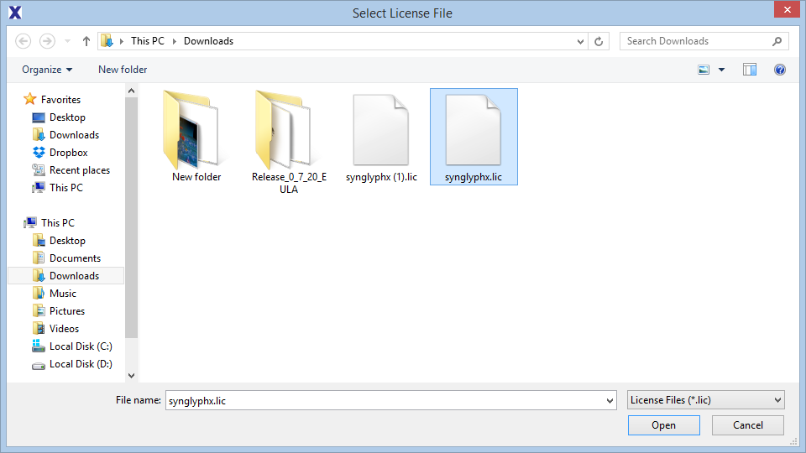

1. Installation should be complete.

# open a .piz file

1. Change the .piz file name to .zip:

In order to send an executable file (.exe) through an email program, the file needs to be compressed into a .zip file. Sometimes email services will block .zip files in their malware filter. Because of this restriction, you will often receive your software program from SynGlyphX with the file extension changed to .piz.

If file extensions are turned on, simply click on the file name and change .piz to .zip:



## If you can’t see the file extension .zip or .piz

1. Go to CONTROL PANEL / FOLDER OPTIONS and click off the **Hide extensions for known file types** option:

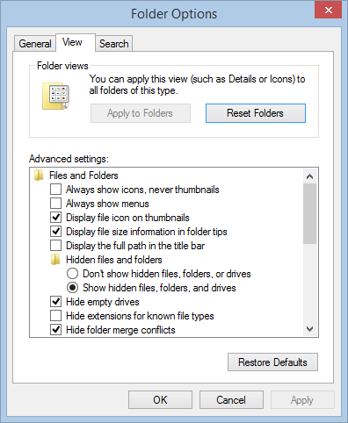

## Change .piz to .zip

1. Right click on the **.piz file** to open up dialog box. Click **RENAME**.

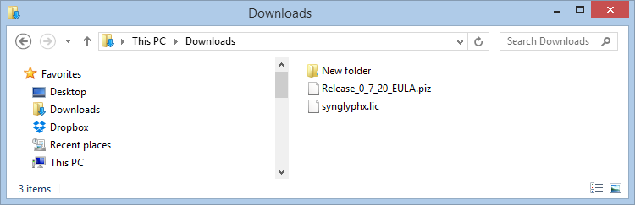

1. Change the **.piz to .zip**. Do not forget the dot! A warning dialog box will pop up. Click **YES**.

