Artificial Intelligence for Games (Game Engines 2)
Space Battle Recreation:
Serenity – Firefly, Reaver and Alliance Battle
Project Proposal & Script

Mark Corrigan
C06026648

Solo Project
DIT (Dublin Institute of Technology)

Submitted to -
Bryan Duggan
Lecturer of Games Programming

Statement of Problem
For this Project we are tasked with reproducing a Space Battle from a TV Series or a Movie of our Choosing. I have decided to recreate the Battle from the Movie “Serenity”.

Scene includes Numerous Ships the main being “Serenity” herself who is leading a fleet of Reaver Ships towards a Battle with unsuspecting Alliance Troops who believe they have Serenity captured and caught off guard as they lie in wait unaware of what is coming.

Design Objectives
With this project there are a number of Objective that I will need to achieve and some which are already completed as requested:
(1) Firstly – We were required to acquire the Models needed for the Scene (Either by Downloading them or Making them).
(2) Secondly – We needed to set up our chosen scene in a Unity Project.
(3) Third – Over the Easter Break we have to Program the Ships by writing numerous AI Scripts that will make the ships reenact the scene properly.
A reason that we were required to acquire the Models and set up the Scene beforehand is that it is time consuming and this gets it out of the way so that our time is Strictly dedicated to writing the Scripts required for the Project.

Technical Approach
I have completed steps one and two of the Design by finding models of the Ships online and I also had to create one or two of them as I couldn’t find them online.
For the main part of this Project which is the Programming, I will need to write a number of different codes which will achieve actions required for the Scene such as:
- Seek
- Flee
- Arrive
- Evade
- Movement
- Swarming
We have covered all of the above scripts in class but I will also need reproduce them as well as create new Scripts to add in extra each ship so that they behave properly, they will require their own individual script as well as having shared scripts as some of them might be chasing the same enemy or seeking a set destination.
Selecting Design Concept

The reason I chose to recreate this Scene is a number of Reasons. Firstly and probably most importantly is that Firefly is one of my favourite TV shows and I feel that the Battle that is in the Follow up Movie “Serenity” is the best way to utilize all the Scripts that we have learned.

Deliverables
For this project there are a number of Deliverables. Some of which are accompanying this Document, they include a Unity Project with the required Models in a scene with a Skybox which can be seen below: And a script of the Events that will take place within your Scene which is at the End of this Document.
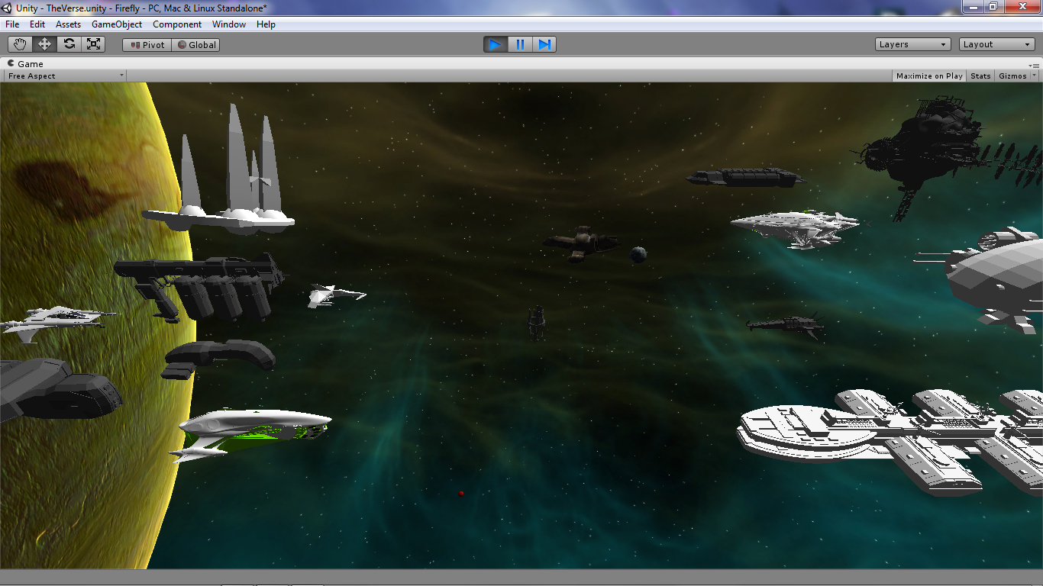
Then the final Deliverable will be a Unity Scene that will be as close as I can possibly get to re-creating the Scene from the Movie which is to be fully automated with AI Scripts and there may also be a report requested to accompany it (as of yet unspecified).
SCRIPT

Beginning
The Scene will begin with a camera pointing towards the left hand side of a fleet of Alliance Ships(Blue Ships) who are positioned between a Planet and a Blue Tinted Cosmic Cloud. They are Lying in wait in front of the Planet for what they believe to be the unsuspecting Crew of the Serenity.
The Camera will move from a side view to a Position behind the fleet of ships and then switch to a Camera that represents the Lead Ships View Screen.
There are numerous Cameras that the player can switch between to get a great view.
Next Step
The Camera will stay focused on the Cloud until after a few seconds Serenity will Burst through the Cloud appearing to be alone.
Serenity will appear barely visible and the Camera will zoom in towards it.
When the camera gets to about half way between Serenity and the Fleet of Ships the Camera will stop and zoom back out as a Fleet of Reaver Ships Suddenly begin to appear from the Cloud in hot pursuit of Serenity.
Next Step
As soon as the Reaver Ships appear the Alliance Ships will break formation and begin to attack the Reavers. The Reavers will also break up and attack random ships except for Serenity who is being pursued by a leader Reaver Ship the entire time.
In the background numerous ships will be attacking, seeking and evading each other while trying to destroy each other.
Next Step
Serenity will be seeking a certain point on the Planet but to reach it it will need to maneuver in and around any ship that get in its way while evading fire from the Reaver Ship that is in Pursuit.
The fleets of ships will now be in heated battle. Serenity will encounter certain ships that are going to explode (I will achieve this by instantiating explosions) when Serenity gets within a certain distance of the desired ship.
Serenity will either fly through an explosion or Sway around it.
Next Step
A large ship will also move into Serenity’s path blocking it. The Ship will then Pitch upwards to avoid it.
After reaching the top most point of the large ship Serenity will do a Complete Loop and rotate returning to a level flight and begin again to fly towards her desired destination all the Time being followed by the Lead Reaver ship.
Next Step
Just as Serenity reaches her destination the pursuing Reaver ship gets off a Shot which sends the Ship Spinning out of Control and Hurtling towards the Planet.
Next Step
When Serenity reaches this point the Scene will Change. It will go to a new Scene where it will show Serenity falling from the Sky towards the Ground. It will be spinning out of Control and losing altitude.
Next Step
After a number of Rotations and when the Ship is almost near the Ground it will regain control.
Next Step
The ship must do a Crash Landing so it will hit a runway and bounce a number of times.
The ship will still be going at the same speed heading towards what looks like a Hangar.
When the ship reaches the Hangar it is still going a quite a speed and when entering it the engines of the Ship will get ripped off and destroyed (I’ll achieve this with a simple Destroy Object on Collision script or perhaps I will instantiate explosions).
Finally
Serenity will then begin to lose speed and slowly rotate to it right around its center for about 180 degrees (facing the entrance of the Hangar) before coming to a complete stop.

Listed Activities in the Scene
During the Scene there will be numerous actions occurring not just in the Main Area but throughout the Scene. In the background the enemy ships will all be fighting/doing their own thing while Serenity is trying to get to her desired Destination. Theses activities will range from and between:
- Ships will be attacking each other
- Ships will be chasing other ships around the Scene
- Ships will be spinning out of Control
- Ships will be Exploding
- Ships will be shooting Lazers/Rockets
- Lights will be flashing
- The Cosmic Cloud will be Flashing and Moving(Interactive Cloth)
- Planets are Rotating
- Objects in Space will be floating around.
- The Player can switch cameras during the Battle for their desired view point.

