PYTHON

**Math Operators from Highest to Lowest Precedence:-**

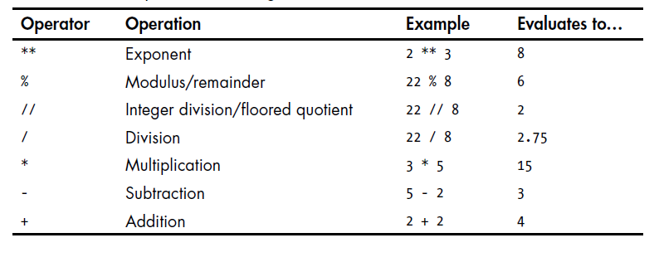

The order of operations (also called precedence) of Python math operators is similar to that of mathematics. The **\*\*** operator is evaluated first, the **\***, /, //, and % operators are evaluated next, from left to right; and the + and - operators are evaluated last (also from left to right). You can use Parentheses to override the usual precedence if you need to.

**The Difference Between the == and = Operators:-**

**•** The **==** operator (equal to) asks whether two values are the same as each other.

• The **=** operator (assignment) puts the value on the right into the variable on the left.