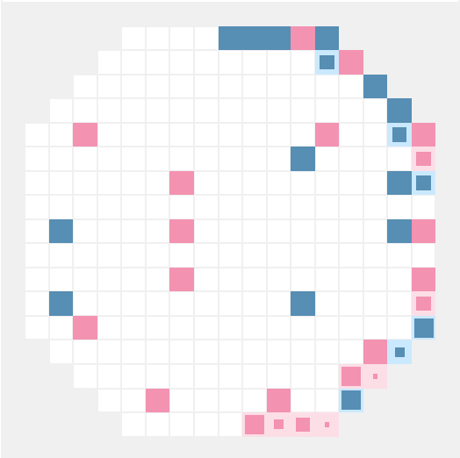
Anton Outkine
The Battle Arena
antonoutkine@gmail.com – antonoutkine.com – github.com/outkine
Freshman at the University of Chicago, self-taught programmer and designer

Personal Projects
I have worked on projects in: Rust, C++, Java, Scala, Elixir, Javascript, Typescript, Lua, OCaml, Python, and Elm. I prefer statically typed functional languages, especially Rust, Scala, and Elm.

Robot Rumble (robotrumble.org, github.com/robot-rumble)
I conceived, designed, and programmed an AI competition website. Players write a program for a team of robots (either red or blue), and then those programs fight one another in 1v1 ranked battles.

The website uses Scala Play and embedded Elm components for dynamic portions. The Play app lives in an AWS ECS instance and uses Akka, SQS, and Lambda to simulate battles. The remote code execution model (which runs JS and Python on the browser, desktop, and Lambda) uses Webassembly and Rust.

In August, my fellow Rust programmer and I successfully ran a tournament of 50 participants and more than 10k battles. Our beta launches in 2021.

Leadership History
Chicago Regional Manager, CodeDay
CodeDay is an overnight competition that happens 3x/year across the U.S. I led a dozen volunteers in promoting and running the Chicago event with over 100 participants. I also gave workshops on Python, Elm, and Reactjs.

Founder and Executive Director, Chicode NFP
I founded a nonprofit that organizes coding events and clubs around Chicago. We worked with the Chicago Public Schools Office of Computer Science to introduce hundreds of students around the city to programming.

Work History
Analytics Intern, Marketing Team, M1 Finance (Chicago)
June-August 2019
I built customer value models in Jupyter Notebook and improved feature usage of various mobile acquisition vendors (like AppsFlyer).

Software Engineering Intern, Art. Lebedev Studio (Moscow, Russia)
July 2017 & July-August 2018
I created a landing page for a work collaboration platform, revived an old Django site for housing large photo collections, and created a Three.js text animation for a government agency.

Education
Class of 2024, University of Chicago (Math and CS double major)
Class of 2020, Northside College Prep High School (4.0 GPA)
Languages: native English and Russian speaker, conversant in Spanish

