Достижения

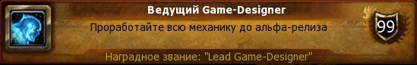

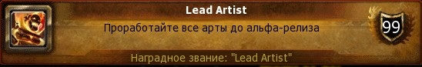

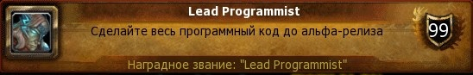

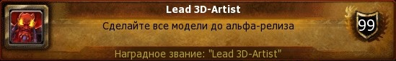

Game design (free)

5 points

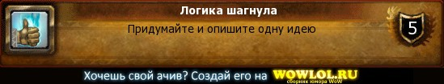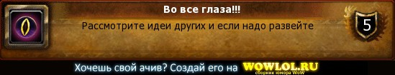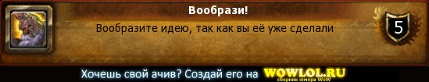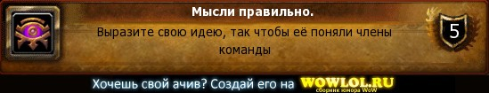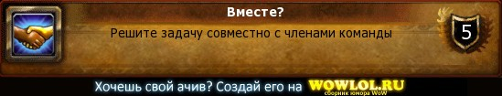

10 points

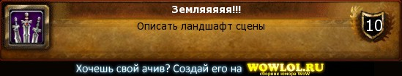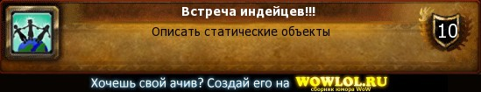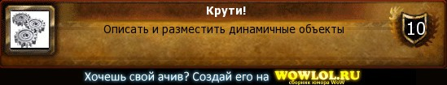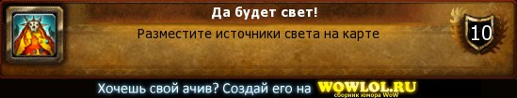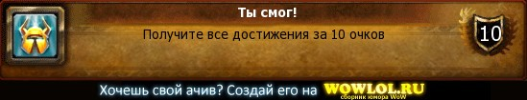

Artist design

5 points

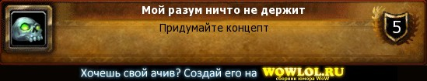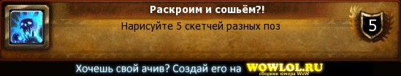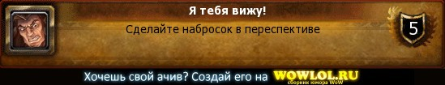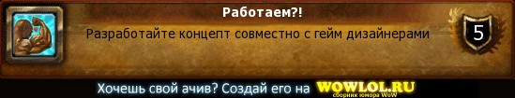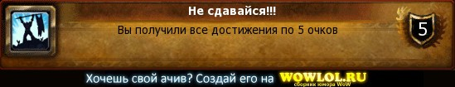

10 points

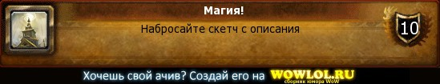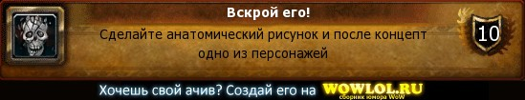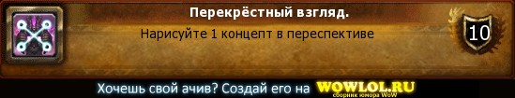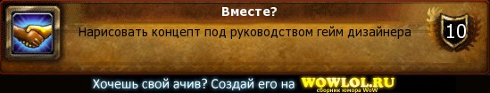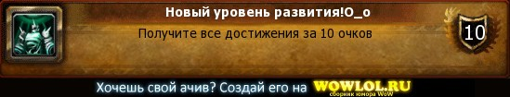

3D design

5 points

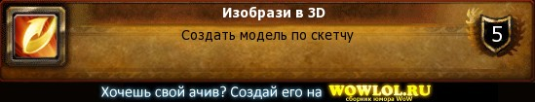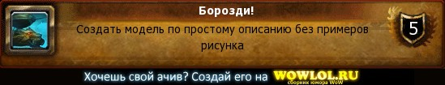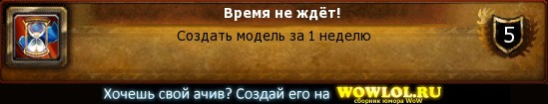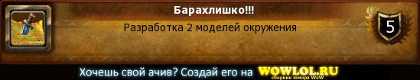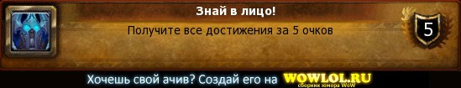

10 points

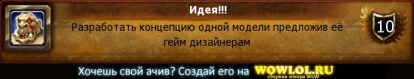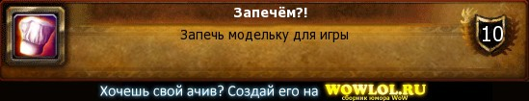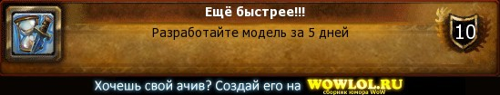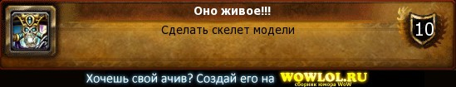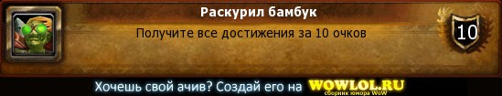

Program code

5 points

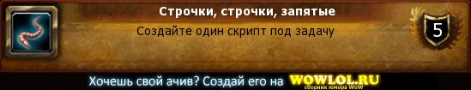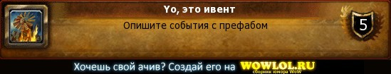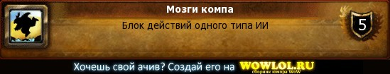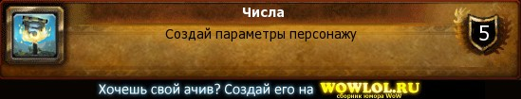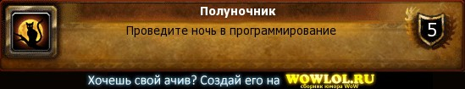

10 points

