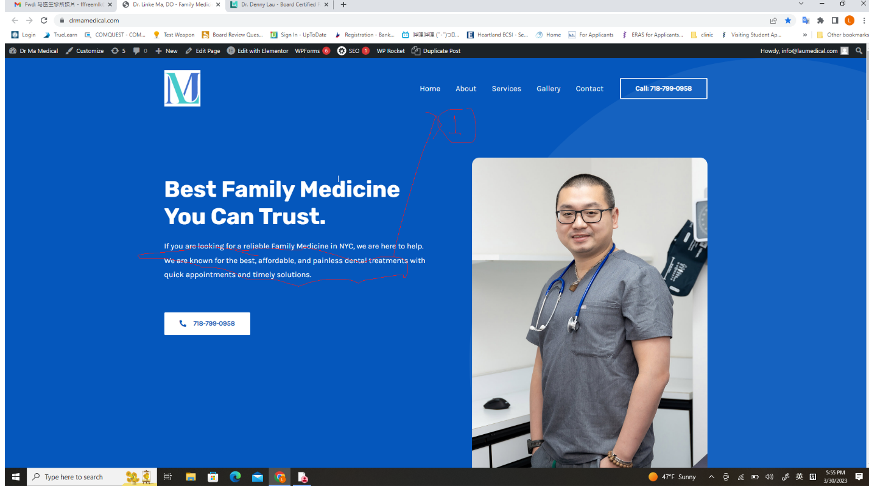
change1 ：

change the title to professional physician that you can trust

If you're searching for a reliable and professional family medicine doctor in NYC, we're here to help. Dr. Linke Ma is a board-certified family medicine physician who earned his Doctor of Osteopathic Medicine degree from Midwestern University - Chicago College of Osteopathic Medicine. He completed his family medicine residency at Northwell Plainview Hospital and has over 11 years of experience in the medical field. Dr. Ma is professional, patient, and knowledgeable. He believes that preventive care and routine check-ups, along with advocating for a healthy lifestyle, are essential for maintaining a healthy and happy life.

如果你正在寻找一位可靠和专业的纽约家庭医生，我们很乐意为您提供帮助。马林可医生是一位获得认证的家庭医学专家，他在中西部大学芝加哥骨科医学院获得了医学博士学位。Northwell Plainview Hospital医院接受家庭医学住院医师培训，并在医学领域拥有超过11年的经验。马医生专业、耐心、知识渊博，他相信预防保健和定期检查，以及倡导健康的生活方式，对于维护健康和幸福的生活至关重要。
Change 2 : 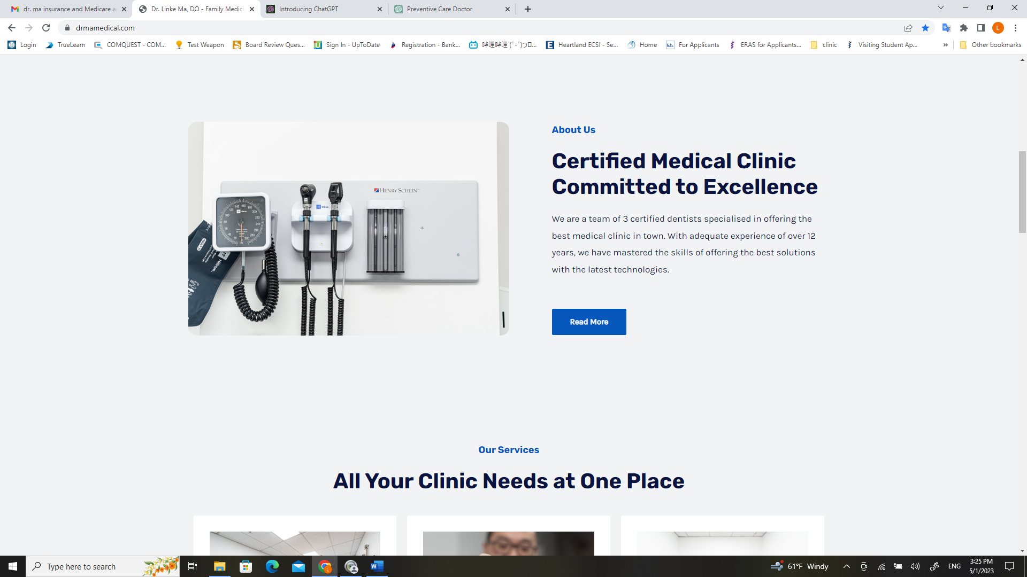

Original:
We are a team of 3 certified dentists specialised in offering the best medical clinic in town. With adequate experience of over 12 years, we have mastered the skills of offering the best solutions with the latest technologies.

Change to
Dr. Ma takes the time to get to know his patients on a personal level, understanding patients' medical history, lifestyle habits, and overall health goals. He prioritizes preventive measures, such as regular check-ups and screenings, to catch potential health issues early and prevent them from developing into more serious conditions. Additionally, Dr. Ma places a strong emphasis on patient education, empowering individuals to take an active role in their own health and wellbeing

马医生会花时间在个人层面上了解他的病人，理解病人的病史、生活习惯和整体健康目标。他优先考虑预防措施，例如定期检查和筛查，以及早期发现潜在的健康问题，防止它们发展成更严重的疾病。此外，马医生非常注重患者教育，鼓励个人积极参与自己的健康和福祉。

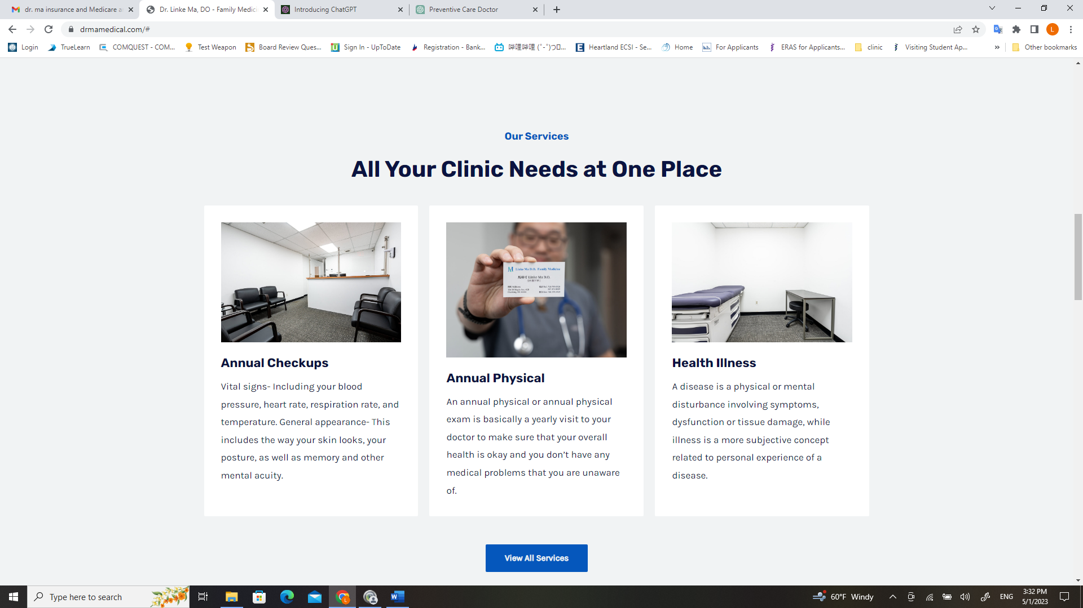
Change 3

Remove annual check ups
Change it to immunization : We provides immunizations ensures that individuals have access to the latest and most effective vaccines

我们提供免疫接种服务，确保个人可以接触到最新、最有效的疫苗

Under the annual physical:
Change the explanation to
During the annual physical visit, Dr. Ma spends time with his patients to conduct a thorough check-up and ensure that they are healthy and on track to meet their health goals. He provides guidance and recommendations for improvement as needed and prioritizes preventive care measures, such as providing immunizations and scheduling appropriate cancer screenings, to catch potential health issues early and prevent them from developing into more serious conditions.

在年度体检期间，马医生花时间对患者进行彻底的检查，确保患者身体健康并达到其健康目标；如有需要，提供建议和指导以改善患者的健康状况。他优先考虑预防性保健措施，例如提供免疫接种和安排适当的癌症筛查，早期发现潜在的健康问题，防止其发展成更严重的疾病。

Please change heath illness:
To sick visit:

During a sick visit, Dr. Ma listens carefully to the patient's symptoms, performs a thorough exam, makes an accurate diagnosis, and develops a personalized treatment plan. He also maintains open and ongoing communication with the patient, monitoring their progress and making adjustments to the treatment plan as needed.

在就诊病人时，马医生仔细聆听患者的症状，进行全面检查，做出准确的诊断，并制定个性化的治疗计划。他还保持与患者的持续沟通，监测其病情进展并调整治疗计划。

Change 4
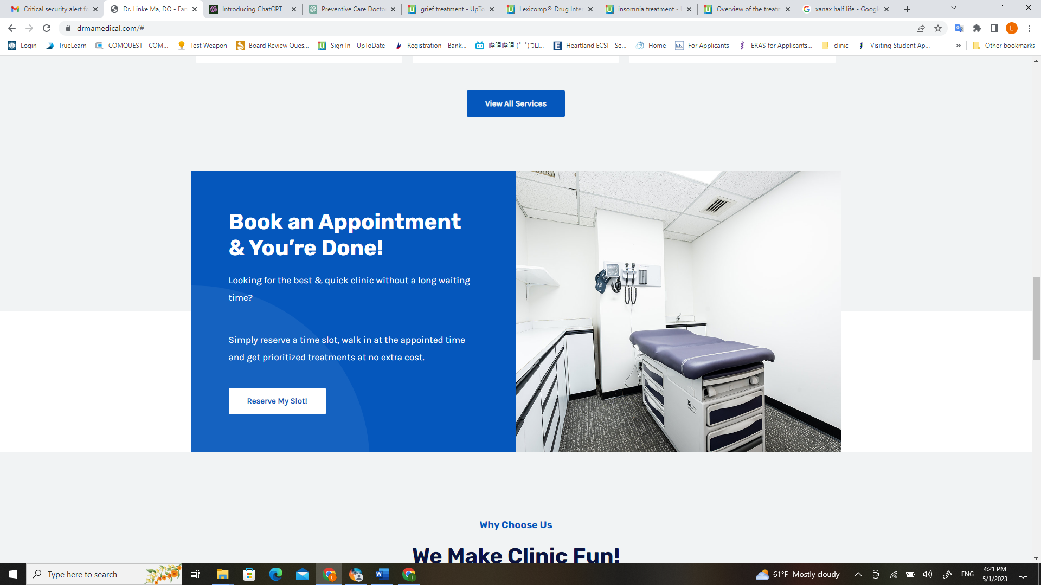

Please change reserve my slot

To make an appointment

And link to zocdoc

Change 6 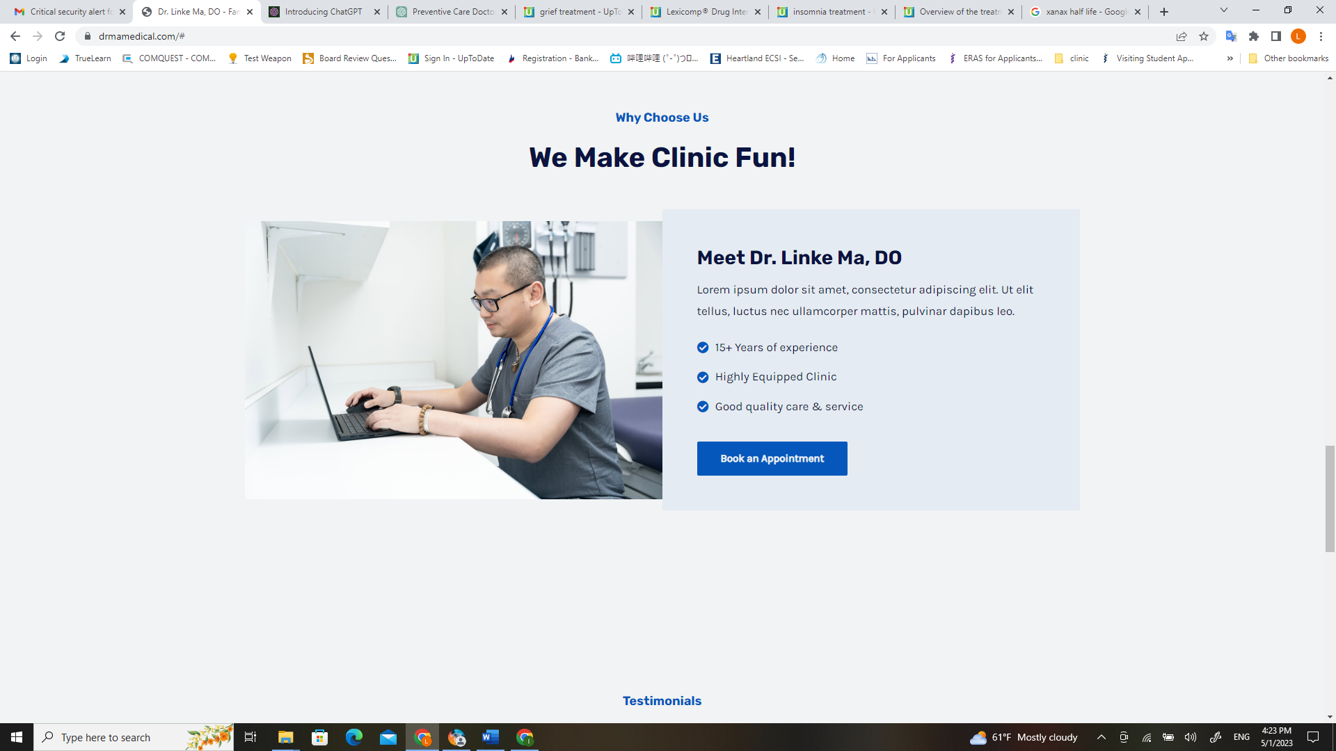

Remove the title:

Why contact us
We make clinic fun
Under meet dr. Linke ma d.o
Remove the non English section

And change experience from 15 to 11

Change 7

Remove the testimony section entirely

Change 8

Need a Chinese version web site

