Lesson 02 Demo 02
Testing Different LLM Models

Objective: To compare the performance of leading large language models—GPT-4, DeepSeek, Claude, Cohere, Copilot, and LLaMA—based on accuracy, response quality, and adaptability

Tools required: GPT-4, DeepSeek, Claude, Cohere, Copilot, and LLaMA

Prerequisites: None

Steps to be followed:
- Testing GPT 4
- Testing DeepSeek
- Testing Claude
- Testing Cohere
- Testing Copilot
- Testing LLaMA
Step 1: Testing GPT 4
  - Open ChatGPT with the link given: https://chatgpt.com/

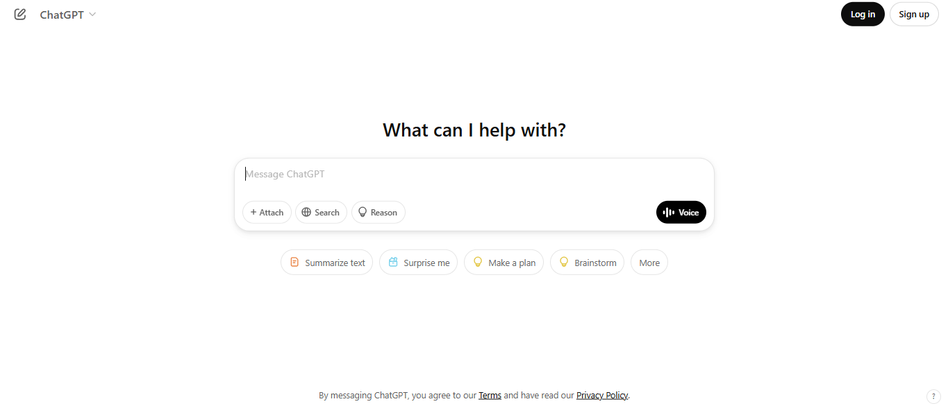

  - Write the prompt below to calculate how many students are only on the robotics team:

A school has 240 students. One-third of the students are in the science club, and half of those in the science club also participate in the robotics team. Additionally, one-fourth of the total students are in the drama club, and 20% of those in the drama club also participate in the robotics team. How many students are only on the robotics team? Think step by step before giving the final answer.



Output is as shown below:






Step 2: Testing DeepSeek
2.1 Open DeepSeek with the link given: https://www.deepseek.com/

2.2 Click on Sign up

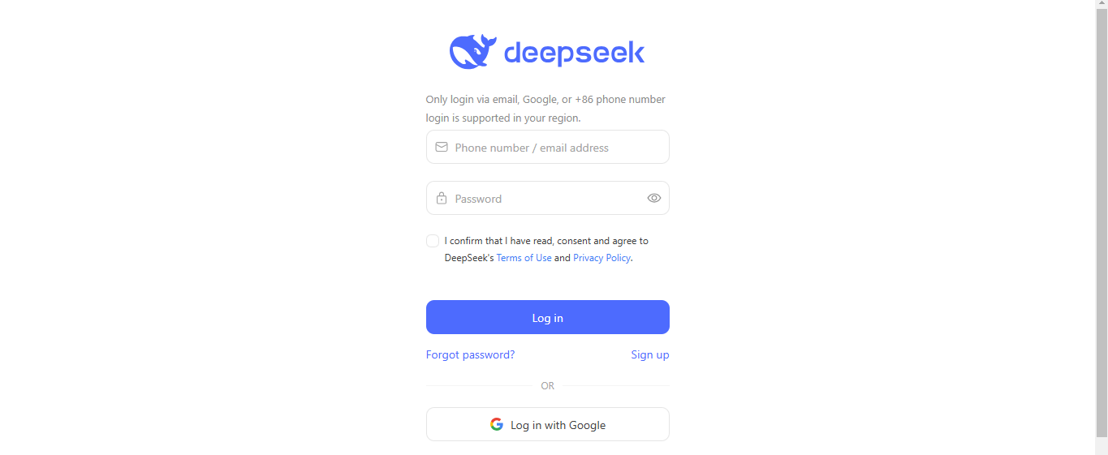

2.3 Enter your details and click on Sign up

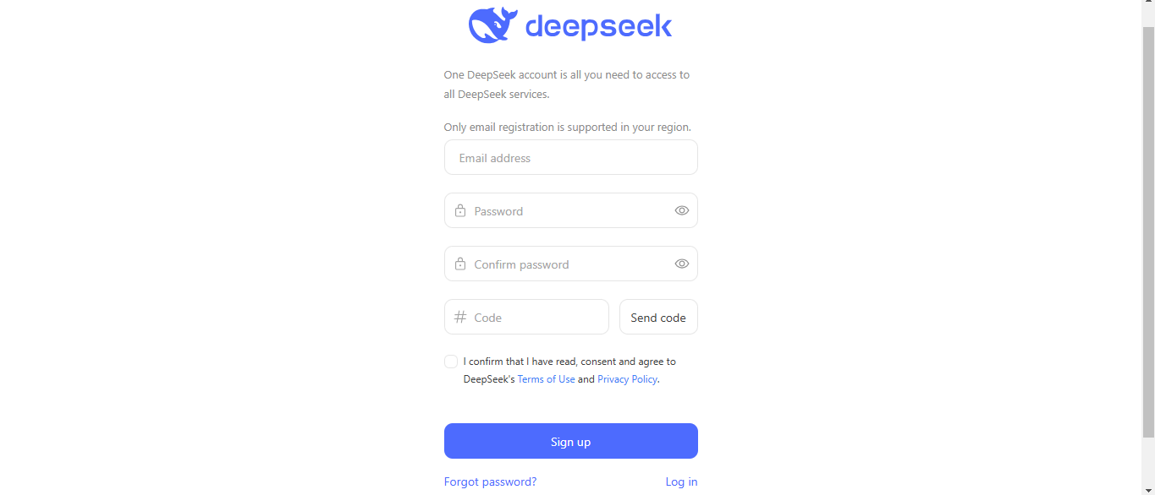

Note: Fill in your details, click on Send code, and then click on Sign up

2.4 Click on Start Now



2.5 Write the prompt below to calculate how many students are only on the robotics team:

A school has 240 students. One-third of the students are in the science club, and half of those in the science club also participate in the robotics team. Additionally, one-fourth of the total students are in the drama club, and 20% of those in the drama club also participate in the robotics team. How many students are only on the robotics team? Think step by step before giving the final answer.



Output is as shown below:




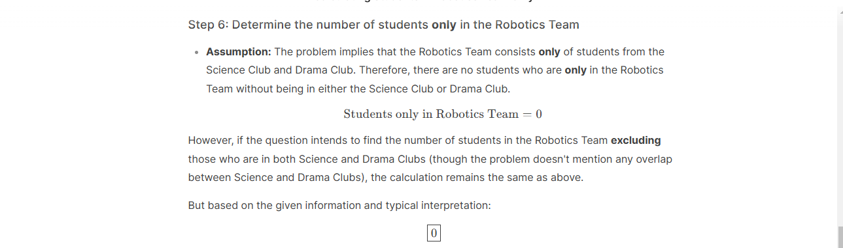

Step 3: Testing Claude
3.1 Open Claude with the link given: https://claude.ai

Note: Follow the on-screen instructions and create your free account

3.2 Write the prompt below to calculate how many students are only on the robotics team:

A school has 240 students. One-third of the students are in the science club, and half of those in the science club also participate in the robotics team. Additionally, one-fourth of the total students are in the drama club, and 20% of those in the drama club also participate in the robotics team. How many students are only on the robotics team? Think step by step before giving the final answer.


Output is as shown below:




Step 4: Testing Cohere
4.1 Open Cohere with the link given: https://cohere.com/
Click on Try the playground, follow the on-screen instructions, and create your Cohere account

4.2 Click on the Playground option
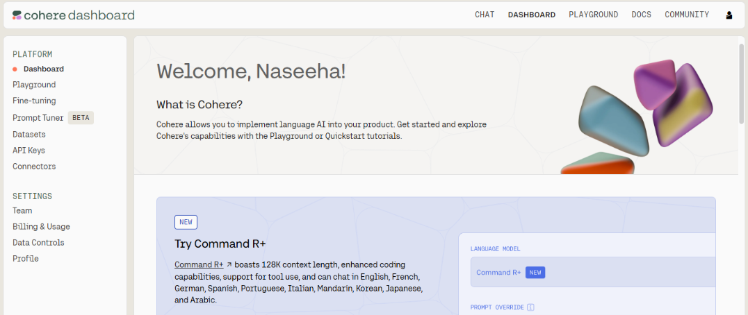

4.3 Write the prompt below to calculate how many students are only on the robotics team:

A school has 240 students. One-third of the students are in the science club, and half of those in the science club also participate in the robotics team. Additionally, one-fourth of the total students are in the drama club, and 20% of those in the drama club also participate in the robotics team. How many students are only on the robotics team? Think step by step before giving the final answer.

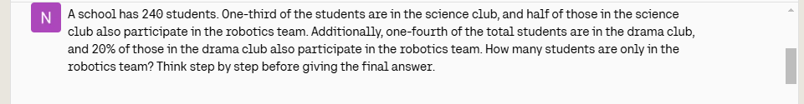
Output is as shown below:
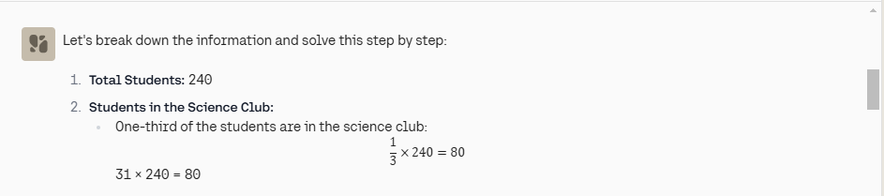
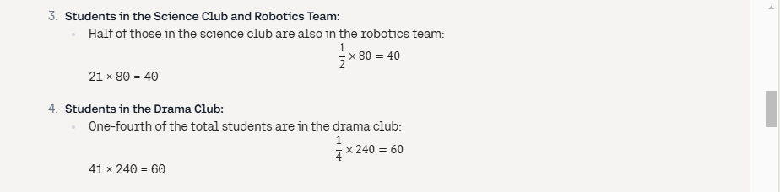
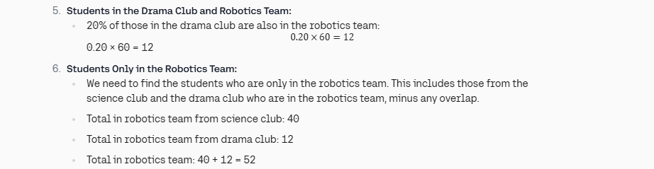
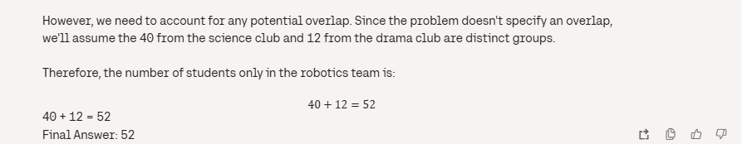

Step 5: Testing Copilot
5.1 Open Copilot with the link given: https://copilot.microsoft.com/chats/PBoVYL2MR4sWjTqXWsSBw
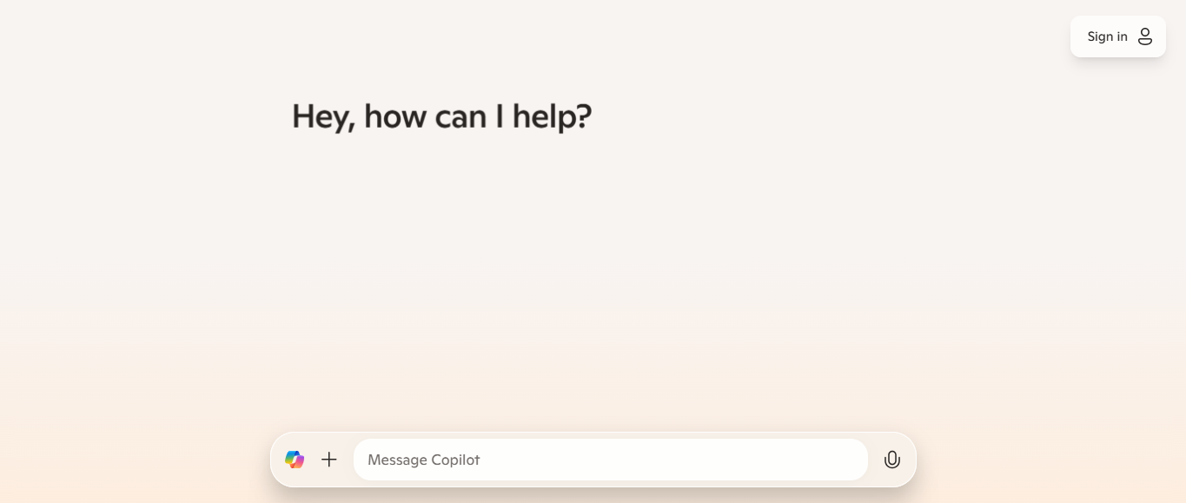

5.2 Write the prompt below to calculate how many students are only on the robotics team:

A school has 240 students. One-third of the students are in the science club, and half of those in the science club also participate in the robotics team. Additionally, one-fourth of the total students are in the drama club, and 20% of those in the drama club also participate in the robotics team. How many students are only on the robotics team? Think step by step before giving the final answer.


Output is as shown below:
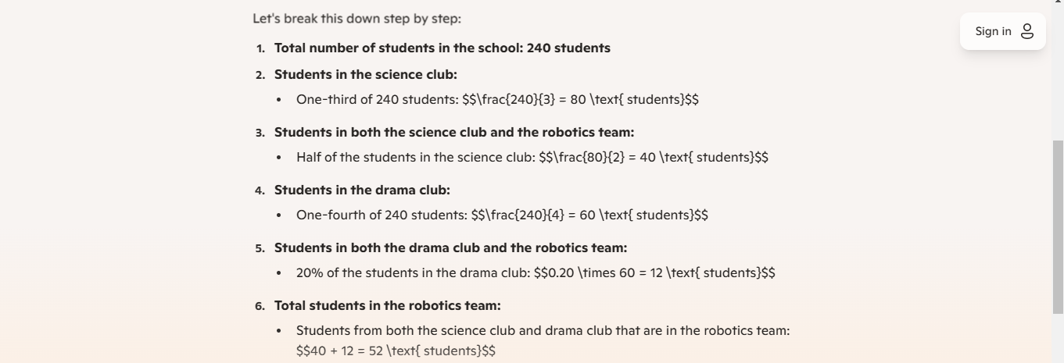
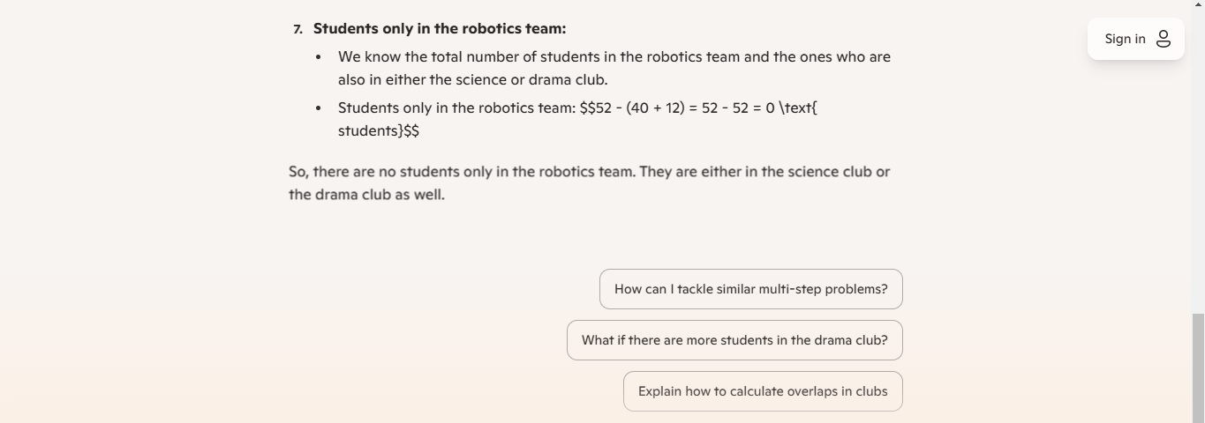

Step 6: Testing LLaMA
  - Open LLaMA with the link given: https://ai.meta.com/ and click on Try Meta AI


6.2 Write the prompt below to calculate how many students are only on the robotics team:

A school has 240 students. One-third of the students are in the science club, and half of those in the science club also participate in the robotics team. Additionally, one-fourth of the total students are in the drama club, and 20% of those in the drama club also participate in the robotics team. How many students are only on the robotics team? Think step by step before giving the final answer.


Output is as shown below:
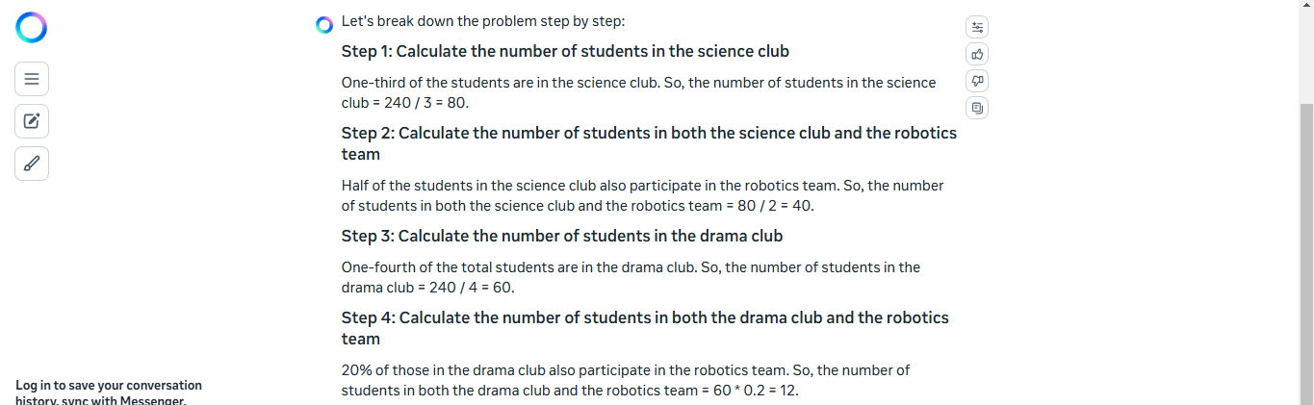
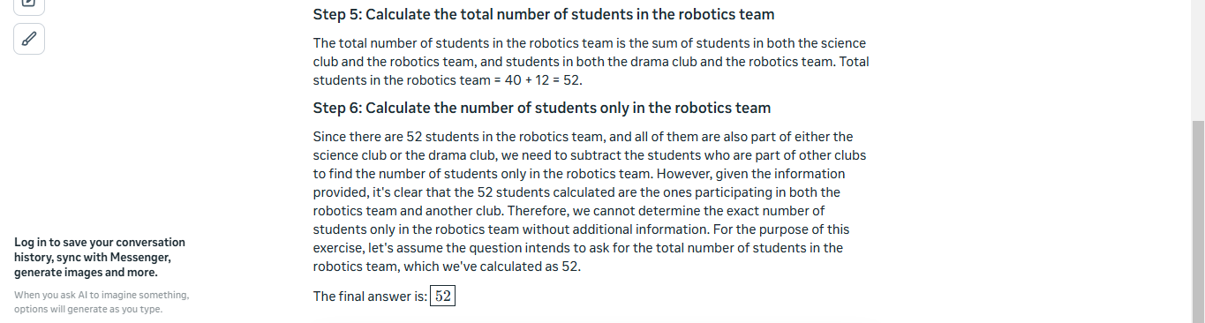
Conclusion:
By following the above steps, you have successfully compared the performance of leading large language models like GPT-4, DeepSeek, Claude, Cohere, Copilot, and LLaMA based on accuracy, response quality, and adaptability.

