Advanced Generative AI: Models and Architecture
Lab Guide



Note: The screenshots are only for your reference. Your LMS may look different depending on the course content.

This section will guide you to:
● Use labs for executing all the demos included in this course

Step 1: Log into the Simplilearn LMS. Click on Practice Labs, and then click on Launch Lab
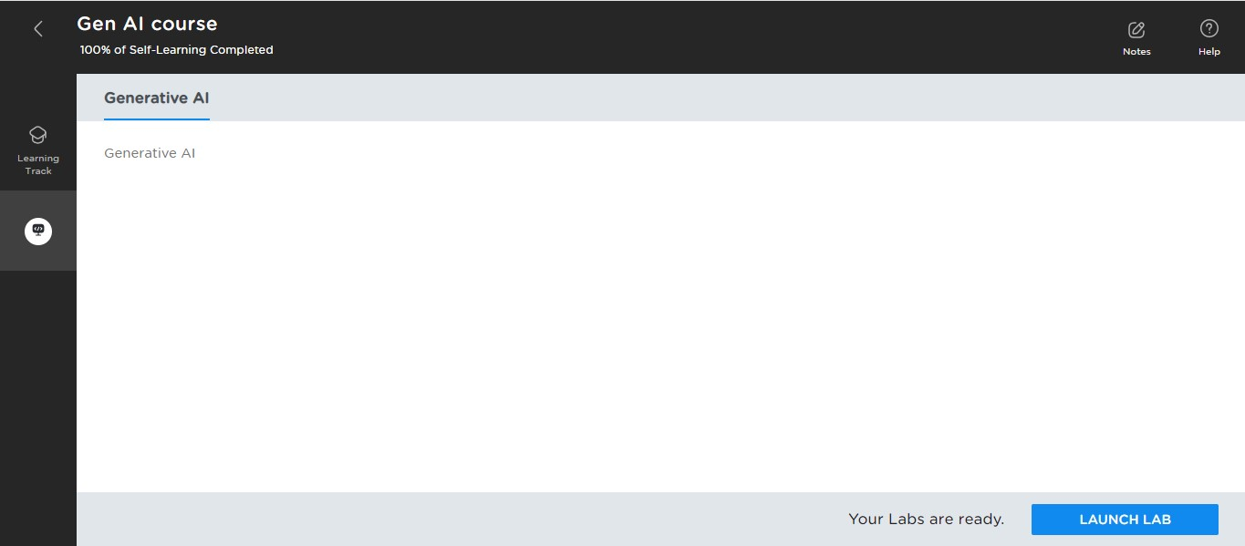

Click on Practice Labs
Click on Launch Lab to launch it

Step 2: A small screen will pop up in the middle of your screen with essential information about the lab; click on the Launch Lab button.
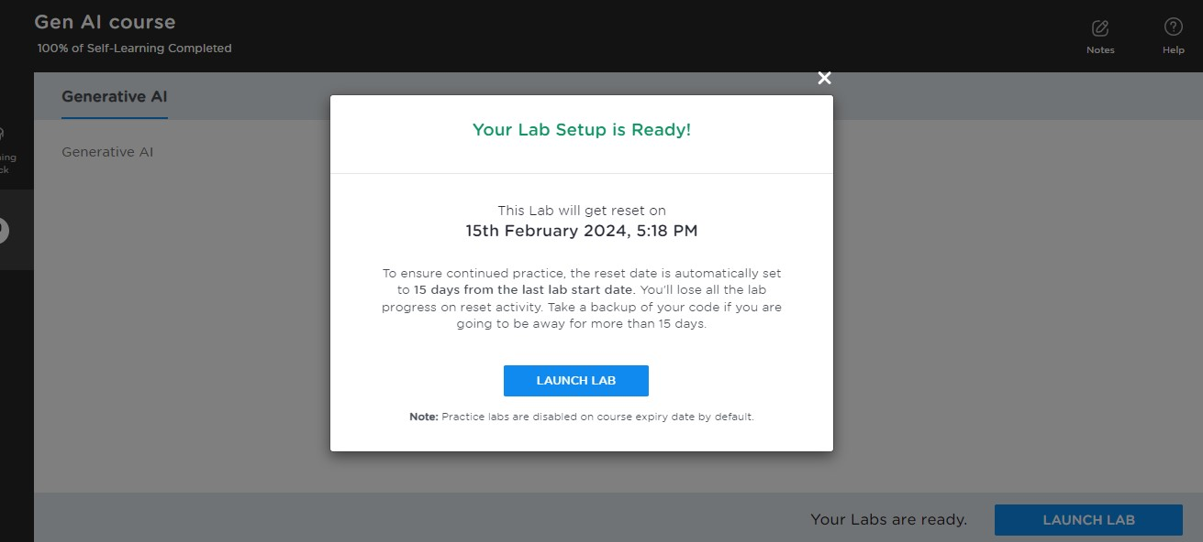
Step 3: End your lab by clicking the End Lab button
