# Summary

This document is about the overall goal and content of the project.

## Goal

Project Great Game is a historical fiction, text based adventure game.

This project aims to force players to make **tough choices under extreme conditions and an unknown environment.**

* Should you risk your mission to save one little girl from getting sold to slavery?
* Should you abandon your fellow man due to scarce resources?
* Is that person lying just to get your money?
* What does that person feel about you?
* With not enough information, what choice will you make?

# Gameplay

The player is a British/Russian officer traveling to Khiva.

The player’s goal is to successfully ally Khivan khan and free Russian slaves within it.

As the player travels to Khiva, he faces hazardous desert and untrustworthy Turcoman tribes.

The player must resourcefully use his supplies and money to reach Khiva.

When facing untrustworthy natives, player must successfully finish dialogue checks to progress.

During the British playthrough, Russian forces are approaching Khiva. Therefore, player must reach and finish the mission beforehand.

# Lore

The game takes place in Khiva, Uzbekistan during 1820 and 1840.

# Content

The game is based on The Great Game written by Peter Hopkirk.

The story is about British India sending officers to free Russian slaves held in Khiva to eliminate Russian excuse to invade Khiva.

**Prologue** : Prince Alexander Bekovich getting captured by Khivans. (pg. 17)

**Main Story** : Captain Abbott’s mission to free Russian slaves held in Khiva. (pg. 213)

**Epilogue** : Captain Abbott travelling to Moscow to meet Tsar Nicholas. (pg. 226)

# Core Mechanics

**Event occurrence based on selected response**

* Depending on an event, the player will select a response.
* Depending on the selected response, the follow up event will occur and so on.

**Resources management**

The main usage of resources will be for mere survival.

* Water
* Food
* Money

**Traveling**

The travelling mechanic will take strong reference from Faster Than Light.

Based on the resources at hand, the player can plot a route he wants to take.

* Country Map
  + Player can only move between countries.
  + Player can only move to adjacent countries.
  + If player is currently in India, he can only move to either Afghanistan or Baluchistan.

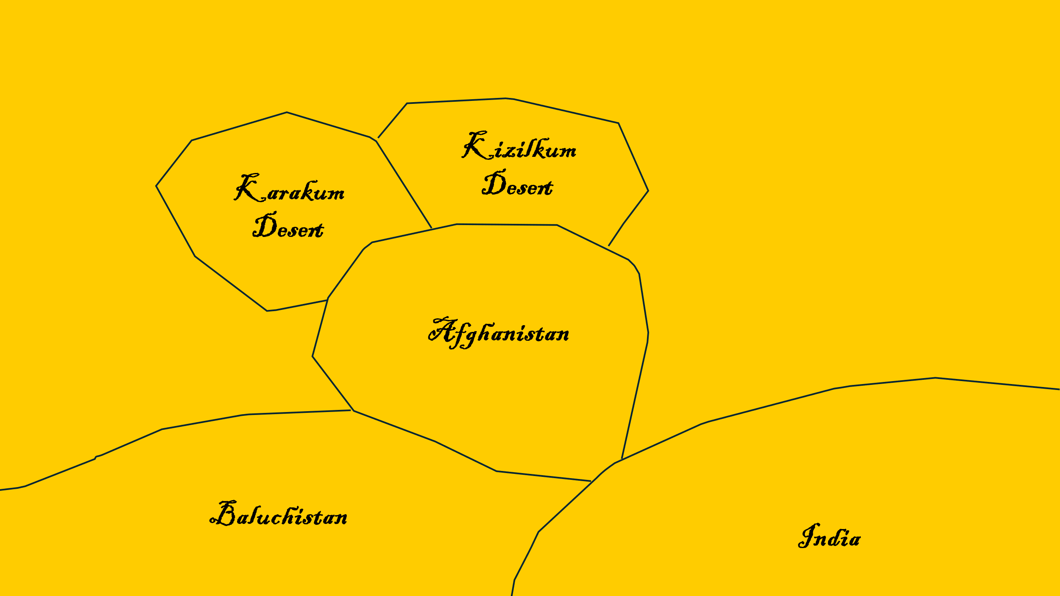

* City Map
  + Player can only move between cities.
  + Here, player starts from Herat. He must move to Khiva to finish the mission.

# Art Style

The art style will take strong reference from Frostpunk.

Intend to use Leonardo AI to produce this kind of artwork.

