# Summary

This document outlines the lore behind the project Great Game.

# Historical Context

The Great Game took place during 19th century in Central Asia. Victorian British and Tsarist Russia were fighting a secret war to get a hold on Central Asia. It began with Peter the Great’s ambition to gain access to rich Central Asian resources and markets. To do so, Russia dispatched brilliant officers for possible allies. Seeing such move, British Empire interpreted as a possible Russian incursion into Indian border. So, she also decided to dispatch officers to find out any possible route that Russia could invade. In addition, she needed allies in Central Asia to act as a buffer between India and Russia.

Young British and Russian officers, who risked their lives for their allegiances, were disguised as holy men or native horse-traders to play the Great Game. They are to face difficult challenges, confronting savage Khans, travelling through hazardous deserts, meeting untrustworthy natives, and so on. They mapped secret passes, gathered intelligence, and sought the allegiance of powerful khans. Some would be forever famous for their success. Some would never return.

# Location

The game takes place in Central Asia.

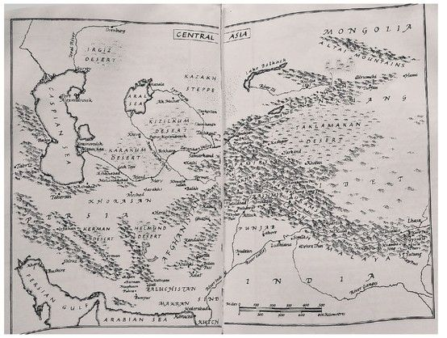

# Characters

**Prologue PC : Prince Alexander Bekovich**

|  |  |  |
| --- | --- | --- |
| Picture | Personality | Background |
|  | Honorable  Determined  Gullible | A Muslim prince from Caucasus who converted to Christianity.  An officer of the Elite Life Guards regiment. |

**Main PC 1 : Captain James Abbott**

|  |  |  |
| --- | --- | --- |
| Picture | Personality Traits | Background |
|  | Resourceful  Political/Diplomatic  Lack understanding of Khivan culture  Evangelical | An artillery officer of Bengal Artillery.  First officer to be sent to Khiva.  He will later be betrayed by his guide and attacked by desert raiders. |

**Main PC 2 : Lieutenant Richmond Shakespear**

|  |  |  |
| --- | --- | --- |
| Picture | Personality Traits | Background |
|  | Political/Diplomatic  Good understanding of Khivan culture  Too Ambitious | A political assistant to the British Mission to Herat.  An artillery instructor of British East India Army. |

NPC

# Muslim Culture