# Summary

This document outlines the rules of travel system.

# Goal

The travel system is to provide a linear travelling experience to the player.

This means once the player moves on to a different area, he cannot go back.

The player will use two maps for travelling, Country Map and City Map.

### Rules

**Country Map :** shows the countries that player can travel to. (Deferred)

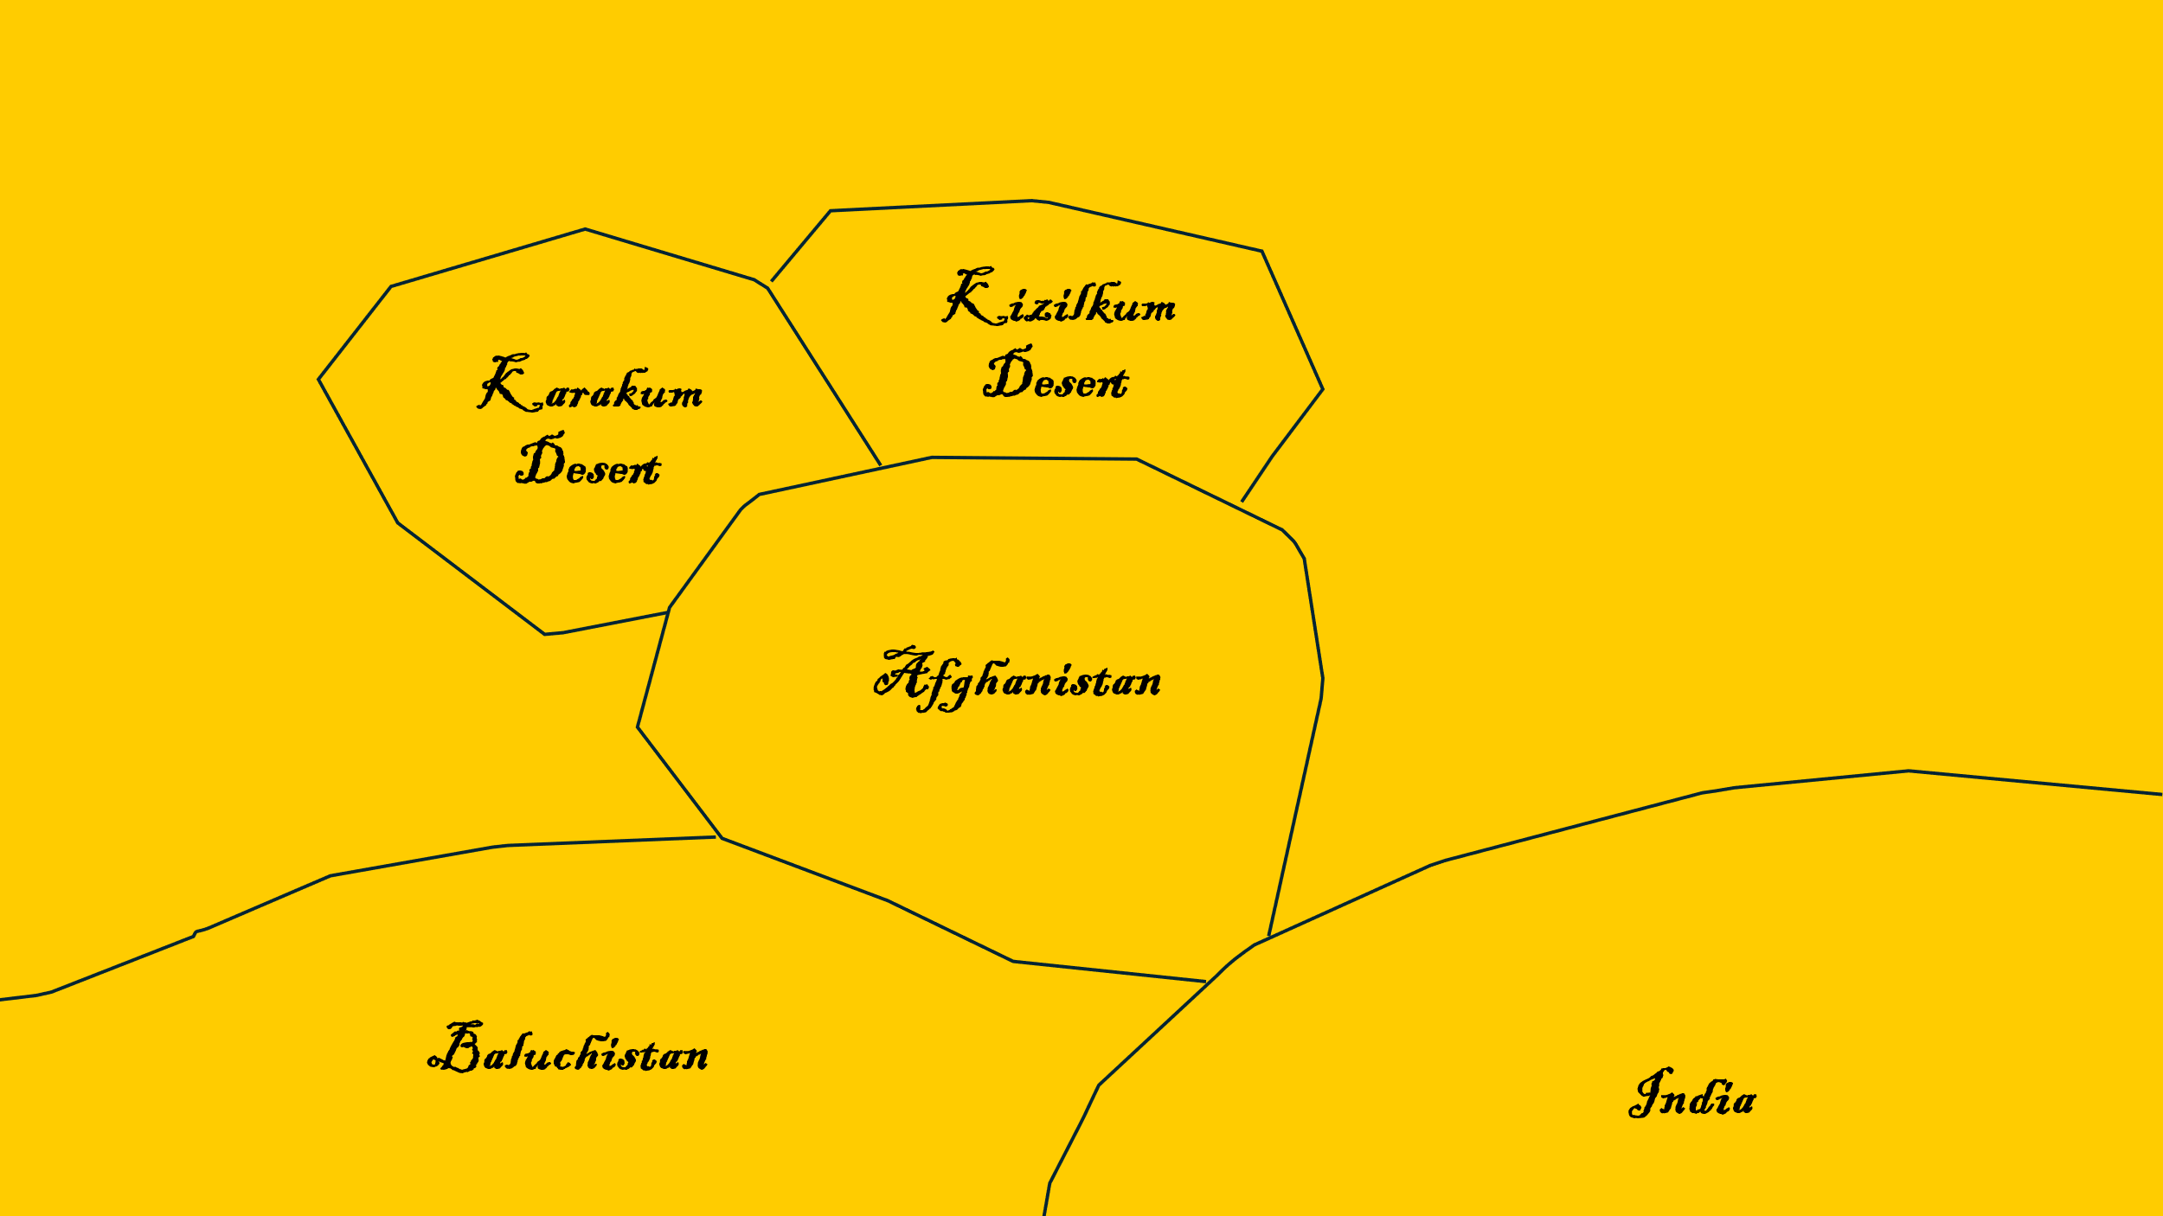

* Player can open Country Map when reaches the last city of country he is currently in.
* Player can only move to adjacent country.
* Once he leaves the current country, he can never go back.
* Travelling will spend Supplies.

**City Map :** shows the cities that player can travel to.

* Player can open City Map anytime.
* City Map automatically opens up when an encounter is done.
* Travelling will spend Supplies.
* Once he leaves the current city, he can never go back.
* Each city contains one encounter.
* Player cannot go back to previous city.