Modeling Air Traffic Control
John A. Keenan

Is there a problem in Air Traffic Control that can benefit from Cognitive Modeling?
Air Traffic generally moves very safely in the United States, however serious problems frequently occur. These problems do not necessarily result in crashes. Air traffic controllers are well trained and respond to recognize emergency situations according to established safety procedures, thus the number of problems is minimized in public perception.
As the upward pressures on volumes of air travel grow, however, the number of problem situations, and the related risks can be expected to grow. Table I compares Air Transport Association data from the decade 1950 through 1959 to the decade 1988 through 1997. The data is displayed in ten-year increments, because given the generally high safety record for air travel, a small number of accidents can cause the safety statistics of any given year to vary widely from overall averages.

Table I, Safety Record of U. S. Airlines
Period | Ave. Passengers carried | Ave. Aircraft miles (k) | Ave. Departs (k) | Ave. Fatal Accidents/100,000 Departs | Ave. number fatal accidents | Ave. number of fatalities
1950-59 | 38 million | 757 million | 3.23 million | .2122 | 6.7 | 159.5
1988-97 | 505 million | 4.825 billion | 7.33 million | .0519 | 3.8 | 130.1

Table I shows that in the five decades, “passengers carried” increased by over 13 times, “aircraft miles traveled” increased over six times and the “number of departures” more than doubled. During this period, piston powered aircraft were replaced by jumbo jets with increased capacity for both load and distance. The increased viability of night flying accounted for many additional takeoffs. The major factor was that the economics of flying improved compared to overall inflation; thus more people flew more often.
As a result of increased pilot skill, improved methods of air traffic control, reliability of the aircraft and other factors, the number of fatal accidents per hundred thousand departures decreased 75%. With this vast decrease in the number of accidents, even the total number of fatalities decreased by nearly 20% in spite of the relatively greater increase in number of passengers and passenger miles flown.
The details of the safety information summarized in this table are included in a spreadsheet as Appendix A to this report.
While precise information on the causes of these crashes and collisions can not be determined, an examination of the ten events with the greatest number of passenger fatalities (see Table II on the next page) gives us clues as to the classes of problems. Primary classes include structural faults, crew errors, controller errors, acts of terrorism, and fires.
Approximately 20% to 30% of the events have implications of human controller involvement.
A blatant, but non-fatal, example of such human failures comes from the National Transportation Safety Board analysis of what might be called a hazardous violation of “separation standards” at Chicago. November 19, 1996, at 1924 Central Standard Time, Alitalia flight 638 landed on runway 09R at O’Hare International Airport, Chicago, Illinois, without landing clearance from O’Hare Air Traffic Control Tower. The flight originated about 12 hours previously in Rome, Italy. It landed about 7000 feet behind Japan AirLines (JAL) flight 038.

Table II, Summary of accidents with most passenger fatalities
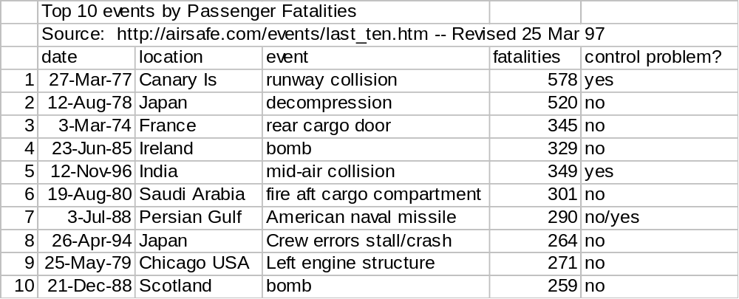
Many human blunders were identified in the Alitalia investigative report. The experienced Italian co-pilot, who spoke good English, was being upgraded to a 767 aircraft and was being supervised by an English 767 training team (pilot and supervisory co-pilot). The Italian co-pilot was new to Chicago O’Hare, arguably the world’s busiest commercial airport. That co-pilot failed to change radio frequencies upon request of the approach controller to the assigned tower frequency. The approach controller and the tower controller both failed to use the procedures to be used when they recognized a potential conflict situation. The pilot then proceeded to “touch-down” by determining visually (but correctly) that there was no cross traffic and that he would not touch down on the runway until JAL038 was “rolling out” to the taxiway. What could have been a routine arrival became an at-risk arrival when the training team ultimately decided that a self-executed “missed approach” procedure was not necessary.
This example serves to illustrate the large numbers of routine goals, operators, methods, and selection rules (GOMS) which are involved in maintaining air traffic safety. They can be analyzed in a human-computer interaction/interface model environment. Various types of modeling have been used as tools for evaluating methods of reducing air travel risks. Since human errors are a major source of air traffic control (ATC) problems, it seems logical that Human-Computer Interaction/Interface (HCI) modeling can be expected to become a prime tool for ATC system designers. HCI modeling can be used to develop enhancements to usability of radar screens and other instruments, routine and emergency operational procedures, methods of communication between controllers and between controllers and pilots, and other air traffic activities involving human-computer interfaces.

How Can Modeling Help?
Since World War II, scientists have been increasingly concerned with improving “Man-machine interfaces” as they were first called. Scientists helped military technicians use radar to track enemy aircraft, thus providing an air defense in times of war and stress. These systems became known as command and control systems. Improvements were made in displays and in the information available to display. Analogue radar data was converted to digital data, sent over (1100 bit per second) transmission lines to distant places, and displayed after being further processed remotely by a computer. From almost the beginning, psychologists worked with the system designers to make displays more understandable and the range of possible operator actions both wider and more logical. The quantitative system evaluation tools used in those early days (late 1950’s) evolved into tools to evaluate more “ordinary” applications for more “ordinary” users, such as secretaries using word processors.
Since 1980 scientists, have been developing quantitative analysis tools and techniques for modeling and examining dynamic human interaction with computer systems. A well-known tool is the Model of Humans as Processors (MHP) of information (see chapter 2 of the Card, Moran, and Newell book^{iii} published in 1983). With use of this model scientists increasingly were able to predict system performance when humans and computers interacted. As the predictions became more accurate, certain types of questions became easier to answer (e.g. how long does it take to complete a certain type of routine computer-oriented task?). These early models were very idealistic and required a great deal of detail regarding human-computer interaction methods being used. Yet within these constraints, comparisons could be made between predicted results and measured results; the models could then be further improved. In 1983, technology was specified for defining human-computer interactions/interfaces as a series of Goals, Operators, Methods and Selection rules and GOMS models were born.

What kinds of models are there and which are best for modeling air traffic control?
There are at least four models in a family including the “GOMS” model, and a number of other modeling environments including one called “EPIC.” In the 1994 time frame, a report was published at Carnegie Mellon University identifying the then four variants of GOMS plus some of the alternatives. This 1994 report lead to two ACM publications , which separated the comparison of models themselves from the choice of modeling technique. Later, one of these authors (Kieras) authored a paper comparing one of the GOMS models (the CPM-GOMS model) with EPIC. Figure 1, on the next page, is adapted from the 1994 Carnegie Mellon report. Figure 1 is intended to clarify the relationships of five modeling environments: 1) the Keystroke-Level Model (KLM), 2) the “Card, Moran and Newell (CMN)” GOMS model, 2) the Natural GOMS Language (NGOMSL) model, 4) the Cognitive, Perception, and Motor (CPM) GOMS model and 5) the EPIC model.
The Keystroke-Level Model (KLM) is the simplest GOMS technique. It allows operators K= press a key, P= point with a mouse, H= home hands on a device, D= draw a line segment, M= mentally prepare, and R= system response. In using KLM, the analyst must specify the method to be used (e.g. copy a word from one location to another); in later techniques the method is chosen by applying knowledge of the task situation, the 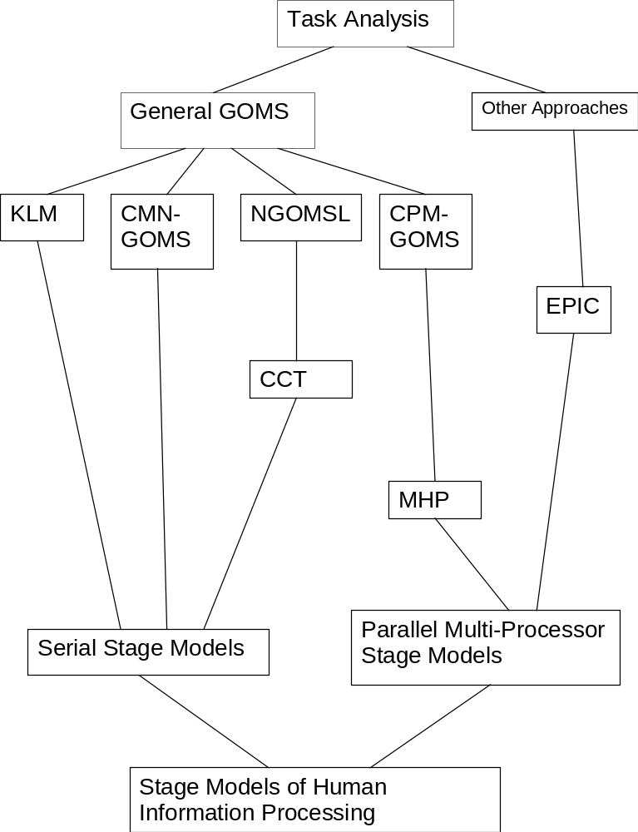
Figure 1, Relationship of GOMS and EPIC models
knowledge of methods, and the selection rules. Furthermore, the specified method is limited to being “goals in sequence” form and containing only keystroke-level primitive operators. Thus neither M nor R, for example, can happen concurrently with another operator.
The upgrade of modeling to add selection rules for making a choice of one of several possible methods was the next stage of modeling. This model, CMN GOMS, appears to be based on the Model Human Processor (MHP) but Kieras and John say “but in fact CMN do not make a tight linkage [to MHP].” However, CMN GOMS is in program form, thus the analysis is general and executable. CMN calls for a breadth-first expansion of a goal hierarchy until the desired level of detail is attained. There are sufficient and detailed examples that researchers have been able to develop their own analyses. The CMN model is still limited to the serial stage model (only one goal and operator being performed at a time).
Natural GOMS Language (NGOMSL) is the third technique. The NGOMSL is built on top of the CCT or Cognitive Complexity Theory language. NGOMSL models are also in program form; “they make the method structure very explicit and can represent very general methods.” The technique for NGOMSL “consists of a top-down breadth-first expansion of the user’s top-level goals into methods, until the methods contain only the operators chosen to be primitive.” It is said “this heuristic of drafting a method in terms of operators helps the analyst avoid getting bogged down in details prematurely, as does the breadth-first approach, which also appears to help the analyst identify shared methods in the system [being modeled].” While only serial goals and operators can be considered, NGOMSL can not only estimate execution time but also predicted “pure learning time for the procedural knowledge represented in the methods.”
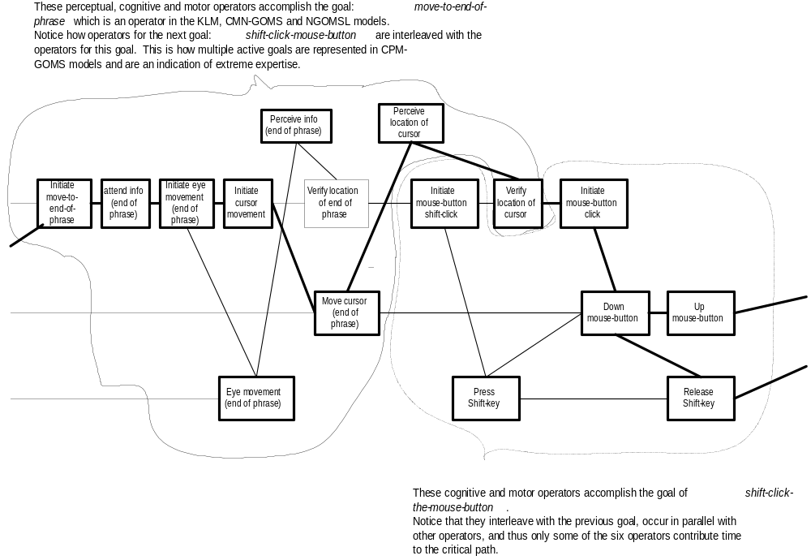
Figure 2, Overlapping of goals using CPM-GOMS
The fourth technique, “CPM-GOMS, is a task analysis technique based directly on the Model Human Processor (MHP) and thus, on the parallel multi-processor stage model of human information processing.” It does not make assumptions that the
Operators are performed serially, that is, Cognitive, Perceptual, and Motor (CPM) operators at the level of MHP processor cycle times can be performed in parallel as the task demands. In fact, the analyst constructs a schedule chart (PERT chart) to show the temporal dependencies between the various serial and parallel activities. CPM also is an acronym meaning Critical Path Method since the critical path in a schedule chart provides a simple prediction of total task time. Figure 2, adapted from the Carnegie Mellon report by John and Kieras shows how cognitive and motor goals overlap the perceptual goals thus achieve a lower task performance time than if each goal were done serially.
Finally EPIC (Executive Process-Interactive Control) is a technology which has some of its conceptual beginnings in CPM-GOMS. A weakness in CPM-GOMS is that the construction of the schedule charts is quite labor intensive especially if the number of benchmark tasks is large. EPIC has generative and reactive capabilities. The generative grammar has a set of rules for generating all of the grammatical sentences in its language. The reactive capability reacts in simulated real time to events initiated by the task environment. Together these capabilities have been developed to account for human multiple-task performance in situations such as aircraft cockpit tasks. In these situations a human must perform two or more reactive tasks concurrently meeting constraints such as priorities, time limits and needs for accuracy. The architecture is depicted in Figure 3. Note the model can, in parallel perform arm/hand movement, speaking, watching and hearing. The Cognitive Processor includes working memory, production memory and long-term memory.
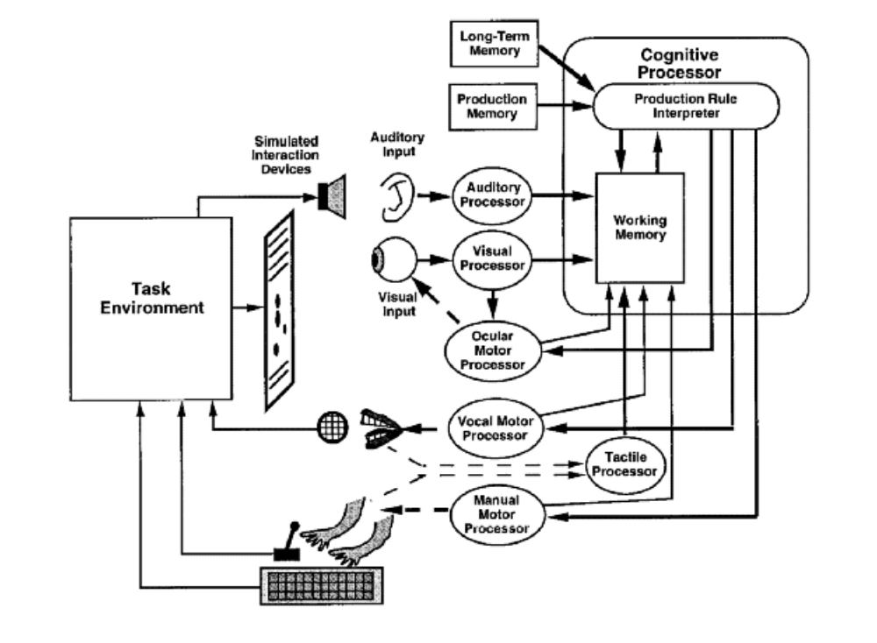 Figure 3, the EPIC model architecture

Basically the KLM, CMN-GOMS, and NGOMSL are only capable of modeling “serial” tasks, thus are inappropriate for air traffic control modeling where each individual controller typically is doing multiple time-critical tasks concurrently. However, the CPM-GOMS has been used to model telephone operator workstations, where the operators develop a great deal of overlap (parallelism) in their tasks. This type of task is functionally equivalent to the air traffic control task
For example, while phone operators talk by phone to customers, radar controllers talk by radio to pilots. While telephone operators, concurrently (in parallel), call up databases to get information for the customer, radar controllers look at flight strips to get data about the flights they have under control. Telephone operators have substantial information in their personal working and long term memory about call routing and billing; radar controllers have personal working and long term memory about air routes, current weather, and separation standards. Radar controllers are constantly scanning for conflict potential (as are pilots). [I cannot recall a comparable function performed routinely by telephone operators unless it is to be alert for life and fire emergencies].
In reference ^{vii} Kieras describes how the EPIC model is “a production rule cognitive processor surrounded by perceptual-motor peripherals.” The model includes a number of features that emulate the Model Human Processor (MHP). These features have allowed Kieras and Meyer to model a telephone operator task (using data, including videotapes from the CPM-GOMS model data gathering). The single, but substantially parallel task they modeled is the “Bill-to” call type task of a telephone operator. [About two staff-months of effort were required for modeling this task.] Some conclusions have been drawn based upon three analyses: 1) observed performance using the videotapes, 2) modeled performance with CPM-GOMS and 3) modeled performance with EPIC.
Measures of predicted versus actual performance are more informative than correlation measures. Using engineering “10-20% rules of thumb,” EPIC models give usefully accurate predictions of total task execution time. The hierarchical motor-parallel model, which is only moderately efficient, is more accurate than more optimized models – even though the human operators are very highly practiced at the task. As noted above, two staff-months of skilled model building were required to construct the “Bill-to” model, considerably less than for the CPM-GOMS models. It is now a year since the EPIC report was published, yet it would appear that EPIC is the most promising for modeling air traffic control. Lisp is required to create a solution in EPIC and only partial documentation, is available. However, according to David Kieras there is a version of EPIC available for research use.
Examples of such routine ATC tasks to model first might be 1) at an en route center identifying the planes about to land at a major airport, or 2) managing a single runway at a multi-runway airport.

What modeling extensions may be needed and what are the next steps?
If one wished to model the en route air traffic control system as described in Mackay, one would need to account for the use of input devices that are still non-standard. There are publications that can help in thinking about this issue, but it certainly would call for an extension from any of the traditional models.
In particular, Mackay describes adding resistors to “flight strip holders” so they can be tracked automatically and correlated with displayed targets. Apparently controllers in the experimentation conducted by Mackay et al favor this technology, but this begs the question about how it affects the overall maximum performance available. Thus the desire to model the modified system Mackay describes.
A look at the application of modeling techniques to other problems ^{ix,} provides some step by step suggestions on how to proceed to model various aspects of the air traffic control problem. The three next steps are: 1) get the environment with which to create the model, 2) select the task to be modeled, and 3) get data with which to build and test the model,.
Probably the easiest condition to meet would be getting the modeling environment by getting a copy of EPIC from the University of Michigan. Even though it has limited documentation, graduate students doing research have used it. Adapting code generated at Michigan has created the code shown in figure 4.
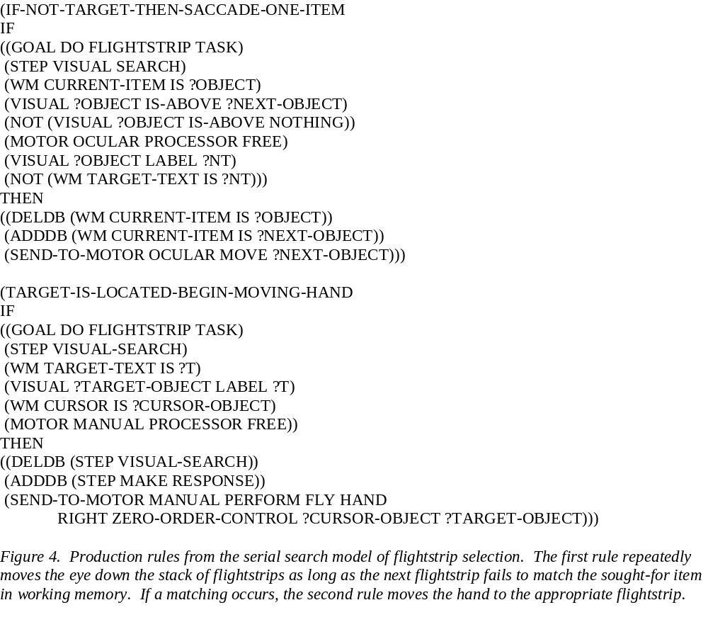 Deciding on the task to model and choosing where to gather the data need to proceed concurrently. That is because getting the data is more easily said than done as controllers “have to consistently break the rules in order to make the traffic flow properly.”
For example, in a terminal situation with good visibility, a tower controller at an airport might tell a certain flight that it is cleared for “immediate” departure on runway <14L>. The departing aircraft, which probably was alerted to the expected maneuver, is expected to pull onto runway <14L>, turn, and without slowing, start forward motion down the runway. This immediately implements a departure on the runway prior to an incoming aircraft only 3 miles (one-minute) away from touching down on that same runway. If all goes as expected and it usually does, the departing aircraft will be airborne in about 30 seconds – leaving the runway clear for the arriving aircraft. [We might call this option 0]
If the departing aircraft fails to move fast enough soon enough, alternative measures must be taken. Some options are: 1) the departing aircraft’s clearance can be revoked and it must get off the runway (if on) or 2) the arriving aircraft may be diverted to another runway, or 3) the arriving aircraft may be directed to do a “missed approach.”
The “rule book” tends to favor option 3 (missed approach), however it is a very costly option in terms of traffic flow, and thus is seldom used. If the incoming aircraft must execute a missed approach, it must accelerate, veer to the left or right depending upon the missed approach pattern for that runway, and fly around to a point where it can re-enter the approach pattern. [At a large and busy airport like Chicago O’Hare, this might require an additional 50 to 75 miles of flying, added fuel costs and perhaps a 25 minute delay in landing.]
If the departing aircraft has not yet entered the runway, option 1 might be exercised. However, option 2 is selected at many airports where the geometry of the runways permits that option safely. For example, at Washington National (Raegan) Airport, there is an option when landing on runway <36>, due North, for the incoming aircraft to “extend” to runway <33> (meaning bank right and align itself with runway <33>). This lengthens the path for an incoming aircraft, giving the previous aircraft more time to clear
the runway. (Runways <33> and <36> intersect at Washington, so unless one aircraft clears the intersection, or holds short of the intersection, there can be a rule violation because two aircraft are operating, one on each runway. This was the situation at the Canary Islands airport in 1977 when over 500 people died.)
If a departing aircraft is moving down runway <14L> as at Chicago O’Hare, and the incoming aircraft is diverted to landing on <09R>, there also may be a technical rule violation. This is because the incoming aircraft may bank right, and turn right over the departing aircraft at a low level before landing on runway <09R>. This becomes more critical if either aircraft is very heavy, thus creating large wake turbulence. Obviously, individual controllers would not like be recorded taking this action (Mackay had to guarantee her data would be kept confidential).
Located as UW Milwaukee is near Mitchell Field (Milwaukee) and O’Hare (Chicago), one of these, preferably O’Hare, is an ideal choice. O’Hare, a key hub for cross-country traffic, would certainly require FAA (Federal Aviation Agency) permission to use. If an En Route Center were to be used, Joliet Center (near Chicago) would be suitable. If one wished to model the Navy Tactical Data System, the for-runner of the FAA terminal system, finding a system close to Milwaukee might be difficult, but cooperation from the Office of Naval Research, Cognitive Science Program, sponsors of EPIC, might be possible.
Since the author has worked most on terminal air traffic control, and in particular on the O’Hare implementation, this seems like a desirable choice to model. In particular, the use of runway <14L> has many interesting features to model, which after being modeled, can be generalized.

Conclusions
It is feasible to create a model of the human controller interface for air traffic control. The model with its use for associated research could be suitable for critical systems analysis and design. This is true both from a human-computer interaction point of view and from a management information systems point of view.
To show that such HCI models are useful in researching alternative improvements in ATC, specific tasks to be considered must be identified. Those tasks can then be modeled as presently being handled, and as alternatively being evaluated [e.g. using methods being evaluated in Europe (Mackay) versus methods being evaluated in the U.S. (MITRE)].

Appendix A, Detailed Air Safety Data Spreadsheet
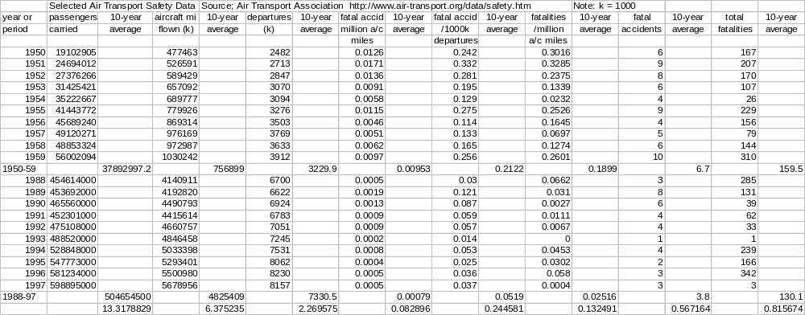

Air Transport Association – Data and Statistics; http://www.air-transport.org/data/safety.htm
Email, December 7, 1998, Dr. D. E. Kieras, previously cited (op cit.).
National Transportation Safety Board, History of Alitalia flight 638 on 19 Nov 1996; http://ntsb.gov/Aviation/CHI/Inarr_97.
80-1 Card, Stuart K., Thomas P. Moran and Allen Newell; The keystroke-level model for user performance with interactive systems; Communications of the ACM, 23 (1980), Pages 396 - 410.
83-1 Card, Stuart K., Thomas P. Moran and Allen Newell, The Psychology of Human-Computer Interaction, Lawrence Erlbaum Associates, Hillsdale, NJ (1983).
94-5 John, Bonnie E. and D. E. Kieras; The GOMS family of analysis techniques: Tools for design and evaluation; Technical Report CMU-CS-94-181, Carnegie Mellon University, 1994.
96-5 John, Bonnie E., and David E. Kieras, Using GOMS for user interface design and evaluation: which technique?; ACM Transactions on Computer-Human Interactions, 3, 4, (Dec 1996), Pages 287 - 319.
? 96-6 John, Bonnie E., and David E. Kieras, The GOMS family of user interface analysis techniques: comparison and contrast; ACM Transactions on Computer-Human Inter-actions, 3, 4, (Dec 1996), Pages 320 - 351.
97-3 Kieras, David E., Scott D. Wood, and David E. Meyer; ACM Predictive engineering models based on the EPIC architecture for a multimodal high-performance human-computer interaction task; Transactions on Computer-Human Interaction, 4, 3, (Sep 1997), Pages 230 - 275.
96-? Kieras, David E. and David E. Meyer; The EPIC Architecture: Principles of Operation; ftp.ai.eecs.umich.EPICarch.ps, 7/1/96 (25 pages).
95-? Kieras, David E. and David E. Meyer; An overview of the EPIC Architecture for cognition and Performance with Application to Human-Computer Interaction; EPIC Report Number 5, December 5, 1995, University of Michigan. Ann Arbor, MI (32 pages).
? Mackay, Wendy E. et al; Reinventing the familiar: exploring an augmented reality design space for air traffic control; CHI '98 Human factors in computing systems, Apr 1998, Pages 558 - 565.
91-1 Card, Stuart K., Jock D. Mackinlay, and George G. Robertson; A morphological analysis of the design space of input devices; ACM Transactions on Information Systems, 9, 2 (Apr 1991), Pages 99 – 122.
88-1 Kieras, David, Towards a practical GOMS model methodology for user interface design; in Helander, Martin (Editor), Handbook of Human-Computer Interaction, Elsevier Science Publishers,

