Routing
- A Router is a process of selecting path along which the data can be transferred from source to the destination. Routing is performed by a special device known as a router.
- A Router works at the network layer in the OSI model and internet layer in TCP/IP model
- A router is a networking device that forwards the packet based on the information available in the packet header and forwarding table.
- The routing algorithms are used for routing the packets. The routing algorithm is nothing but a software responsible for deciding the optimal path through which packet can be transmitted.
- The routing protocols use the metric to determine the best path for the packet delivery. The metric is the standard of measurement such as hop count, bandwidth, delay, current load on the path, etc. used by the routing algorithm to determine the optimal path to the destination.
- The routing algorithm initializes and maintains the routing table for the process of path determination.

- Routing Metrics and Costs
Routing metrics and costs are used for determining the best route to the destination. The factors used by the protocols to determine the shortest path, these factors are known as a metric.
Metrics are the network variables used to determine the best route to the destination. For some protocols use the static metrics means that their value cannot be changed and for some other routing protocols use the dynamic metrics means that their value can be assigned by the system administrator.
The most common metric values are given below:
- Hop count: Hop count is defined as a metric that specifies the number of passes through internetworking devices such as a router, a packet must travel in a route to move from source to the destination. If the routing protocol considers the hop as a primary metric value, then the path with the least hop count will be considered as the best path to move from source to the destination.
- Delay: It is a time taken by the router to process, queue and transmit a datagram to an interface. The protocols use this metric to determine the delay values for all the links along the path end-to-end. The path having the lowest delay value will be considered as the best path.
- Bandwidth: The capacity of the link is known as a bandwidth of the link. The bandwidth is measured in terms of bits per second. The link that has a higher transfer rate like gigabit is preferred over the link that has the lower capacity like 56 kb. The protocol will determine the bandwidth capacity for all the links along the path, and the overall higher bandwidth will be considered as the best route.
- Load: Load refers to the degree to which the network resource such as a router or network link is busy. A Load can be calculated in a variety of ways such as CPU utilization, packets processed per second. If the traffic increases, then the load value will also be increased. The load value changes with respect to the change in the traffic.
- Reliability: Reliability is a metric factor may be composed of a fixed value. It depends on the network links, and its value is measured dynamically. Some networks go down more often than others. After network failure, some network links repaired more easily than other network links. Any reliability factor can be considered for the assignment of reliability ratings, which are generally numeric values assigned by the system administrator.

- Types of Routing
Routing can be classified into three categories:
- Static Routing
- Default Routing
- Dynamic Routing
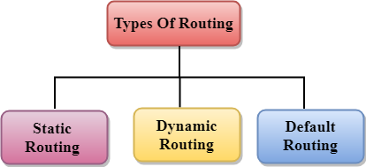

Static Routing
- Static Routing is also known as Nonadaptive Routing.
- It is a technique in which the administrator manually adds the routes in a routing table.
- A Router can send the packets for the destination along the route defined by the administrator.
- In this technique, routing decisions are not made based on the condition or topology of the networks

Advantages Of Static Routing
Following are the advantages of Static Routing:
- No Overhead: It has ho overhead on the CPU usage of the router. Therefore, the cheaper router can be used to obtain static routing.
- Bandwidth: It has not bandwidth usage between the routers.
- Security: It provides security as the system administrator is allowed only to have control over the routing to a particular network.

Disadvantages of Static Routing:
Following are the disadvantages of Static Routing:
- For a large network, it becomes a very difficult task to add each route manually to the routing table.
- The system administrator should have a good knowledge of a topology as he has to add each route manually.

Default Routing
- Default Routing is a technique in which a router is configured to send all the packets to the same hop device, and it doesn't matter whether it belongs to a particular network or not. A Packet is transmitted to the device for which it is configured in default routing.
- Default Routing is used when networks deal with the single exit point.
- It is also useful when the bulk of transmission networks have to transmit the data to the same hp device.
- When a specific route is mentioned in the routing table, the router will choose the specific route rather than the default route. The default route is chosen only when a specific route is not mentioned in the routing table.

Dynamic Routing
- It is also known as Adaptive Routing.
- It is a technique in which a router adds a new route in the routing table for each packet in response to the changes in the condition or topology of the network.
- Dynamic protocols are used to discover the new routes to reach the destination.
- In Dynamic Routing, RIP and OSPF are the protocols used to discover the new routes.
- If any route goes down, then the automatic adjustment will be made to reach the destination.
The Dynamic protocol should have the following features:
- All the routers must have the same dynamic routing protocol in order to exchange the routes.
- If the router discovers any change in the condition or topology, then router broadcast this information to all other routers.

Advantages of Dynamic Routing:
- It is easier to configure.
- It is more effective in selecting the best route in response to the changes in the condition or topology.

Disadvantages of Dynamic Routing:
- It is more expensive in terms of CPU and bandwidth usage.
- It is less secure as compared to default and static routing.
- Metric-based approaches
Robustness can be provided by selecting routes that minimize end-to-end retransmissions or failure probabilities. This requires the selection of a suitable metric for each link.
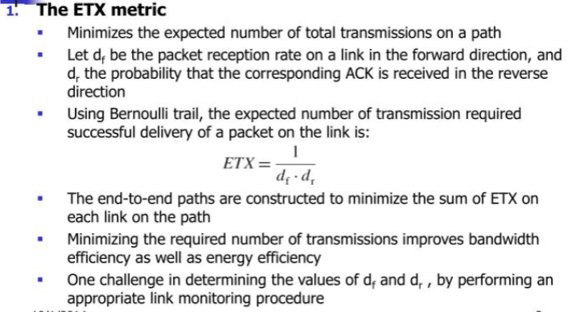
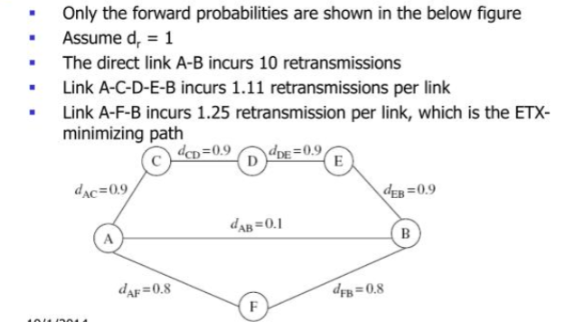
- Routing with diversity
These techniques exploits the diversity provided by the fact that wireless transmissions are broadcast to multiple nodes.
  - Relay diversity
It is a simple technique for providing diversity in wireless routing that exploits the wireless broadcast advantage. This is illustrated in Figure 8.2 by a simple two-hop route from A to B to C. With traditional routing, the reliability of path is purely a function of whether transmissions on A and B and B and C were both successful. However, if C is also allowed to accept packets directly from A (whenever they are received without error), then the reliability can be further increased without any additional energy expenditure.
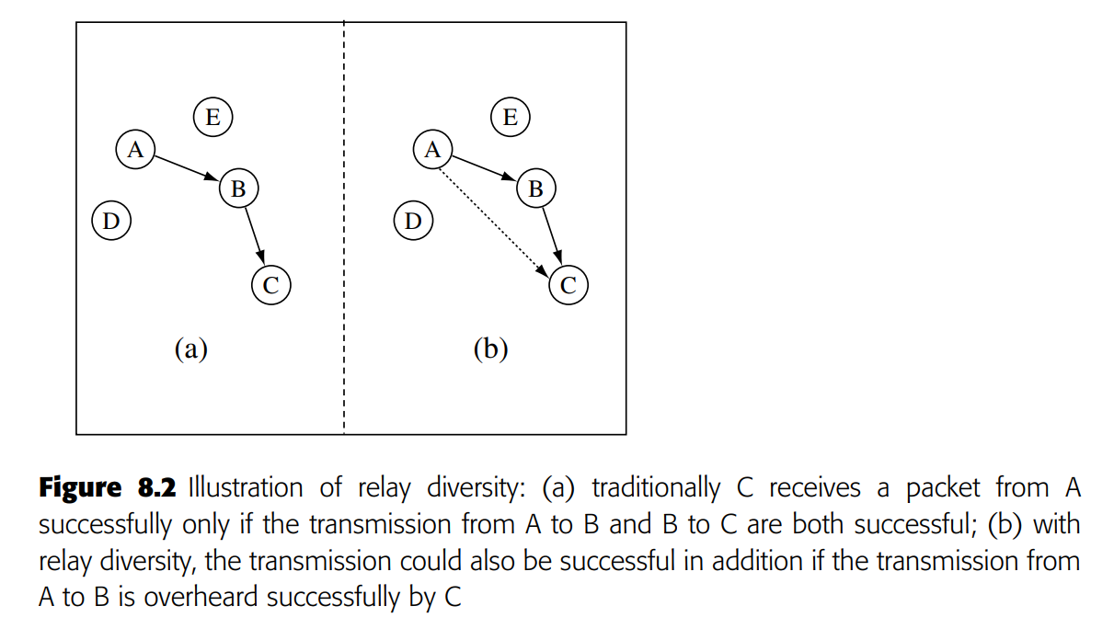
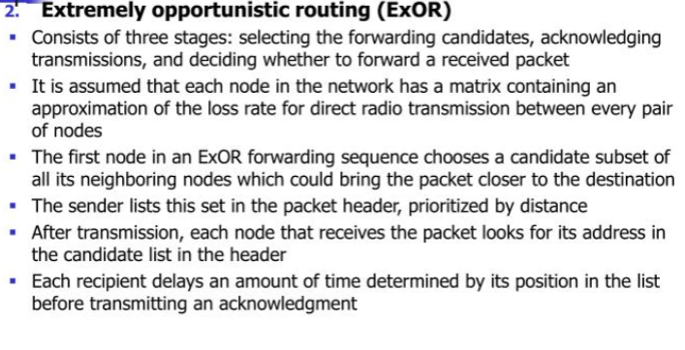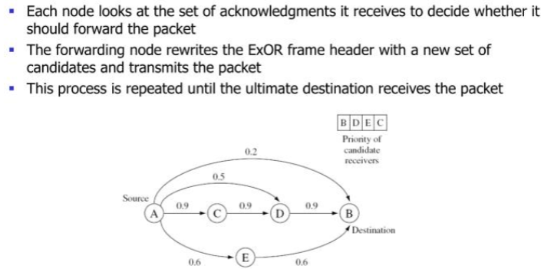

- Geographic routing
Geographic routing (also called georouting or position-based routing) is a routing principle that relies on geographic position information. It is mainly proposed for wireless networks and based on the idea that the source sends a message to the geographic location of the destination instead of using the network address.
Routing in wireless sensor networks is performed in a cooperative way, i.e. each node relies on its neighbours to forward its packets towards the network sink. 5 All sensor nodes participate in the routing procedure acting as routers. This intricacy of the sensor networks implies that the routing functionality is distributed over all network nodes, which however have limited energy, memory and processing capabilities.
geographical routing (GR) targets the efficient support of mobility and scalability while it turns out to be invulnerable against a set of security attacks when security comes into play.
The idea is that each node is characterized by its coordinates and each time a node needs to send a packet, it will forward it to the neighboring node that is closer to the destination than all the rest nodes. To perform this decision, it is required to keep geographical information (the location) for each neighbour in its routing table. This information is gathered through the so-called “BEACON” messages that each node periodically transmits announcing its location.
This localized operation has the following important advantages: • It facilitates the mobility support. • It is scalable. • It introduces minimal routing overhead. GR is a proactive routing protocol since beacons are emitted periodically. The disadvantage of proactive routing protocols is that routing messages are exchanged even when no traffic to route exists.
Some geographic protocols are
Greedy Perimeter Stateless Routing (GPSR) - The most widely cited geographical routing protocol is the Greedy Perimeter Stateless Routing (GPSR) algorithm for wireless sensor networks . The algorithm consists of two methods for forwarding packets:
1. Greedy forwarding.
2. Perimeter forwarding
Greedy forwarding: the source node transmits the packet towards the neighbours that is closest to the destination (and furthest from the source node), which is the locally optimal choice of next hop.
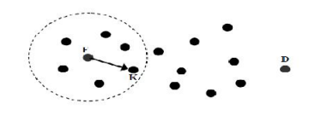
Fig. Greedy forwarding

Perimeter forwarding: When greedy forwarding is not possible and the packet has not reached its destination, i.e. there is a void between the node and the destination, perimeter forwarding is performed to travel around the void. This is achieved based on the proactive calculation of planar graphs.
Geographical and Energy Aware Routing (GEAR): Energy consumption related improvements have been introduced here. In GEAR, the next hop is decided taking into account the value of the learned cost function for each neighbour apart from its location. This “learned cost” function reflects the available (remaining) energy of each node, thus allowing for better load balancing among neighbours.
Energy Aware Greedy Routing (EAGR): It relies on energy information to prolong the lifetime of the network. In this work, nodes with remaining energy below a predefined threshold are considered as dead and are excluded from the list of candidates for forwarding neighbours.
- Routing to mobile sinks
In a sensor network with a mobility sink (e.g., controlled robots or humans/vehicles equipped with gateway devices), data must be transmitted from static sensor sources to the mobile sink. A key advantage of incorporating mobile sinks into the design of a sensor network is that it may enable the gathering of timely information from remote deployments, and may also potentially improve energy efficiency.
Two-tier data dissemination (TTDD): In the two-tier data dissemination (TTDD) approach, all nodes in the network are static, except for the sinks that are assumed to be mobile with unknown/uncontrolled mobility.
The data about each event are assumed to originate from a single source. Each active source creates a grid overlay dissemination network over the static network, with grid points acting as dissemination nodes.
A mobile sink, when it issues queries for information, sends out a locally controlled flood that discovers its nearest dissemination point. The query is then routed to the source through the overlay network. The sink includes in the query packet information about its nearest static neighbor, which acts as a primary agent.
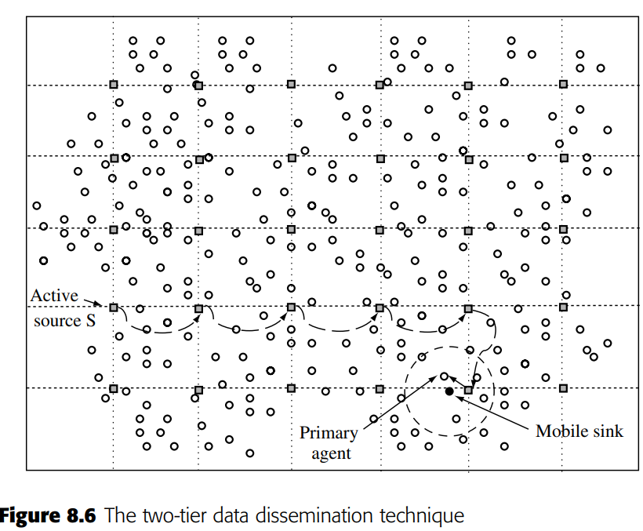
An alternative immediate agent is also chosen when the sink is about to go out of reach of the primary agent for robust delivery. The source sends data to the sink through the overlay dissemination network to its closest grid dissemination node, which then forwards it to its primary agent.
As the sink moves through the network, new primary agents are selected and the old ones time out; when a sink moves out of reach of its nearest dissemination node, a new dissemination node is discovered and the process continues.
Asynchronous dissemination to mobile sinks:
The scalable energy-efficient asynchronous dissemination technique (SEAD) presented to provides for communication of information from a given source in a static sensor network to multiple mobile sinks.
Each mobile sink selects a nearby static access node to communicate information to and from the source. Only the access node keeps track of sink movement, so long as it does not move too far away.
When the hop-count between the sink and the nearest access point exceeds a threshold, a new access node is selected by the sink. Data are sent from the source first to the various access nodes through a dynamically maintained multi-cast dissemination tree, which then forwards the information to their respective sinks.
Data mules:
For sparsely deployed sensor networks (e.g. deployed over large areas), the network may never be truly connected; in the most extreme case no two sensor devices may be within radio range of each other.
The MULE (mobile ubiquitous LAN extensions) architecture aims to provide connectivity in this environment through the use of mobile nodes that may help transfer data between sensors and static access points, or may themselves act as mobile sinks.
It is assumed that MULE nodes do not have controlled mobility and that their movements are random and unpredictable.
Whenever a MULE node comes into contact with a sensor node, it is assumed that all the sensors data are transferred over to the MULE. Whenever the MULE comes into contact with an access point, it transfers all information to the access point.
It is assumed that there is sufficient density of MULE nodes, with sufficiently uniform mobility, so that all sensor nodes can be served, although delays are likely to be quite high.
Both MULEs and sensors are assumed to have limited buffers, so that new data are stored or transferred only if there is buffer space available.
Learning enforced time domain routing:
The hybrid learning enforced time domain routing (HLETDR) technique (Figure 8.7) is proposed for situations where the sink follows a somewhat predictable but stochastic repeated pattern .
It is assumed that events happen rarely, so that the sink does not issue queries, but rather that sources need to push data about events towards the sink. Nodes near the path of the sink’s movements, called moles, learn the probability distribution of the sink’s appearance in their vicinity.
The periodic time between tours of the sink is divided into multiple domains, such that the sink may be more likely to be in the vicinity of one set of moles in one time domain, and in the vicinity of another set of moles in another time domain.
For each time domain, local forwarding probabilities are maintained at intermediate nodes. When data are generated, depending on the time, they are routed through the intermediate nodes based on these probabilities to try and reach a mole that the sink will pass by.
Initially, the probability weights at nodes are all equal, resulting in unbiased random walks. Over time, these weights are reinforced positively or negatively by moles, depending on the sink probability distribution and success of the data delivery. Multiplicative weight update rules for reinforcements are found to be most efficient and robust. A few iterations may suffice to determine efficient routes for data to reach a mole that is highly likely to encounter the sink and be delivered successfully.
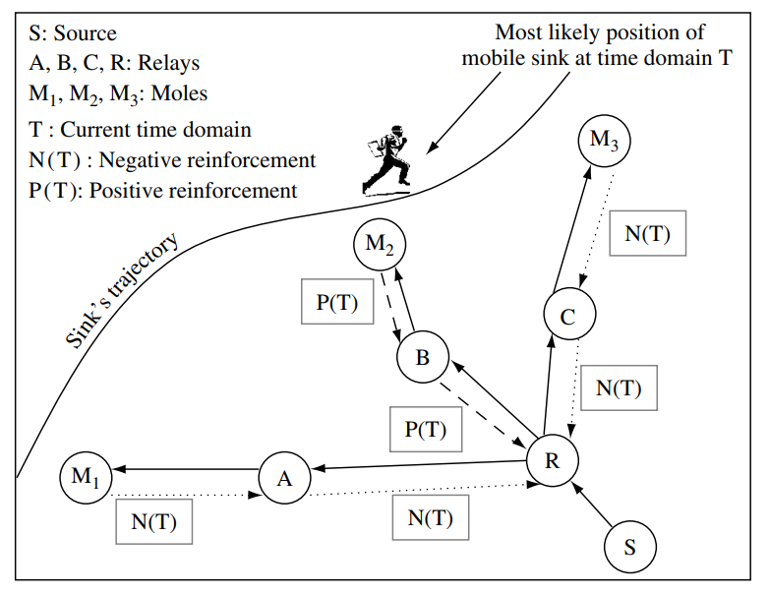

- Data-centric Routing
In Wireless Sensor Networks, data centric routing is used to control the redundancy of data. This is because the sensors nodes don not have global identification number which specifies them uniquely; hence data is transmitted to each node with significant redundancy.
This data-centric approach to networking has two great advantages in terms of efficiency:
- Communication overhead for binding, which could cause significant energy wastage, is minimized.
- In-network processing is enabled because the content moving through the network is identifiable by intermediate nodes. This allows further energy savings through data aggregation and compression.

Directed diffusion technique
One of the first proposed event-based data-centric routing protocols for WSN is the directed diffusion technique
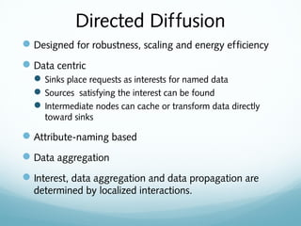
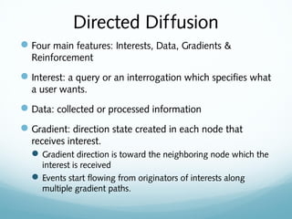
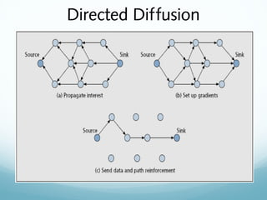
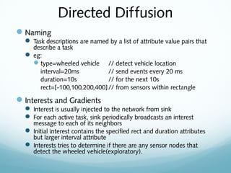
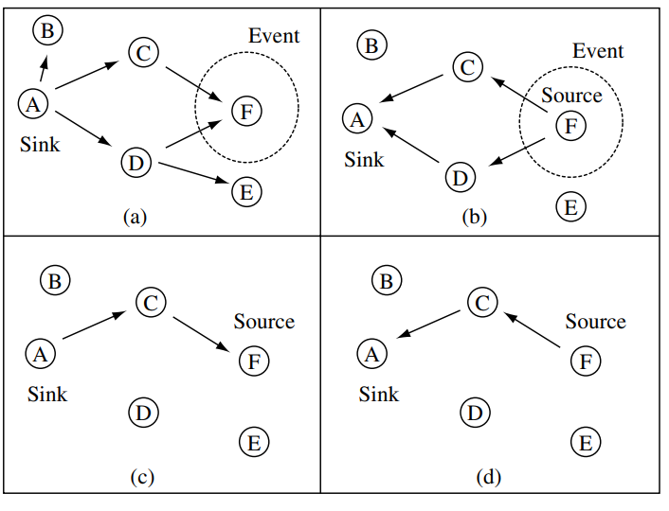
- Data-gathering with compression
Several academics have studied WSN data collection using routing and in-network compression. While compression type is application-specific, these studies show broad concepts and tradeoffs. Most of these studies measure efficiency by counting the total amount of data bit transmissions (i.e., cumulative bits over each hop of transmission) every round of data-gathering from all sources. Combining routing with compression can enhance network data speed and energy efficiency by reducing the number of transmissions, combining routing with compression.
LEACH (Low Energy Adaptive Clustering Hierarchy)
The LEACH protocol is a simple routing mechanism proposed for continuous data-gathering applications.
In LEACH, as shown in figure the network is organized into clusters.
The cluster-heads periodically collect and aggregate/compress the data from nodes within the cluster using TDMA, before sending them to the sink.
The cluster-heads may send to the sink through a direct transmission or through multiple hops. Cluster-heads are rotated periodically for load balancing.
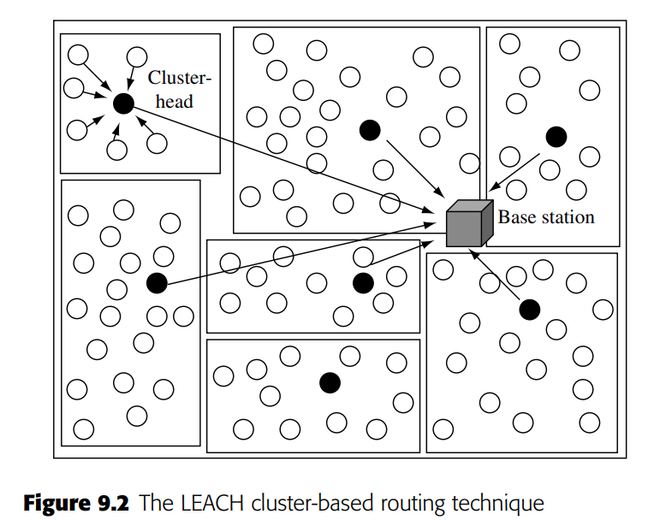
Leach protocol functions in rounds and each round contains two phases; first is cluster setup stage and second is steady state storage with the aim to reduce trivial energy costs.

Also, here in each round some fixed number of cluster heads are elected and do not then stand a chance to become a cluster head next time in one cycle.
This is needed to balance energy consumption. These kinds of protocols are invented to minimize the energy consumption by aggregating data and to reduce the transmission to the base station.
A node can become a cluster head only if it has an energy value greater than a threshold value that is set earlier.
Advantages
There are many advantages of leach protocol. Firstly, cluster heads combine the whole date which leads to the reduction of traffic in the entire network. Secondly, there is a considerable saving in the energy consumption as the routing is single hop from nodes to cluster heads. Thirdly, this protocol improves and increases the lifespan of the network. Fourthly, to create a cluster the location information of node is not necessary. And lastly, leach is self organized and completely distributed as is does not need any control information from the base station.

Disadvantages
The leach protocol has three demerits. Firstly, it does not give a clue about exact number of cluster heads in the network. Secondly, an important disadvantage is that if the cluster head due to some reason dies, then the cluster will be of no use because the data that was collected by the cluster head will never reach the base station. Lastly, since the clusters are distributed randomly, this sometimes results into an increase in energy consumption and can affect the entire network’s performance.
Even though it has many merits and demerits, the Leach Protocol was the first protocol of hierarchical routing which brought in data fusion.
- Querying
In basic data-gathering scenarios, information from all nodes needs to be provided continuously to the sink. In many other settings, the sink may not be interested in all the information that is sensed within the network.
In such cases, the nodes may store the sensed information locally and only transmit it in response to a query issued by the sink. Therefore, the querying of sensors for desired information is a fundamental networking operation in WSN.
Queries can be classified in many ways:
- Continuous versus one-shot queries: depending on whether the queries are requesting a long duration flow or a single datum.
- Simple versus complex queries: complex queries are combinations that consist of multiple simple sub-queries (e.g. queries for a single attribute type); e.g. “What are the location and temperature readings in those nodes in the network where (a) the light intensity is at least w and the humidity level is between x and y OR (b) the light intensity is at least z.” Complex queries may also be aggregate queries that require the aggregation of information from several sources; e.g. “report the average temperature reading from all nodes in region R1.”
- Queries for replicated versus queries for unique data: depending on whether the queries can be satisfied at multiple nodes in the network or only at one such node.
- Queries for historic versus current/ future data: depending on whether the data being queried for were obtained in the past and stored (either locally at the same node or elsewhere in the network), or whether the query is for current/future data. In the latter case data do not need to be retrieved from storage.

- Security

Security and privacy are enormous challenges in all types of wired and wireless networks. These challenges are of even greater importance in wireless sensor networks, where the unique characteristics of these networks and the application purposes they serve make them attractive targets for intrusions and other attacks.
Fundamentals of Network Security
Computer and network security is the collection of all policies, mechanisms, and services that afford a computer system or network the required protection from unauthorized access or unintended uses. Most security mechanisms are built to address three well-known services in the CIA security model: Confidentiality, Integrity, and Availability.
The following describes these services in more detail:
1. Confidentiality: Security mechanisms must ensure that only the intended receiver can correctly interpret a message and that unauthorized access and usage is prevented. For example, confidentiality ensures that sensitive information such as a person’s social security number or credit card information are not obtained by an unauthorized individual.
2. Integrity: Security mechanisms must ensure that a message cannot be modified as it propagates from the sender to the receiver, that is, unauthorized individuals should not be able to destroy or alter the contents of sensitive information.
3. Availability: Security mechanisms must ensure that a system or network and its applications are able to perform their tasks at any time without interruption. Availability is often measured in terms of percentages of up or down time.

Examples of attacks on a transmission between a sender and its intended receiver.
