# Shaeed's Football Project! <FootballPlayersProject>

**Why are we doing this?**

We have been tasked with individual projects to showcase what we have learnt over the 9 weeks at QA's Software Development Bootcamp.

This project included Java, Spring Boot, Junit/Mockito testing, Maven, MySQL, and Git.

**How I expected the challenge to go?**

I expected this challenge to be very tough as it was the first time, I've ever built a spring application on my own.

**What went well:** I was able to create a Spring Boot API with full CRUD functionality, achieved 66% coverage with only 1 test failing using Junit and Mockito, created a git feature branch and finally merged in to master successfully,

connected my API to MySQL and h2 database, successfully created Jira Board.

**What could've been better and possible improvements for future revisions of the project:** I could have added a DTO, and I could've had a higher test coverage.

Link to Jira board -> <https://snoordeen.atlassian.net/jira/software/projects/FOOT/boards/2/backlog?issueParent=10003&selectedIssue=FOOT-1&sprintCompleted=>

***SCREENSHOTS OF POSTMAN REQUEST AND OUTPUT OF API, DATABASE PERSISTENCE AND TEST COVERAGE.***

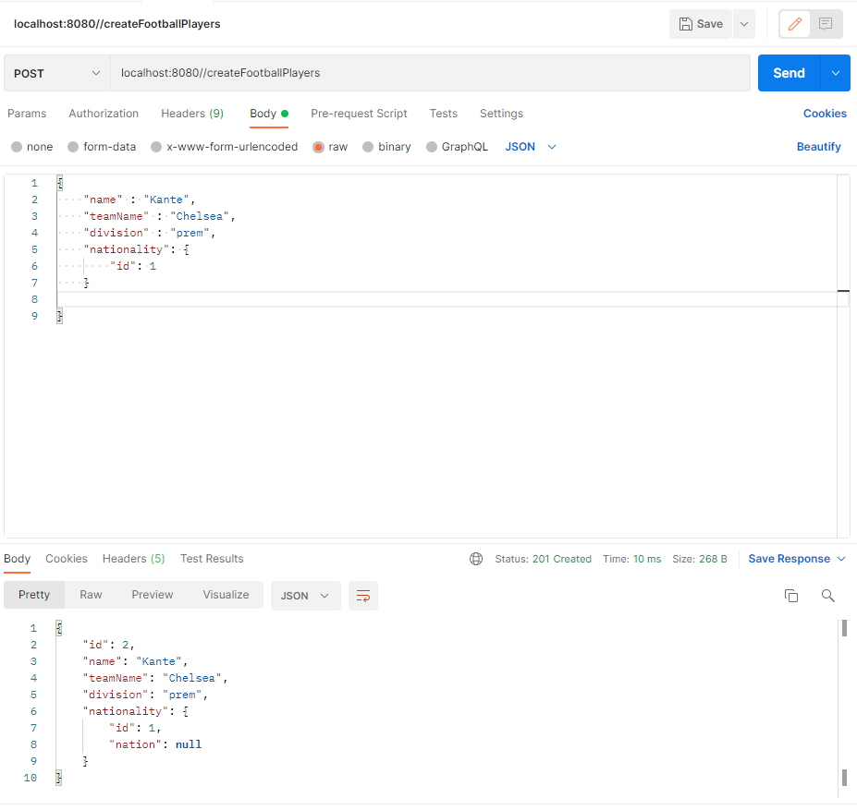**Create players**

**Get Players by id**

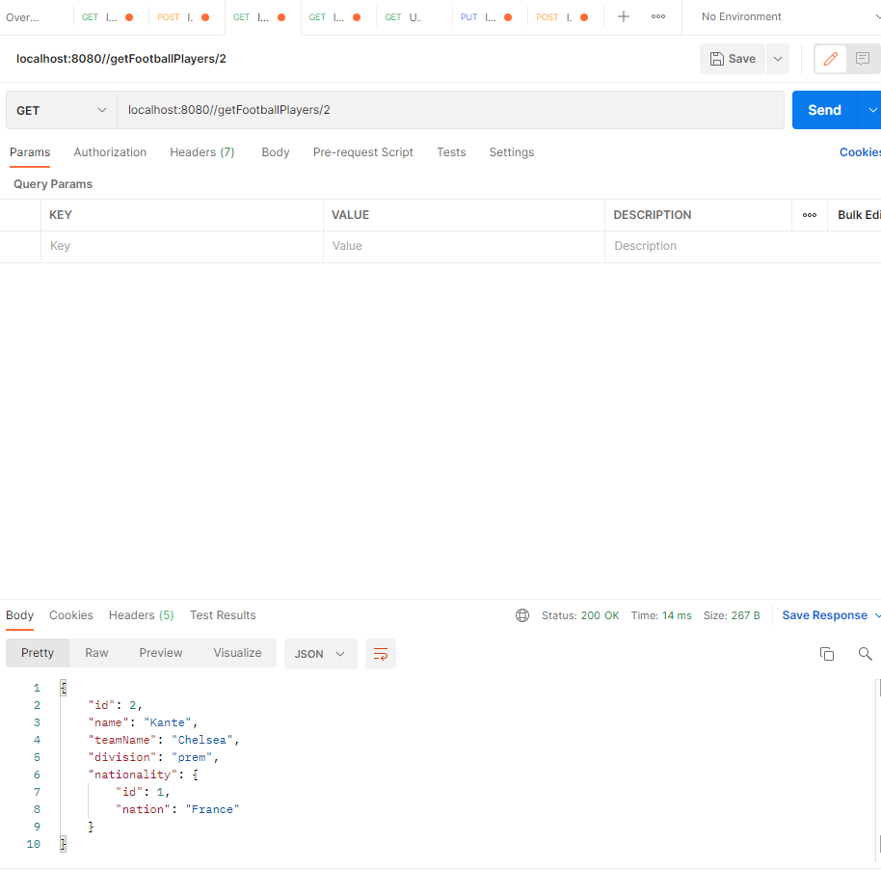

**Get Players by name**

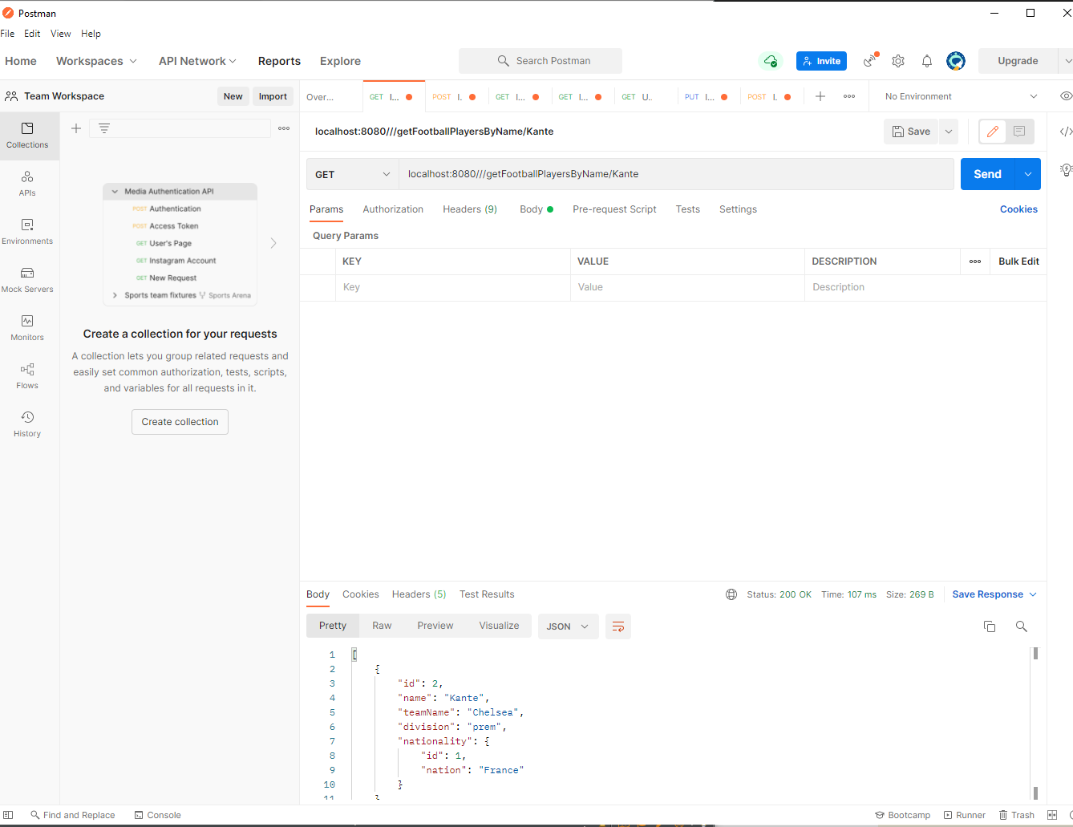

**Get all players**

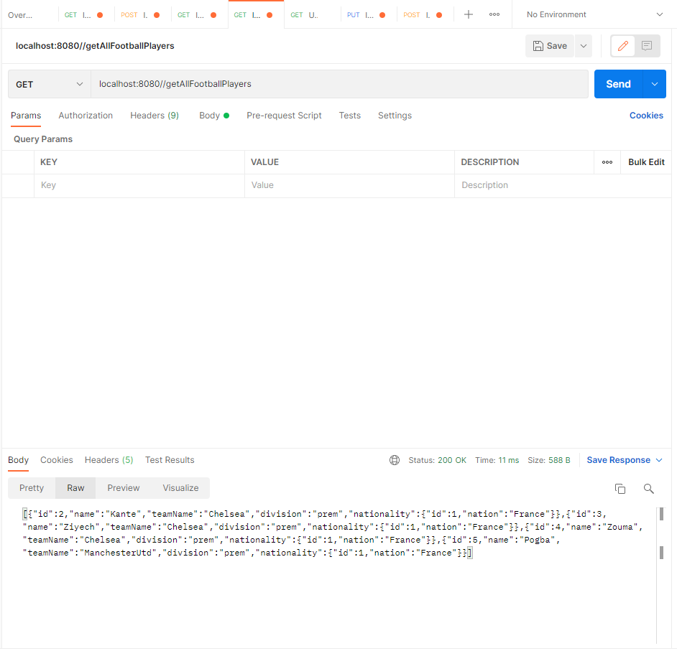

**Update football players**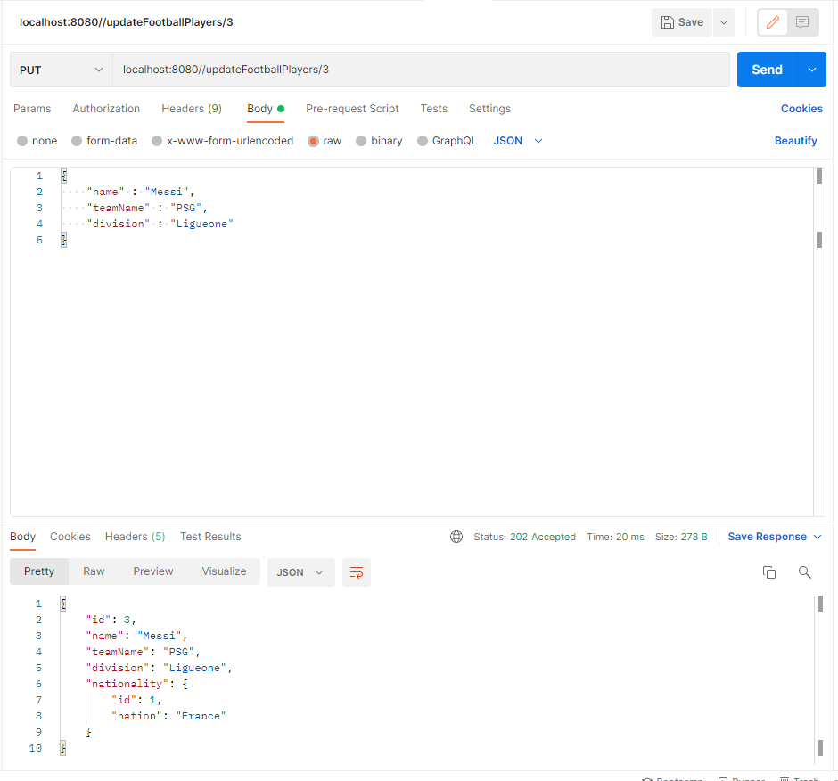

**Delete players**

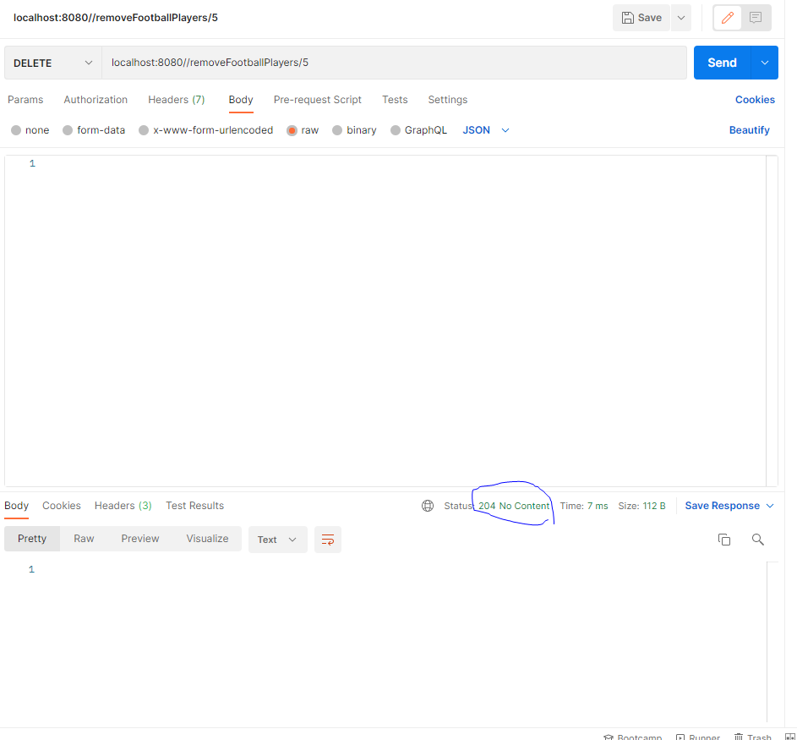

**Add Nationality**

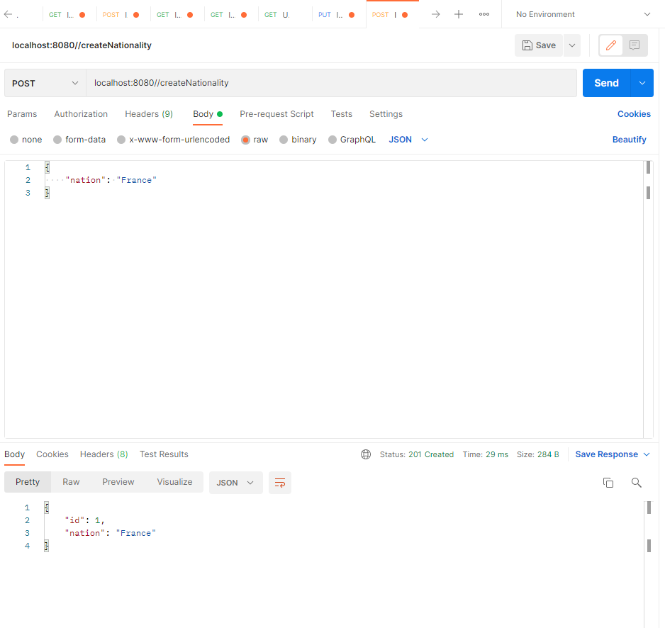

**Database Persistence (H2)**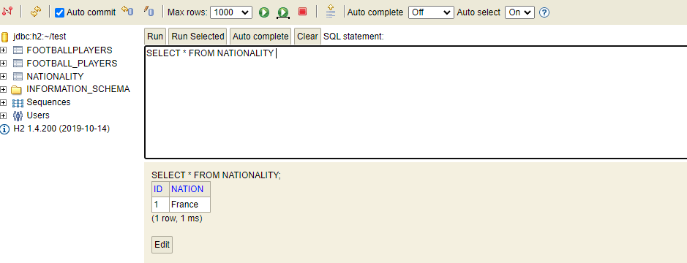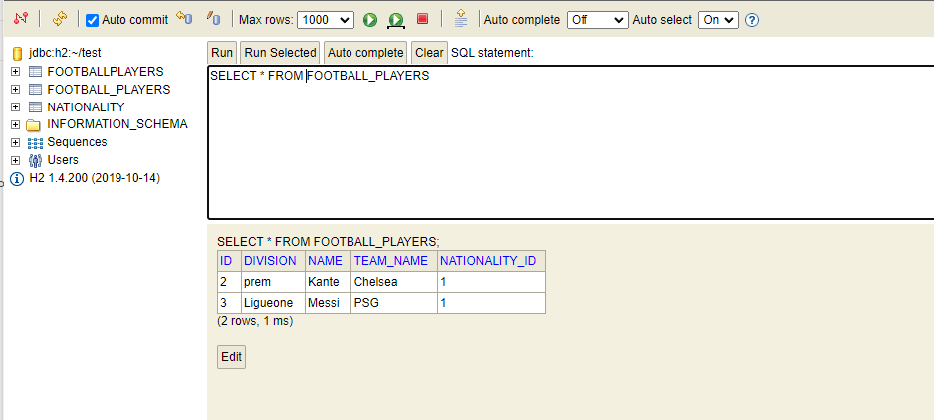

**Test and Coverage**

