- Create your account and login render.com
- Go to your dashboard
- Create a New project (Free tier allows only one project space)
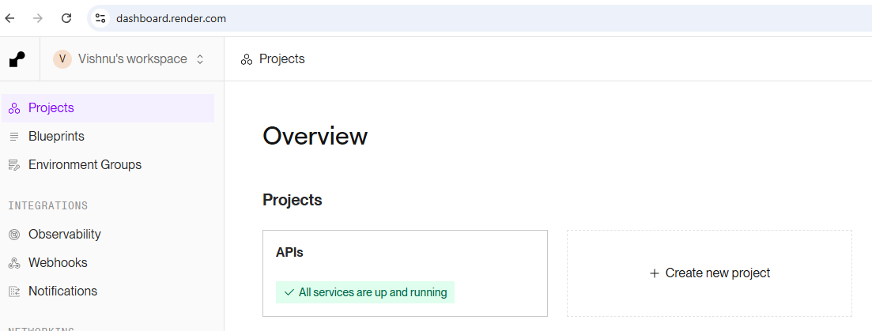
- Once in your project, create a ‘New Service”
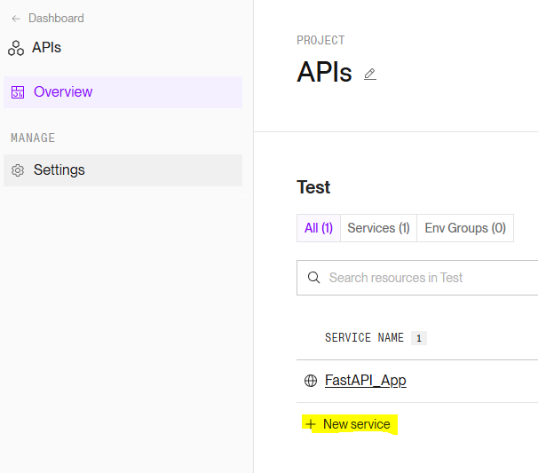
- Choose a “Web Service” while adding
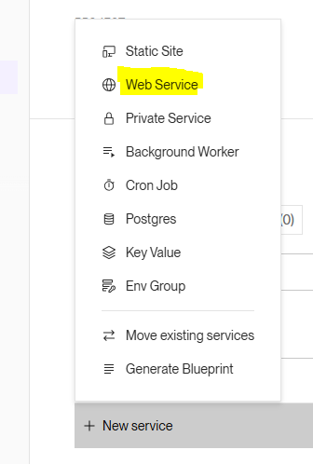
- In your GitHub, create a repository, add the content from ‘1_FastAPI_App’ directory of the code Base. All the files directly to be present in your repo without any sub-folder
- While creating web service in render, Choose your git repo OR choose “Public Git Repository” and provide the link to https://github.com/Vishnu-BKM/FastAPI_App
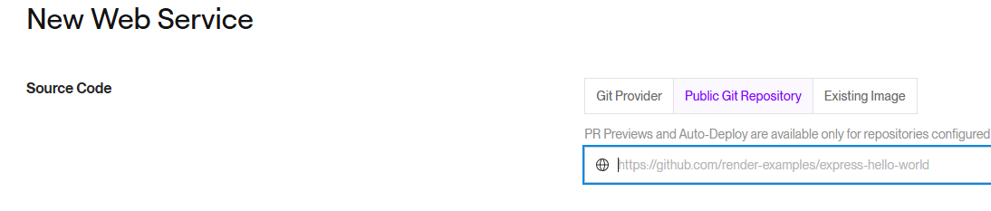
- Once you say ‘connect’, the options appear. Leave all with default, except the following:
  - Start Command : python app.py
  - Choose Free tier
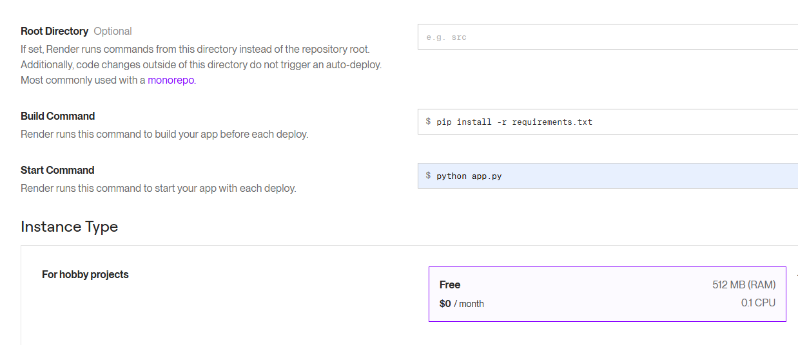
- Say Deploy.
- After a while (since free tier, build and deploy will take some time), Your app will be ready with the url shown
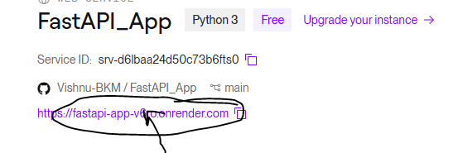
- Copy the Url/docs in your browser to access the app

