**Apple Developer Account Enrollment Tutorial**

I - Developer Account Type:

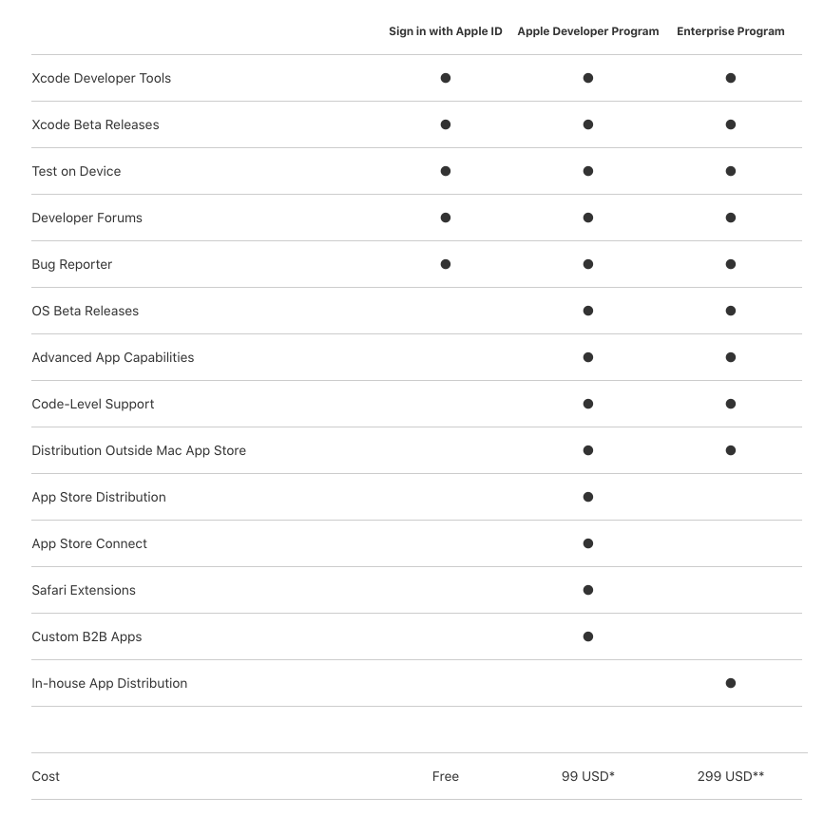

* Choose Apple Developer Program.

II - Register Account:

1. Signing in Apple ID at: <https://developer.apple.com/enroll/>

* Make sure that your account has two factor authentication turned on (setting in <https://appleid.apple.com/account/manage>)
* Choose option Develop at Company / Organization and press Continue

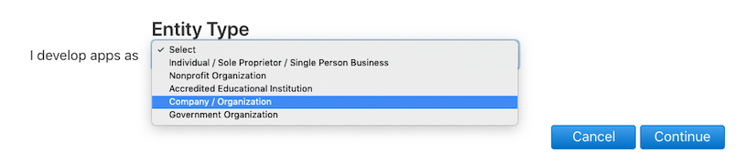

* Check conditions for enrollment.

1. Checking D-U-N-S Number(required for company account register):

* To get company’s D-U-N-S number, choose “Check now” and fill in the form

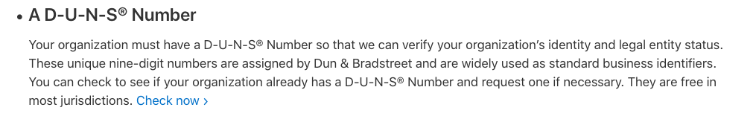

* If company doesn’t have D-U-N-S number, scroll to bottom and choose submit

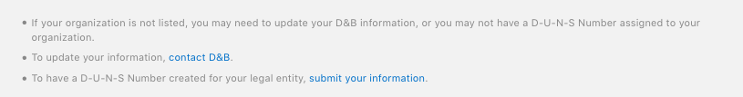

* Register D-U-N-S number: fill company information in the form

Note that in order for the “Work Phone Number” and “Work Email” to be valid in the form, it has to be a non-mobile number, and email domain from the company (i.e. (84-24) 3795-5218 and [lampp@kis-v.com.vn](mailto:lampp@kis-v.com.vn)).

This will need 5 business days to process. After receive the D-U-N-S number, it will need 2 business days for Apple to get company’s D-U-N-S number and information.

1. Register Company Detail:

* After register D-U-N-S number successfully, back to step 1 and choose continue.
* Fill company information in form, this step’s usually take up to 3 business days or more for Apple to process and you will receive an email when this is complete.

1. Payment:

* Use visa/master card or Paypal account to purchase(99$/year).
* Once complete purchase, you will receive a purchase acknowledgement and a membership confirmation email.

**DONE!**