1. Built the generic framework for IV calculator:

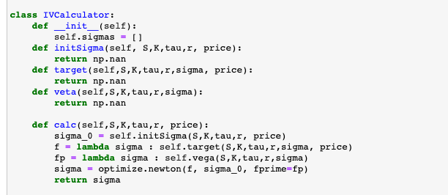

1. Built the BS IV calculator:

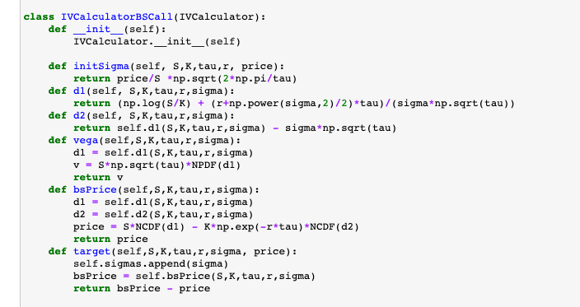

1. Test 1 for CALL BTC-18JAN21 ( bid IV matches)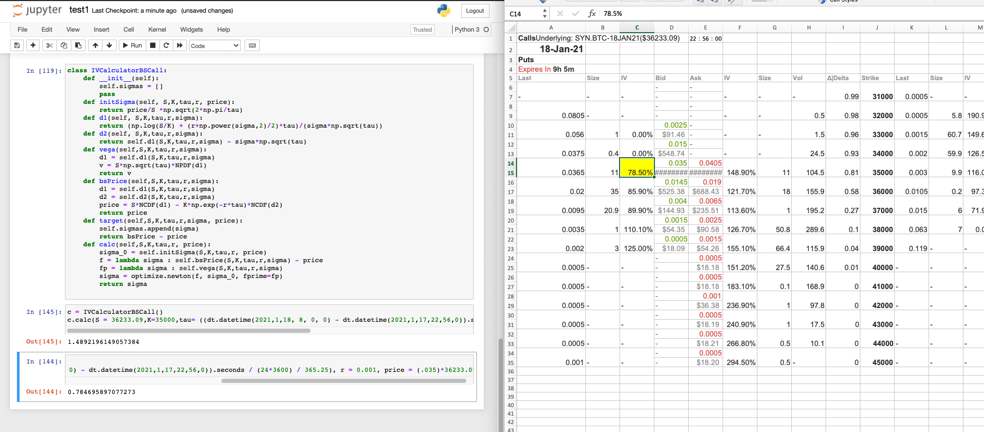
2. Test 1 for CALL BTC-18JAN21 ( ask IV matches)