Programming Assignment 2
Page Rank
By Yang Ou (UFID: 2012-6327 / ouyang89@ufl.edu)
- What is in the submission folder
- Input folder
It contains all kinds of inputs, small, medium and large.
- PageRank.java / SortRank.java / AddInfo.java
PageRank.java iteratively ranks the pages with MapReduce until convergence
SortRank.java sorts the ranks and outputs only 10 records after the iterations implemented in PageRank.java
AddInfo.java outputs the graph information including number of nodes, number of edges, minimum degree, maximum degree and average degree.
- classes folder
It has all compiled classed.
- PageRank.jar
Jar file
- output-small folder
- output-smallGraphInfo folder
- output-medium folder
- output-mediumGraphInfo folder
- output-large folder
- output-largeGraphInfo folder
- runscript-small.sh
Shell script to run the program on FutureGrid.
- runscript-medium.sh
Shell script to run the program on FutureGrid.
- runscript-large.sh
Shell script to run the program on FutureGrid.
- Code design
The PageRank.java will use MapReduce to iteratively rank the pages until they converge. The MapReduce method is shown below:
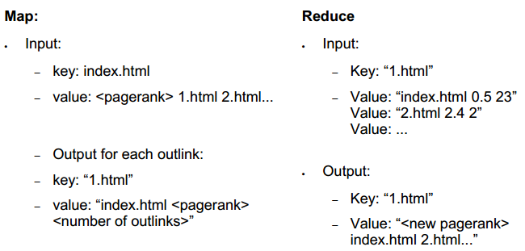
Additionally, the original graph structure (adjacent list) is perserved as output also for the next iteration.
When the ranks converge, SortRank.java uses also MapReduce to sort the ranks and outputs only the top 10 nodes. The MapRecduce method is shown below:
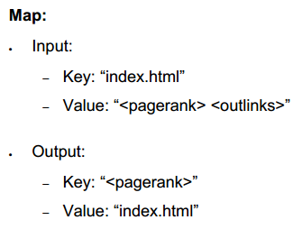
Reduce is simply outputting them.
After that, the graph information is output using another simple MapReduce.
- How many iterations are needed to reach convergence
For me, convergence is defined as 1) the top 10 ranks don’t change for 3 consecutive iterations and 2) The rank values don’t change more than 0.01 in 3 consecutive iterations.
For small graph, it takes 13 iterations to converge.
For medium graph, it takes 11 iterations to converge.
For large graph, it takes 16 iterations to converge.
- How to run the program
- Local machine:
Compile, make JAR file and use the Hadoop command:
hadoop jar PageRank.jar ouyang.PageRank input output
- On AWS:
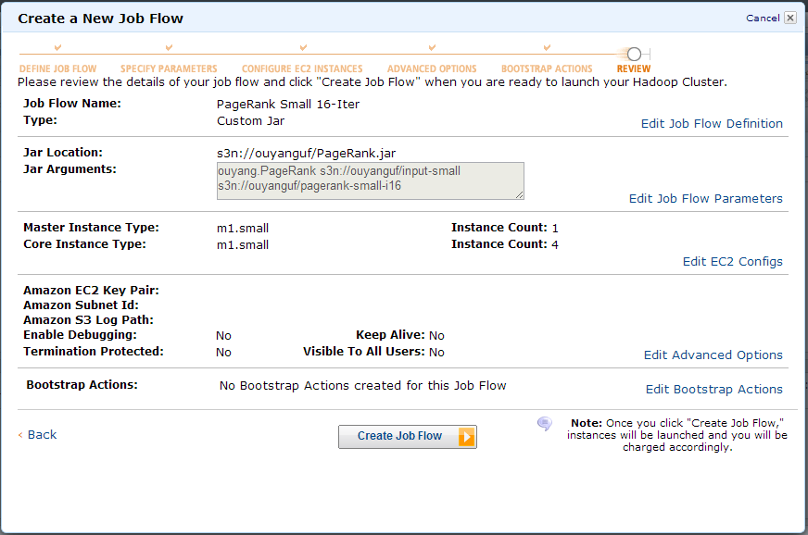

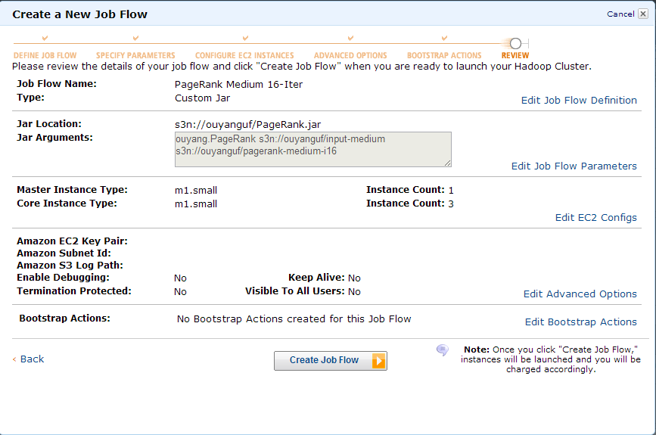

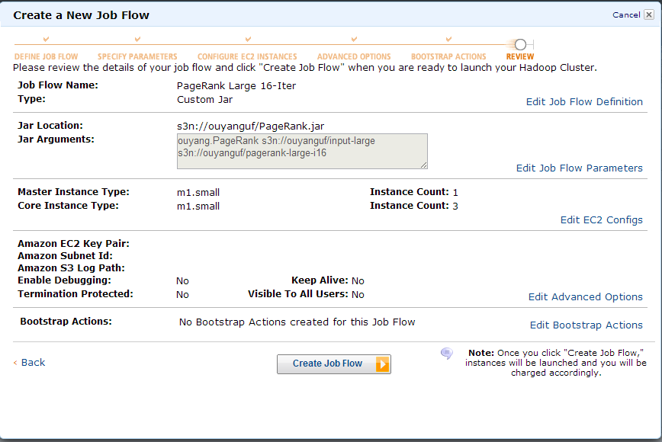
- On FutureGrid
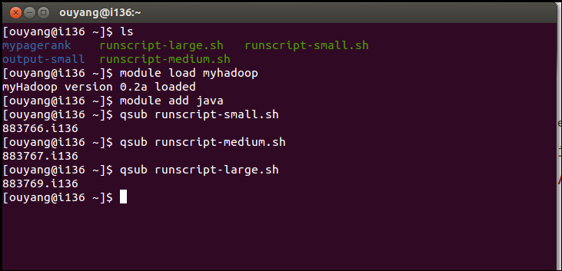
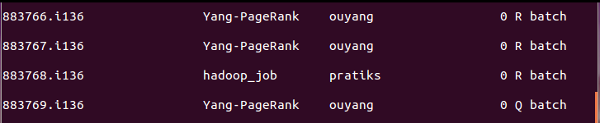
Then a hadoop_run.out will be created as well as the output folder and the outputs are shown in the results section.
- Results
- Results from local hadoop are included in the submisstion folder. Screenshots are shown below.
Output of small graph including top 10 ranks of the pages is shown below:
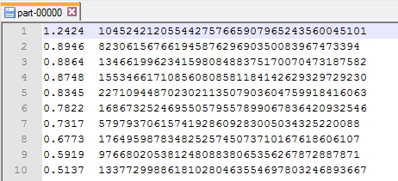
Graph information of the small graph is shown below:
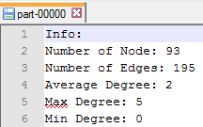
Output of medium graph is shown below:
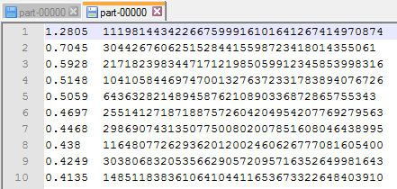
Graph information of medium graph:
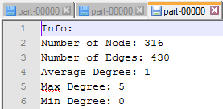
Output of the large graph:
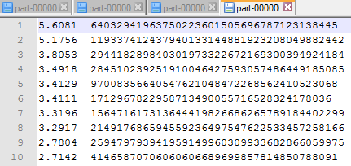
Graph information of the large graph:
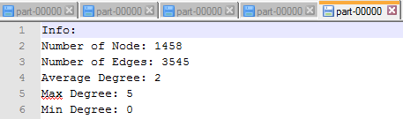
- Results from AWS are listed below:
Rank results of small input:
https://s3.amazonaws.com/ouyanguf/pagerank-small-i16/part-00000
https://s3.amazonaws.com/ouyanguf/pagerank-small-i16/part-00001
https://s3.amazonaws.com/ouyanguf/pagerank-small-i16/part-00002
https://s3.amazonaws.com/ouyanguf/pagerank-small-i16/part-00003
https://s3.amazonaws.com/ouyanguf/pagerank-small-i16/part-00004
https://s3.amazonaws.com/ouyanguf/pagerank-small-i16/part-00005
https://s3.amazonaws.com/ouyanguf/pagerank-small-i16/part-00006
Graph Information of small input:
https://s3.amazonaws.com/ouyanguf/pagerank-small-i16GraphInfo/part-00005
Rank results of medium input:
https://s3.amazonaws.com/ouyanguf/pagerank-medium-i16/part-00000
https://s3.amazonaws.com/ouyanguf/pagerank-medium-i16/part-00001
https://s3.amazonaws.com/ouyanguf/pagerank-medium-i16/part-00002
https://s3.amazonaws.com/ouyanguf/pagerank-medium-i16/part-00003
https://s3.amazonaws.com/ouyanguf/pagerank-medium-i16/part-00004
Graph information of medium input:
https://s3.amazonaws.com/ouyanguf/pagerank-medium-i16GraphInfo/part-00000
Rank results of large input:
https://s3.amazonaws.com/ouyanguf/pagerank-large-i16/part-00000
https://s3.amazonaws.com/ouyanguf/pagerank-large-i16/part-00001
https://s3.amazonaws.com/ouyanguf/pagerank-large-i16/part-00002
https://s3.amazonaws.com/ouyanguf/pagerank-large-i16/part-00003
https://s3.amazonaws.com/ouyanguf/pagerank-large-i16/part-00004
Graph information of large input:
https://s3.amazonaws.com/ouyanguf/pagerank-large-i16GraphInfo/part-00000
- Result from FutureGrid
For small input:
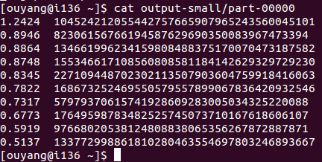
For medium input:
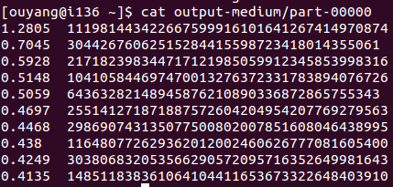
For larger input:
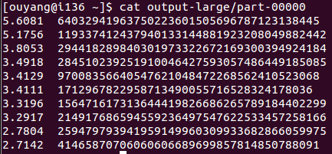
- Comparison
- AWS
For all three graphs, the run time for 16 iterations are almost the same which is shown below:
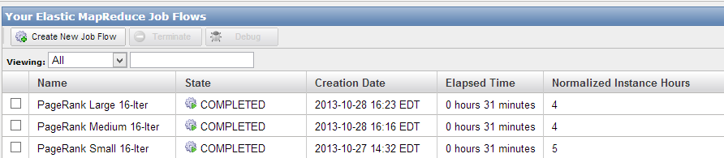
- FutureGrid
For all the graphs I managed to run, the time shown after qstat command is always 00:00:13 like this.
But the real time is different. All the time shown below are recorded by my own stop watch.
For small input, it takes 8 mins 16 secs.
For medium input, it takes 9 mins 20 secs.
For large input, it takes 10 mins 55 secs.
From all the above, we can see that the running performaces are better on FutureGrid. But during time when the india.futuregrid.org server got quite crowded, they took more time than before. I used to have one of them running for more than THREE hours only ending up getting killed by the admin.

- Codes
- PageRank.java
package ouyang;

import ouyang.SortRank;
import ouyang.AddInfo;

import java.io.*;
import java.util.*;

import org.apache.hadoop.fs.*;
import org.apache.hadoop.filecache.DistributedCache;
import org.apache.hadoop.conf.*;
import org.apache.hadoop.io.*;
import org.apache.hadoop.mapred.*;
import org.apache.hadoop.util.*;

public class PageRank extends Configured implements Tool {

public static class Map extends MapReduceBase implements Mapper<LongWritable, Text, Text, Text> {

static enum Counters {INPUT_WORDS}

private Text outputKey = new Text();
private Text outputValue = new Text();
private Text thisLink = new Text();
private double rank = 0.0;
private int degree = 0;

public void map(LongWritable key, Text value, OutputCollector<Text, Text> output, Reporter reporter)
throws IOException {

String line = value.toString();
String[] parts = line.split("[ \t]");

thisLink.set(parts[0]);
if (parts.length >= 2) {
if (parts[1].length() < 10) { // A rank b c...
rank = Double.valueOf(parts[1]);
degree = parts.length - 2;

StringBuilder builder = new StringBuilder();
if (parts.length >= 3) {
for (int i = 2; i < parts.length; i++) {
builder.append(parts[i] + " ");
}
}
outputValue.set("info " + String.valueOf(degree) + " "
+ builder.toString());
output.collect(thisLink, outputValue);

outputValue.set(thisLink.toString() + " "
+ String.valueOf(rank) + " "
+ String.valueOf(degree));
if (parts.length >= 3) {
for (int i = 2; i < parts.length; i++) {
outputKey.set(parts[i]);
output.collect(outputKey, outputValue);
reporter.incrCounter(Counters.INPUT_WORDS, 1);
}
}
} else { // A (no rank) b c ...
rank = 1.0;
degree = parts.length - 1;

StringBuilder builder = new StringBuilder();
if (parts.length >= 2) {
for (int i = 1; i < parts.length; i++) {
builder.append(parts[i] + " ");
}
}
outputValue.set("info " + String.valueOf(degree) + " "
+ builder.toString());
output.collect(thisLink, outputValue);

outputValue.set(thisLink.toString() + " "
+ String.valueOf(rank) + " "
+ String.valueOf(degree));
for (int i = 1; i < parts.length; i++) {
outputKey.set(parts[i]);
output.collect(outputKey, outputValue);
reporter.incrCounter(Counters.INPUT_WORDS, 1);
}
}
} else {// only A
rank = 1.0;
degree = parts.length - 1;

outputValue.set("info 0");
output.collect(thisLink, outputValue);
}

}
}

public static class Reduce extends MapReduceBase implements Reducer<Text, Text, Text, Text> {

private double factor = 0.85;
private Text outputValue = new Text();
//private int numNodes = 0;
//private int numEdges = 0;
//private int minDegree = 1000;
//private int maxDegree = 1;

// public void configure(JobConf job) {
// job.getDouble("pagerank.factor",0.85);
// }

public void reduce(Text key, Iterator<Text> values, OutputCollector<Text, Text> output, Reporter reporter)
throws IOException {

double sum = 0.00;
String outlinks = "";

while (values.hasNext()) {
String line = values.next().toString();
String[] parts = line.split("[ \t]");

if (!parts[0].equals("info")) {//Not info message
sum += Double.valueOf(parts[1]) / Double.valueOf(parts[2]);
} else {// info message
// numNodes++;
// int degree = Integer.parseInt(parts[1]);
// numEdges += degree;
// minDegree = degree < minDegree ? degree : minDegree;
// maxDegree = degree > maxDegree ? degree : maxDegree;
if (parts.length > 2) {
for (int i = 2; i < parts.length; i++) {
outlinks = outlinks.concat(parts[i] + " ");
}
}
}
}
sum = factor * sum + 1 - factor;
sum = Math.round(sum * 10000.0) / 10000.0;
outputValue.set(String.valueOf(sum) + " " + outlinks);
output.collect(key, outputValue);
}
}

public int run(String[] args) throws Exception {

JobConf conf = new JobConf(PageRank.class);
FileSystem fs = FileSystem.get(conf);
//Path temp = new Path("temp");
Path inpath = new Path(" ");
Path outpath = new Path(" ");
int numIter = (args.length == 3) ? Integer.parseInt(args[2]) : 16;

for(int i = 1; i<=numIter;i++){
inpath = (i == 1) ? (new Path(args[0])) : (new Path("outputOfThe"+String.valueOf(i-1)));
//outpath = (i == numIter) ? (new Path(args[1])) : (new Path("outputOfThe"+String.valueOf(i)));
outpath = new Path("outputOfThe"+String.valueOf(i));
conf = new JobConf(PageRank.class);

conf.setJobName("PageRankIteration");
conf.setMapperClass(Map.class);
conf.setReducerClass(Reduce.class);
conf.setOutputKeyClass(Text.class);
conf.setOutputValueClass(Text.class);
conf.setInputFormat(TextInputFormat.class);
conf.setOutputFormat(TextOutputFormat.class);
FileInputFormat.setInputPaths(conf, inpath);
FileOutputFormat.setOutputPath(conf, outpath);
JobClient.runJob(conf);
fs = FileSystem.get(conf);
if(i!=1) {
fs.delete(new Path("outputOfThe"+String.valueOf(i-1)),true);
}
}

conf = new JobConf(SortRank.class);
conf.setJobName("SortRank");
conf.setMapperClass(SortRank.Map.class);
conf.setReducerClass(SortRank.Reduce.class);
conf.setOutputKeyClass(Text.class);
conf.setOutputValueClass(Text.class);
conf.setInputFormat(TextInputFormat.class);
conf.setOutputFormat(TextOutputFormat.class);
FileInputFormat.setInputPaths(conf, new Path("outputOfThe"+String.valueOf(numIter)));
FileOutputFormat.setOutputPath(conf, new Path(args[1]));
JobClient.runJob(conf);
fs = FileSystem.get(conf);
fs.delete(new Path("outputOfThe"+String.valueOf(numIter)),true);

conf = new JobConf(AddInfo.class);
conf.setJobName("AddInfo");
conf.setMapperClass(AddInfo.Map.class);
conf.setReducerClass(AddInfo.Reduce.class);
conf.setOutputKeyClass(Text.class);
conf.setOutputValueClass(Text.class);
conf.setInputFormat(TextInputFormat.class);
conf.setOutputFormat(TextOutputFormat.class);
FileInputFormat.setInputPaths(conf, new Path(args[0]));
FileOutputFormat.setOutputPath(conf, new Path(args[1] + "GraphInfo"));
JobClient.runJob(conf);
//fs = FileSystem.get(conf);
//fs.delete(new Path("outputOfThe"+String.valueOf(numIter)),true);

return 0;
}

public static void main(String[] args) throws Exception {
int res = ToolRunner.run(new Configuration(), new PageRank(), args);
System.exit(res);
}

}

- SortRank.java
package ouyang;

import ouyang.PageRank;

import java.io.*;
import java.util.*;

import org.apache.hadoop.fs.*;
import org.apache.hadoop.filecache.DistributedCache;
import org.apache.hadoop.conf.*;
import org.apache.hadoop.io.*;
import org.apache.hadoop.mapred.*;
import org.apache.hadoop.util.*;

public class SortRank extends Configured {//implements Tool {

public static class Map extends MapReduceBase implements Mapper<LongWritable, Text, Text, Text> {

private Text outputKey = new Text();
private Text outputValue = new Text();

public void map(LongWritable key, Text value, OutputCollector<Text, Text> output, Reporter reporter)
throws IOException {

String line = value.toString();
String[] parts = line.split("[ \t]");
outputValue.set(parts[0]);
outputKey.set(String.valueOf(100.0 - Double.valueOf(parts[1])));
output.collect(outputKey, outputValue);
}
}

public static class Reduce extends MapReduceBase implements Reducer<Text, Text, Text, Text> {

private int numOutput = 0;
//private Text empty = new Text();
public void reduce(Text key, Iterator<Text> values, OutputCollector<Text, Text> output, Reporter reporter)
throws IOException {
while (values.hasNext()) {
//String line = values.next().toString();
double thekey = Math.round((100.0 - Double.valueOf(key.toString())) * 10000.0) / 10000.0;
Text newkey = new Text(String.valueOf(thekey));
//value.set(line);
//System.out.println(numOutput);
if(numOutput < 10) { //Number of displayed records
output.collect(newkey, values.next());
numOutput++;
} else {
values.next();
//output.collect(empty, empty);
}

}
}
}
}

- AddInfo.java
package ouyang;

import ouyang.PageRank;

import java.io.*;
import java.util.*;

import org.apache.hadoop.fs.*;
import org.apache.hadoop.filecache.DistributedCache;
import org.apache.hadoop.conf.*;
import org.apache.hadoop.io.*;
import org.apache.hadoop.mapred.*;
import org.apache.hadoop.util.*;

public class AddInfo extends Configured {//implements Tool {

public static class Map extends MapReduceBase implements Mapper<LongWritable, Text, Text, Text> {

static enum Counters {INPUT_WORDS}

private Text outputKey = new Text();
private Text outputValue = new Text();
private Text thisLink = new Text();
private double rank = 0.0;
private int degree = 0;

public void map(LongWritable key, Text value, OutputCollector<Text, Text> output, Reporter reporter)
throws IOException {

String line = value.toString();
String[] parts = line.split("[ \t]");

degree = parts.length - 1;

StringBuilder builder = new StringBuilder();
if (parts.length >= 3) {
for (int i = 2; i < parts.length; i++) {
builder.append(parts[i] + " ");
}
}
outputKey.set("Info:");
outputValue.set(String.valueOf(degree));
output.collect(outputKey, outputValue);

//outputValue.set(parts[1] + " " + builder.toString());
//output.collect(thisLink, outputValue);
}
}

public static class Reduce extends MapReduceBase implements Reducer<Text, Text, Text, Text> {

//private double factor = 0.85;
private Text outputValue = new Text();
private int numNodes = 0;
private int numEdges = 0;
private int minDegree = 99999;
private int maxDegree = 0;

// public void configure(JobConf job) {
// job.getDouble("pagerank.factor",0.85);
// }

public void reduce(Text key, Iterator<Text> values, OutputCollector<Text, Text> output, Reporter reporter)
throws IOException {

//double sum = 0.00;
//String outlinks = "";

while (values.hasNext()) {// && key.toString().equals("Info:"))
String line = values.next().toString();
String[] parts = line.split("[ \t]");
numNodes++;

int degree = Integer.parseInt(parts[0]);
numEdges += degree;
if(degree<minDegree)
minDegree = degree;
if(degree > maxDegree)
maxDegree = degree;
}
if(key.toString().equals("Info:")){
Text out = new Text();
out.set("\nNumber of Node: "+numNodes+ "\nNumber of Edges: "+ numEdges + "\nAverage Degree: " + numEdges/numNodes + "\nMax Degree: "+ maxDegree + "\nMin Degree: "+ minDegree);
output.collect(key, out);
} else {
output.collect(key, values.next());
}
}
}
}

- runscript-small.sh
#!/bin/bash

#PBS -q batch
#PBS -N Yang-PageRank
#PBS -l nodes=4:ppn=8
#PBS -o hadoop_run.out
#PBS -e hadoop_run.err
#PBS -j oe
#PBS -V

module add java

### Run the myHadoop environment script to set the appropriate variables
#
# Note: ensure that the variables are set correctly in bin/setenv.sh
. /N/soft/myHadoop/bin/setenv.sh

#### Set this to the directory where Hadoop configs should be generated
# Don't change the name of this variable (HADOOP_CONF_DIR) as it is
# required by Hadoop - all config files will be picked up from here
#
# Make sure that this is accessible to all nodes
export HADOOP_CONF_DIR="${HOME}/myHadoop-config"

#### Set up the configuration
# Make sure number of nodes is the same as what you have requested from PBS
# usage: $MY_HADOOP_HOME/bin/pbs-configure.sh -h
echo "Set up the configurations for myHadoop"
# this is the non-persistent mode
$MY_HADOOP_HOME/bin/pbs-configure.sh -n 4 -c $HADOOP_CONF_DIR
# this is the persistent mode
# $MY_HADOOP_HOME/bin/pbs-configure.sh -n 4 -c $HADOOP_CONF_DIR -p -d /oasis/cloudstor-group/HDFS
echo

#### Format HDFS, if this is the first time or not a persistent instance
echo "Format HDFS"
$HADOOP_HOME/bin/hadoop --config $HADOOP_CONF_DIR namenode -format
echo

#### Start the Hadoop cluster
echo "Start all Hadoop daemons"
$HADOOP_HOME/bin/start-all.sh
#$HADOOP_HOME/bin/hadoop dfsadmin -safemode leave
echo

#### Run your jobs here
echo "Run the Hadoop jobs"
$HADOOP_HOME/bin/hadoop --config $HADOOP_CONF_DIR dfs -mkdir Data
$HADOOP_HOME/bin/hadoop --config $HADOOP_CONF_DIR dfs -copyFromLocal $HOME/mypagerank/input/small-input Data
$HADOOP_HOME/bin/hadoop --config $HADOOP_CONF_DIR dfs -ls Data/small-input
$HADOOP_HOME/bin/hadoop --config $HADOOP_CONF_DIR jar $HOME/mypagerank/PageRank.jar ouyang.PageRank Data/small-input Outputs
$HADOOP_HOME/bin/hadoop --config $HADOOP_CONF_DIR dfs -ls Outputs
$HADOOP_HOME/bin/hadoop --config $HADOOP_CONF_DIR dfs -copyToLocal Outputs $HOME/output-small
echo

#### Stop the Hadoop cluster
echo "Stop all Hadoop daemons"
$HADOOP_HOME/bin/stop-all.sh
echo

#### Clean up the working directories after job completion
echo "Clean up"
$MY_HADOOP_HOME/bin/pbs-cleanup.sh -n 4 -c $HADOOP_CONF_DIR
echo

- runscript-medium.sh
#!/bin/bash

#PBS -q batch
#PBS -N Yang-PageRank
#PBS -l nodes=4:ppn=8
#PBS -o hadoop_run.out
#PBS -e hadoop_run.err
#PBS -j oe
#PBS -V

module add java

### Run the myHadoop environment script to set the appropriate variables
#
# Note: ensure that the variables are set correctly in bin/setenv.sh
. /N/soft/myHadoop/bin/setenv.sh

#### Set this to the directory where Hadoop configs should be generated
# Don't change the name of this variable (HADOOP_CONF_DIR) as it is
# required by Hadoop - all config files will be picked up from here
#
# Make sure that this is accessible to all nodes
export HADOOP_CONF_DIR="${HOME}/myHadoop-config"

#### Set up the configuration
# Make sure number of nodes is the same as what you have requested from PBS
# usage: $MY_HADOOP_HOME/bin/pbs-configure.sh -h
echo "Set up the configurations for myHadoop"
# this is the non-persistent mode
$MY_HADOOP_HOME/bin/pbs-configure.sh -n 4 -c $HADOOP_CONF_DIR
# this is the persistent mode
# $MY_HADOOP_HOME/bin/pbs-configure.sh -n 4 -c $HADOOP_CONF_DIR -p -d /oasis/cloudstor-group/HDFS
echo

#### Format HDFS, if this is the first time or not a persistent instance
echo "Format HDFS"
$HADOOP_HOME/bin/hadoop --config $HADOOP_CONF_DIR namenode -format
echo

#### Start the Hadoop cluster
echo "Start all Hadoop daemons"
$HADOOP_HOME/bin/start-all.sh
#$HADOOP_HOME/bin/hadoop dfsadmin -safemode leave
echo

#### Run your jobs here
echo "Run the Hadoop jobs"
$HADOOP_HOME/bin/hadoop --config $HADOOP_CONF_DIR dfs -mkdir Data
$HADOOP_HOME/bin/hadoop --config $HADOOP_CONF_DIR dfs -copyFromLocal $HOME/mypagerank/input/medium-input Data
$HADOOP_HOME/bin/hadoop --config $HADOOP_CONF_DIR dfs -ls Data/medium-input
$HADOOP_HOME/bin/hadoop --config $HADOOP_CONF_DIR jar $HOME/mypagerank/PageRank.jar ouyang.PageRank Data/medium-input Outputs
$HADOOP_HOME/bin/hadoop --config $HADOOP_CONF_DIR dfs -ls Outputs
$HADOOP_HOME/bin/hadoop --config $HADOOP_CONF_DIR dfs -copyToLocal Outputs $HOME/output-medium
echo

#### Stop the Hadoop cluster
echo "Stop all Hadoop daemons"
$HADOOP_HOME/bin/stop-all.sh
echo

#### Clean up the working directories after job completion
echo "Clean up"
$MY_HADOOP_HOME/bin/pbs-cleanup.sh -n 4 -c $HADOOP_CONF_DIR
Echo
- runscript-large.sh
#!/bin/bash

#PBS -q batch
#PBS -N Yang-PageRank
#PBS -l nodes=4:ppn=8
#PBS -o hadoop_run.out
#PBS -e hadoop_run.err
#PBS -j oe
#PBS -V

module add java

### Run the myHadoop environment script to set the appropriate variables
#
# Note: ensure that the variables are set correctly in bin/setenv.sh
. /N/soft/myHadoop/bin/setenv.sh

#### Set this to the directory where Hadoop configs should be generated
# Don't change the name of this variable (HADOOP_CONF_DIR) as it is
# required by Hadoop - all config files will be picked up from here
#
# Make sure that this is accessible to all nodes
export HADOOP_CONF_DIR="${HOME}/myHadoop-config"

#### Set up the configuration
# Make sure number of nodes is the same as what you have requested from PBS
# usage: $MY_HADOOP_HOME/bin/pbs-configure.sh -h
echo "Set up the configurations for myHadoop"
# this is the non-persistent mode
$MY_HADOOP_HOME/bin/pbs-configure.sh -n 4 -c $HADOOP_CONF_DIR
# this is the persistent mode
# $MY_HADOOP_HOME/bin/pbs-configure.sh -n 4 -c $HADOOP_CONF_DIR -p -d /oasis/cloudstor-group/HDFS
echo

#### Format HDFS, if this is the first time or not a persistent instance
echo "Format HDFS"
$HADOOP_HOME/bin/hadoop --config $HADOOP_CONF_DIR namenode -format
echo

#### Start the Hadoop cluster
echo "Start all Hadoop daemons"
$HADOOP_HOME/bin/start-all.sh
#$HADOOP_HOME/bin/hadoop dfsadmin -safemode leave
echo

#### Run your jobs here
echo "Run the Hadoop jobs"
$HADOOP_HOME/bin/hadoop --config $HADOOP_CONF_DIR dfs -mkdir Data
$HADOOP_HOME/bin/hadoop --config $HADOOP_CONF_DIR dfs -copyFromLocal $HOME/mypagerank/input/large-input Data
$HADOOP_HOME/bin/hadoop --config $HADOOP_CONF_DIR dfs -ls Data/large-input
$HADOOP_HOME/bin/hadoop --config $HADOOP_CONF_DIR jar $HOME/mypagerank/PageRank.jar ouyang.PageRank Data/large-input Outputs
$HADOOP_HOME/bin/hadoop --config $HADOOP_CONF_DIR dfs -ls Outputs
$HADOOP_HOME/bin/hadoop --config $HADOOP_CONF_DIR dfs -copyToLocal Outputs $HOME/output-large
echo

#### Stop the Hadoop cluster
echo "Stop all Hadoop daemons"
$HADOOP_HOME/bin/stop-all.sh
echo

#### Clean up the working directories after job completion
echo "Clean up"
$MY_HADOOP_HOME/bin/pbs-cleanup.sh -n 4 -c $HADOOP_CONF_DIR
echo

