Programming Assignment 1

For Cloud Computing and Storage

Yang OU (UFID: 2012-6327)

Task ONE
- Source code locations:
- See Appendix A of this article (source code pasted)
- Assignment1/wordcount1/WordCount.java
- Jar file location:
- Assignment1/wordcount1/WordCount1.jar
- Input:
- Local:
Assignment1/wordcount1/input/bible+shakes1.nopunc
……
Assignment1/wordcount1/input/bible+shakes10.nopunc (10 copied of bible)
- Amazon S3:
https://s3.amazonaws.com/ouyanguf/input/bible%2Bshakes1.nopunc
……
https://s3.amazonaws.com/ouyanguf/input/bible%2Bshakes10.nopunc (10 copies)
- How to run:
- Local:
cd into Assignment1/wordcount1 and type command
$ hadoop jar WordCount1.jar WordCount input output
(Default Setting: Enable Case Sensitive. To disable, add “-Dwordcount.case.sensitive=false” to command)
- Amazon EMR:
See Appendix D of this article (Screenshots pasted)
(Default Setting: Enable Case Sensitive. To disable, add “-Dwordcount.case.sensitive=false” to command)
- Results:
- Results from local Hadoop: Assignemt1/wordcount1/output
- Results from Amazon EMR:
https://s3.amazonaws.com/ouyanguf/output1/part-00000
https://s3.amazonaws.com/ouyanguf/output1/part-00001
https://s3.amazonaws.com/ouyanguf/output1/part-00002
https://s3.amazonaws.com/ouyanguf/output1/part-00003
https://s3.amazonaws.com/ouyanguf/output1/part-00004

Task TWO
- Source code locations:
- See Appendix B of this article (source code pasted)
- Assignment1/wordcount2/WordCount.java
- Jar file location:
- Assignment1/wordcount2/WordCount2.jar
- Input:
- Local:
Assignment1/wordcount2/input/bible+shakes1.nopunc
……
Assignment1/wordcount2/input/bible+shakes10.nopunc (10 copied of bible)
- Amazon S3:
https://s3.amazonaws.com/ouyanguf/input/bible%2Bshakes1.nopunc
……
https://s3.amazonaws.com/ouyanguf/input/bible%2Bshakes10.nopunc (10 copies)
- How to run:
- Local:
cd into Assignment1/wordcount2 and type command
$ hadoop jar WordCount2.jar WordCount input output
- Amazon EMR:
See Appendix E of this article (Screenshots pasted)
- Results:
- Results from local Hadoop: Assignemt1/wordcount2/output
- Results from Amazon EMR:
https://s3.amazonaws.com/ouyanguf/output2/part-00000
https://s3.amazonaws.com/ouyanguf/output2/part-00001
https://s3.amazonaws.com/ouyanguf/output2/part-00002
https://s3.amazonaws.com/ouyanguf/output2/part-00003
https://s3.amazonaws.com/ouyanguf/output2/part-00004

Task THREE
- Source code locations:
- See Appendix C of this article (source code pasted)
- Assignment1/wordcount3/WordCount.java
- Jar file location:
- Assignment1/wordcount3/WordCount3.jar
- Input:
- Local:
Assignment1/wordcount3/input/bible+shakes1.nopunc
……
Assignment1/wordcount3/input/bible+shakes10.nopunc (10 copied of bible)
- Amazon S3:
https://s3.amazonaws.com/ouyanguf/input/bible%2Bshakes1.nopunc
……
https://s3.amazonaws.com/ouyanguf/input/bible%2Bshakes10.nopunc (10 copies)
- Patterns File:
Assignment1/wordcount3/word-patterns.txt
- How to run:
- Local:
cd into Assignment1/wordcount3 and type command
$ hadoop jar WordCount3.jar WordCount input output –only word-patterns.txt
- Amazon EMR:
See Appendix F of this article (Screenshots pasted)
- Results:
- Results from local Hadoop: Assignemt1/wordcount3/output
- Results from Amazon EMR:
https://s3.amazonaws.com/ouyanguf/output3/part-00000
https://s3.amazonaws.com/ouyanguf/output3/part-00001
https://s3.amazonaws.com/ouyanguf/output3/part-00002
https://s3.amazonaws.com/ouyanguf/output3/part-00003
https://s3.amazonaws.com/ouyanguf/output3/part-00004

Appendix A
Source code of task 1

import java.io.*;
import java.util.*;

import org.apache.hadoop.fs.Path;
import org.apache.hadoop.filecache.DistributedCache;
import org.apache.hadoop.conf.*;
import org.apache.hadoop.io.*;
import org.apache.hadoop.mapred.*;
import org.apache.hadoop.util.*;

public class WordCount extends Configured implements Tool {

public static class Map extends MapReduceBase implements Mapper<LongWritable, Text, Text, IntWritable> {

static enum Counters { INPUT_WORDS }

private final static IntWritable one = new IntWritable(1);
private Text word = new Text();

private boolean caseSensitive = true;
private Set<String> patternsToSkip = new HashSet<String>();

private long numRecords = 0;
private String inputFile;

public void configure(JobConf job) {
caseSensitive = job.getBoolean("wordcount.case.sensitive", true);
inputFile = job.get("map.input.file");

if (job.getBoolean("wordcount.skip.patterns", false)) {
Path[] patternsFiles = new Path[0];
try {
patternsFiles = DistributedCache.getLocalCacheFiles(job);
} catch (IOException ioe) {
System.err.println("Caught exception while getting cached files: " + StringUtils.stringifyException(ioe));
}
for (Path patternsFile : patternsFiles) {
parseSkipFile(patternsFile);
}
}
}

private void parseSkipFile(Path patternsFile) {
try {
BufferedReader fis = new BufferedReader(new FileReader(patternsFile.toString()));
String pattern = null;
while ((pattern = fis.readLine()) != null) {
patternsToSkip.add(pattern);
}
} catch (IOException ioe) {
System.err.println("Caught exception while parsing the cached file '" + patternsFile + "' : " + StringUtils.stringifyException(ioe));
}
}

public void map(LongWritable key, Text value, OutputCollector<Text, IntWritable> output, Reporter reporter) throws IOException {
String line = (caseSensitive) ? value.toString() : value.toString().toLowerCase();

for (String pattern : patternsToSkip) {
line = line.replaceAll(pattern, "");
}

StringTokenizer tokenizer = new StringTokenizer(line);
while (tokenizer.hasMoreTokens()) {
word.set(tokenizer.nextToken());
output.collect(word, one);
reporter.incrCounter(Counters.INPUT_WORDS, 1);
}

if ((++numRecords % 100) == 0) {
reporter.setStatus("Finished processing " + numRecords + " records " + "from the input file: " + inputFile);
}
}
}

public static class Reduce extends MapReduceBase implements Reducer<Text, IntWritable, Text, IntWritable> {
public void reduce(Text key, Iterator<IntWritable> values, OutputCollector<Text, IntWritable> output, Reporter reporter) throws IOException {
int sum = 0;
while (values.hasNext()) {
sum += values.next().get();
}
output.collect(key, new IntWritable(sum));
}
}

public int run(String[] args) throws Exception {
JobConf conf = new JobConf(getConf(), WordCount.class);
conf.setJobName("wordcount");

conf.setOutputKeyClass(Text.class);
conf.setOutputValueClass(IntWritable.class);

conf.setMapperClass(Map.class);
conf.setCombinerClass(Reduce.class);
conf.setReducerClass(Reduce.class);

conf.setInputFormat(TextInputFormat.class);
conf.setOutputFormat(TextOutputFormat.class);

List<String> other_args = new ArrayList<String>();
for (int i=0; i < args.length; ++i) {
if ("-skip".equals(args[i])) {
DistributedCache.addCacheFile(new Path(args[++i]).toUri(), conf);
conf.setBoolean("wordcount.skip.patterns", true);
} else {
other_args.add(args[i]);
}
}

FileInputFormat.setInputPaths(conf, new Path(other_args.get(0)));
FileOutputFormat.setOutputPath(conf, new Path(other_args.get(1)));

JobClient.runJob(conf);
return 0;
}

public static void main(String[] args) throws Exception {
int res = ToolRunner.run(new Configuration(), new WordCount(), args);
System.exit(res);
}
}

Appendix B
Source code of task 2

import java.io.*;
import java.util.*;

import org.apache.hadoop.fs.Path;
import org.apache.hadoop.filecache.DistributedCache;
import org.apache.hadoop.conf.*;
import org.apache.hadoop.io.*;
import org.apache.hadoop.mapred.*;
import org.apache.hadoop.util.*;

public class WordCount extends Configured implements Tool {

public static class Map extends MapReduceBase implements Mapper<LongWritable, Text, Text, IntWritable> {

static enum Counters { INPUT_WORDS }

private final static IntWritable one = new IntWritable(1);
private Text word = new Text();

private boolean caseSensitive = true;
private Set<String> patternsToSkip = new HashSet<String>();

private long numRecords = 0;
private String inputFile;

public void configure(JobConf job) {
caseSensitive = job.getBoolean("wordcount.case.sensitive", true);
inputFile = job.get("map.input.file");

if (job.getBoolean("wordcount.skip.patterns", false)) {
Path[] patternsFiles = new Path[0];
try {
patternsFiles = DistributedCache.getLocalCacheFiles(job);
} catch (IOException ioe) {
System.err.println("Caught exception while getting cached files: " + StringUtils.stringifyException(ioe));
}
for (Path patternsFile : patternsFiles) {
parseSkipFile(patternsFile);
}
}
}

private void parseSkipFile(Path patternsFile) {
try {
BufferedReader fis = new BufferedReader(new FileReader(patternsFile.toString()));
String pattern = null;
while ((pattern = fis.readLine()) != null) {
patternsToSkip.add(pattern);
}
} catch (IOException ioe) {
System.err.println("Caught exception while parsing the cached file '" + patternsFile + "' : " + StringUtils.stringifyException(ioe));
}
}

public void map(LongWritable key, Text value, OutputCollector<Text, IntWritable> output, Reporter reporter) throws IOException {
String line = (caseSensitive) ? value.toString() : value.toString().toLowerCase();

for (String pattern : patternsToSkip) {
line = line.replaceAll(pattern, "");
}

StringTokenizer tokenizer = new StringTokenizer(line);

String first = null; //First word in the double-word
String second = null; //Second word in the double-word

if (tokenizer.hasMoreTokens()) { //Skip the first word
first = tokenizer.nextToken();
}

while (tokenizer.hasMoreTokens()) {
second = tokenizer.nextToken(); //Assign the next word to variable second
word.set(first+" "+second); //Set the doube-word as one word
first = second; //Reset variable first for the next double-word
output.collect(word, one); //Output double-word
reporter.incrCounter(Counters.INPUT_WORDS, 1); //Report to reporter
}

if ((++numRecords % 100) == 0) {
reporter.setStatus("Finished processing " + numRecords + " records " + "from the input file: " + inputFile);
}
}
}

public static class Reduce extends MapReduceBase implements Reducer<Text, IntWritable, Text, IntWritable> {
public void reduce(Text key, Iterator<IntWritable> values, OutputCollector<Text, IntWritable> output, Reporter reporter) throws IOException {
int sum = 0;
while (values.hasNext()) {
sum += values.next().get();
}
output.collect(key, new IntWritable(sum));
}
}

public int run(String[] args) throws Exception {
JobConf conf = new JobConf(getConf(), WordCount.class);
conf.setJobName("wordcount");

conf.setOutputKeyClass(Text.class);
conf.setOutputValueClass(IntWritable.class);

conf.setMapperClass(Map.class);
conf.setCombinerClass(Reduce.class);
conf.setReducerClass(Reduce.class);

conf.setInputFormat(TextInputFormat.class);
conf.setOutputFormat(TextOutputFormat.class);

List<String> other_args = new ArrayList<String>();
for (int i=0; i < args.length; ++i) {
if ("-skip".equals(args[i])) {
DistributedCache.addCacheFile(new Path(args[++i]).toUri(), conf);
conf.setBoolean("wordcount.skip.patterns", true);
} else {
other_args.add(args[i]);
}
}

FileInputFormat.setInputPaths(conf, new Path(other_args.get(0)));
FileOutputFormat.setOutputPath(conf, new Path(other_args.get(1)));

JobClient.runJob(conf);
return 0;
}

public static void main(String[] args) throws Exception {
int res = ToolRunner.run(new Configuration(), new WordCount(), args);
System.exit(res);
}
}

Appendix C
Source code of task 3

import java.io.*;
import java.util.*;

import org.apache.hadoop.fs.Path;
import org.apache.hadoop.filecache.DistributedCache;
import org.apache.hadoop.conf.*;
import org.apache.hadoop.io.*;
import org.apache.hadoop.mapred.*;
import org.apache.hadoop.util.*;

public class WordCount extends Configured implements Tool {

public static class Map extends MapReduceBase implements Mapper<LongWritable, Text, Text, IntWritable> {

static enum Counters { INPUT_WORDS }

private final static IntWritable one = new IntWritable(1);
private Text word = new Text();

private boolean caseSensitive = true;
private Set<String> patternsToSkip = new HashSet<String>();
private Set<String> patternsOnly = new HashSet<String>(); //Creat a new set to store only patterns we want
private boolean havePatternsFile = false; //Creat boolean to specify whether there is a file

private long numRecords = 0;
private String inputFile;

public void configure(JobConf job) {
caseSensitive = job.getBoolean("wordcount.case.sensitive", true);
inputFile = job.get("map.input.file");

if (job.getBoolean("wordcount.skip.patterns", false)) {
Path[] patternsFiles = new Path[0];
try {
patternsFiles = DistributedCache.getLocalCacheFiles(job);
} catch (IOException ioe) {
System.err.println("Caught exception while getting cached files: " + StringUtils.stringifyException(ioe));
}
for (Path patternsFile : patternsFiles) {
parseSkipFile(patternsFile);
}
}

if (job.getBoolean("wordcount.only.patterns", false)) { //If user set "wordcount.only.patterns" to true
havePatternsFile = true; //Set havePatternsFile to true because there is a file
Path[] patternsFiles = new Path[0]; //Get the path of the patters file
try {
patternsFiles = DistributedCache.getLocalCacheFiles(job);
} catch (IOException ioe) {
System.err.println("Caught exception while getting cached files: " + StringUtils.stringifyException(ioe));
}
for (Path patternsFile : patternsFiles) {
parseOnlyFile(patternsFile); //Call parseOnlyFile to store patterns into set patternsOnly
}
}

}

private void parseSkipFile(Path patternsFile) {
try {
BufferedReader fis = new BufferedReader(new FileReader(patternsFile.toString()));
String pattern = null;
while ((pattern = fis.readLine()) != null) {
patternsToSkip.add(pattern);
}
} catch (IOException ioe) {
System.err.println("Caught exception while parsing the cached file '" + patternsFile + "' : " + StringUtils.stringifyException(ioe));
}
}

private void parseOnlyFile(Path patternsFile) { //Method parseOnlyFile
try {
BufferedReader fis = new BufferedReader(new FileReader(patternsFile.toString())); //Read patterns file to BufferedReader
String line = null; //String line
while ((line = fis.readLine()) != null) { //While there is a new line
String[] words = line.split(" "); //Split the line into String array by space
for (String word : words) { //For all Strings(patterns) in the array
patternsOnly.add(word); //Add those Srings(patterns) to the set patternsOnly
}
}
} catch (IOException ioe) {
System.err.println("Caught exception while parsing the cached file '" + patternsFile + "' : " + StringUtils.stringifyException(ioe));
}
}

public void map(LongWritable key, Text value, OutputCollector<Text, IntWritable> output, Reporter reporter) throws IOException {
String line = (caseSensitive) ? value.toString() : value.toString().toLowerCase();

for (String pattern : patternsToSkip) {
line = line.replaceAll(pattern, "");
}

StringTokenizer tokenizer = new StringTokenizer(line);
if(havePatternsFile) { //If user specift -only command to filter the patterns
while (tokenizer.hasMoreTokens()) {
String next = tokenizer.nextToken();
if (patternsOnly.contains(next)){ //Add word to output only if set patternsOnly contains the word
word.set(next);
output.collect(word, one);
reporter.incrCounter(Counters.INPUT_WORDS, 1);
}
}
} else {
while (tokenizer.hasMoreTokens()) { //If user doesn't specify -only command, use the old version
word.set(tokenizer.nextToken());
output.collect(word, one);
reporter.incrCounter(Counters.INPUT_WORDS, 1);
}
}

if ((++numRecords % 100) == 0) {
reporter.setStatus("Finished processing " + numRecords + " records " + "from the input file: " + inputFile);
}
}
}

public static class Reduce extends MapReduceBase implements Reducer<Text, IntWritable, Text, IntWritable> {
public void reduce(Text key, Iterator<IntWritable> values, OutputCollector<Text, IntWritable> output, Reporter reporter) throws IOException {
int sum = 0;
while (values.hasNext()) {
sum += values.next().get();
}
output.collect(key, new IntWritable(sum));
}
}

public int run(String[] args) throws Exception {
JobConf conf = new JobConf(getConf(), WordCount.class);
conf.setJobName("wordcount");

conf.setOutputKeyClass(Text.class);
conf.setOutputValueClass(IntWritable.class);

conf.setMapperClass(Map.class);
conf.setCombinerClass(Reduce.class);
conf.setReducerClass(Reduce.class);

conf.setInputFormat(TextInputFormat.class);
conf.setOutputFormat(TextOutputFormat.class);

List<String> other_args = new ArrayList<String>();
for (int i=0; i < args.length; ++i) {
if ("-skip".equals(args[i])) {
DistributedCache.addCacheFile(new Path(args[++i]).toUri(), conf);
conf.setBoolean("wordcount.skip.patterns", true);
} else if ("-only".equals(args[i])) { //Add -only command
DistributedCache.addCacheFile(new Path(args[++i]).toUri(), conf); //Get the patterns file
conf.setBoolean("wordcount.only.patterns", true); //Set "wordcount.only.patterns" to true
} else {
other_args.add(args[i]);
}
}

FileInputFormat.setInputPaths(conf, new Path(other_args.get(0)));
FileOutputFormat.setOutputPath(conf, new Path(other_args.get(1)));

JobClient.runJob(conf);
return 0;
}

public static void main(String[] args) throws Exception {
int res = ToolRunner.run(new Configuration(), new WordCount(), args);
System.exit(res);
}
}

Appendix D
Steps of how to perform task 1 on Amazon EMR
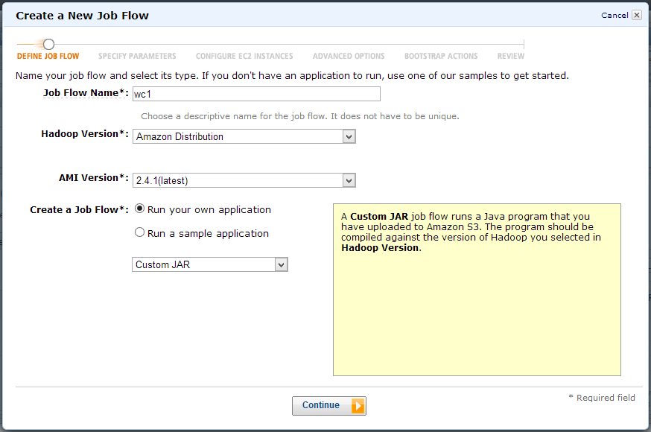
Creat Job Flow
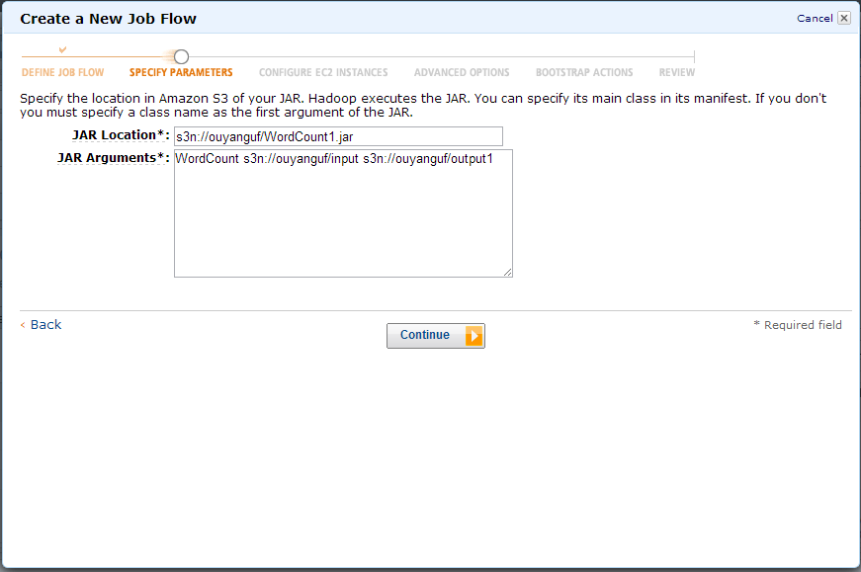
Set arguments
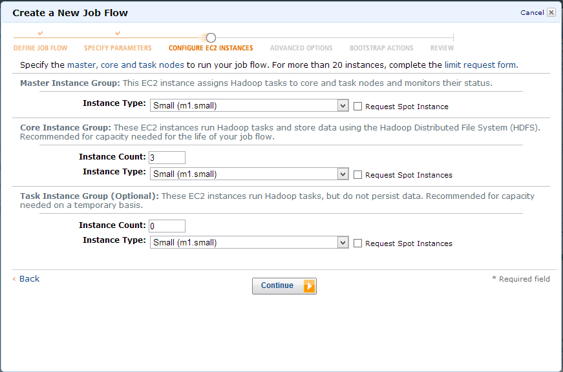
Set instances

Advanced options
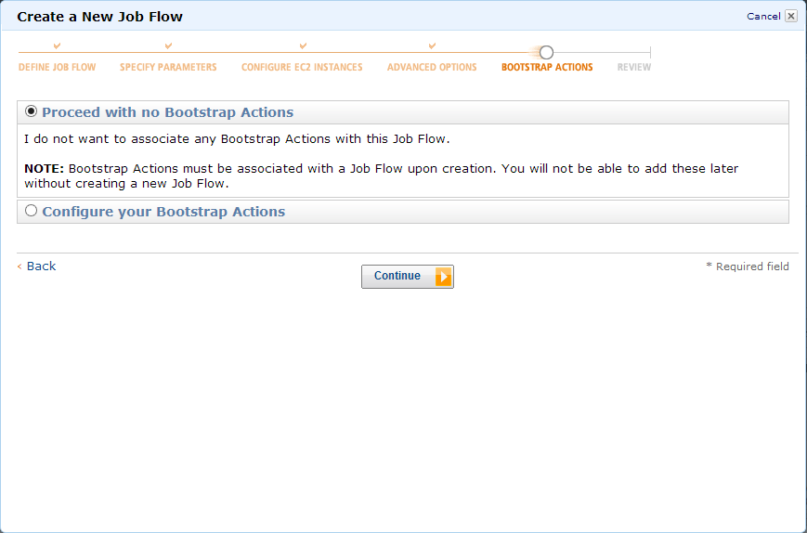
Bootstrap Options
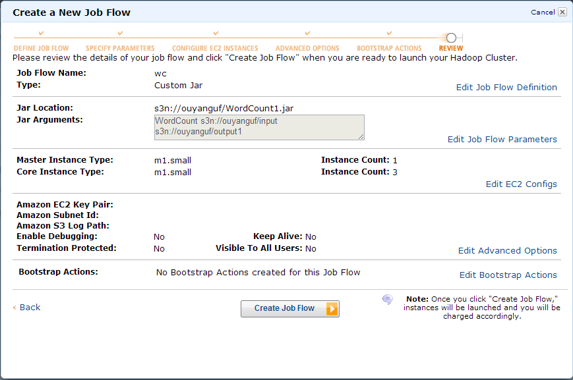
Review
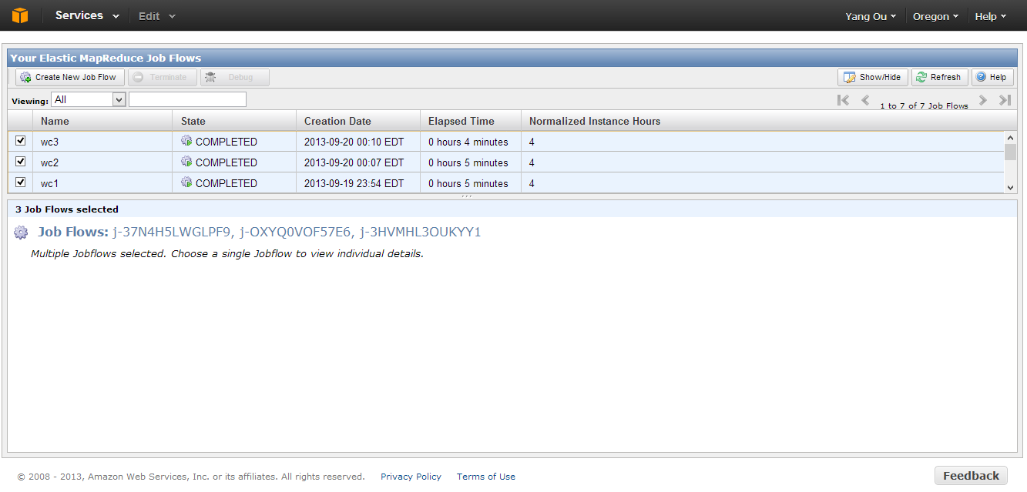
Done

Appendix E
Steps of how to perform task 2 on Amazon EMR
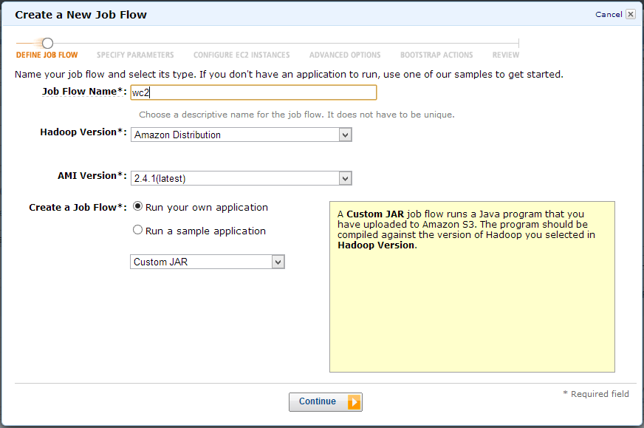
Creat Job Flow
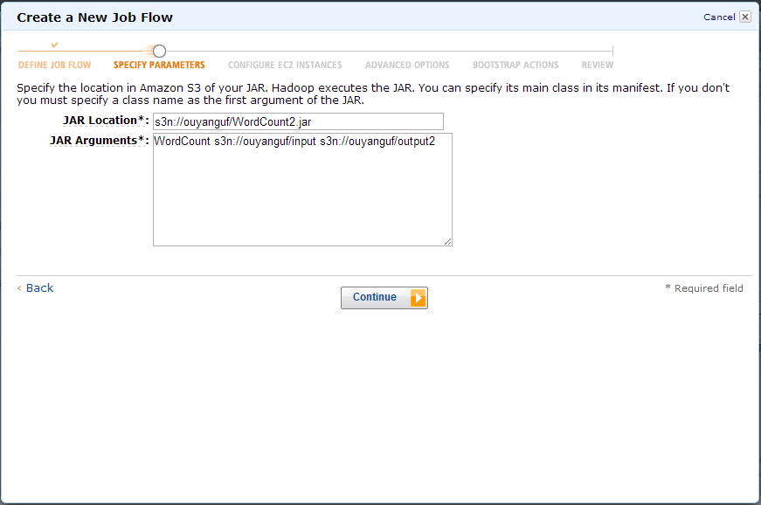
Set auguments
Set instances
Advanced options
Bootstrap Options
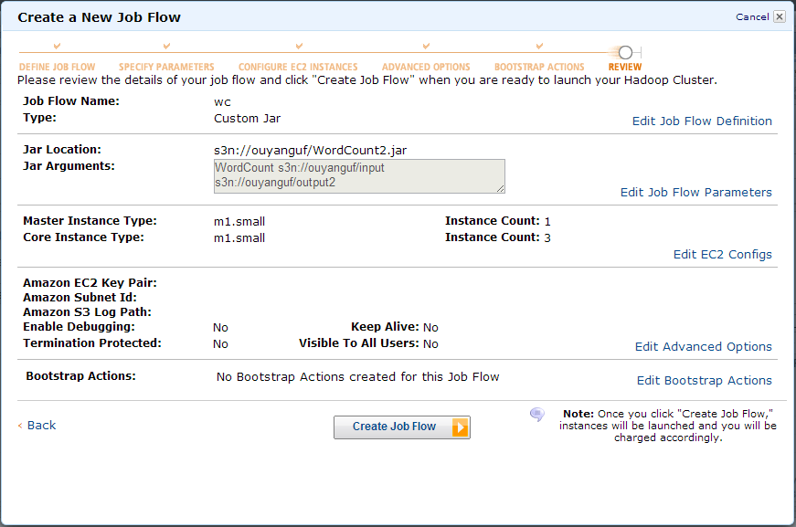
Review

Done

Appendix F
Steps of how to perform task 3 on Amazon EMR
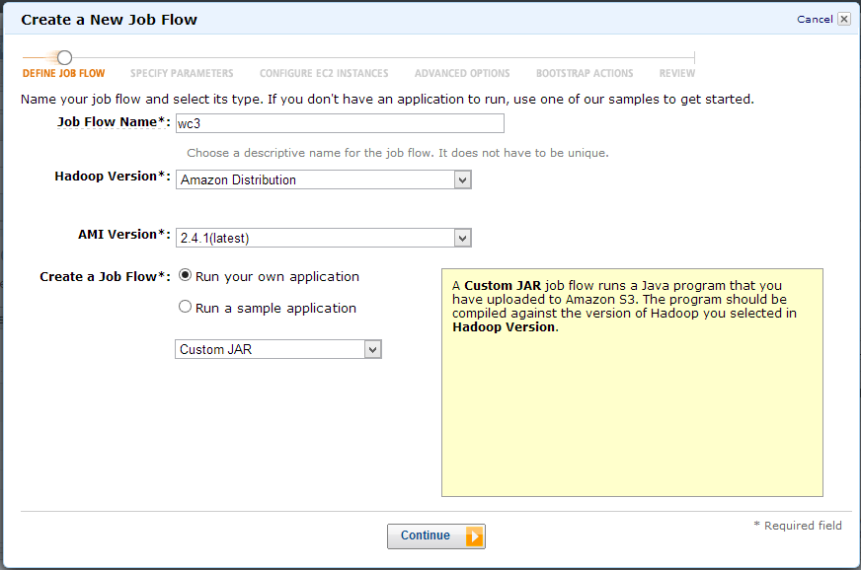

Creat job flow
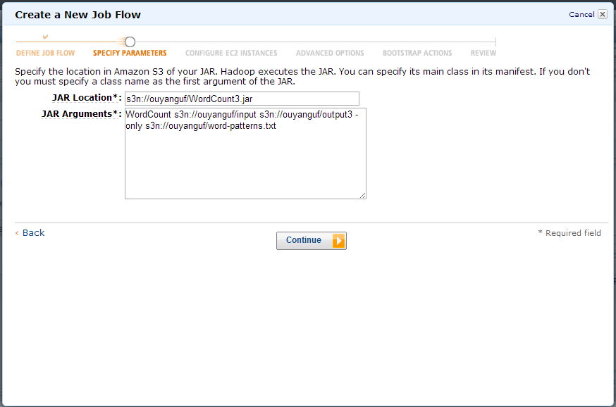
Set arguments
Set instances
Advanced options
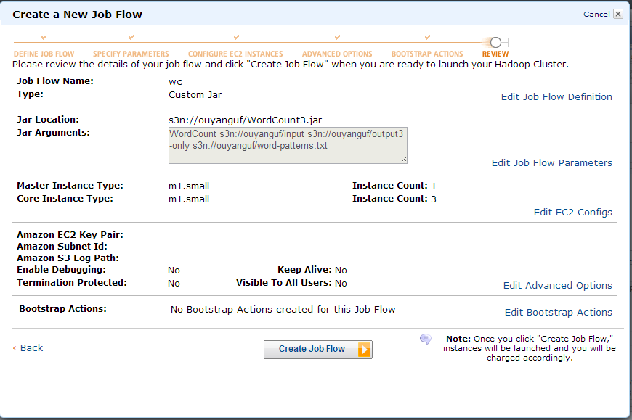
Review
Done

