Cinder 创建磁盘过程的中的可用域分析

Cinder_api在创建Volume时进行的Zone检查
在Cinder创建Volume时，cinder_api会创建一个名为“create_volume_api”的TaskFlow，该TaskFlow中的ExtractVolumeRequestTask，会对传入的Zone名称进行过滤，如果过滤结果与预期不符，创建Volume将会失败。
cinder.volume.flows.api.create_volume.ExtractVolumeRequestTask的execute方法：
def execute(self, context, size, snapshot, image_id, source_volume,
availability_zone, volume_type, metadata, key_manager,
source_replica, consistencygroup, cgsnapshot, group):
...........
availability_zone = self._extract_availability_zone(availability_zone,
snapshot,
source_volume,
group)
...........
从当前的日志分析，如果在Cinder创建磁盘时传入错误的可用域ExtractVolumeRequestTask中的_extract_availability_zone会抛出异常，导致ExtractVolumeRequestTask执行失败，整个创建Vol流程被终止！！！
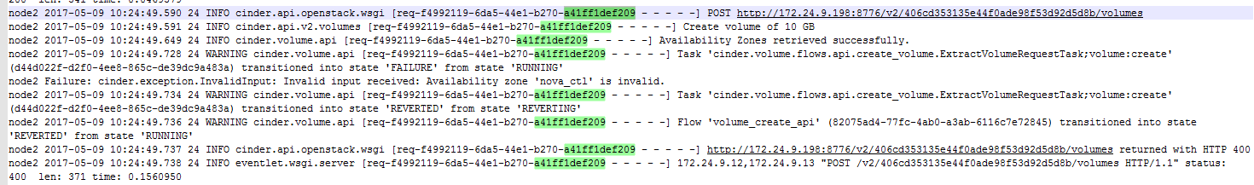
分析_extract_availability_zone方法的代码：
def _extract_availability_zone(self, availability_zone, snapshot,
source_volume, group):
"""Extracts and returns a validated availability zone.
This function will extract the availability zone (if not provided) from
the snapshot or source_volume and then performs a set of validation
checks on the provided or extracted availability zone and then returns
the validated availability zone.
"""
# If the volume will be created in a group, it should be placed in
# in same availability zone as the group.
"""
group指的是cinder的consistency groups特性（https://docs.openstack.org/admin-guide/blockstorage-consistency-groups.html）
该参数传入值当前情况下一般为None
"""
if group:
try:
availability_zone = group['availability_zone']
except (TypeError, KeyError):
pass
# Try to extract the availability zone from the corresponding snapshot
# or source volume if either is valid so that we can be in the same
# availability zone as the source.
"""
如果不指定创建卷时的Zone，那么：
方案1.从快照创建时，指定为快照的Zone，从已有卷创建时，指定为已有卷Zone，由于Image时没有zone信息的，因此如果从Image创建时一般参考方案2！
方案2.如果方案1任然不能指定出Zone，那么依次取default_availability_zone，storage_availability_zone
默认情况下default_availability_zone的值为None；
而storage_availability_zone的值为Nova
"""
if availability_zone is None:
if snapshot:
try:
availability_zone = snapshot['volume']['availability_zone']
except (TypeError, KeyError):
pass
if source_volume and availability_zone is None:
try:
availability_zone = source_volume['availability_zone']
except (TypeError, KeyError):
pass
if availability_zone is None:
if CONF.default_availability_zone:
availability_zone = CONF.default_availability_zone
else:
# For backwards compatibility use the storage_availability_zone
availability_zone = CONF.storage_availability_zone
"""
从环境上打印的信息来看self.availability_zones里只包含“nova”一个Zone，
allow_availability_zone_fallback的值为False时会抛出异常（allow_availability_zone_fallback默认为False）。
"""
if availability_zone not in self.availability_zones:
"""
allow_availability_zone_fallback的作用是，当输入的Zone不满足情形时，对输入进行回退！默认为False！！
回退为default_availability_zone或者storage_availability_zone（default_availability_zone优先级更高）！！
"""
if CONF.allow_availability_zone_fallback:
original_az = availability_zone
availability_zone = (
CONF.default_availability_zone or
CONF.storage_availability_zone)
LOG.warning(_LW("Availability zone '%(s_az)s' "
"not found, falling back to "
"'%(s_fallback_az)s'."),
{'s_az': original_az,
's_fallback_az': availability_zone})
else:
msg = _("Availability zone '%(s_az)s' is invalid.")
msg = msg % {'s_az': availability_zone}
raise exception.InvalidInput(reason=msg)
# If the configuration only allows cloning to the same availability
# zone then we need to enforce that.
"""
cloned_volume_same_az表示创建卷时是否要求源的Zone和输入Zone一致（主要针对从快照创建和卷创建），默认为True!!
"""
if CONF.cloned_volume_same_az:
snap_az = None
try:
snap_az = snapshot['volume']['availability_zone']
except (TypeError, KeyError):
pass
if snap_az and snap_az != availability_zone:
msg = _("Volume must be in the same "
"availability zone as the snapshot")
raise exception.InvalidInput(reason=msg)
source_vol_az = None
try:
source_vol_az = source_volume['availability_zone']
except (TypeError, KeyError):
pass
if source_vol_az and source_vol_az != availability_zone:
msg = _("Volume must be in the same "
"availability zone as the source volume")
raise exception.InvalidInput(reason=msg)
return availability_zone
从上面的分析可以看出ExtractVolumeRequestTask.availability_zones中不包含输入的Zone！因此需要打开allow_availability_zone_fallback，以防流程报错。

ExtractVolumeRequestTask.availability_zones是如何生成的？！
回到create_volume.py中可以看到ExtractVolumeRequestTask在get_flow方法中创建：
def get_flow(db_api, image_service_api, availability_zones, create_what,
scheduler_rpcapi=None, volume_rpcapi=None):
.......
api_flow.add(ExtractVolumeRequestTask(
image_service_api,
availability_zones,
rebind={'size': 'raw_size',
'availability_zone': 'raw_availability_zone',
'volume_type': 'raw_volume_type'}))
.......
return taskflow.engines.load(api_flow, store=create_what)
cinder.volume.flows.api.create_volume.get_flow方法
在cinder.volume.api.API.create方法中被调用，其入参availability_zones通过storage_availability_zone和list_availability_zones方法的返回值组装：
create方法：
raw_zones = self.list_availability_zones(enable_cache=True)
availability_zones = set([az['name'] for az in raw_zones])
if CONF.storage_availability_zone:
availability_zones.add(CONF.storage_availability_zone)
……
try:
sched_rpcapi = (self.scheduler_rpcapi if (
not cgsnapshot and not source_cg and
not group_snapshot and not source_group)
else None)
volume_rpcapi = (self.volume_rpcapi if (
not cgsnapshot and not source_cg and
not group_snapshot and not source_group)
else None)
flow_engine = create_volume.get_flow(self.db,
self.image_service,
availability_zones,
create_what,
sched_rpcapi,
volume_rpcapi)
except Exception:
msg = _('Failed to create api volume flow.')
LOG.exception(msg)
raise exception.CinderException(msg)

list_availability_zones方法：
- Cinder对Zone信息进行了缓存，list_availability_zones方法在调用时可以指定是否直接从缓存获取信息！
- 内存中的Zone信息会每隔一段时间更新(az_cache_duration,默认3600s)！
3. 内存中Zone的值来自数据库表services，选取规则如下：
A.获取所有topic字段为cinder-volume的记录；
B.将记录中的availability_zone和disabled封装为{name：available}，返回。（这里disabled=0时，available取值为True）
def list_availability_zones(self, enable_cache=False):
refresh_cache = False
"""
是否从内存获取Zone信息，创建Volume时该值为True。
"""
if enable_cache:
"""
availability_zones_last_fetched是上一次更新Cache的时间戳，判断是否需要进行更新
"""
if self.availability_zones_last_fetched is None:
refresh_cache = True
else:
cache_age = timeutils.delta_seconds(
self.availability_zones_last_fetched,
timeutils.utcnow())
if cache_age >= CONF.az_cache_duration:
refresh_cache = True
"""
从数据库获取Zone的值！
"""
if refresh_cache or not enable_cache:
topic = constants.VOLUME_TOPIC
ctxt = context.get_admin_context()
services = objects.ServiceList.get_all_by_topic(ctxt, topic)
az_data = [(s.availability_zone, s.disabled)
for s in services]
disabled_map = {}
for (az_name, disabled) in az_data:
tracked_disabled = disabled_map.get(az_name, True)
disabled_map[az_name] = tracked_disabled and disabled
azs = [{'name': name, 'available': not disabled}
for (name, disabled) in disabled_map.items()]
if refresh_cache:
now = timeutils.utcnow()
self.availability_zones = azs
self.availability_zones_last_fetched = now
LOG.debug("Availability zone cache updated, next update will"
" occur around %s.", now + datetime.timedelta(
seconds=CONF.az_cache_duration))
else:
azs = self.availability_zones
LOG.info(_LI("Availability Zones retrieved successfully."))
return tuple(azs)

回到cinder.volume.api.API.create中，我们看到list_availability_zones返回值中所有的Zone都被利用了，但是从上面的分析可以看出，raw_zones中的字典构成为：{name：available}，available决定了当前cinder_volume服务的状态是否为disable？为啥一个服务已经disable了，他的zone依然合法呢？
raw_zones = self.list_availability_zones(enable_cache=True)
availability_zones = set([az['name'] for az in raw_zones])
if CONF.storage_availability_zone:
availability_zones.add(CONF.storage_availability_zone)
通过在volume节点配置storage_availability_zone可以修改services表中的zone信息，该值默认为nova！
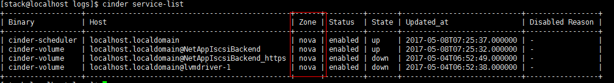

Nova创建虚机时Zone信息的传递
Nova创建虚机时可以指定Zone，但是这里的Zone是Nova使用的和Cinder的Zone没有直接关系，可以在主机聚合页面查看。
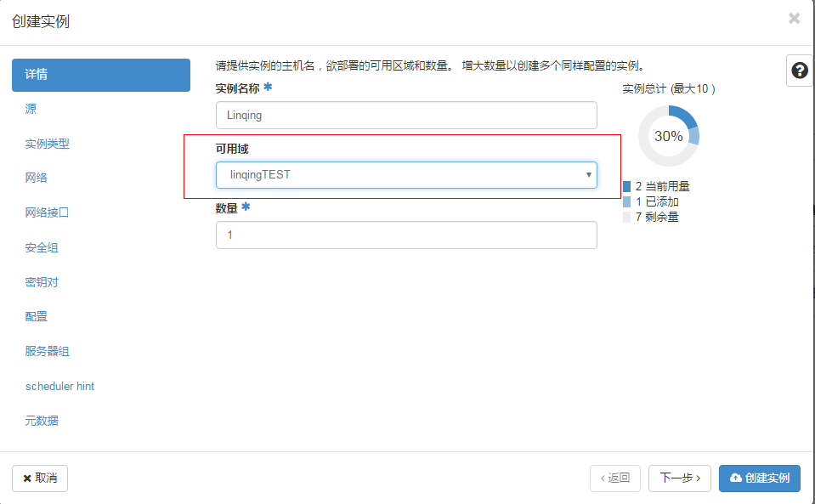
n-compute创建虚机时调用
nova.virt.block_device. DriverVolumeBlockDevice
的attached方法挂载到磁盘。
根据创建实例时源选择的不同，DriverVolumeBlockDevice，有不同的派生。
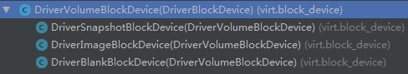
由于只有从Image创建VM时，有可能需要创建Vol，因此先分析DriverImageBlockDevice的attach方法。
该方法很简单，调用cinder_api创建一个Volume，之后调用DriverVolumeBlockDevice执行attach。
值得注意的是nova请求cinder创建vol时传递的zone，及_get_volume_create_az_value方法！
def attach(self, context, instance, volume_api,
virt_driver, wait_func=None, do_check_attach=True):
LOG.info("by linqing run DriverImageBlockDevice attach")
if not self.volume_id:
av_zone = _get_volume_create_az_value(instance)
vol = volume_api.create(context, self.volume_size,
'', '', image_id=self.image_id,
availability_zone=av_zone)
if wait_func:
self._call_wait_func(context, wait_func, volume_api, vol['id'])
self.volume_id = vol['id']
super(DriverImageBlockDevice, self).attach(
context, instance, volume_api, virt_driver,
do_check_attach=do_check_attach)

_get_volume_create_az_value方法控制nova创建的vol的zone是否需要和虚机相同，且通过配置项cross_az_attach来控制，改配置项默认为True，表示不需要相同（nova.conf.cinder.py中定义了这个配置项）！

def _get_volume_create_az_value(instance):
"""Determine az to use when creating a volume
Uses the cinder.cross_az_attach config option to determine the availability
zone value to use when creating a volume.
:param nova.objects.Instance instance: The instance for which the volume
will be created and attached.
:returns: The availability_zone value to pass to volume_api.create
"""
# If we're allowed to attach a volume in any AZ to an instance in any AZ,
# then we don't care what AZ the volume is in so don't specify anything.
if CONF.cinder.cross_az_attach:
return None
# Else the volume has to be in the same AZ as the instance otherwise we
# fail. If the AZ is not in Cinder the volume create will fail. But on the
# other hand if the volume AZ and instance AZ don't match and
# cross_az_attach is False, then volume_api.check_attach will fail too, so
# we can't really win. :)
# TODO(mriedem): It would be better from a UX perspective if we could do
# some validation in the API layer such that if we know we're going to
# specify the AZ when creating the volume and that AZ is not in Cinder, we
# could fail the boot from volume request early with a 400 rather than
# fail to build the instance on the compute node which results in a
# NoValidHost error.
return instance.availability_zone

