PROJECT1

DEVOPS ENGR. 21/04/2023.

* LAMP STACK IMPLEMENTATION
* **Step 1 — Installing Apache and Updating the Firewall**
* To get the instance ID(EC2) connected to the ubuntu OS terminal(Install Apache using Ubuntu’s package manager)
* ssh -i "Hill_EC2.pem" ubuntu@ec2-13-48-28-237.eu-north-1.compute.amazonaws.com.

To update the firewall on the Apache web server

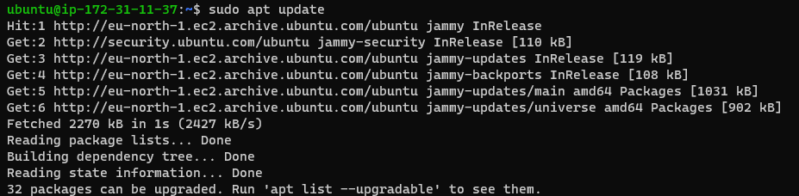

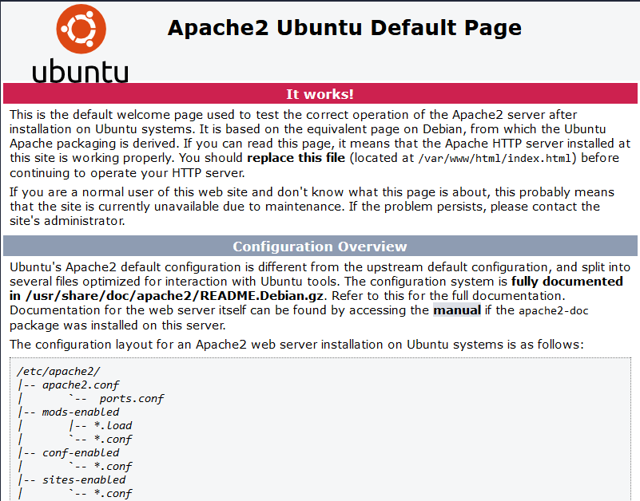

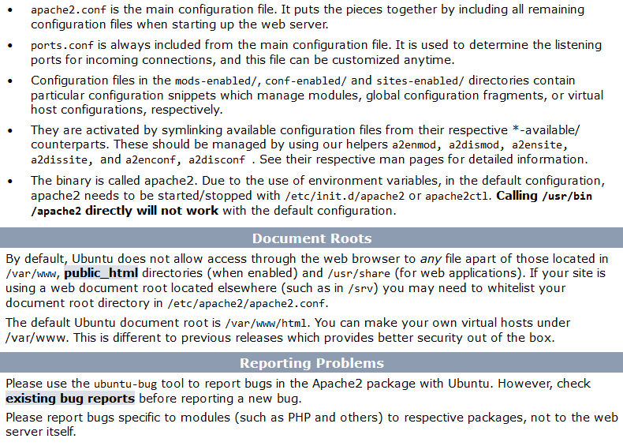

# **Step 2 — Installing MySQL**

I need to install a [Database Management System (DBMS)](https://en.wikipedia.org/wiki/Database#Database_management_system) to be able to store and manage data for your site in a [relational database](https://en.wikipedia.org/wiki/Relational_database). [MySQL](https://www.mysql.com).

ubuntu@ip-172-31-11-37:~$ sudo apt install mysql-server

Reading package lists... Done

Building dependency tree... Done

Reading state information... Done

mysql-server is already the newest version (8.0.32-0ubuntu0.22.04.2).

0 upgraded, 0 newly installed, 0 to remove and 18 not upgraded.

ubuntu@ip-172-31-11-37:~$ sudo mysql

Welcome to the MySQL monitor. Commands end with ; or \g.

Your MySQL connection id is 10

Server version: 8.0.32-0ubuntu0.22.04.2 (Ubuntu)

Copyright (c) 2000, 2023, Oracle and/or its affiliates.

Oracle is a registered trademark of Oracle Corporation and/or its

affiliates. Other names may be trademarks of their respective

owners.

Type 'help;' or '\h' for help. Type '\c' to clear the current input statement.

mysql>

It’s recommended that you run a security script that comes pre-installed with MySQL. This script will remove some insecure default settings and lock down access to your database system. Before running the script you will set a password for the **root** user, using mysql_native_password as default authentication method. We’re defining this user’s password as PassWord.1.

ALTER USER 'root'@'localhost' IDENTIFIED WITH mysql_native_password BY 'PassWord.1';

Exit the MySQL shell with:

mysql> exit

Start the interactive script by running:

$ sudo mysql_secure_installation.

**Note**: Enabling this feature is something of a judgment call. If enabled, passwords which don’t match the specified criteria will be rejected by MySQL with an error. It is safe to leave validation disabled, but you should always use strong, unique passwords for database credentials.

Answer Y for yes, or anything else to continue without enabling.

VALIDATE PASSWORD PLUGIN can be used to test passwords

and improve security. It checks the strength of password

and allows the users to set only those passwords which are

secure enough. Would you like to setup VALIDATE PASSWORD plugin?

Press y|Y for Yes, any other key for No: always say no as it will still prompt you to add password before you login into my sql server.

When you’re finished, test if you’re able to log in to the MySQL console by typing:

$ sudo mysql -p

Notice the -p flag in this command, which will prompt you for the password used after changing the **root** user password. The password i used was We!come@$140

To exit the MySQL console, type:

mysql> exit

Notice that you need to provide a password to connect as the **root** user.

For increased security, it’s best to have dedicated user accounts with less expansive privileges set up for every database, especially if you plan on having multiple databases hosted on your server.

**Note**: At the time of this writing, the native MySQL PHP library mysqlnd doesn’t support caching_sha2_authentication, the default authentication method for MySQL 8. For that reason, when creating database users for PHP applications on MySQL 8, you’ll need to make sure they’re configured to use mysql_native_password instead.

Your MySQL server is now installed and secured. Next, we will install PHP, the final component in the LAMP stack.

# **Step 3 — Installing PHP**

You have Apache installed to serve your content and MySQL installed to store and manage your data. [PHP](https://www.php.net) is the component of our setup that will process code to display dynamic content to the end user. In addition to the php package, you’ll need php-mysql, a PHP module that allows PHP to communicate with MySQL-based databases. You’ll also need libapache2-mod-php to enable Apache to handle PHP files. Core PHP packages will automatically be installed as dependencies.

To install these 3 packages at once, run:

ubuntu@ip-172-31-42-227:~$ sudo apt install php libapache2-mod-php php-mysql

Creating config file /etc/php/7.4/mods-available/json.ini with new version

Setting up php7.4-readline (7.4.3-4ubuntu2.18) ...

Creating config file /etc/php/7.4/mods-available/readline.ini with new version

Setting up php7.4-opcache (7.4.3-4ubuntu2.18) ...

Creating config file /etc/php/7.4/mods-available/opcache.ini with new version

Setting up php7.4-cli (7.4.3-4ubuntu2.18) ...

update-alternatives: using /usr/bin/php7.4 to provide /usr/bin/php (php) in auto mode

update-alternatives: using /usr/bin/phar7.4 to provide /usr/bin/phar (phar) in auto mode

update-alternatives: using /usr/bin/phar.phar7.4 to provide /usr/bin/phar.phar (phar.phar) in auto mode

Creating config file /etc/php/7.4/cli/php.ini with new version

Setting up libapache2-mod-php7.4 (7.4.3-4ubuntu2.18) ...

Creating config file /etc/php/7.4/apache2/php.ini with new version

Module mpm_event disabled.

Enabling module mpm_prefork.

apache2_switch_mpm Switch to prefork

apache2_invoke: Enable module php7.4

Setting up php7.4 (7.4.3-4ubuntu2.18) ...

Setting up libapache2-mod-php (2:7.4+75) ...

Setting up php (2:7.4+75) ...

Processing triggers for man-db (2.9.1-1) ...

Processing triggers for php7.4-cli (7.4.3-4ubuntu2.18) ...

Processing triggers for libapache2-mod-php7.4 (7.4.3-4ubuntu2.18) ...

ubuntu@ip-172-31-42-227:~$ php -v

PHP 7.4.3-4ubuntu2.18 (cli) (built: Feb 23 2023 12:43:23) ( NTS )

Copyright (c) The PHP Group

Zend Engine v3.4.0, Copyright (c) Zend Technologies

with Zend OPcache v7.4.3-4ubuntu2.18, Copyright (c), by Zend Technologies

At this point, your LAMP stack is completely installed and fully operational.

* **L**inux (Ubuntu)
* **A**pache HTTP Server
* **M**ySQL
* **P**HP

# **Step 4 — Creating a Virtual Host for your Website using Apache**

In this project, you will set up a domain called projectlamp, but you can replace this with any domain of your choice.

Apache on Ubuntu 20.04 has one server block enabled by default that is configured to serve documents from the **/var/www/html** directory.  
 We will leave this configuration as is and will add our own directory next next to the default one.

Create the directory for projectlamp using **‘mkdir’** command as follows:

sudo mkdir /var/www/projectlamp

Next, assign ownership of the directory with your current system user:

sudo chown -R $USER:$USER /var/www/projectlamp

Then, create and open a new configuration file in Apache’s sites-available directory using your preferred command-line editor. Here, we’ll be using vi or vim (They are the same by the way):

sudo vi /etc/apache2/sites-available/projectlamp.conf

This will create a new blank file. Paste in the following bare-bones configuration by hitting on i on the keyboard to enter the insert mode, and paste the text:

<VirtualHost *:80>

ServerName projectlamp

ServerAlias www.projectlamp

ServerAdmin webmaster@localhost

DocumentRoot /var/www/projectlamp

ErrorLog ${APACHE_LOG_DIR}/error.log

CustomLog ${APACHE_LOG_DIR}/access.log combined

</VirtualHost>

ubuntu@ip-172-31-42-227:~$ sudo mkdir /var/www/projectlamp

ubuntu@ip-172-31-42-227:~$ sudo chown -R $USER:$USER /var/www/projectlamp

ubuntu@ip-172-31-42-227:~$ sudo vi /etc/apache2/sites-available/projectlamp.conf

ubuntu@ip-172-31-42-227:~$

To save and close the file, simply follow the steps below:

1. Hit the esc button on the keyboard
2. Type :
3. Type wq. **w** for write and **q** for quit
4. Hit ENTER to save the file

You can use the **ls** command to show the new file in the **sites-available** directory

sudo ls /etc/apache2/sites-available.

ubuntu@ip-172-31-42-227:~$ sudo ls /etc/apache2/sites-available

000-default.conf default-ssl.conf projectlamp.conf

ubuntu@ip-172-31-42-227:~$

With this VirtualHost configuration, we’re telling Apache to serve projectlamp using **/var/www/projectlampl** as its web root directory. If you would like to test Apache without a domain name, you can remove or comment out the options ServerName and ServerAlias by adding a **#** character in the beginning of each option’s lines. Adding the **#** character there will tell the program to skip processing the instructions on those lines.

You can now use ***a2ensite*** command to enable the new virtual host:

sudo a2ensite projectlamp

ubuntu@ip-172-31-42-227:~$ sudo a2ensite projectlamp

Enabling site projectlamp.

To activate the new configuration, you need to run:

systemctl reload apache2

ubuntu@ip-172-31-42-227:~$

You might want to disable the default website that comes installed with Apache. This is required if you’re not using a custom domain name, because in this case Apache’s default configuration would overwrite your virtual host. To disable Apache’s default website use ***a2dissite*** command , type:

sudo a2dissite 000-default

ubuntu@ip-172-31-42-227:~$ sudo a2dissite 000-default

Site 000-default disabled.

To activate the new configuration, you need to run:

systemctl reload apache2

ubuntu@ip-172-31-42-227:~$

To make sure your configuration file doesn’t contain syntax errors, run:

sudo apache2ctl configtest

ubuntu@ip-172-31-42-227:~$ sudo apache2ctl configtest

Syntax OK

Finally, reload Apache so these changes take effect:

sudo systemctl reload apache2

Your new website is now active, but the web root **/var/www/projectlamp** is still empty. Create an index.html file in that location so that we can test that the virtual host works as expected:

ubuntu@ip-172-31-42-227:~$ sudo echo 'Hello LAMP from hostname' $(curl -s http://13.48.27.107/latest/meta-data/public-hostname) 'with public IP' $(curl -s http://13.48.27.107/latest/meta-data/public-ipv4) > /var/www/projectlamp/index.html

ubuntu@ip-172-31-42-227:~$:

http://<Public-IP-Address>:80

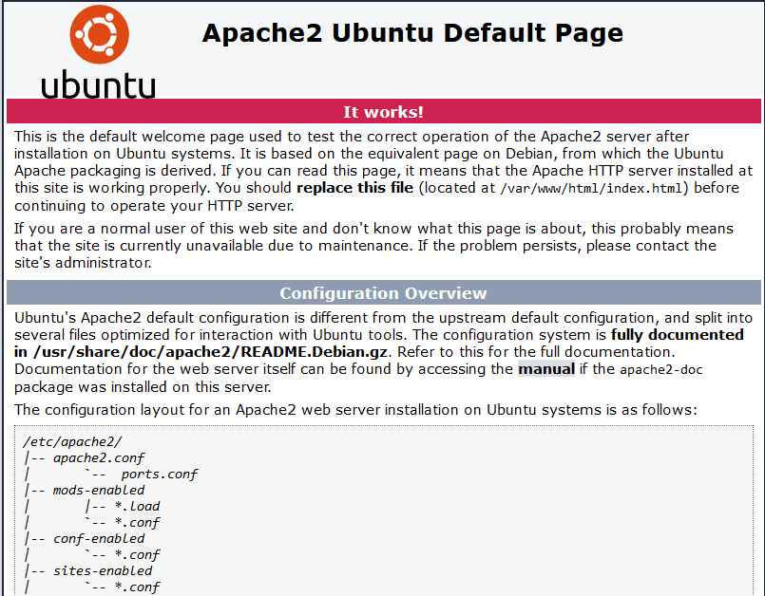

If you see the text from ***‘echo’*** command you wrote to index.html file, then it means your Apache virtual host is working as expected.  
 In the output you will see your server’s public hostname (DNS name) and public IP address. You can also access your website in your browser by public DNS name, not only by IP – try it out, the result must be the same (port is optional)

http://<Public-DNS-Name>:80

You can leave this file in place as a temporary landing page for your application until you set up an index.php file to replace it. Once you do that, remember to remove or rename the index.html file from your document root, as it would take precedence over an index.php file by default.

**Step 5 — Enable PHP on the website**

With the default **DirectoryIndex** settings on Apache, a file named index.html will always take precedence over an index.php file. This is useful for setting up maintenance pages in PHP applications, by creating a temporary index.html file containing an informative message to visitors. Because this page will take precedence over the index.php page, it will then become the landing page for the application. Once maintenance is over, the index.html is renamed or removed from the document root, bringing back the regular application page.

In case you want to change this behavior, you’ll need to edit the **/etc/apache2/mods-enabled/dir.conf** file and change the order in which the **index.php** file is listed within the **DirectoryIndex** directive:

sudo vim /etc/apache2/mods-enabled/dir.conf

Then to clear every thing i(insert), esc, :(shift:), %d then insert again

<IfModule mod_dir.c>

#Change this:

#DirectoryIndex index.html index.cgi index.pl index.php index.xhtml index.htm

#To this:

DirectoryIndex index.php index.html index.cgi index.pl index.xhtml index.htm

</IfModule>

After saving and closing the file, you will need to reload Apache so the changes take effect:

sudo systemctl reload apache2

Finally, we will create a PHP script to test that PHP is correctly installed and configured on your server.

Now that you have a custom location to host your website’s files and folders, we’ll create a PHP test script to confirm that Apache is able to handle and process requests for PHP files.

Create a new file named index.php inside your custom web root folder:

Sudo vim /var/www/projectlamp/index.php

Insert, esc, :%d which is just to clear things or just insert :q

This will open a blank file. Add the following text, which is valid PHP code, inside the file:

<?php

phpinfo();

:wq(save apache2 file)

When you are finished, save and close the file, refresh the page and you will see a page similar to this:

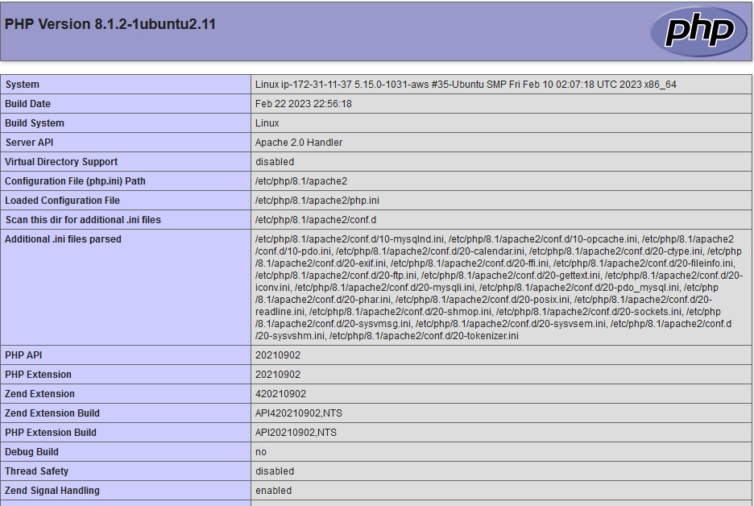

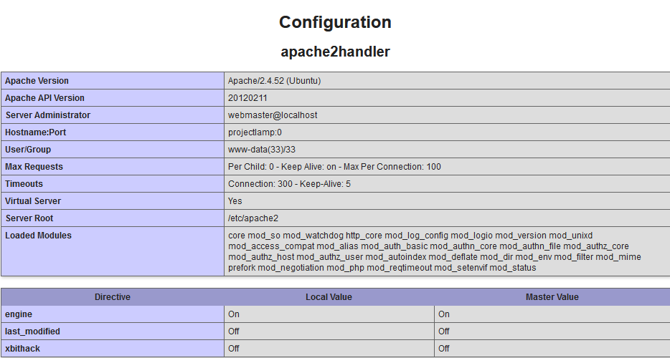

This page provides information about your server from the perspective of PHP. It is useful for debugging and to ensure that your settings are being applied correctly.

If you can see this page in your browser, then your PHP installation is working as expected.

After checking the relevant information about your PHP server through that page, it’s best to remove the file you created as it contains sensitive information about your PHP environment -and your Ubuntu server. You can use rm to do so:

sudo rm /var/www/projectlamp/index.php

Then reload apache

sudo systemctl reload apache2