WEEK #8
1# A file management system needs to organize a batch of filenames based on the length of the name rather than alphabetical order. Write a Python program to sort a list of strings (filenames) based on the length of each element.
filenames = input("Enter filenames separated by space: ").split()
filenames.sort(key=len)
print("Sorted by length:", filenames)

2# A marketing team has two separate lists of email addresses from two different campaigns. Write a Python program to create a master list containing all unique emails from both lists (Union). (An email can be part of both lists)
list1 = set(input("Enter first email list: ").split())
list2 = set(input("Enter second email list: ").split())
master = list1.union(list2)
print("Master email list:", list(master))
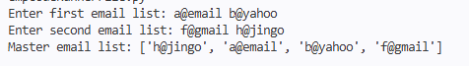

3# A cyber-security tool is comparing two server access logs to identify suspicious IP addresses that appear in both logs. Write a Python program to find the common elements between two lists (Intersection).
list1 = set(input("Enter first list: ").split())
list2 = set(input("Enter second list: ").split())
common = list1.intersection(list2)
print("Common elements:", list(common))
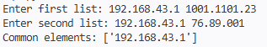
4# A data visualization tool needs to plot a curve. Write a Python program that generates a list of tuples, where the first element is a number and the second is five times its cube, for a range of inputs.
start = int(input("Enter start value: "))
end = int(input("Enter end value: "))
result = []
for i in range(start, end+1):
result.append((i, 5*(i**3)))

print(result)
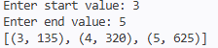
5# A Natural Language Processing (NLP) pre-processor needs to clean and analyze raw text data. Assume the variable data contains the string: "Different string Methods!". Write a Python script using string methods to: • Tokenize the string into a list of individual words. • Normalize the text by converting it to uppercase. • Find the index position of the substring "rules". • Search for a specific character (e.g., 'o') to see if it exists. • Sanitize the text by replacing the exclamation point with a question mark.
data = "Different string Methods!"

# tokenize
words = data.split()

# uppercase
upper_text = data.upper()

# find substring
index = data.find("rules")

# search character
exists = 'o' in data

# replace symbol
sanitized = data.replace("!", "?")

print("Tokens:", words)
print("Uppercase:", upper_text)
print("Index of 'rules':", index)
print("Contains 'o':", exists)
print("Sanitized:", sanitized)
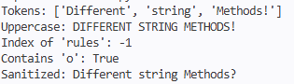
6# A data compression utility needs to analyze the entropy of a text file. Write a Python program to calculate the frequency of every character present in a given string.
text = input("Enter a string: ")
freq = {}
for char in text:
if char in freq:
freq[char] += 1
else:
freq[char] = 1
print("Character frequencies:")
for k,v in freq.items():
print(k, ":", v)
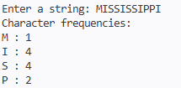
7# A simple encryption tool obfuscates passwords by reading them backward. Write a Python program to reverse the order of characters in a user-provided string. Example: • Input: "Security" • Output: "ytiruceS"
text = input("Enter string: ")
reverse = text[::-1]
print("Reversed:", reverse)
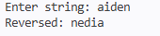
8# A product labeling system generates short "SKU codes" based on product names. Write a Python program that takes a string and generates a new string made of the first 2 and last 2 characters. (Constraint: If the product name is shorter than 2 characters, return an empty string) Example: • Input: "Panasonic" • Output: "Paic"
text = input("Enter product name: ")
if len(text) < 2:
result = ""
else:
result = text[:2] + text[-2:]

print("SKU:", result)
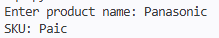
9# A library catalog system contains sorted Book IDs. To optimize lookup speeds, write a Python program to implement Binary Search using the divide and conquer approach to find a specific Book ID.
arr = list(map(int, input("Enter sorted Book IDs: ").split()))
target = int(input("Enter Book ID to search: "))
low = 0
high = len(arr) - 1
found = False
while low <= high:
mid = (low + high) // 2

if arr[mid] == target:
print("Book ID found at index", mid)
found = True
break
elif arr[mid] < target:
low = mid + 1
else:
high = mid - 1

if not found:
print("Book ID not found")
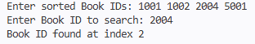
10# An educational algorithm visualizer needs to show students how sorting works step-by-step. Write a Python program to implement the Insertion Sort algorithm that prints the state of the list after every iteration to visualize the intermediate steps.
arr = list(map(int, input("Enter numbers: ").split()))
for i in range(1, len(arr)):
key = arr[i]
j = i - 1
while j >= 0 and key < arr[j]:
arr[j+1] = arr[j]
j -= 1

arr[j+1] = key
print("Step", i, ":", arr)
