*Frameworx Specification*

Product Inventory Management API REST Specification

**TMF637**

**Release 14.5.0**

**November 2014**

|  |  |
| --- | --- |
| **Latest Update: Frameworx Release 14.5** | **Member Evaluation** |
| **Version 2.0.0** | **IPR Mode: RAND** |

# NOTICE

Copyright © TM Forum 2014. All Rights Reserved.

This document and translations of it may be copied and furnished to others, and derivative works that comment on or otherwise explain it or assist in its implementation may be prepared, copied, published, and distributed, in whole or in part, without restriction of any kind, provided that the above copyright notice and this section are included on all such copies and derivative works. However, this document itself may not be modified in any way, including by removing the copyright notice or references to TM FORUM, except as needed for the purpose of developing any document or deliverable produced by a TM FORUM Collaboration Project Team (in which case the rules applicable to copyrights, as set forth in the [TM FORUM IPR Policy](http://www.tmforum.org/IPRPolicy/11525/home.html), must be followed) or as required to translate it into languages other than English.

The limited permissions granted above are perpetual and will not be revoked by TM FORUM or its successors or assigns.

This document and the information contained herein is provided on an "AS IS" basis and TM FORUM DISCLAIMS ALL WARRANTIES, EXPRESS OR IMPLIED, INCLUDING BUT NOT LIMITED TO ANY WARRANTY THAT THE USE OF THE INFORMATION HEREIN WILL NOT INFRINGE ANY OWNERSHIP RIGHTS OR ANY IMPLIED WARRANTIES OF MERCHANTABILITY OR FITNESS FOR A PARTICULAR PURPOSE.

Direct inquiries to the TM Forum office:

240 Headquarters Plaza,

East Tower – 10th Floor,

Morristown, NJ  07960 USA

Tel No.  +1 973 944 5100

Fax No.  +1 973 944 5110

TM Forum Web Page: [www.tmforum.org](http://www.tmforum.org/)

# Table of Contents

NOTICE 2

Table of Contents 3

List of Tables 4

Introduction 5

RESOURCE MODEL 6

PRODUCT Resource 6

Field Descriptions 7

Status attribute 8

State machine diagram for status attribute on product 9

Notification Resource Models 12

ProductCreationNotification 12

ProductValueChangeNotification 13

ProductStatusChangeNotification 13

ProductDeletionNotification 14

ProductBatchNotification 14

API OPERATION TEMPLATES 16

GET /inventoryApi/product/{ID} 16

PUT inventoryApi/product/{ID} 17

PATCH inventoryAPI/product/{ID} 19

POST inventoryAPI/product 20

DELETE inventoryApi/product/{ID} 21

API NOTIFICATIOn TEMPLATES 23

REGISTER LISTENER POST /hub 23

UNREGISTER LISTENER DELETE hub/{id} 23

publish {EventTYPE} POST /listener 24

Release History 25

# List of Tables

N/A

# Introduction

The following document is the template for the REST API documentation.

# RESOURCE MODEL

## PRODUCT Resource

|  |
| --- |
| {  "id": " 42",  “href”: “http://server:port/inventoryApi/product/42”,  "name": "Broadband",  "description": "Description of the instantiated broadband product",  "status": "active",  "isCustomerVisible": true,  "isBundle" : true,  "productSerialNumber": "Not useful in this case, we are describing a service…",  "startDate": "2013-07-21 08:16:39ZGMT+1",  "orderDate": "2013-07-21 06:16:39ZGMT+1",  "terminationDate": "",  "productOffering":  {  "id": " 4",  "href": "http://server:port/catalogApi/productOffering/4",  "name": "My Quick BB Offer"  },  "productSpecification":  {  "id": " 4",  "href": " http://server:port/catalogApi/ productSpecification /42"  },  "productCharacteristic":[  {  "name":"speed",  "value":"16M"  }],  "productRelationship":[  {  "type":"contains",  "product":{  "id": "59",  "href":" http://server:port/inventoryApi/product/59"  }  }],  "billingAccount": [  {  "id": "678",  "href": <http://server:port/billingApi/billingAccount/678>”,  “name” : “account name”  }],  "relatedParty": [  {  "id": "42",  "role":"partner",  "href":"http://serverlocation:port/partnerManagement/partner/42"  }],  "place":”<http://map.google.com/.../1234112GDE>”,  "realizingResource": [  {  “id": "not useful in this case, we are describing a service…",  "href": "not useful in this case, we are describing a service…"  }],  "realizingService": [  {  "id": "46779",  "href": "http://server:port/inventoryApi/service/46779"  }],  "productPrice" : [{  "name" : "…",  "description" : "",  "validFor":{  "startDateTime":"2013-04-19T16:42:23-04:00",  "endDateTime":"2013-06-19T00:00:00-04:00"  },  "priceType":"recurring",  "recurringChargePeriod":"monthly",  "unitOfMeasure":"",  "price":{  "amount":"12",  "currency":"$"  }  }]  } |

### Field Descriptions

|  |  |  |
| --- | --- | --- |
| Field Name | Mandatory/  Optional | Description |
| Id | M | “id” is the ID created for the product |
| Name | M | “name” is the name of the product. It could be the same as the name of the Product Offering |
| Description | O | “description” is the description of the product. It could be copied from the description of the Product Offering. |
| Status | M | “status” is the lifecycle status of the product. |
| isBundle | M |  |
| isCustomerVisible | M |  |
| productSerialNumber | O | “productSerialNumber” is the serial number for the product. This is typically applicable to tangible products e.g. Broadband Router. |
| startDate | O | “startDate” is the date from which the product starts |
| orderDate | O | “orderDate” is the date when the product was ordered. |
| terminationDate | O | “terminationDate” is the date when the product was terminated. Not applicable to active products. |
| productOffering | M | “productOffering” is a link to the product offering. |
| productSpecification | O | “productSpecification” is a link to the product specification. It may be useful to manage links directly to the ProductSpec, when the product is a non-bundle one you may not manage the ProductOffering link with this Product. |
| productCharacteristics | O | “productCharacteristics” is a list of name value pairs to list the various relevant characteristics of the instantiated product. |
| productRelationships | O | “productRelationships” is a collection of a number of types of relationships between the product e.g bundle.  The value of the ‘type’ attribute should describe the direction of the relationship. E.g. “isContainedIn” |
| billingAccount | O | “billingAccount” is a link to the billing account on which the product is billed. This is optional because in some cases the parent is billed and not all the children. |
| relatedParties | O | “relatedParties” is a link to collection of parties. Each party will contain a role and a link. |
| agreementItem | O | “agreementItem” is a link to the agreement item for the product. Agreement item will contain the terms and conditions for the product including the product term. |
| Place | O | “place” is a link to the place where the product is provided. |
| Service | O | “service” is a link to the service that realizes the product. |
| Resource | O | “resource” is a link to the resource that realizes the product. |
| productPrice | O | “productPrice” is a collection of all applicable prices for the product, it’s an override of the default one specified in the ProductOffering. |
| -name |  |  |
| -description |  |  |
| -valid for |  |  |

### Status attribute

The status attribute is used by a state machine through the different lifecycle stages for the product records. Valid status values are:|

|  |  |  |
| --- | --- | --- |
| **Status code** | **Description** |  |
| created | No identified status yet - newly injected into the target system |  |
| pending active | Prepared, but not active for customer yet |  |
| aborted | Activation aborted for technical / internal reasons |  |
| cancelled | Activation aborted by customer / legal request |  |
| active | Active for customer use of product |  |
| pending terminate | To be terminated, but still in use |  |
| terminated | No longer active for customer | From this status on, the ratedProductUsage collection will have a values |
| suspended | Temporary suspension, not usable for customer, typically because of barring caused by payment / dunning issues or customer request |  |

### State machine diagram for status attribute on product

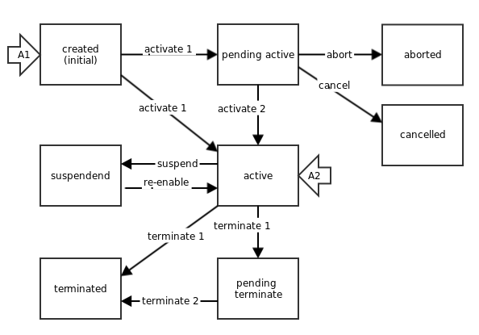

UML Model:

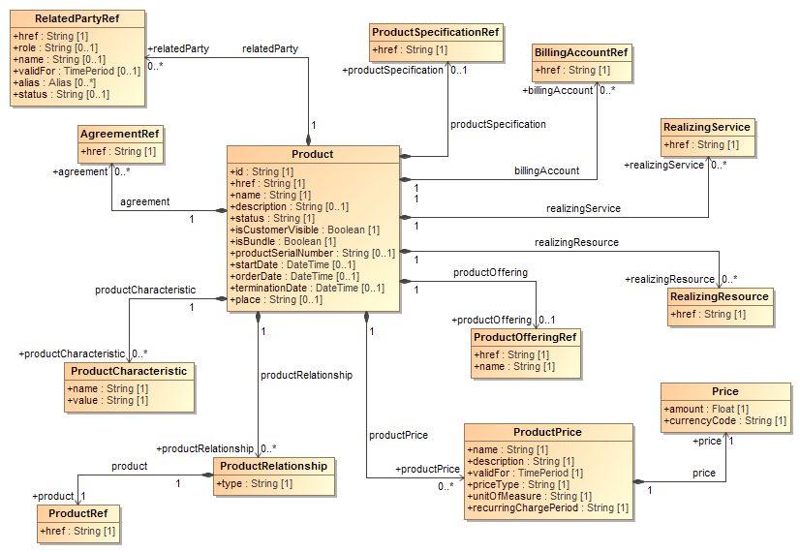

## Notification Resource Models

### ProductCreationNotification

Used to notify that a product entry was created in the inventory

|  |
| --- |
| {  "event": {  "id": "http://server:port/inventoryApi/product/42",  "name": "Broadband",  "description": "Description of the instantiated broadband product",  "status": "active",  "isCustomerVisible": true,  "isBundle": true,  "startDate": "2013-07-21 08:16:39ZGMT+1",  "orderDate": "2013-07-21 06:16:39ZGMT+1",  "productOffering":  {  "href": "http://server:port/catalogApi/productOffering/4",  "name": "My Quick BB Offer"  },  "productSpecification":  {  "href": " http://server:port/catalogApi/productOffering/4"  },  "productCharacteristics":[  {  "name":"speed",  "value":"16M"  }],  "productRelationships":[  {  "type":"contains",  "product":{  "id":" http://server:port/inventoryApi/product/59"  }  }],  "billingAccount":  {  "id": "http://server:port/billingApi/billingAccount/678"  },  "relatedParties": [  {  "role":"partner",  "reference":"http://serverlocation:port/partnerManagement/partner/42"  }],  "realizingServices": [  {  "id": “46779”,  "href": "http://server:port/inventoryApi/service/46779"  }],  "productPrice" : [{  "name" : "…",  "description" : "",  "validFor":{  "startDateTime":"2013-04-19T16:42:23-04:00",  "endDateTime":"2013-06-19T00:00:00-04:00"  },  "priceType":"recurring",  "recurringChargePeriod":"monthly",  "unitOfMeasure":"",  "price":{  "amount":"12",  "currency":"$"  }  }]  },  "eventType": "productCreationNotification"  } |

### ProductValueChangeNotification

Used to notify that a product entry was modified in the inventory

|  |
| --- |
| {  "event": {  "id": “42”,  "href": "http://server:port/inventoryApi/product/42",  "productCharacteristics":[  {  "name":"speed",  "value":"32M"  }]  },  "eventType": "productValueChangeNotification"  } |

### ProductStatusChangeNotification

Used to notify that a product entry status has changed in the inventory

|  |
| --- |
| {  "event": {  "href": "http://server:port/inventoryApi/product/42",  "status": “active”  },  "eventType": "productStatusChangeNotification"  } |

### ProductDeletionNotification

Used to notify that a product entry was removed from the inventory

|  |
| --- |
| {  "event": {  "id": “http://server:port/inventoryApi/product/42”,  },  "eventType": "ProductDeletionNotification" } |

### ProductBatchNotification

Used to notify that one or many changes appeared in the inventory concerning a specific party, this (these) change(s) being the result of a specific business interaction.

|  |
| --- |
| {  "event": [  {  "event": {  "id": “http://server:port/inventoryApi/product/42”,  },  "eventType": "ProductDeletionNotification"  },  {  "event": {  "id": “http://server:port/inventoryApi/product/42”,  “state” : “…”  },  "eventType": "ProductStateChangeNotification"  }  ],  "reason" : "Contract Termination",  “details” : {  “name” : “”,  “value” : “”  }  "eventType": "ProductTransactionNotification" } |

# API OPERATION TEMPLATES

For every single of operation on the entities use the following templates and provide sample REST requests and responses.

Remember that the following Uniform Contract rules must be used :

|  |  |  |
| --- | --- | --- |
| Operation on Entities | Uniform API Operation | Description |
| Query Entities | GET Resource | GET must be used to retrieve a representation of a resource. |
| Create Entity | POST Resource | POST must be used to create a new resource |
| Partial Update of an Entity | PATCH Resource | PATCH must be used to partially update a resource  For reconciliation processes |
| Complete Update of an Entity | PUT Resource | PUT must be used to completely update a resource identified by its resource URI |
| Remove an Entity | DELETE Resource | DELETE must be used to remove a resource |

Filtering and attribute selection rules are described in the TMF REST Design Guidelines.

Notifications are also described in a subsequent section.

## GET /inventoryApi/product/{ID}

This Uniform Contract operation is used to retrieve the representation of a product inventory.

Note that collections can be retrieved via GET /inventoryApi/product with no {ID}

Description :

* Allows to retrieve product inventory content
* Filtering is enabled on all attributes and field selection also
* The resource is a managed entity.
* The identifier is an hyperlink

Behavior :

* Returns HTTP/1.1 status code 200 if the request was successful.

Case : Querying the product inventory to retrieve an overview of all the top level products for a given customer

|  |
| --- |
| **REQUEST** |
| GET /inventoryApi/product/?relatedParties.role=customer&relatedParties.reference=42&isTopLevel=true&fields=name, description, status  Accept: application/json |
| **RESPONSE** |
| 200  Content-Type: application/json  [{  "id": "42",  "href": "http://server:port/inventoryApi/product/42",  "name": "Broadband",  "description": "Description of the instantiated broadband product",  "status": "active"  }, {  "id": "55",  "href": "http://server:port/inventoryApi/product/55",  "name": "Mobile data access",  "description": "Description of the instantiated broadband product",  "status": "active"  }] |

## PUT inventoryApi/product/{ID}

This Uniform Contract operation is used to completely update the representation of a product.

Description :

* Replaces a product entry inside the inventory
* The resource is a managed entity

Behavior :

* Returns HTTP/1.1 status code 201 if the request was successful.
* Standard error codes in case of errors.

|  |
| --- |
| **REQUEST** |
| PUT inventoryApi/product/42  Content-type: application/json  {  "id": "42",  "href": "http://server:port/inventoryApi/product/42",  "name": "Broadband",  "description": "Description of the instantiated broadband product",  "status": "active",  "startDate": "2013-07-21 08:16:39ZGMT+1",  "orderDate": "2013-07-21 06:16:39ZGMT+1",  "terminationDate": "",  "productOffering":  {  “id” : “4”,  "href": "http://server:port/catalogApi/productOffering/4",  "name": "My Quick BB Offer"  },  "productSpecification":  {  "id": " http://server:port/catalogApi/productOffering/4"  },  "productCharacteristics":[  {  "name":"speed",  "value":"16M"  }],  "productRelationships":[  {  "type":"contains",  "product":{  "id":" http://server:port/inventoryApi/product/59"  }  }],  "billingAccount":  {  "id": "http://server:port/billingApi/billingAccount/678"  },  "relatedParties": [  {  "role":"partner",  "reference":"http://serverlocation:port/partnerManagement/partner/42"  }],  "realizingServices": [  {  "id": " 46779",  "href": "http://server:port/inventoryApi/service/46779"  }],  "productPrice" : [{  "name" : "…",  "description" : "",  "validFor":{  "startDateTime":"2013-04-19T16:42:23-04:00",  "endDateTime":"2013-06-19T00:00:00-04:00"  },  "priceType":"recurring",  "recurringChargePeriod":"monthly",  "unitOfMeasure":"",  "price":{  "amount":"12",  "currency":"$"  }  }]  } |
| **RESPONSE** |
| 201  Content-Type: application/json  { JSON Resource Representation with every attributes  } |

## PATCH inventoryAPI/product/{ID}

Description :

* Partially updates a product entry in the inventory
* The resource is a managed entity

Behavior :

* Returns HTTP/1.1 status code 201 if the request was successful.
* Standard error codes in case of an error.

Case : Patch the product inventory entry once the service delivery is fully done, thus linking the service ID to the product instance

|  |
| --- |
| **REQUEST** |
| PATCH inventoryApi/product/42  Content-type: application/json  {  "realizingServices": [  {  "id": "http://server:port/inventoryApi/service/46779"  }]  } |
| **RESPONSE** |
| 201  Content-Type: application/json  { JSON Resource Representation with every attributes  } |

## POST inventoryAPI/product

Description :

* Allows to create a new product entry in the inventory
* The resource is a managed entity

Behavior :

* Returns HTTP/1.1 status code 201 if the request was successful.
* Standard error codes in case of an error.

|  |
| --- |
| **REQUEST** |
| POST inventoryApi/product  Content-type: application/json  {  "name": "Samsung Galaxy S4",  "description": "Description of the instantiated handset product",  "status": "active",  "productSerialNumber": "59745034OOR030",  "startDate": "",  "orderDate": "2013-07-21 06:16:39ZGMT+1",  "terminationDate": ""  "productOffering":  {  "id": "http://server:port/catalogApi/productOffering/22",  "name": "My Quick BB Offer"  },  "productSpecification":  {  "id": " http://server:port/catalogApi/productOffering/21"  },  "productCharacteristics":[  {  "name":"color",  "value":"black"  }]  "billingAccount":  {  "id": "http://server:port/billingApi/billingAccount/678"  },  "relatedParties": [  {  "role":"partner",  "reference":"http://serverlocation:port/partnerManagement/partner/42"  }],  "place":”<http://map.google.com/.../1234112GDE>”,  "realizingResources": [  {  "id": " http://server:port/inventoryApi/device/659394EDOD0O"  }],  "productPrice" : [{  "name" : "…",  "description" : "",  "validFor":{  "startDateTime":"2013-04-19T16:42:23-04:00",  "endDateTime":"2013-06-19T00:00:00-04:00"  },  "priceType":"non-recurring",  "price":{  "amount":"300",  "currency":"$"  }  }]  } |
| **RESPONSE** |
| 201  Content-Type: application/json  { JSON Resource Representation with every provided and default attributes  } |

## DELETE inventoryApi/product/{ID}

Description :

* Delete a product in the inventory

Behavior :

* Returns HTTP/1.1 status code 200 if the request was successful.
* Standard error codes in case of an error.
* Under certain policies, some errors may be raised when using this operation (for example if integrity violations are forbidden in the inventory).

|  |
| --- |
| **REQUEST** |
| DELETE inventoryApi/product/42 |
| **RESPONSE** |
| 200 |

# API NOTIFICATIOn TEMPLATES

For every single of operation on the entities use the following templates and provide sample REST notification POST calls.

It is assumed that the Pub/Sub uses the Register and UnRegister mechanisms described in the REST Guidelines reproduced below.

## REGISTER LISTENER POST /hub

Description :

Sets the communication endpoint address the service instance must use to deliver information about its health state, execution state, failures and metrics. Subsequent POST calls will be rejected by the service if it does not support multiple listeners. In this case DELETE /api/hub/{id} must be called before an endpoint can be created again.

Behavior :

Returns HTTP/1.1 status code 204 if the request was successful.

Returns HTTP/1.1 status code 409 if request is not successful.

|  |
| --- |
| **REQUEST** |
| POST /api/hub  Accept: application/json  {"callback": "http://in.listener.com"} |
| **RESPONSE** |
| 201  Content-Type: application/json  Location: /api/hub/42  {"id":"42","callback":"http://in.listener.com","query":null} |

## UNREGISTER LISTENER DELETE hub/{id}

Description :

Clears the communication endpoint address that was set by creating the Hub.

Behavior :

Returns HTTP/1.1 status code 204 if the request was successful.

Returns HTTP/1.1 status code 404 if the resource is not found.

|  |
| --- |
| **REQUEST** |
| DELETE /api/hub/{id}  Accept: application/json |
| **RESPONSE** |
| 204 |

## publish {EventTYPE} POST /listener

Description :

Provide the Event description

Behavior :

Returns HTTP/1.1 status code 201 if the service is able to set the configuration.

|  |
| --- |
| **REQUEST** |
| POST /client/listener  Accept: application/json  {    "event": {  EVENT BODY   },  "eventType": "eventType" } |
| **RESPONSE** |
| 201  Content-Type: application/json |

Example see TMF REST Design Guidelines.

## Release History

|  |  |  |  |
| --- | --- | --- | --- |
| **Release Number** | **Date** | **Release led by:** | **Description** |
| Release 1.0 | 04/15/2013 | Pierre Gauthier  TM Forum  [pgauthier@tmforum.org](mailto:pgauthier@tmforum.org) | First Release of Draft Version of the Document. |
| Release 1.1 |  |  | Updated for use in the Paris Spec Jam – and rebranded. |