Basic SQUEEZE 7 Training Course

SQUEEZE 7 Training Notes

Demonstration Files and Exercises

Course tutors: Eric Mackay / Oscar Vazquez
Flow Assurance & Scale Team (FAST)
Institute of Petroleum Engineering
Heriot-Watt University
Edinburgh
EH14 4AS
phone +44 131 451 3670 / 3301
fax +44 131 451 3127
email Eric.Mackay@pet.hw.ac.uk
Oscar.Vazquez@pet.hw.ac.uk
web www.pet.hw.ac.uk

Single Phase Single Layer Radial Reservoir Model
(Model 3; Single layer; files Case3s)

Numerical (cell) model for radial displacement in unfractured wells

Demonstration Files

(1) case3s-1.dat:

(a) Adsorption squeeze in a single layer system;
Field return concentration data matched in model;
Non-equilibrium Freundlich adsorption isotherm used;
(d) Concentration vs. radial distance from wellbore also displayed.

DATA:
Radial model; 1 layer; Conventional units (ft, bpm, bpd)
Well radius 6 inches (0.5 ft)
Model radius 80 ft
Layer thickness 20 ft
Porosity 0.23
Freundlich isotherm parameters k=500; n=0.4; r2=0.1 (1/day)
Number of cells 40
Treatment:
Main stage 4 bpm for 4.75 hours with [SI] = 150,000 ppm
Overflush 4 bpm for 9.75 hours
Shut in 12 hours
Production
9 (monthly) stages with water production rates between 826 bpd and 8781 bpd
Plot field data and calculate how long it takes to reach 10 ppm and 5 ppm (MIC)

(2) case3s-2.dat:

(a) Same as case3s-1, except metric units used;
(b) case3s-1 return curve also plotted for comparison.

Exercises 1 - 3

Exercise 1: Modify Case3s-1 to Double Injection Concentration

Assess the impact of doubling the injection concentration (same volume of water, double the volume of chemical)

(a) Double injected inhibitor concentration;
(b) Compare calculated results with inhibitor return data from case3s-1, but remove field data from previous squeeze

Method: Read the case3s-1.dat file.
Click the “Edit Model” button
Select “Stage Properties” tab
Double click in “Inj/Prod Controls“ for stage 1
(currently reading [SI] 150000)
Double click in “Wat Conc” box for component 1
(currently reading 150000)
Double the injected inhibitor concentration from 150,000 ppm to 300,000 ppm.
Click OK to return to “Stage Properties”
Select “Graphics Options” tab
Click “Remove Table” on bottom right
Double click on “Click here 1” and select Case3s-1.out file to plot for comparison
Click OK to return to main dialogue box
You will be prompted to save the input file. Call it ex1.dat.
(only need to type ex1)
Click the “Run Model” button
Save the output to file ex1.out (default output file name)

Results: The green line is the previously calculated case with 150,000 ppm (case3s-1)
The black line is the newly calculated case with double the concentration (ex1)

Exercise 2: Modify Case3s-1 to Double Injection Volume

Assess the impact of doubling the injection volume (double the volume of water and chemical => same concentration)

(a) Double injection time or volume;
(b) Compare calculated results with return data from case3s-1 and ex1.

Exercise 3: Modify Case3s-1 to Double Overflush Volume

Assess the impact of doubling the overflush volume

(a) Double time of overflush stage;
(b) Compare calculated results with return data from case3s-1, ex1 and ex2.

Single Phase Multi-layer Radial Reservoir Model
(Model 3; Multi layer; files Case3m)

Numerical (cell) model for radial displacement in unfractured wells

Demonstration Files

(1) case3m-1.dat:

(a) Additional completion to case3s-1 – perforate an extra 50 ft into two new layers
Height (ft) | Porosity (fraction) | Permeability (md)
20 | 0.23 | 500
10 | 0.17 | 300
40 | 0.25 | 1200

(b) Same inhibitor and isotherm as in case3s-1;
(c) Layer flow rates are calculated automatically.
(d) Higher injection pump rates (6 bpm) and predict higher water production rate (average 8000 stbw/d for one year after treatment).
(e) Pump bigger treatment volume (Main inhibitor stage 1800 bbls, overflush 4320 bbls).

(2) case3m-2.dat:

(a) Use prediction from reservoir simulator to identify water production rates in each layer
(b) Flow rates are calculated automatically during injection, but are based on PIDf numbers during the production stages;

Exercises 4 - 7

Exercise 4: Modify Case3m-1 to a 5-layer System

(1) Selective adsorption squeeze in a 5-layer system.

(2) Reservoir property data:

Phi EffPerm(md) Height(ft)
0.22 170.0 50.0
0.17 130.0 45.0
0.21 150.0 50.0
0.15 90.0 55.0
0.25 220.0 60.0

(3) Inhibitor/rock interaction:

Adsorption process - a single-isotherm applies with rate number of r2 = 0.1
Freundlich form: k = 500; n = 0.3.

(4) Squeeze strategy & schedule:

(a) Only layers 1- 4 are squeezed
(b) All layers are open throughout production
(c) Preflush injection: 5 bbl/min; total volume = 200 bbl
Inhibitor concentration = 100 ppm
(d) Inhibitor injection: 5 bbl/min; total volume = 600 bbl
Inhibitor concentration = 70000 ppm
(e) Seawater overflush: 5 bbl/min; total volume = 1600 bbl
(f) Shut-in: 12 hours
(g) Production: 5000 bbl/day for 460 days
(h) Water flow rate distribution is evaluated in terms of "EffPerm".

Exercise 5: Further Modifications to Exercise 4

Water rate is changed as follows:

(a) Injected water rate distribution is evaluated in terms of
permeability height product (as is).
(b) Water flow rate distribution during production is evaluated in
terms of user specified "PIDf" numbers in two periods of production

(i) In the first 200 days, the flow rates for 5 layers are:

Layer Index Water Production (bbl/d)
1 900
2 750
3 1100
4 850
5 1400

(ii) In the following 260 days, the flow rates for 5 layers are:

Layer Index Water Production (bbl/d)
1 1400
2 850
3 1100
4 750
5 900

Exercise 6: Sensitivity simulation based on Exercise 5

This is a sensitivity simulation exercise:

(1) All injection stage volumes are doubled compared to Exercise 5;
(2) Compare calculated results with return data from ex6 with ex5.

Exercise 7: Sensitivity simulation based on Exercise 6

This is a sensitivity simulation exercise:

(1) The injection concentration is doubled compared to Exercise 6;
(2) What do you need to do to keep well returns above MIC to the end of 460 days whilst minimizing inhibitor volume? You may only change the injection stage properties.

Single Phase Single Layer Linear Reservoir Model
(Model 3; Single Layer; files Case2)

Analytical model for linear displacement in fractured wells

Demonstration File

(1) case2-1.dat:

DATA:
Linear model; 1 layer; Conventional units (bbls)
Porosity 0.25
Freundlich isotherm parameters k=300; n=0.26
Treatment:
Main stage 129.8 bbls with [SI] = 110,000 ppm
Overflush 2700 bbls
Production
Produce 1,000,000 bbls of water
Plot inhibitor return concentrations vs volume of water produced and calculate what volume must be produced before well reaches 5 ppm, 3ppm and 1 ppm (MIC)

Isotherm Derivation & Validation (Model 5)

Demonstration File

1. case5.dat:

Coreflood fact data and experimental effluent data

Core material type: Clashach

Length of core: Lcor = 14.03 cm

Core diameter: Dcor = 2.58 cm

Core pore volume: 1pv = 15.27 ml

Core plug bulk volume: Vb = 73.35 cc

Core porosity: Rho = pore vol./bulk vol. = 0.2082

Injected C: CI = 50042.5 mg/L (active)

Total dead volume: Vd = 8.34 ml

Injection rate: Qw = 30 ml/hr

Volume of inhibitor slug: VI = 129.6 ml

Shut-in: 16 hours

Total seawater postflush volume: ~ 565.8 pv / 8640 ml

Porosity: 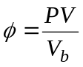, where 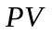 is the pore volume and 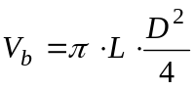 is the bulk volume.

Exercise 8

1. Coreflood fact data:

Core material type: Clashach

Length of core: Lcor = 13.99 cm

Core diameter: Dcor = 2.55 cm

Core pore volume: 1pv = 16.58 ml

Core plug bulk volume: Vb = 71.35 cc

Core porosity: Rho = pore vol./bulk vol. = 0.233

Injected C: CI = 32640.0 mg/L (active)

Total dead volume: Vd = 3.26 ml

Injection rate: Qw = 30 ml/hr

Volume of inhibitor slug: VI = 88.75 ml

Shut-in: 16 hours

Total seawater postflush volume: ~ 1560 pv / 25865 ml

Oven temperature: T = 70˚C

2. Experimental effluent data: (file"Ex8-raw-data.xls")

Sample | Sample vol | Cum vol. | Inject pv | Active inhibitor conc.
1 | 2.5 | 1.25 | 0.045 | 11.67277228
2 | 2.5 | 3.75 | 0.104504505 | 13.62425743
3 | 2.5 | 6.25 | 0.254654655 | 12.79306931
4 | 2.5 | 8.75 | 0.404804805 | 13.11831683
5 | 2.5 | 11.25 | 0.554954955 | 42.64356436
6 | 2.5 | 13.75 | 0.705105105 | 701.0891089
7 | 2.5 | 16.25 | 0.855255255 | 3686.138614
8 | 2.5 | 18.75 | 1.005405405 | 10781.53846
9 | 2.5 | 21.25 | 1.155555556 | 16509.23077
10 | 2.5 | 23.75 | 1.305705706 | 20177.94872
11 | 2.5 | 26.25 | 1.455855856 | 22124.61538
12 | 2.5 | 28.75 | 1.606006006 | 23247.69231
14 | 2.5 | 33.75 | 1.906306306 | 24033.84615
16 | 2.5 | 38.75 | 2.206606607 | 24595.38462
18 | 2.5 | 43.75 | 2.506906907 | 25669.91786
20 | 2.5 | 48.75 | 2.807207207 | 25782.34086
24 | 2.5 | 58.75 | 3.407807808 | 27281.31417
26 | 2.5 | 63.75 | 3.708108108 | 27955.85216
28 | 2.5 | 68.75 | 4.008408408 | 28480.49281
30 | 2.5 | 73.75 | 4.308708709 | 28368.06982
1 | 2.5 | 91.25 | 5.35975976 | 25483.02752
2 | 2.5 | 93.75 | 5.50990991 | 16709.63303
3 | 2.5 | 96.25 | 5.66006006 | 19723.3945
4 | 2.5 | 98.75 | 5.81021021 | 19991.2844
5 | 2.5 | 101.25 | 5.96036036 | 19924.31193
6 | 2.5 | 103.75 | 6.110510511 | 20594.0367
7 | 2.5 | 106.25 | 6.260660661 | 20962.38532
8 | 2.5 | 108.75 | 6.410810811 | 17613.76147
9 | 2.5 | 111.25 | 6.560960961 | 12099.07407
10 | 2.5 | 113.75 | 6.711111111 | 8313.888889
11 | 2.5 | 116.25 | 6.861261261 | 6150.925926
12 | 2.5 | 118.75 | 7.011411411 | 4562.5
14 | 2.5 | 123.75 | 7.311711712 | 3102.5
16 | 2.5 | 128.75 | 7.612012012 | 2237.314815
18 | 2.5 | 133.75 | 7.912312312 | 1865.555556
20 | 2.5 | 138.75 | 8.212612613 | 1456.62037
22 | 2.5 | 143.75 | 8.512912913 | 1255.327103
24 | 2.5 | 148.75 | 8.813213213 | 1129.11215
26 | 2.5 | 153.75 | 9.113513514 | 1019.953271
28 | 2.5 | 158.75 | 9.413813814 | 938.0841121
30 | 2.5 | 163.75 | 9.714114114 | 876.682243
32 | 2.5 | 168.75 | 10.01441441 | 849.3925234
34 | 2.5 | 173.75 | 10.31471471 | 723.1775701
36 | 2.5 | 178.75 | 10.61501502 | 658.364486
38 | 2.5 | 183.75 | 10.91531532 | 625.7142857
40 | 2.5 | 188.75 | 11.21561562 | 590.952381
44 | 2.5 | 198.75 | 11.81621622 | 542.2857143
50 | 2.5 | 213.75 | 12.71711712 | 469.2857143
54 | 2.5 | 223.75 | 13.31771772 | 427.5714286
60 | 2.5 | 238.75 | 14.21861862 | 375.4285714
64 | 5 | 248.75 | 14.89429429 | 345.1857143
70 | 5 | 278.75 | 16.6960961 | 251.3285714
74 | 5 | 298.75 | 17.8972973 | 214.5235849
80 | 10 | 328.75 | 19.84924925 | 166.3160377
84 | 10 | 368.75 | 22.25165165 | 127.0613208
90 | 10 | 428.75 | 25.85525526 | 97.44811321
94 | 10 | 468.75 | 28.25765766 | 88.1509434
100 | 10 | 528.75 | 31.86126126 | 81.26415094
104 | 10 | 568.75 | 34.26366366 | 78.85377358
110 | 10 | 628.75 | 37.86726727 | 65.76886792
115 | 10 | 678.75 | 40.87027027 | 62.66981132
120 | 10 | 728.75 | 43.87327327 | 59.57075472
125 | 10 | 778.75 | 46.87627628 | 56.12735849
130 | 10 | 828.75 | 49.87927928 | 53.37264151
140 | 10 | 928.75 | 55.88528529 | 48.89622642
150 | 10 | 1028.75 | 61.89129129 | 44.0754717
160 | 10 | 1128.75 | 67.8972973 | 40.63207547
171 | 250 | 1238.75 | 81.71111111 | 37.90384615
173 | 20 | 1508.75 | 91.02042042 | 32.71095238
179 | 20 | 1628.75 | 98.22762763 | 30.38190476
187 | 20 | 1788.75 | 107.8372372 | 28.15714286
194 | 20 | 1928.75 | 116.2456456 | 26.9752381
207 | 20 | 2188.75 | 131.8612613 | 24.1247619
221 | 20 | 2468.75 | 148.6780781 | 21.55238095
235 | 20 | 2748.75 | 165.4948949 | 19.84904762
243 | 20 | 2908.75 | 175.1045045 | 18.98
256 | 20 | 3168.75 | 190.7201201 | 18.39038462
264 | 20 | 3328.75 | 200.3297297 | 16.28461538
270 | 20 | 3448.75 | 207.5369369 | 15.86346154
277 | 20 | 3588.75 | 215.9453453 | 15.26682692
297 | 20 | 3988.75 | 239.9693694 | 13.43058252
312 | 20 | 4288.75 | 257.9873874 | 12.65097087
331 | 20 | 4668.75 | 280.8102102 | 11.16262136
352 | 20 | 5088.75 | 306.0354354 | 10.34757282
374 | 20 | 5528.75 | 332.4618619 | 9.745145631
395 | 20 | 5948.75 | 357.6870871 | 9.249029126
416 | 20 | 6368.75 | 382.9123123 | 8.752912621
437 | 20 | 6788.75 | 408.1375375 | 7.831553398
458 | 20 | 7208.75 | 433.3627628 | 7.441747573
460 | 570 | 7248.75 | 452.2816817 | 6.981067961
461 | 900 | 7818.75 | 496.4258258 | 6.521827411
462 | 685 | 8718.75 | 544.0234234 | 6.188324873
463 | 732.5 | 9403.75 | 586.590991 | 6.003045685
464 | 697.5 | 10136.25 | 629.5339339 | 5.891878173
465 | 817.5 | 10833.75 | 675.0294294 | 4.446700508
466 | 727.5 | 11651.25 | 721.4258258 | 5.203815261
467 | 1447.5 | 12378.75 | 786.7411411 | 4.800702811
468 | 1440 | 13826.25 | 873.4528529 | 4.287650602
469 | 2167.5 | 15266.25 | 981.7861862 | 3.994477912
470 | 1320 | 17433.75 | 1086.515916 | 3.884538153
471 | 2160 | 18753.75 | 1191.02042 | 3.923380567
472 | 1560 | 20913.75 | 1302.732132 | 4.048987854
473 | 1477.5 | 22473.75 | 1393.948348 | 4.04159919
474 | 1380 | 23951.25 | 1479.759159 | 4.00465587
475 | 1200 | 25331.25 | 1557.236637 | 3.915991903

Exercise 9: Modify Case3s-1 to use Isotherm Derived in Ex 8

(a) Copy isotherm (mg/l version) into a new file called Ex8.txt in the isotherm folder (use template.txt) for this purpose, remembering to enter number of lines of data which you can identify by pasting the data into MS Excel)
(b) Make “Adsorption Type” equilibrium
(c) Compare calculated results with return data from case3s-1.

Final Exercise: From Core Flood to Field Design

Derive adsorption isotherm from core flood data. Model core flood using derived isotherm to validate. History match last squeeze (no. 3) and then compare use of new isotherm to model next squeeze treatment. Design next treatment and perform sensitivity calculations to optimise.

Data: Core flood description enclosed.
Effluent concentrations in file coreflood.xls
Summary of three previous field treatments and proposed next squeeze enclosed.
Return concentrations from last treatment in file sqz3returns.xls

Table 1: Summary of Inhibitor Core Flood

Experiment ID. | Flood 1
Core Length (cm) | 15.253
Core Diameter (cm) | 2.461
Core Weight (gram)
Porosity (%) | 22.34 %
Dead Volume (ml)  inlet & outlet | 3.20  0.5 & 2.70
Confining Pressure(psi) | 2000
Back Pressure (psi) | 250
Permeability(20°C) (mD)  Initial  After oil & demulsifier injection  Final | 268  180  229
Pore Volume (ml)  Initial  Sor  During inhibitor injection | 23.16  14.41  16.21
Initial water saturation  Residual oil saturation | 29.9%  37.8%
Inhibitor flood & SW  postflush flowrate (m/hr) | 60
Shut-in Time (hours) | 18
Brief Summary of Mineralogy of Core
Used in Flood 1
Mineral types: | Porosity 26%
Quartz | 58%
Feldspar - microcline  - orthoclase | 6%
Carbonate - Calcite/ferroan dol. | 2%
Lithic fragments | 2%
Clay types - Authigenic  Detritial | 3%  2%
Pyrite | <0.5

Summary of Previous Squeezes (Nos. 1-3) and Planned Treatment No. 4

1.0 Data

Treatment Number 4
Company
Product
Proposal Number
Date of Issue
Gross Production 9,018 bfpd
Water Cut 60%
Water Production 5411 bwpd
Production Interval 480 ft
Porosity 26%
Tubing Volume 257 bbls
Overflush Volume (including tubing volume) 2770 bbls
Squeeze Life Calculated for 126 days
Prepared by

2.0 Summary of Previous Treatments

Squeeze Number | Treatment  Date | Duration  of Squeeze  (days) | Volume  (Litres) | Overflush Vol  + Tbg Vol  ( bbls) | Overflush  Radius  (ft) | Effective  Concn.  ( % ) | Squeeze  Life  (mmbls  produced  water)
1 | 21/10/97 | 107 | 2600 | 2002 | 5 | 15 | 10,918
2 | 25/11/97 | 36 | 3245 | 3667 | 7 | 15 | 142,138
3 | 18/2/98 | 74 | 6837 | 3667 | 7 | 15 | 411,65

3.0 Treatment Procedure

Spearhead

A. Pump 50 bbls of FTSW containing 5 litres of X and 5 litres of inhibitor.

Pumping Rate 5 bbls/min
X 0.5 litres/min
Inhibitor 0.5 litres/min
Treatment time 10 minutes

Pump 50 bbls of FTSW containing 5 litres of inhibitor.

Pumping Rate 5 bbls/min
Inhibitor 0.5 litres/min
Treatment time 10 minutes
Treatment volume at this stage 100 bbls
Cumulative treatment volume 100 bbls
Stage time 20 minutes

Hint: To calculate the inhibitor concentration we use the following equation, 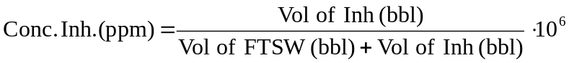

Main Treatment

B. Pump 314 bbls of FTSW containing 8800 litres of inhibitor.

Pumping Rate 5 bbls/min
Inhibitor 139 litres/min approx.
Treatment volume at this stage 369 bbls
Cumulative treatment volume 469 bbls
Stage time 1 hour 13 minutes

Overflush

Note Pump all chemical lines to well while pumping overflush.

C. Pump 2770 bbls of FTSW overflush (including 257 bbls tubing displacement volume with no added chemical)

Pumping Rate 5 bbls/min
Treatment volume at this stage 2770 bbls
Cumulative treatment volume 3239 bbls
Stage time 9 hour 14 minutes

Summary

Total treatment volume 3239 bbls
Total treatment time 10 hour 47 minutes

Guidelines for Certain Control and Isotherm Parameters

a. Choice of Δt:

In practice, the Δt used in the provided example datasets or the following Δt values may be adopted as first estimates:

adsorption squeeze:

preflush/injection/overflush Δt = 0.001 days
shut-in (equilibrium adsorption) Δt = 0.10 days
shut-in (non-equilibrium adsorption) Δt = 0.02 days
production (0-2 days) Δt = 0.01 days
production (3-10 days) Δt = 0.05 days
production (11days-1st month) Δt = 0.10 days
production (till end of simulation) Δt = 0.50 days

b. Freundlich parameters for history matching:

k = 50 - 1000
n = 0.05 - 0.5
r2 = 0.05 - 0.5

If running the SQUEEZE software gives a black screen, and you are not using Windows 7
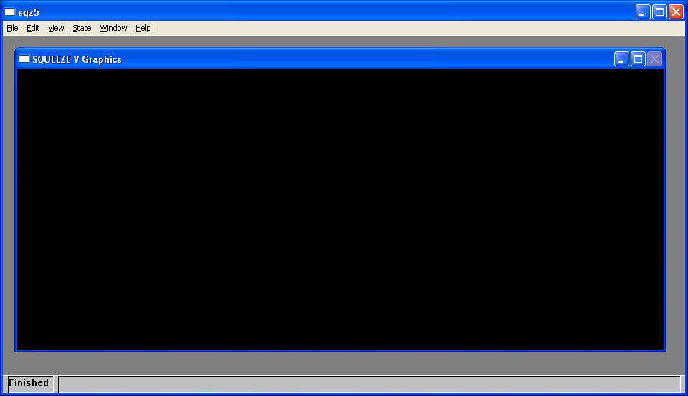
Eg

then do the following:

- Right click on the background desktop and select “Properties”
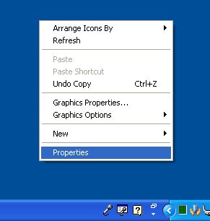

- Go to the “Settings” tab and change the “Color quality” from “Highest” to “Medium”
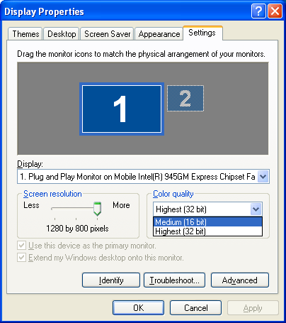

- Click “OK” and rerun the SQUEEZE model.
If running the SQUEEZE software gives a black screen, and you are using Windows 7 then do the following:
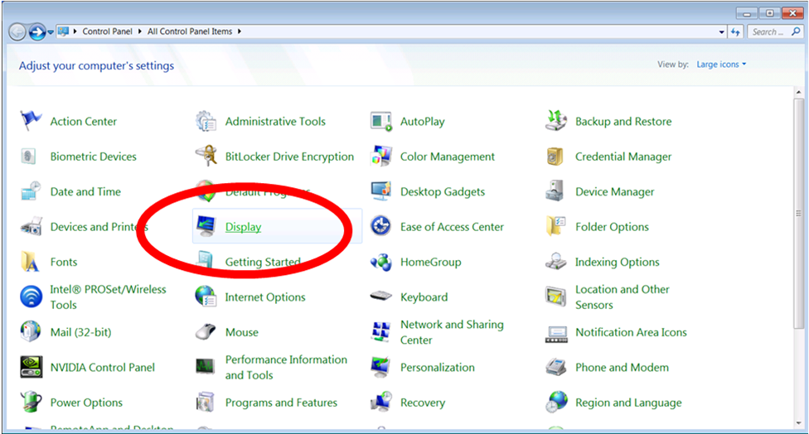
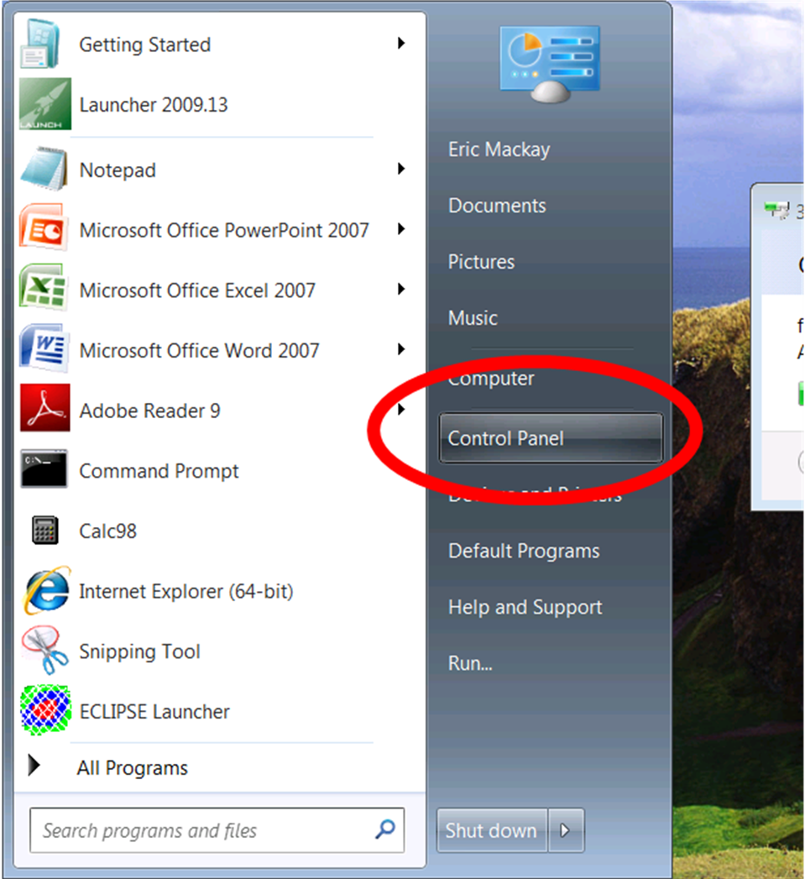
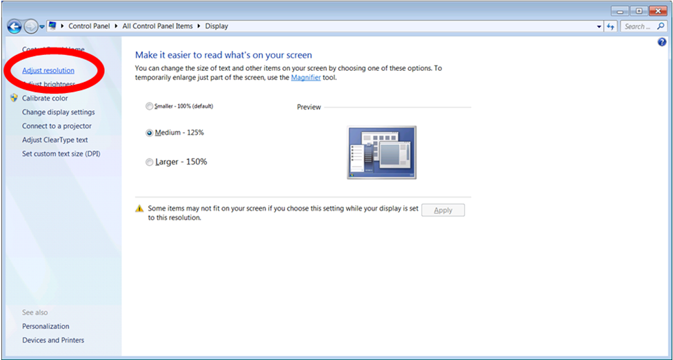

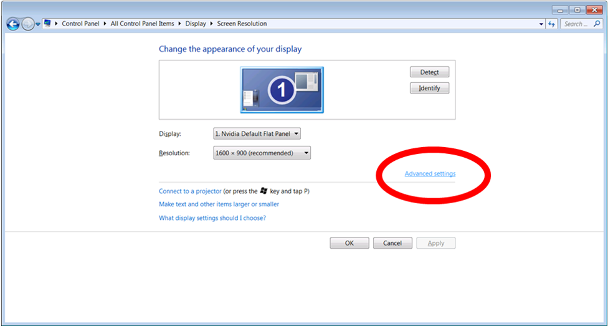
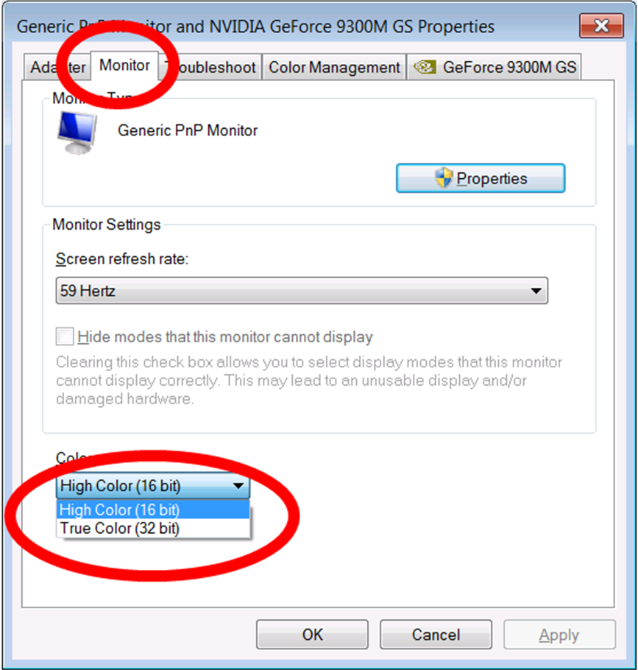

…..and try again

