Supplementary Note: Energy–Architecture Trade-offs for CRN
Why a transient Stage-I wave/netting layer can be adaptive – and why it should be locally gated
Version: v2.1 (clean, reviewer-facing) | Build date: 2026-01-26 | Artifact pack: CRN_step6_release_candidate (CSV/PNG + code)

1. Purpose, scope, and the missing Step 1
This Supplementary Note documents an alternative, architecture-level protocol designed to evaluate a specific hypothesis: a CRN-like Stage-I wave/netting mechanism may be adaptive in some neural subsystems (transport/search), yet maladaptive in others (recurrent associative memory), thereby creating selection pressure for modular (locally gated) architectures. The note provides methods, quantitative results, and limitations in a format intended to be self-contained for reviewers.
The earlier draft started with “Step 2” because it was written as an internal development log. For publication, we restore the logical Step 1 here: the conceptual framing that links the Stage-I/Stage-II decomposition to an energetic objective. Subsequent sections then report the computational evidence (Experiments A–D) and a robustness audit.

1.1 Stage-I vs Stage-II (conceptual framing)
We distinguish two functional stages. Stage I is a wave-like, analog pre-selection process (CRN-like “netting”) that can explore a state space or propagate candidate activations at low marginal cost per candidate. Stage II is a discrete fixation/broadcast step (e.g., spiking-driven commitment, long-range broadcast, or global workspace-like routing) that is comparatively expensive per act.
Energetically, Stage I is advantageous if it reduces the expected number of costly Stage-II broadcasts. A minimal inequality is:
ΔE ≈ (ΔN_broadcast · E_comm) − E_stageI > 0,
where E_comm is the cost of a broadcast/commitment event, E_stageI is the cost of running Stage I for the decision episode, and ΔN_broadcast is the reduction in the number of required broadcasts (or corrective broadcasts) achieved by Stage-I pre-selection. Equivalently, defining a dimensionless checkpoint χ = E_stageI / E_comm, Stage I is energetically justified when χ < ΔN_broadcast. In the protocol below, this energetic logic is implemented as a “modularity/gating cost” term in an abstract fitness function (Section 4).

1.2 Conceptual schematic
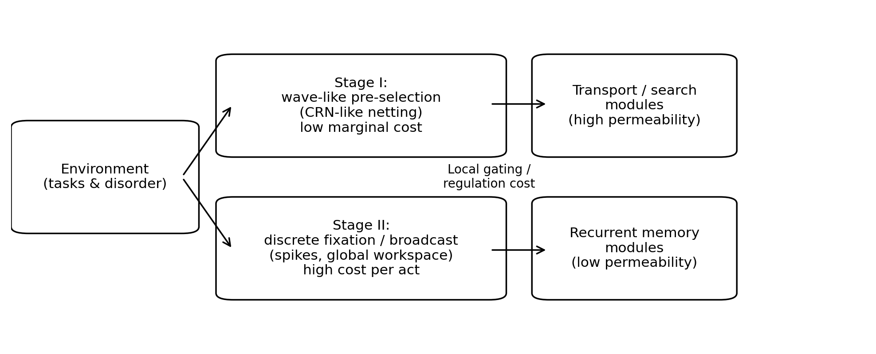
Figure S0. Conceptual framing. Stage I is a low-marginal-cost wave/netting layer (CRN-like) that supports transport/search. Stage II is an expensive discrete fixation/broadcast step. A modular architecture can locally gate permeability/noise regimes so that transport modules remain highly permeable while recurrent memory modules remain confined.

2. Terminology and workflow overview
To keep the presentation reviewer-facing, we avoid internal jargon and define the few abstract control variables used throughout.
Noise/permeability parameter (n): a scalar control that increases effective transport permeability. In the memory proxy we use an effective temperature T_env; in the transport proxy we use a dephasing/noise rate κ. When comparing architectures, we treat both as instances of the same abstract control parameter n.
Single-parameter (global) architecture: one shared n is applied to both transport and memory subsystems.
Modular (locally gated) architecture: transport and memory subsystems can use different n values (n_T and n_M), at the price of an added modularity/gating cost.
Environment mixture (p_transport): fraction of episodes (or fitness weight) in which the dominant demand is transport/search rather than recurrent memory.
Modularity cost (c_mod): dimensionless penalty applied to modular architectures, representing extra control circuitry, gating, regulation, or energetic overhead.
Workflow. The artifact pack CRN_step6_release_candidate contains code, CSV backends, and paper-ready figures for four computational blocks (plus a packaging wrapper). For transparency we keep the internal labels “Step 2–Step 5” in filenames, but the scientific narrative is:
- Experiment A (Step 2): recurrent microcircuit toy (SBM) – permeability vs confinement in a pattern-completion proxy.
- Experiment B (transport proxy): CRN/GKSL transport metric – intermediate-noise optimum (ENAQT-like).
- Experiment C (Step 3): architecture trade-off – transport and memory prefer different noise regimes.
- Experiment D (Step 4): evolutionary selection model – when modular separation is selected.
- Robustness audit (Step 5): stability of the selection boundary under alternative proxy definitions.

3. Methods

3.1 Experiment A: recurrent microcircuit toy (SBM pattern-completion proxy)
Topology. We generate a stochastic block model (SBM) graph with N=150 nodes arranged into three equal clusters (50 nodes each). Edges are placed independently with within-cluster probability p_in=0.30 and between-cluster probability p_out=0.02.
Disorder. Each node i receives a local energy offset E_i sampled uniformly: E_i ~ U[−ε, +ε] with ε=3.0. This represents heterogeneity in excitability, inhibition, and synaptic noise as an effective energetic landscape.
Dynamics. We simulate a continuous-time Markov master equation dP/dt = Q P on the graph. Transition rates follow a Metropolis-like rule controlled by an effective temperature T_env. For an edge j→i, the rate is proportional to exp(−max(E_i−E_j,0)/T_env). In the maximal-permeability limit (T_env→∞), energy barriers are ignored and transport reduces to topological diffusion.
Pattern-completion task. The cue set S is a random 20% subset of the target cluster C0. The target set T is the remaining 80% of C0. Distractors D are all nodes outside C0 (clusters C1 and C2). Initial mass is uniform on S. We integrate to t_end=100.
Metrics. Recall = Σ_{i∈T} P_i(t_end). Leakage = Σ_{j∈D} P_j(t_end). Selectivity is reported as Recall/Leakage (ratio of means across trials). We run n=100 independent graph+disorder realizations (seeded for reproducibility).

3.1.1 Summary statistics (Table S1)
Table S1 reports mean ± 95% confidence interval (CI) for Recall and Leakage, and Selectivity as the ratio of means, for the three permeability regimes used in Experiment A.
Regime (T_env) | Recall (mean ± 95% CI) | Leakage (mean ± 95% CI) | Selectivity (Recall/Leakage)
0.1 | 0.480 ± 0.046 | 0.400 ± 0.042 | 1.200
1.0 | 0.275 ± 0.011 | 0.657 ± 0.011 | 0.418
inf | 0.267 ± 0.000 | 0.667 ± 0.000 | 0.400

3.2 Experiment B: transport proxy (CRN/GKSL) and the ENAQT-like optimum
Transport in disordered substrates is represented using an open-system CRN/GKSL proxy metric computed in the included R12-CROWN suite. Operationally, we use the Liouvillian spectral gap g(κ) as a scalar proxy for transport/relaxation speed under dephasing rate κ. This proxy exhibits an intermediate-noise maximum (an ENAQT-like window), consistent with the idea that neither fully coherent nor fully classical limits are optimal.
In the trade-off experiments below, the transport proxy is normalized to [0,1] as transport_norm(κ) = g(κ)/max_κ g(κ). The full backend is provided as step3_transport_gap_sweep.csv.

3.3 Experiment C: architecture trade-off (single-parameter global vs modular control)
We combine the transport proxy (Section 3.2) and the memory proxy (Section 3.1) on a shared discrete grid of the abstract noise/permeability parameter n. Concretely, we reuse the same numeric grid values for T_env (memory) and κ (transport) as a notational identification n≈T_env≈κ. This identification is not a microscopic claim; it is an architectural thought experiment: what happens if a system has only one global regulator of permeability?
Single-parameter global architecture. A global parameter n is applied to both modules, yielding an expected fitness:
F_global(n) = p_transport · T(n) + (1 − p_transport) · M(n),
where T(n) is the normalized transport proxy and M(n) is the bounded memory proxy M = Recall/(Recall+Leakage).
Modular architecture. Transport and memory use independent local parameters (n_T, n_M), but modularity carries a penalty c_mod:
F_modular(n_T,n_M) = p_transport · T(n_T) + (1 − p_transport) · M(n_M) − c_mod.
For each pair (p_transport, c_mod), we exhaustively search over the discrete grid to find the best single-parameter global strategy and the best modular strategy.

3.4 Experiment D: selection dynamics (replicator-mutation demo)
To translate the trade-off into an evolutionary statement, we treat each architecture/noise setting as a strategy with fitness given by the functions above. We then (i) compute a phase diagram over (p_transport, c_mod) indicating whether the best modular strategy beats the best single-parameter global strategy, and (ii) illustrate population dynamics using a deterministic softmax-like replicator-mutation update p_{t+1} ∝ p_t · exp(β·fitness), with a small uniform mutation rate μ. This is a simplified selection model intended to show directionality, not a literal population-genetic reconstruction.

3.5 Robustness audit (proxy sensitivity)
Because both transport and memory are represented by proxies, we test whether the modular-selection boundary is stable to reasonable alternative proxy definitions. We recompute the winner map across 9 combinations of transport metrics (gap normalization variants) and memory metrics (bounded recall fraction, bounded selectivity ratio, normalized utility Recall−Leakage). We then report a consensus modular-win rate for each (p_transport, c_mod) cell.

4. Results

4.1 Experiment A: high permeability reduces selectivity in the recurrent memory proxy
Across 100 realizations, the low-temperature regime (T_env=0.1) yields substantially higher selectivity than the high-permeability limit (T_env→∞). In this proxy model, increasing permeability accelerates leakage through weak inter-cluster edges, degrading pattern completion selectivity (Table S1; Figures S1–S2).
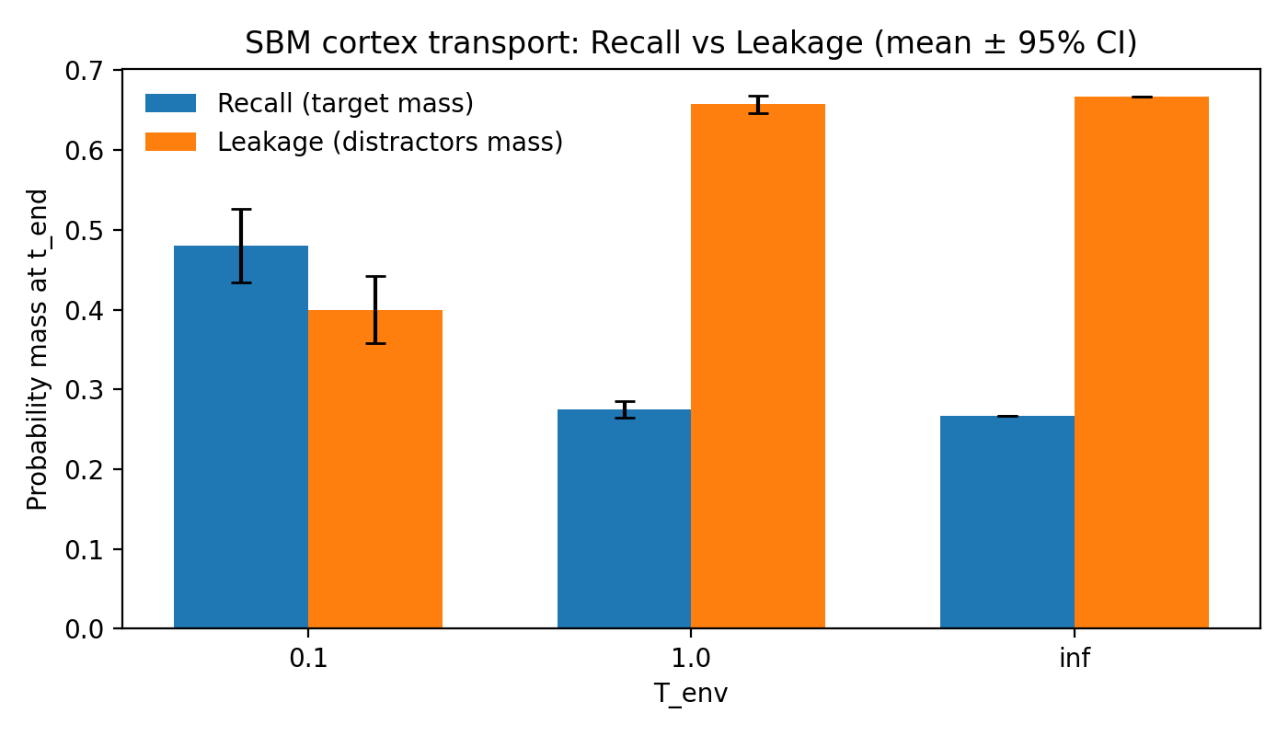
Figure S1. Experiment A. Recall and Leakage (mean ± 95% CI) vs permeability regime T_env.
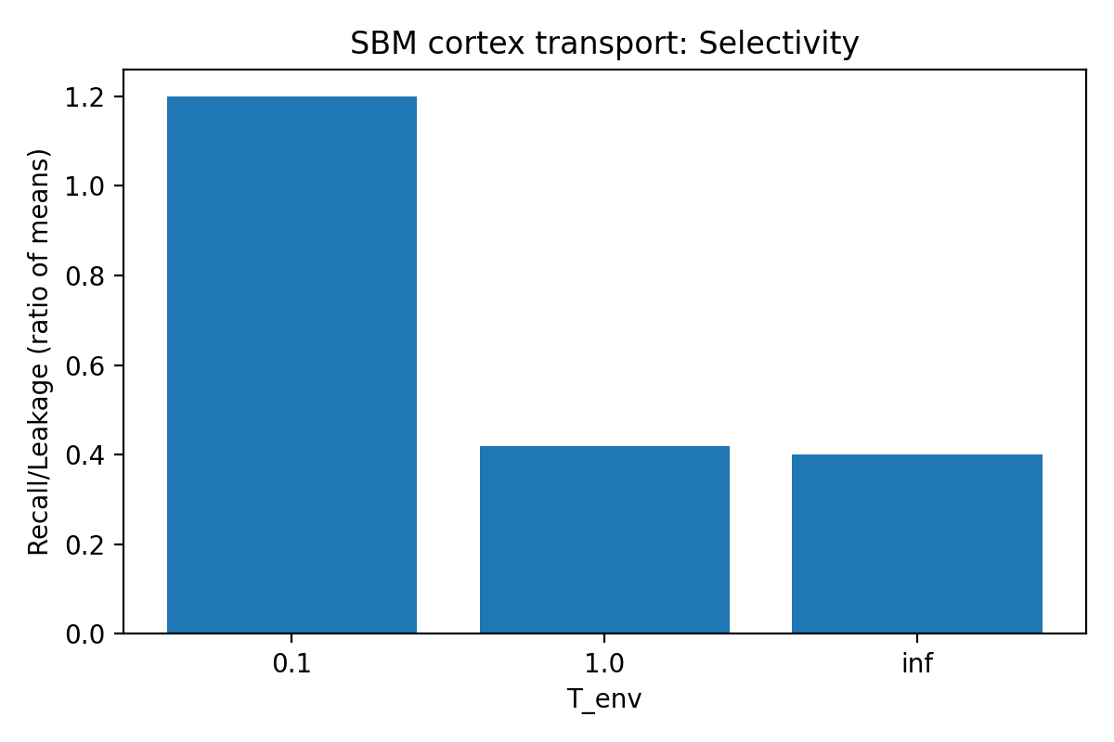
Figure S2. Experiment A. Selectivity (Recall/Leakage, ratio of means) vs permeability regime T_env.

4.2 Experiment B: transport proxy has an intermediate-noise optimum (ENAQT-like window)
The transport proxy g(κ) exhibits a clear intermediate-noise maximum (Figure S3). On the provided grid, the maximum normalized transport is achieved near κ≈0.5, consistent with an ENAQT-like optimum in which moderate dephasing suppresses localization/interference without fully destroying coherent propagation.
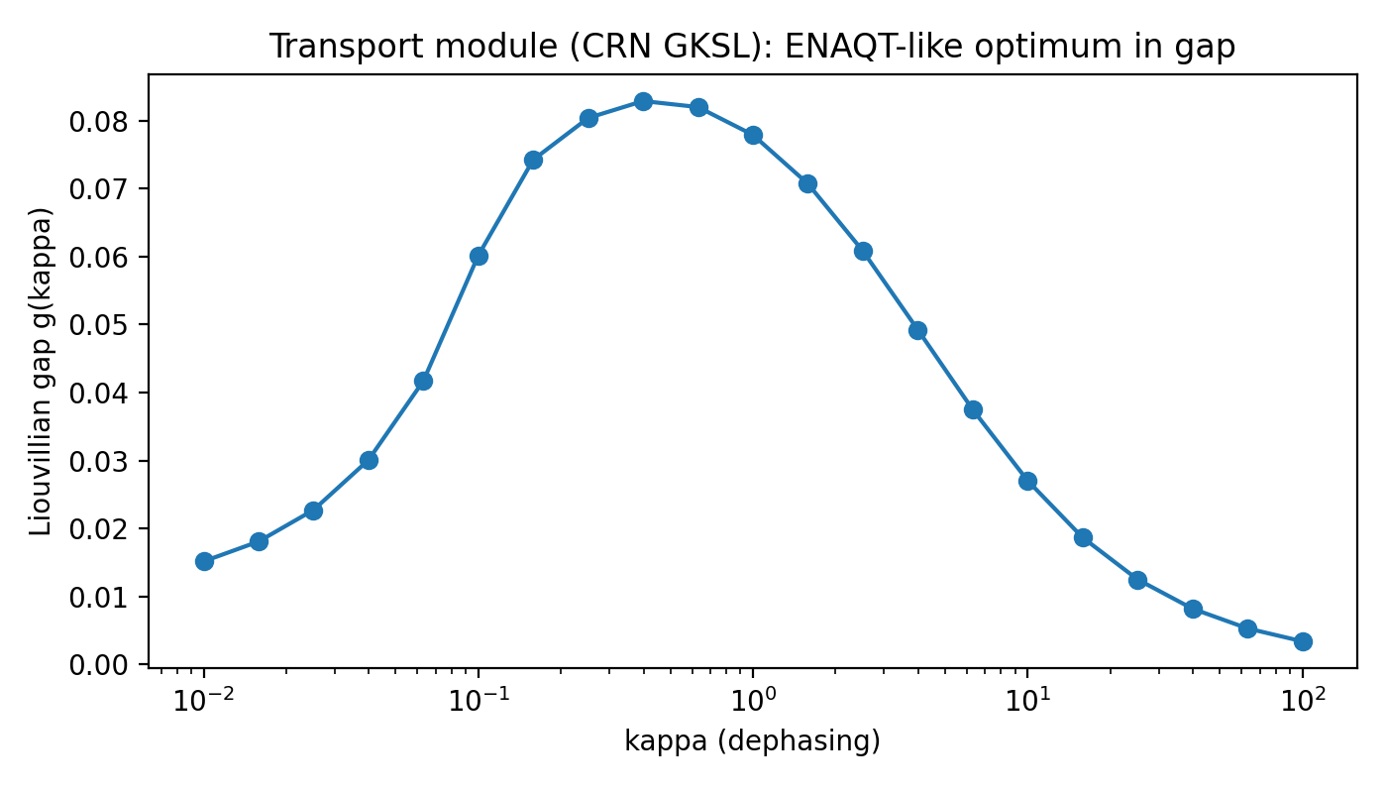
Figure S3. Experiment B. Liouvillian spectral gap g(κ) vs dephasing rate κ (transport proxy).

4.3 Experiment C: transport and memory prefer different noise regimes (architecture-level trade-off)
On the shared noise/permeability grid, the transport objective is maximized near n≈0.5 (normalized transport ≈0.995), whereas the memory objective is maximized at much lower noise, n≈0.01 (bounded memory metric ≈0.679). Therefore, any single global regulator n must choose a compromise that is suboptimal for at least one subsystem. Figures S4–S5 visualize this trade-off.
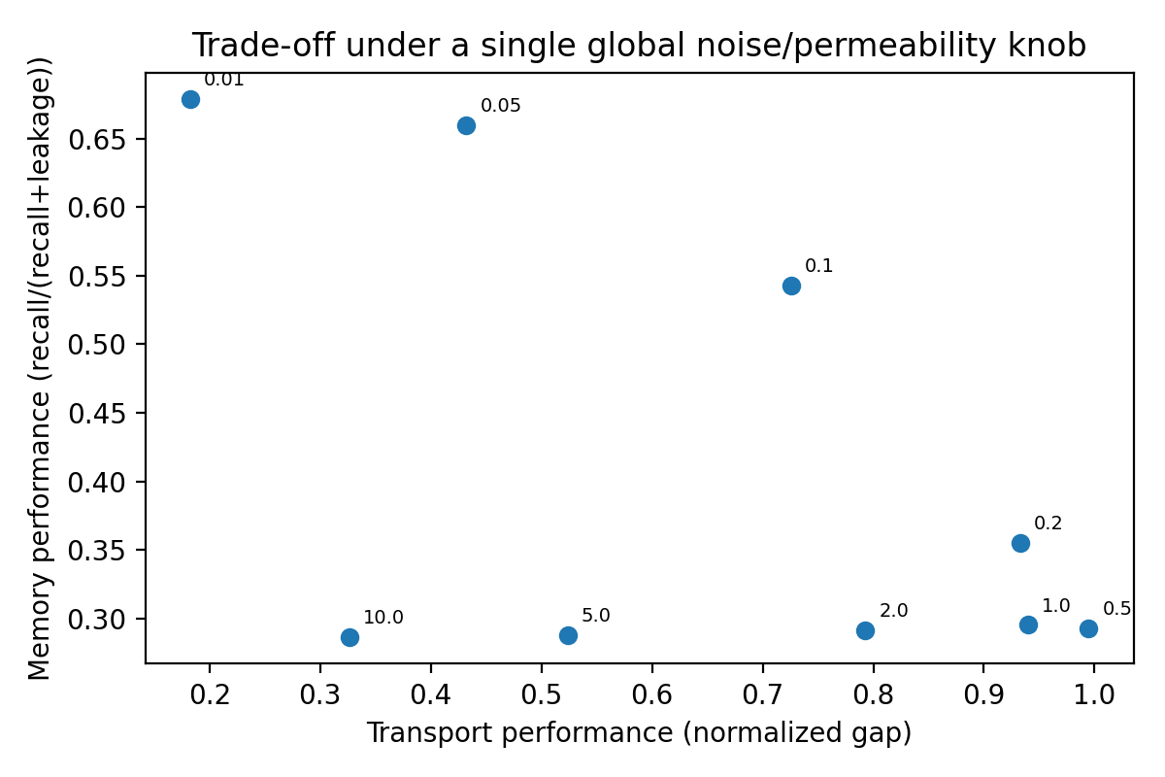
Figure S4. Experiment C. Pareto-like scatter: transport performance (normalized gap) vs memory performance (Recall/(Recall+Leakage)) under a single global control parameter n.
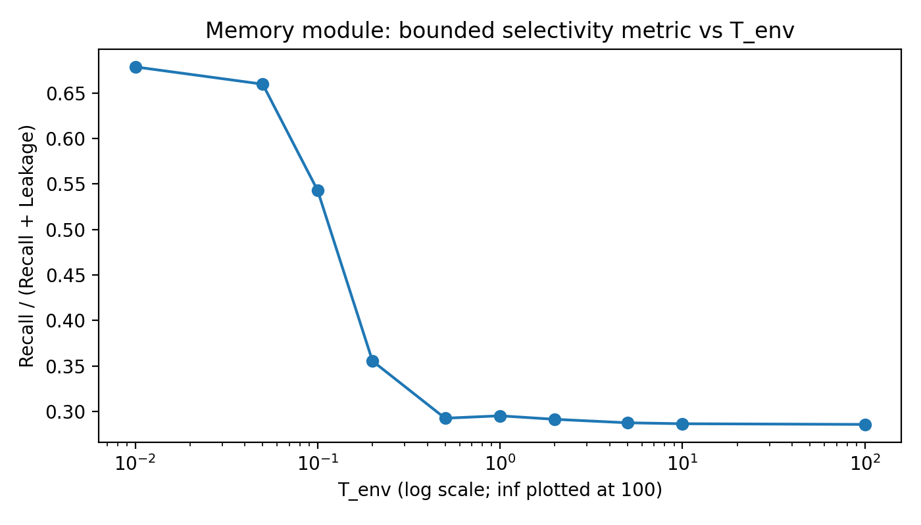
Figure S5. Experiment C. Memory bounded metric vs T_env (the memory proxy prefers low permeability).

4.4 Experiment D: selection favors modular separation in mixed environments (up to a cost threshold)
The phase diagram in Figure S6 compares the best modular strategy to the best single-parameter global strategy across environment mixtures (p_transport) and modularity costs (c_mod). As expected, modularity offers little benefit when the environment demands almost exclusively memory (p_transport≈0) or almost exclusively transport (p_transport≈1), because the optimal regulator is then essentially unique. In contrast, for mixed environments (intermediate p_transport), modular separation can dominate up to a non-trivial cost threshold.
A representative benchmark at p_transport=0.5 (transport and memory equally weighted) is:
max c_mod where modular wins: ≈0.19 (Step 4 default proxies) and ≈0.16 (Step 5 consensus, modular-win rate ≥0.8).
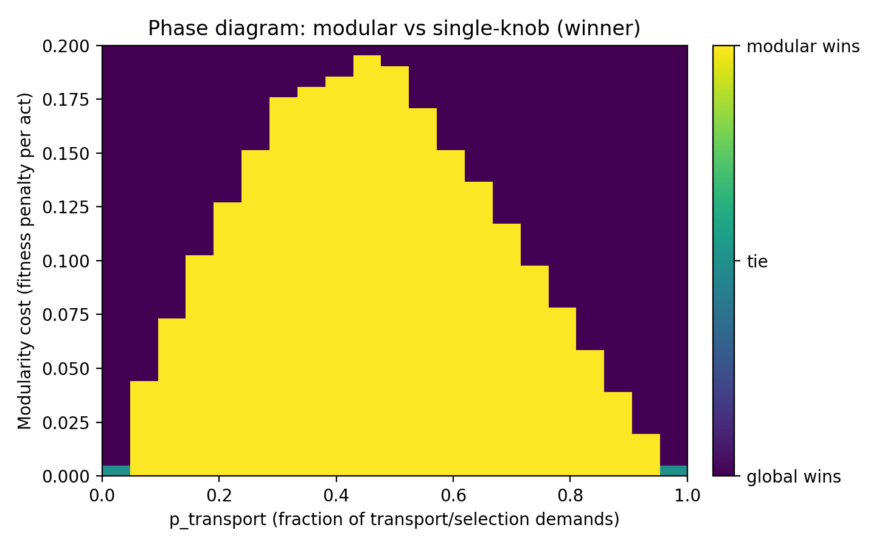
Figure S6. Experiment D. Phase diagram: modular vs single-parameter global winner over (p_transport, c_mod).
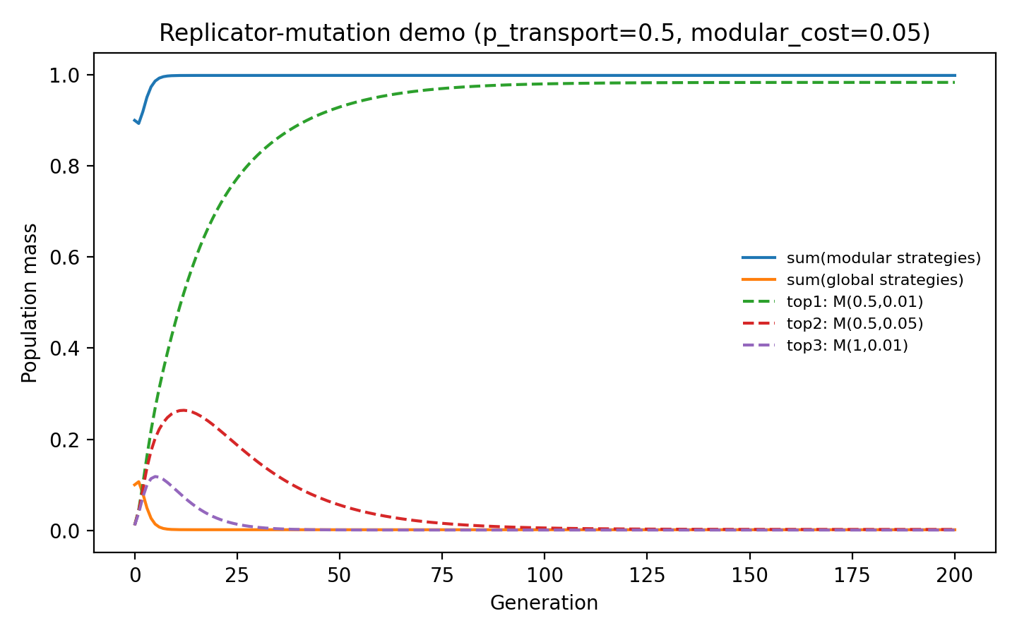
Figure S7. Experiment D. Replicator-mutation demo at a representative point (p_transport=0.5, c_mod=0.05): modular strategies accumulate population mass under selection.

4.5 Robustness audit: consensus boundary and a negative control
Figure S8 summarizes the robustness audit: for each (p_transport, c_mod) cell we report the fraction of proxy pairs (9 total) for which modularity wins. Figure S9 compares boundary curves obtained in Step 4 (default proxies) against conservative consensus thresholds. Finally, Figure S10 is a negative control: when the memory metric is artificially set equal to the transport metric (no trade-off), modularity never helps once a non-zero modularity cost is present.
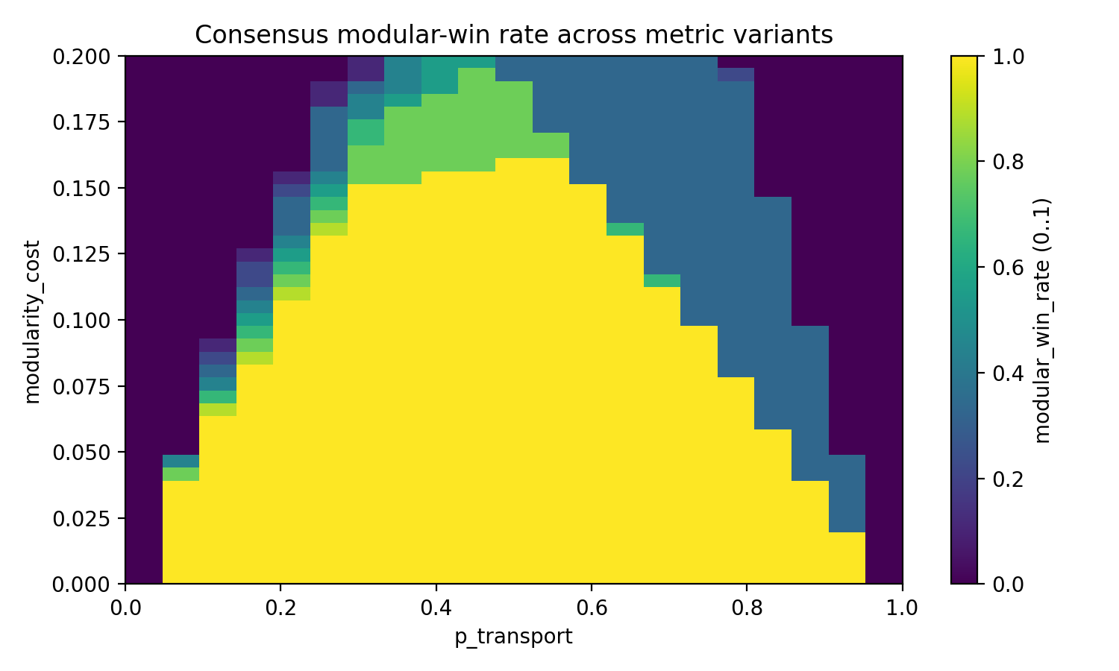
Figure S8. Robustness audit. Consensus modular-win rate across 9 proxy pairs.
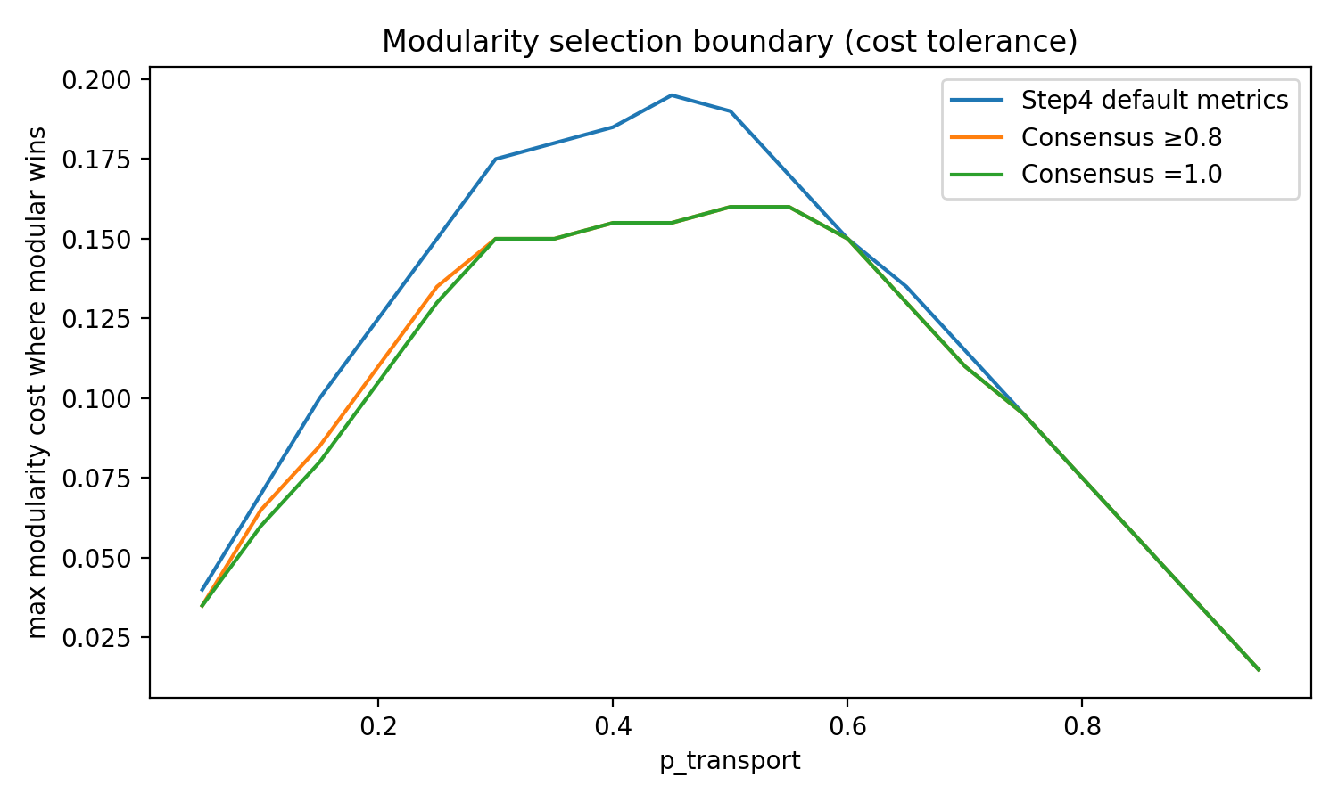
Figure S9. Robustness audit. Boundary curves: maximal modularity cost compatible with modular dominance (Step 4 default vs consensus thresholds).
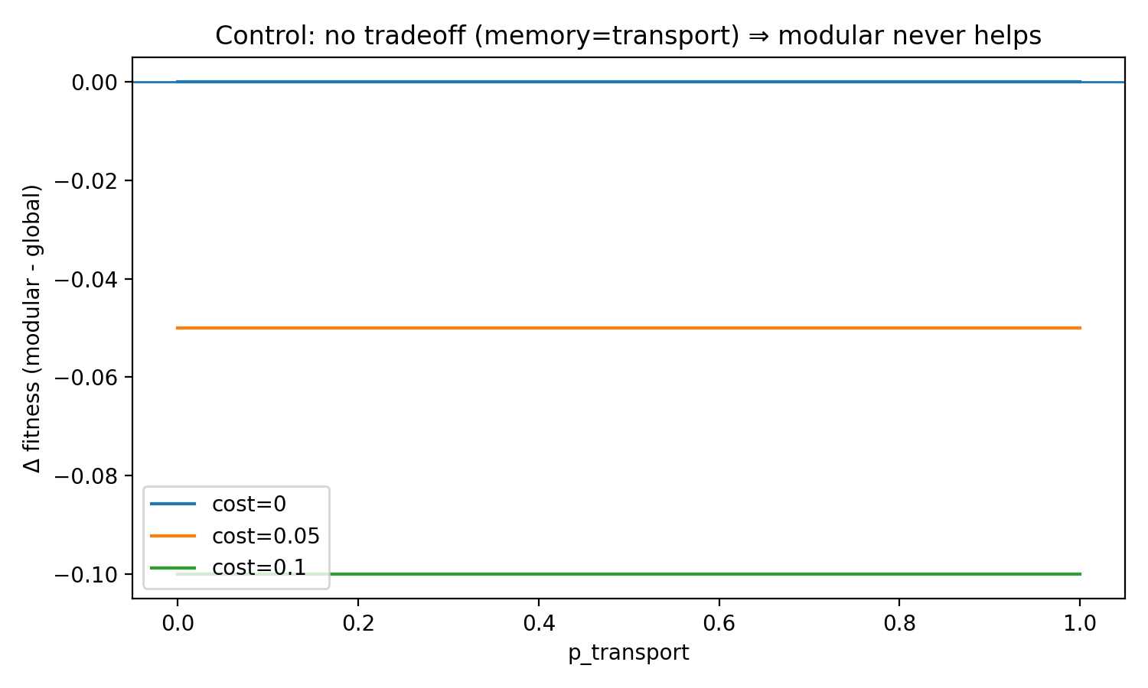
Figure S10. Negative control (no trade-off). Modular architectures do not outperform single-parameter global tuning when transport and memory objectives are identical.

5. Linking the architectural result to the energetic argument for Stage-I netting
The computational blocks above do not simulate metabolic energy directly. Instead, they establish an architectural fact: transport/search and recurrent memory can require opposing permeability regimes. This creates an immediate energy–architecture link once Stage II (commitment/broadcast) carries a high cost per act.
If Stage I (wave-like netting) is globally applied at high permeability, the recurrent memory subsystem becomes more prone to leakage/interference (Experiment A), increasing downstream costs: additional corrective broadcasts, longer decision times, or increased error rates. Conversely, suppressing permeability globally protects memory but degrades transport/search efficiency (Experiment B). Therefore, a one-parameter global regulator is energetically fragile in mixed-task environments.
A modular architecture can be read as an energetic compromise: pay an overhead to locally gate or regulate Stage-I permeability (captured abstractly by c_mod), but reduce the expected number of expensive Stage-II broadcasts and corrections across the full task distribution (captured abstractly by the mixed objective with p_transport). The selection boundary (Figures S6–S9) can therefore be interpreted as an admissible range of gating overheads for which local regime separation remains beneficial.
Mapping to the Stage-I energy checkpoint. In the main CRN framework, the checkpoint χ = E_stageI/E_comm compares the per-episode cost of Stage I to a single Stage-II broadcast. In this Supplementary Note, c_mod plays a similar role but at an architectural (fitness) level: it penalizes having separate local regulators. A conservative reading is that the empirical boundary c_mod≈0.16 at p_transport=0.5 (consensus) corresponds to a regime where gating/regulation overhead is small compared to the benefit of avoiding global mis-tuning. This interpretation is qualitative and should not be over-quantified without an explicit biophysical mapping between c_mod and χ.
In short: Stage-I netting is plausibly advantageous because it can reduce the number of costly Stage-II broadcasts, but it should not be assumed to be universally beneficial across all network motifs. The present protocol supports the narrower, publication-safe claim: if Stage-I netting improves transport/search while high permeability harms recurrent memory selectivity, then modular gating is an evolvable solution provided its control cost is not prohibitive.

6. Limitations and required follow-ups
- Memory proxy is linear. The SBM microcircuit uses a linear Markov transport equation rather than a nonlinear attractor network (e.g., Hopfield-like dynamics, thresholding, spiking, and structured inhibition). The qualitative leakage mechanism is plausible, but quantitative thresholds will shift in more biophysical models.
- “CRN” in Experiment A is approximated by the extreme maximal-permeability limit T_env→∞ (energies ignored). This is a useful stress test but is not equivalent to the full CRN/GKSL wave-layer model used elsewhere (which may include sinks, structured coupling, and non-trivial steady states).
- The identification n≈T_env≈κ is architectural, not microscopic. It is intended to test the hypothesis “one global permeability regulator is insufficient in mixed-task environments”, not to claim that the same physical parameter controls both subsystems in vivo.
- Selection model is illustrative. The replicator-mutation dynamics is a deterministic demonstration of directionality under a chosen fitness function. A publication should present it as a heuristic evolutionary pressure argument rather than a population-genetics result.
- Energy interpretation is qualitative. We do not compute metabolic budgets; c_mod is an abstract penalty. A stronger version would explicitly connect c_mod to measurable costs (e.g., inhibitory control, neuromodulatory gating, myelination, or maintenance of coherent carriers).

7. Reproducibility and artifacts
All numerical claims above are backed by CSV files and regenerable code included in the release candidate archive. The most citation-ready backends (for manuscript/SI) are:
- paper/tables/step2_cortex_transport_trials.csv, paper/tables/step2_cortex_transport_summary.csv
- paper/tables/step3_transport_gap_sweep.csv, paper/tables/step3_memory_summary.csv, paper/tables/step3_combined_tradeoff.csv
- paper/tables/step4_best_strategy_grid.csv
- paper/tables/step5_robustness_consensus_grid.csv, paper/tables/step5_boundary_compare_step4_vs_consensus.csv, paper/tables/key_numbers.csv
Minimal reproduction commands (from the root of CRN_step6_release_candidate):
python -m pip install -r env/requirements.txt
python steps/step2_repro_bundle/CRN_step2_repro_bundle/step2_cortex_transport/run_cortex_transport.py
python steps/step3_architecture_tradeoff_bundle/CRN_step3_bundle/step3_architecture_tradeoff/run_step3_architecture_tradeoff.py
python steps/step4_evolutionary_selection_bundle/step4_evolutionary_selection/run_step4_evolutionary_selection.py
python steps/step5_consolidated_evidence_bundle/CRN_step5_consolidated_evidence_bundle/code/run_step5_robustness_audit.py

References (selected; non-exhaustive)
Attwell D, Laughlin SB. An energy budget for signaling in the grey matter of the brain. J Cereb Blood Flow Metab. 2001.
Lennie P. The cost of cortical computation. Curr Biol. 2003.
Plenio MB, Huelga SF. Dephasing-assisted transport: quantum networks and biomolecules. New J Phys. 2008.
Caruso F, Chin AW, Datta A, Huelga SF, Plenio MB. Highly efficient energy excitation transfer in light-harvesting complexes: the fundamental role of noise-assisted transport. J Chem Phys. 2009.

