Q1. Write a program to replace a substring inside a string with other string ?
ANS:package JavaIntro1;
import java.lang.String;
public class RepSubStr {
public static void main(String[] args) {
String number = "112211221122";
String replace = number.replace("11","33");
System.out.println("Old String "+number);
System.out.println("Replaced Substring "+replace);
}
}
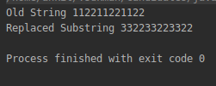

Q2. Write a program to find the number of occurrences of the duplicate words in a string and print them ?
Ans
public class FreqOfDup {
public static void main(String[] args) {
String test = "This is test to test the duplicate words in test test is this and this is test";
CountFreq(test);
}
public static void CountFreq(String count)
{
Map<String,Integer> wordcount = new HashMap<String, Integer>();
String[] words = count.split(" ");
for(String w:words)
{
String temp = w.toLowerCase();
if(wordcount.containsKey(temp))
{
wordcount.put(temp,wordcount.get(temp)+1);
}
else
wordcount.put(temp,1);
}
System.out.println("Word"+"\t\t\t"+"Count");
System.out.println("----"+"\t\t\t"+"-----");
for (Map.Entry<String ,Integer> entry:wordcount.entrySet()) {
System.out.println(entry.getKey()+" \t\t\t\t"+entry.getValue());

}

}
}

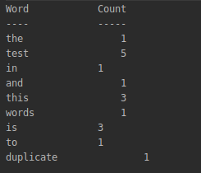

Q3. Write a program to find the number of occurrences of a character in a string without using loop?
Anspackage JavaIntro1;
public class NumOfOccurWithoutLoop {
public static void main(String[] args) {
String S = "This is a test string with aaaa and bbbb";
int l =S.length();
int ln = S.replace("a","").length();
System.out.println("No. of occurrences of a = "+(l-ln));
}
}
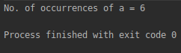

Q4. Calculate the number & Percentage Of Lowercase Letters,Uppercase Letters, Digits And Other Special Characters In A String
Anspackage JavaIntro1;
public class CharPercent {
public static void main(String[] args) {
int upcase = 0, lowcase = 0, spchar = 0, digit = 0, slength = 0;
String test = "This Is a tEst StRing to C@l(u!@te (#@R FrEQueNcY 12345678908766544321334567";
for (char w : test.toCharArray()) {
if (Character.isUpperCase(w))
upcase += 1;
else if (Character.isLowerCase(w))
lowcase += 1;
else if (Character.isDigit(w))
digit += 1;
else
spchar += 1;
}
slength = test.length();
System.out.println("No. of uppercase letter = " + upcase + " Percentage of uppercase letter = " + (upcase*100/ slength) );
System.out.println("No. of lowercase letter = " + lowcase + " Percentage of lowercase letter = " + (lowcase*100 / slength) );
System.out.println("No. of digit = " + digit + " Percentage of digits = " + (digit*100 / slength) );
System.out.println("No. of special character = " + spchar + " Percentage of special characters = " + (spchar*100/ slength) );
}
}
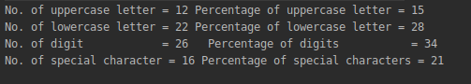

Q5. Find common elements between two arrays.
Anspackage JavaIntro1;
import java.util.Arrays;
public class DupCharArr {
public static void main(String[] args) {
int[] arr1={1,2,3,1,2,4,5,6,7,6,8,9,4,5,0};
int[] arr2={4,5,6,7,4,5,6,7,4,5,6,7,4,5,6};
StringBuffer sb1 = new StringBuffer();
StringBuffer sb2 = new StringBuffer();
for (int k:
arr1) {
sb1.append(k);
}
for (int k:
arr2) {
sb2.append(k);
}
for (int i = 0; i < sb1.length(); i++) {
int c=0;
for (int j = i + 1; j < sb1.length(); j++) {
if (sb1.charAt(i) == sb1.charAt(j)) {
sb1.deleteCharAt(j);
c++;
}
if(c>=1)
sb1.deleteCharAt(i);
}
}
for (int i = 0; i < sb2.length(); i++) {
int c=0;
for (int j = i + 1; j < sb2.length(); j++) {
if (sb2.charAt(i) == sb2.charAt(j)) {
sb2.deleteCharAt(j);
c++;
}
if(c>=1)
sb2.deleteCharAt(i);
}
}
int count = 0;
for (int i = 0; i < sb1.length(); i++) {
for (int j = 0; j < sb2.length(); j++) {
if (sb1.charAt(i) == sb2.charAt(j)) {
count+=1;
}
}
}
System.out.println("Number of duplicate elements = "+count);
}
}
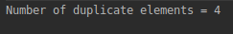

Q6. There is an array with every element repeated twice except one. Find that element
Anspackage JavaIntro1;

import java.util.HashMap;
import java.util.HashSet;
import java.util.Map;
public class NotDupEle {
public static void main(String[] args) {
int[] arr={1,1,4,4,7,7,3,3,5,5,8,9,9,0,0};
Map<Integer,Integer> set = new HashMap();
for (int i : arr) {
if(set.containsKey(i))
set.put(i,set.get(i)+1);
else
set.put(i,1);
}
for (Map.Entry<Integer, Integer> entry : set.entrySet()) {
if (entry.getValue() == 1) {
System.out.printf("Non duplicate element is "+entry.getKey());
}
}
}}
Q7. Write a program to print your Firstname,LastName & age using static block,static method & static variable respectively
Anspackage JavaIntro1;
public class StaticTest {
static String fname;
static String lname;
static int Age;
static {
System.out.println("Static block called");
fname = "Ankit";
lname = "Arora";
Age = 20;
System.out.println("First name = "+fname+" Last name = "+lname+" Age = "+Age);
}
static void change()
{
System.out.println("Static method called");
lname = "Sagar";
Age = 25;
}
void display()
{
System.out.println("First name = "+fname+" Last name = "+lname+" Age = "+Age);
}
public static void main(String[] args) {
StaticTest st = new StaticTest();
st.change();
st.display();
}
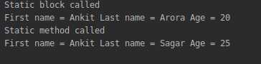
}

Q8. Write a program to reverse a string and remove character from index 4 to index 9 from the reversed string using String Buffer
Anspackage JavaIntro1;
public class StringBuffRevDelete {
public static void main(String[] args) {
StringBuffer sb = new StringBuffer("Java programming Language");
System.out.println("string: " + sb);
System.out.println("reverse: " + sb.reverse());
System.out.println("After removing characters 4 through 9 "+sb.delete(4,9));
}
}
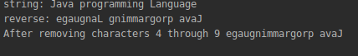

Q9.Write a program to display values of enums using a constructor & getPrice() method (Example display house & their prices)
Ansenum House {
Mansion(900),Bungalow(20),BeachHouse(500),Appartment(15),Castle(1200);
private int price;
House(int p) {
price = p;
}
int getPrice() {
return price;
}
}
public class EnumExample {
public static void main(String args[]){
System.out.println("All House prices:");
for (House c : House.values()) System.out.println(
c + " costs " + c.getPrice() + " thousand dollars.");
}
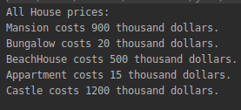
}

Q10.Write a single program for following operation using overloading
A) Adding 2 integer number
B) Adding 2 double
C) multiplying 2 float
D) multiplying 2 int
E) concate 2 string
F) Concate 3 String
Anspackage JavaIntro1;
public class Overloading {
int Add(int a, int b) {
return a + b;
}
double Add(double a, double b) {
return a + b;
}
int Mul(int a, int b) {
return a * b;
}
float Mul(float a, float b) {
return a * b;
}
String Concatenate(String a, String b) {
return a + " " + b;
}
String Concatenate(String a, String b, String c) {
return a + " " + b + " " + c;
}
public static void main(String[] args) {
Overloading o = new Overloading();
System.out.println("Addition of two integers = " + o.Add(2, 3));
System.out.println("Addition of two doubles = " + o.Add(2.54, 7.89));
System.out.println("Multiplication of two int = " + o.Mul(5, 2));
System.out.println("Multiplication of two float = " + o.Mul(5.2f, 2.5f));
System.out.println("Concatenation of two strings = " + o.Concatenate("Two", "Strings"));
System.out.println("Concatenation of three strings = " + o.Concatenate("Two", "Strings", "Plus third"));
}
}
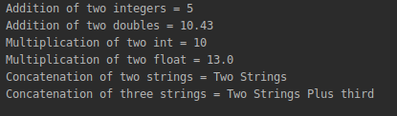

Q11.Create 3 sub class of bank SBI,BOI,ICICI all 4 should have method called getDetails which provide there specific details like rateofinterest etc,print details of every banks
Anspackage JavaIntro1;
abstract class Bank
{
String name="";
double rate;
int branch;
Bank(){}
Bank(String name,float r,int b)
{
this.name=name;
this.rate=r;
this.branch=b;
}
public void getDetails()
{
System.out.println("Name: "+name);
System.out.println("Rate: "+rate);
}
}
class SBI extends Bank
{
SBI()
{
name="SBI";
rate=4.5;
}
public void getDetails()
{
super.getDetails();
}
}
class BOI extends Bank
{
BOI()
{
name="BOI";
rate=4.4;
}
public void getDetails()
{
super.getDetails();
}
}
class ICICI extends Bank
{
String facility;
ICICI()
{
name="ICICI";
rate=4.6;
}
public void getDetails()
{
super.getDetails();
}
}
class BankDetails
{
public static void main(String[] args)
{
SBI sbi=new SBI();
BOI boi=new BOI();
ICICI i=new ICICI();
sbi.getDetails();
boi.getDetails();
i.getDetails();
}
}
