Plan of Action

Plan van aanpak



Name: Oscar Veldman  
Student number: 0879062  
Class: INF3C  
Module code: CMISTG01

Table of Contents

Introduction 3

Case 3

Description 3

Software 3

Scope 3

Acceptance criteria 3

User Stories 4

Legend 4

Design 5

Diagrams 5

Sources 5

# Introduction

In the first two weeks I interviewed multiple programmers at VI Company. From the interviews came two big cases and a lot small cases. In the next headline I wrote the cases I choose. We have chosen this case because we believe we can make it in the internship time. Also we think it’s the most interesting subject to make.

# Case

## Description

It’s an application to easily translate a label for a website. VI Company programs the same website for multiple language. They don’t want make the websites twice. So now they put a label in the code, then the website read an JSON file. They split the JSON files in multiple folders with language names. By these folders the website knows which language it must chose. But this isn’t very clear to the programmers of VI Company. My assignment is make an application that you can change easily a label with a clear view over the labels.

## Software

* A web application (ASP.NET Core)
  + JSON

## Scope

* It’s only for programmers for VI Company
* We are not going to translate the routes
* It’s a local application without a login

## Acceptance criteria

# User Stories

1. As user I can add a label, because the system remembers the label
2. As user I can translate a label, because each label has the good translating for each language
3. As user I can add a language, because there are multiple languages for one website
4. As user I can switch between language, because I want to see the other language in one program
5. As user I can delete a label, because we don’t want unnecessary labels in the JSON
6. As user I can add multiple groups for a label, because there are singular and   
   plural words for one label
7. As user I can add a variable name in a label, because there is something not a specified name in a label. For example, a username.
8. As user I can easily see which label aren’t translating yet, because we want a clear view of the labels.
9. As user I can travel fast to a label, because it’s efficient.
10. As user I can easily sort the labels, because we want a clear view of the labels.
11. As user I can give the label a layout, because I don’t want make three labels where it can easily be one label.
12. As user I can see fast how the label looks like, because it’s efficient.
13. As user I can change a label name, because I know a better name.
14. As user I want the labels who are empty has a default value, because the website can’t show an empty label
15. As user I can which labels has the same description, because I can decide to combine the labels
16. As user I can easily see which label aren’t present on the website, because I can decide to delete the label
17. As user I can see which label is not relevant for the website, because I can decide to delete the label
18. As user I can delete a language, because there aren’t unnecessary languages in the program
19. As user I can change the label on runtime, because I don’t want deploy the website again
20. As user I can export the labels, because I want to make notes with the labels
21. As user I can change the file location, because the file location isn’t fixed

## Legend

Must have  
Should have  
Could have  
Won’t have

# Design

It’s how the design can be without coloring.

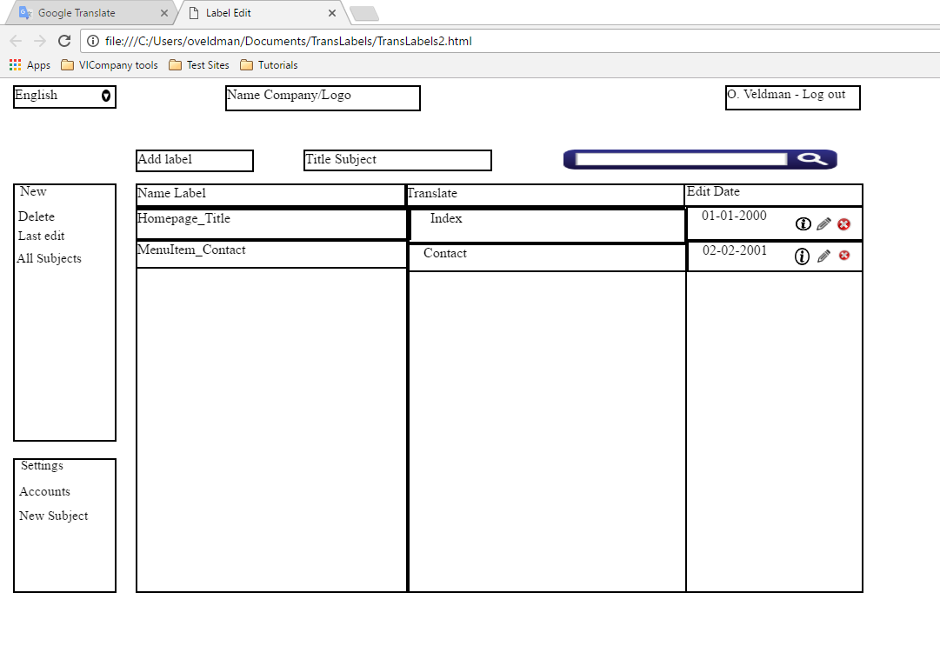

# Diagrams

# Sources