Chapter I

Introduction
Game development is a process of creating a video game with the use of programming. It is also known that the game industry is growing and getting more and more competitive according to the article entitled “The Top 10 Benefits of Video Game Design” (2018, May 12). Game developers are the ones who are developing the video games.
Video games especially puzzle games, have been proven to be able to improve memory and cognitive skills. Puzzle is not only for teens, but also for adults. The benefits of puzzle games to people is numerous. For example, playing jigsaw puzzles improves the visual-spatial reasoning of a person. A puzzle game may increase the IQ of the player and it can also relieve stress according to the article “The Surprising Benefits of Puzzles for Adults” (2013, March 14).
Horror-themed games can help us overcome certain fears according to the article “Four Reasons Why Horror Games are Good for Your Health” (2016, June 17). An audience with regular encounter or finding pleasure on playing horror games will gradually control their fears. According to Mathias Clasen, mediums such as fictions or games which promote as a ‘emotional simulator’ can broaden the horizons of the audience so they can exercise their reaction to terrible or frightening scenes.
These insights of puzzle and horror games leads the proponents into developing “Scene 6:38”.
A. Purpose and Description
San Juan National High School (SJNHS) or formerly known as San Juan Municipal High School (SJMHS) is a public high school located in P. Narcisso St., Brgy. Corazon De Jesus San Juan City, which all started as a project that Mayor Joseph Ejercito Estrada proposed as its own foothold for the election. After the election, Mayor Joseph Ejercito Estrada and the local government immediately start the project he proposed for the community. As he undertakes on starting the project the mayor created committees whereas its sole purpose is an assistance on the educational aspect of the project composed of retired school supervisors, and other public and private school officials. The school open its door on July 13, 1970 with six sections of three hundred first year students, ten teachers and two administrative staff members. They also accommodate faculty development programs were launched mainly to upgrade the academic standard of the school. The development program includes in-service trainings such as seminars, conferences for teaching and non-teaching staff and furthering the studies of the teachers provided that the facilities and education of the school are developing, to establish a comfortable learning space and environment for teaching of students.
Today, one of English faculty teacher in San Juan National High School named as Mrs. Genalyn Abalos, a client of Eleventen to work on the proponents’ project in the event that her students will play the project.

B. Project Context
The importance of a video game's narrative is that the players will be more immersed and feel involved inside the game. It gives meaning in the game and the player will understand what they will have to do. A video game's advantage, over other types of narratives, is that the player is part of the story. The player lives the entire experience and shares the setbacks and successes of the main character.
The project that will be developed is a mystery-puzzle game. The player of this project will take on the role of a female investigator named as Emcy Mcclain which her job is to solve the case that is situated in a place called Dakira Village where inhabitant of the village will perish every night. The aim of “Scene 6:38” is to enhance problem-solving skills and the ability to solve challenging puzzles of the players and simultaneously, immerse the players in the thrill of a mystery game. The target audience of “Scene 6:38” are for high school students with ages 15 to 18.
There will also be a promotional website where information is provided about the game and the developers.

C. Objectives
General Objectives
The general objectives of the study is to develop a 3D, mystery-puzzle game with a horror theme entitled “Scene 6:38”.
Specific Objectives
a. To develop a mystery-puzzle game
b. To create playable character and non-playable characters
c. To create a game world with interactable objects
d. To create different levels for the game
e. To implement journal feature
f. To implement save and load feature
g. To implement NPC interactions and appropriate NPC behaviors
h. To implement inventory system
i. To create appropriate sound effects and user interface
j. To develop a functional and dynamic promotional website
k. To test and evaluate the project using questionnaires.

D. Scope and Delimitation
Scope
The game “Scene 6:38” is a three-dimensional horror-themed mystery-puzzle game with a third person perspective. The game will have one playable character which is the main character which can be controlled using the WASD keys, where the W is used as to move forward, S for moving backward, A to move to the left, and D to move to the right. Several non-playable characters are also included in the game for the story to progress.
The game world that will be made is a village which includes interactable objects such as the houses where the player can go in and objects that are needed for the game to progress. The game will consist of three levels which also includes five different puzzles for each level. For the first level, there will be puzzles where the player will have to find a way to get inside the house and to find the keys to open the master bedroom, comfort room and the basement. The second level and last level also includes the puzzle in the first level where the player should find a way to get inside the house then solve the puzzles inside.
The game also includes a journal which keeps track of the key actions you have made throughout the game and can be accessed in the in-game menu. There will also be a save and load which can be found in the menu. The game will also include NPC interactions and behaviors in which the player can have a conversation to get hints or clues for the puzzle. The game will also have an inventory system where the player can store the objects that can be found throughout the game to be used for certain puzzles.
The game also includes sound effects appropriate for actions that need sounds. For example, the creaking of a door, picking an object, footsteps, background music. The game also has a user interface where there will be a start button, load button, option button and exit button.
The game also has a dynamic website where each web page has information about the game including the game mechanics, story of the game, screenshots of the game, and the developers of the game.
The proponents will test and evaluate the project by letting the target audience play and test the game, and using questionnaires as a method of surveying the proponent’s project.

Delimitation
The game will be developed for PC that uses a Windows 7 or up Operating System and will be played with the use of keyboard and mouse.
The game does not include an additional playable character. The game also has limited places that can be explored. There will be no experience points or character level in the game. The day will only end if the player has finished the puzzle. If the puzzle was not solved, the player will start over at the beginning of the puzzle.
The game does not require an internet connection and can be played offline.
The proponents will use the unity Game Engine where the game will be developed. The programming language that will be used for the project is C#.
The assets used are made in and Autodesk Maya including the animations, MudBox for the character models, Adobe Photoshop for the textures, Adobe Premiere for the animated scenes, Adobe Illustrator for UI designs, and Adobe Audition for the sound effects.

E. Conceptual Framework
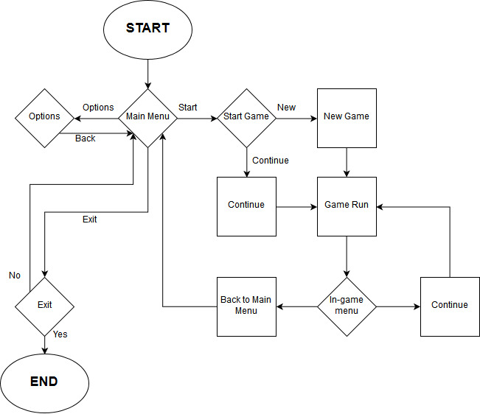
The game will be developed based on the proponent’s conceptual framework to which as it is shown in the figure above will be as general view of the game. The player or the audience will perceive a title screen at the start of the game before the main menu will display, but the title screen will be categorized as a main menu since the main menu will consist of the title screen’s background and three interactive buttons that consist of start button, option button and exit button. The player will be redirected in the new-game menu if the player or the game don’t have any save files and if the game contains a save file then the player will redirect in the continue menu, but the player will have an option to go back to the start game menu so they could be able to start the new-game, instead of continuing the game. In new game menu the player will be spawned in the tutorial field, so players will be able to familiarize of the game’s control, and will explain the mechanics of it so players will overcome some challenges the game would provide. If the players or audience are finished in the tutorial field, the game will abruptly display a black screen and the black screen will fade-out, perceiving a new field, which it would be the start of the game. In continue menu, the player will be loaded to the player’s latest checkpoint in the game. In option menu, the game will display the distinctive attributes of the game that consist of the settings of sound and video system of the proponent’s game. The exit button functions as a way of quitting or closing the game. In Game Run, it operates as a pause feature to which it can be able to continue the game if the player desires, and it is also a method of going back to the main menu. In game, if the players accomplish a puzzle or objective the players will be able to proceed to the next stage, but if the players failed to succeed in finishing the objectives or puzzles the game will reset to the player’s last checkpoint so they could be able to retry the puzzles or objectives which they have failed on accomplishing the puzzles or objectives.

F. Significance of the Study
This study will help the client to provide an enjoyable method for the students to learn and improve their skills in solving puzzles.
This study will also help the target audience in having to play an enjoyable game where they will need to find hidden objects and make the story progress forward and at the same time, helps the target audience to improve their puzzle solving skills.
This study will help benefit the proponents because the proponents will be able to apply and implement the skills and knowledge they have learned in Far Eastern University – Institute of Technology.

G. Definition of Terms
Technical Terms
Journal feature- a record of experiences, ideas, or reflections kept regularly for private use.
3D - a three-dimensional form.
Game world - A game world is an artificial universe, an imaginary place in which the events of the game occur.
NPC - A non-player character is a video game character that is controlled by the game's artificial intelligence rather than by a gamer.
Simulator - a device that enables the operator to reproduce or represent under test conditions phenomena likely to occur in actual performance
Webpage - a hypertext document connected to the World Wide Web.
Website - a group of World Wide Web pages usually containing hyperlinks to each other and made available online by an individual, company, educational institution, government, or organization
Video Game - A video game is an electronic game that involves interaction with a user interface to generate visual feedback on a video device.
Operational Terms
Adobe Audition - is a digital audio workstation from Adobe Systems featuring both a multitrack, non-destructive mix/edit environment and a destructive-approach waveform editing view.
Adobe Illustrator - is a vector graphics editor
Adobe Photoshop - is software that is extensively used for raster image editing, graphic design and digital art.
Adobe Premiere Pro - is a timeline-based video editing app
Autodesk Maya - It is used to create interactive 3D applications, including video games, animated film, TV series, or visual effects.
MudBox - is a proprietary computer-based 3D sculpting and painting tool.
Operating System - the software that supports a computer’s basic functions, such as scheduling tasks, executing applications, and controlling peripherals.
Unity - The engine can be used to create both three-dimensional and two-dimensional games as well as simulations for its many platforms.

