Online Lab: Wien’s law

Name: Yatharth Jain ____________________ Date: 28/05/2026_____

Objective
- Describe what happens to the blackbody spectrum as you increase or decrease the temperature.
- Find the relationship between the temperature and the wavelength at the peak of the curve.

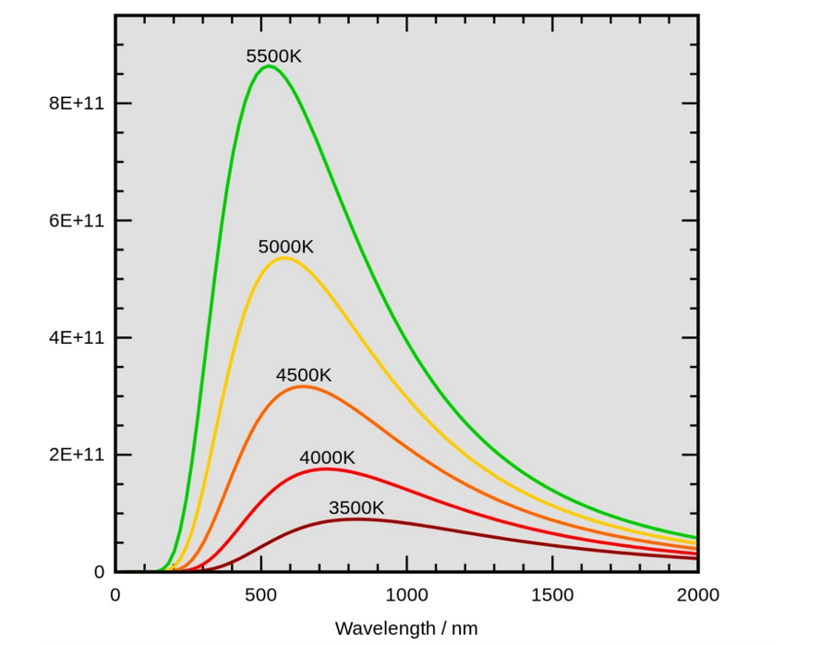
Theory
A black body radiator is a perfect emitter and absorber of all possible wavelengths of radiation.

Radiation curves are graphs of intensity against wavelength of radiation emitted by objects at different temperatures. Below is an example of a radiation curve for a black body radiator.

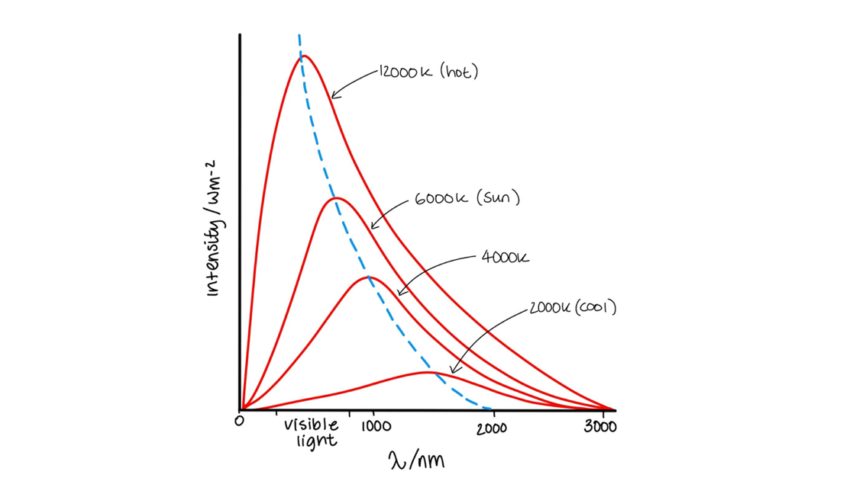
Wien's displacement law states that the peak wavelength ($λ_{max⁡}$)of emitted radiation is inversely proportional to the absolute temperature (T) of the object. The peak wavelength ($λ_{max⁡}$) is the wavelength of light released at maximum intensity.

$$λ_{max⁡}×T=2.898×{10}^{-3} mK$$

Where the unit mK is metres-Kelvin, not milliKelvin.

Online Experiment Setup Instructions
Today’s Online Lab we are going to use one of the PhET simulations. Go to the following website:

https://phet.colorado.edu/sims/html/blackbody-spectrum/latest/blackbody- spectrum_en.html

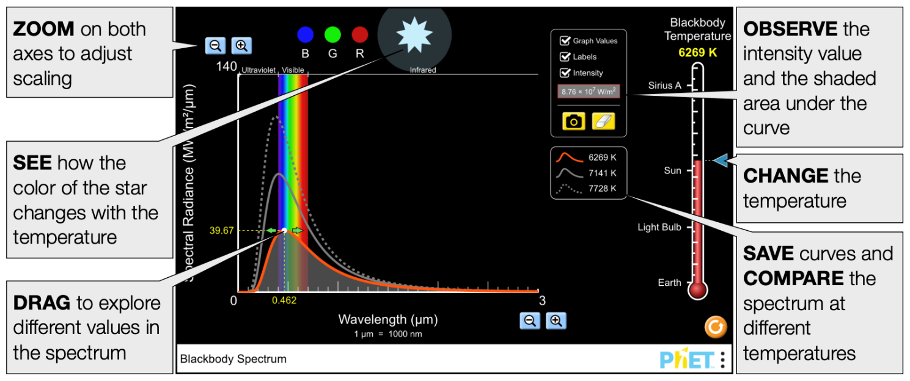

Part A: Blackbody Spectrum
Objects at different temperatures have their own characteristic spectrum-emission curve.

- Select a temperature and write down the colour seen on the star. What type of relationship is there between a star colour and its temperature?

At 8000K, the temperature of the star is a light blue. As the temperature increases the star colour goes towards blue and as the temperature decreases the star colour goes towards red.

- How does the temperature of a star relate to the intensity of radiation? How is this seen on the graph?

As the temperature increases the area under the graph increases. This means that as temperature increases, the intensity of radiation also increases. The graph shifts to the left, towards lower wavelengths as the temperature increases, and the intensity also increases.

- Why does a Sirius A looks blue if it emits light of all wavelengths? Use the graph to support your answer.
Blackbody radiators are theoretical objects which absorb and emit light of all wavelengths. Sirius A has properties of a blackbody but is not a blackbody itself, hence why it absorbs all wavelengths of light. However, there is a greater intensity of light in the blue part of the visible spectrum which causes it to be observed as blue.

- Why does a light bulb looks red if it emits light of all wavelengths? Use the graph to support your answer.
The intensity of light is far less in blue parts of the spectrum than red parts of the spectrum as the light bulb has a very low temperature, leading to the graph shifting towards the right. This means that there is a greater amount of red light in the visible spectrum causing light bulbs to appear red.

- Why does a star colour at the temperature of the Sun looks white?
At the temperature of the sun of 5800K, there is an almost equal distribution of intensity of light over the visible spectrum. Almost all wavelengths of light in the visible spectrum are emitted equally, resulting in white light.

Part B: Wien’s law
Wien’s law states a relationship between the temperature of a blackbody and its peak wavelength emission.

Check the box graph values. On the table below record the values of the peak wavelength emission and its correspondent temperature. Be aware that in this case the temperature will be the independent variable, so be sure to take readings with the same interval distance. Leave the third column blank.

Temperature (K) | Wavelength ($μm$)
4400 | 0.659
5100 | 0.568
5800 | 0.500
6500 | 0.446
7200 | 0.402
7900 | 0.367

Table 1. T and peak-wavelength

Plot a graph of peak-wavelength (y-axis) against temperature (x-axis) on the grid.
Remember to label the axis and use appropriate units.

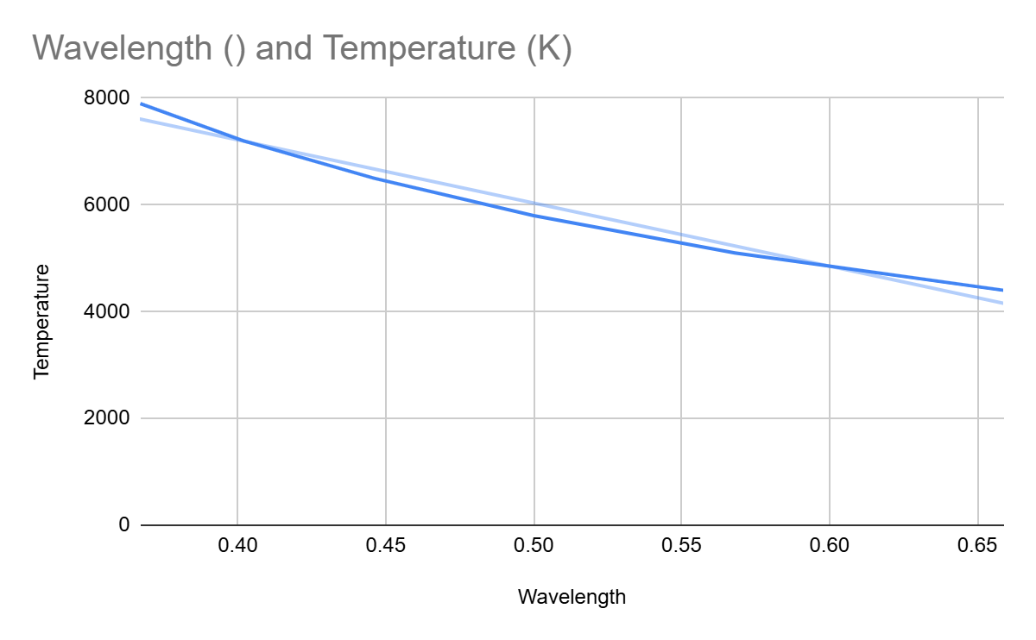

Graph 1. $λ$ vs T

What type of relationship do you recognise? Circle your answer

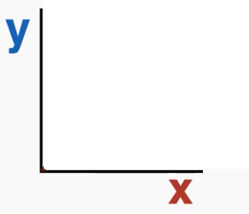
Linear Direct Inverse Quadratic Other
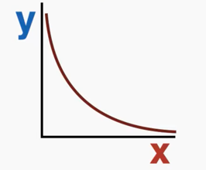
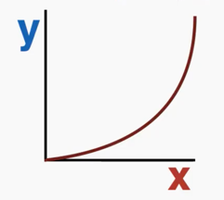
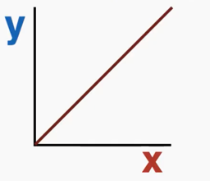

Since you have spotted the type of relationship, use the third column of the table to find the constant of proportionality. Write the mean value and its units:

The relationship is an inverse relationship. Letting T = k/lambda(wavelength).
Graphing 1/lambda vs temperature gives a gradient of: 3.45x10-4.
This is close to Wien’s Constant

