
DEPARTMENT OF
COMPUTER SCIENCE & ENGINEERING
Experiment No. 6

Student Name: Pulkit  Branch: BE CSE  Semester: 6th  Subject Name: System Design | UID: 23BCS11733  Section/Group: KRG_2-B  Subject Code: 23CSH-314  Date of Performance: 25/02/2026

- Aim:
To design a highly scalable video streaming platform similar to YouTube that supports heavy video uploading, adaptive bitrate streaming, and real-time social interactions with high availability and low latency.

- Objective
- Understand the architecture of a massive-scale media streaming system.
- Identify functional requirements such as direct-to-cloud uploads and personalized feeds.
- Identify non-functional requirements including CDN caching, high throughput, and latency constraints.
- Analyze the decoupling of synchronous API requests using event-driven stream processing.
- Design REST APIs for video management, search, and user interactions.
3. Procedure
- Studied real-world video streaming architectures and content delivery networks.
- Identified core entities such as Users, Videos, Interactions, and View Histories.
- Analyzed the Pre-Signed URL pattern to bypass API Gateway bottlenecks for large file uploads.
- Collected functional and non-functional requirements for media delivery.
- Designed APIs for video processing, metadata retrieval, and social engagement.
- Evaluated streaming protocols (HLS/DASH) and separated thumbnail storage for optimization.
- Analyzed stream processing (Apache Flink/Kafka) for real-time, high-volume view aggregation
- System Requirements:
  - Functional Requirements
    - Users can upload videos.
    - Users can watch videos.
    - Users can search for videos.


DEPARTMENT OF
COMPUTER SCIENCE & ENGINEERING
    - Users can like/unlike videos and post comments with real-time count updates.
    - The system supports search, recommendations, and channel subscriptions.
    - Users can sign up, log in, and manage their channels and uploaded content.
  - Non-Functional Requirements
  - The system must scale to handle millions of concurrent viewers and uploads.
  - Video playback should start quickly and switch quality without noticeable buffering. Even at low bandwidth.
  - The platform must maintain high availability (99.9% uptime or higher).
  - Likes and comments should update dynamically with low latency.

- High Level Design (HLD):
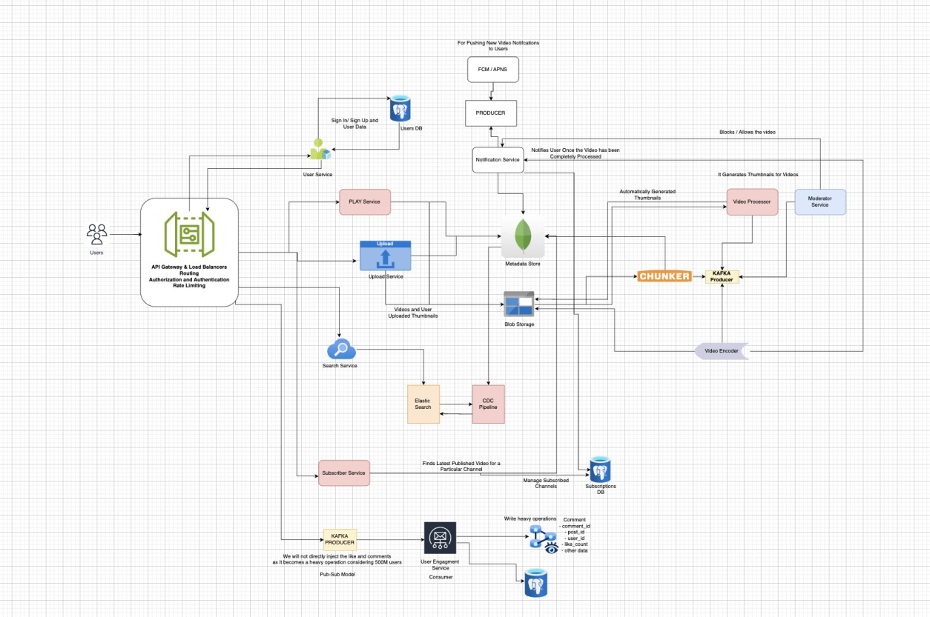

- Learning Outcomes (What I Have Learnt)
- Designed a highly scalable, event-driven video streaming architecture.
- Identified critical functional and non-functional requirements for media delivery.
- Designed REST APIs and decoupled asynchronous processing pipelines.
- Understood the application of CDNs, adaptive bitrate streaming, and stream processing for massive-scale systems.

