Course Name: Computer Vision

Course Code: 19AI621

Course Advisor: Dr. Senthilkumar T

Title : Lane Detection for Autonomous Vehicles using Computer Vision Algorithm

|  |  |
| --- | --- |
| Roll No/Name | Role |
| Abhishek Gopinath [CB.EN.P2AID20002] |  |
| Alan Henry [CB.EN.P2AID20010] |  |
| Jiss Joseph Thomas [CB.EN.P2AID20024] |  |

Dataset : Image/ Video

|  |  |
| --- | --- |
| Size | 300+ KB |
| Row * Column | 640 * 480 / 1280 * 720 |
| Resolution | 360p |
| File Type | PNG / MP4 |
| Color Model | RGB |
| Frame Rate | 50 fps |
| Data Acquisition | <Camera> |

Dataset Description

The dataset has more than 1000 images.

The dataset has challenges like size, orientation, Illumination.

Analysis vs **Analytics**

**Analysis [10 questions]**

**1.** How many vehicles in the frame

2. what are the objects detected in it

3. How many pedestrians are detected in it

4. Detecting road signs.

5. Objects on the interest area.

6. Lines inside the interest area.

7. Traffic signals detected

8. Wet area inside the interest area.

9. Dividers inside the frame.

10. How far the lanes to be detected.

**Analytics [Historical data] [10 questions]**

1. Why vehicles are less in specific area

2. Why more pedestrians are found at certain point

3. Why the road is wet?

4. What type of road we are traveling on.

5. What time do most people drive

6. Do people dim their light while passing

7. How often a certain route is taken.

8. How many speed breakers detected to analyze whether there is school nearby.

9. Why there is no horn sign detected

10. Why vehicle in the front is slowing down

**Industry/Research Labs:** [**Tesla**](https://www.tesla.com/autopilot)**,** [**Waymo**](https://waymo.com)**,** [**Zoox**](https://zoox.com)

|  |
| --- |
| **Features** |
| Lanes |
| Cars |
| Pedestrians |
| Signals colors |
| Size of car |
| Color |
| Lines |

Problem statement:

Given a dataset of video or image of roads, this case study aims to detect lanes in it which helps the vehicle to move autonomously

Determine a **model** that will perform the following:

1. Detect lane
2. Detect cars and pedestrians on road

Reference:

1. [GitHub - rslim087a/road-video: Video required for finding lane lines](https://github.com/rslim087a/road-video)

2. [GitHub - rslim087a/road-image: image required for finding lane lines](https://github.com/rslim087a/road-image)

3. [CULane dataset](https://xingangpan.github.io/projects/CULane.html)

4. [Real-time detection of road lane-lines for autonomous driving](https://www.researchgate.net/publication/331478663_Real-Time_Detection_of_Road_Lane-Lines_for_Autonomous_Driving)

5. [Multi-Lane Detection and Tracking Using Vision for Traffic Situation Awareness](https://ieeexplore.ieee.org/document/9253415)

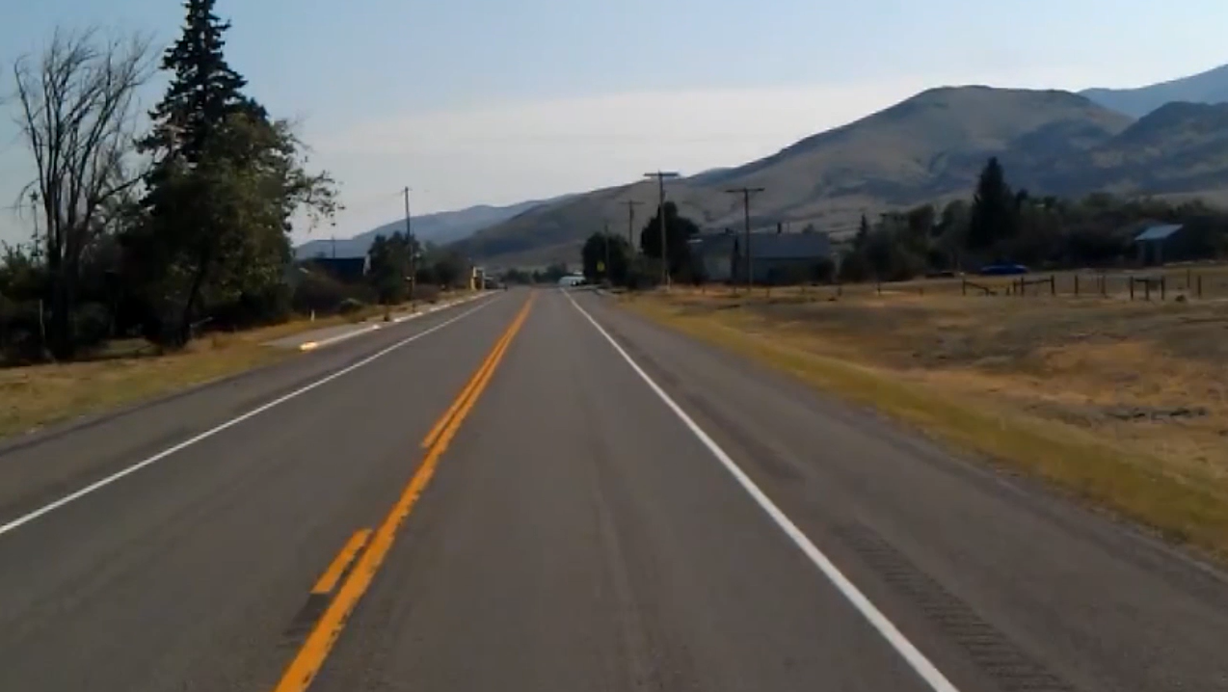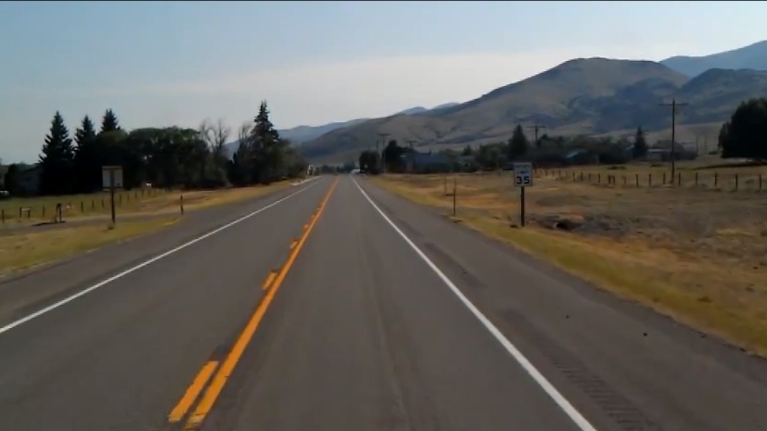6. [Real-Time Tracking and Lane Line Detection Technique for an Autonomous Ground Vehicle System](https://link.springer.com/chapter/10.1007/978-981-15-0633-8_156#:~:text=Vehicle%20tracking%20has%20been%20performed,using%20adaptive%20background%20subtraction%20technique.)