

UNIVERSITY OF HERTFORDSHIRE
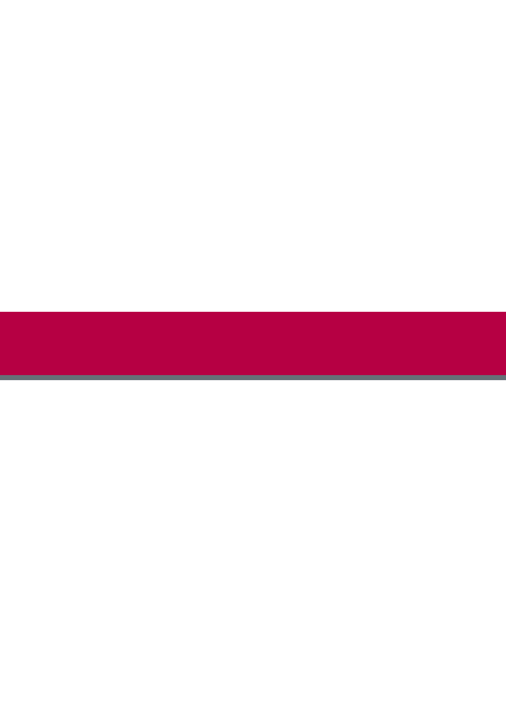
7FTC2006 – Data Handling and Visualisation
Assessment 3 – Final Visualization Report

Student name | Truong Tan Phat
ID number | 9027KVDX
Lecturer/Tutor name | Andy Tai Hock Lin
Student submission date | November 5, 2026

Table of Contents
1. Introduction: 3
2. Dataset and Data Handling: 3
3. Results and Discussion: 4
4. Conclusion: 6
References: 7

1. Introduction:
Associations between screen time and sleep duration and felt stress may exist, but not entirely mediated by screen time. This report explores the association between TikTok use, total daily screen time, sleep hours, and felt stress. The data were obtained from the Screen Time Impact on Mental Health dataset on Kaggle (Dave, n.d.). The dataset comprises 100,000 synthetic records with six characteristics on digital activity and wellness. The analysis examines several patterns and shows the results graphically in Python using a regression scatterplot, boxplot, grouped line chart, and diverging bar chart.
The data set is synthetic therefore the conclusions are patterns in the data, not genuine causality in the real world.

2. Dataset and Data Handling:
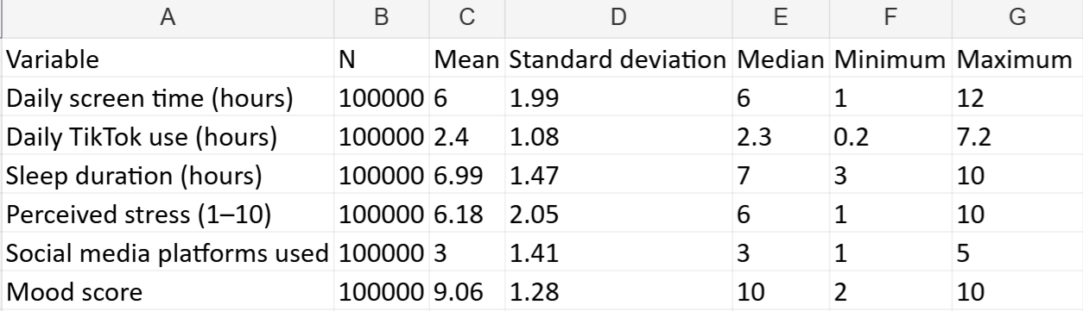
Source: Author's own visualisation based on data from Dave (n.d.).

The dataset was imported and examined using Python and Pandas. An initial audit checked missing values, expected value ranges, consistency, and repeated records. No missing or invalid values were identified by these checks. However, 1,865 rows contained repeated combinations of values. Since the dataset provides no unique respondent identifiers, these records were retained rather than automatically removed.
To support comparisons, stress scores were grouped into low (1–4), moderate (5–7), and high (8–10). Sleep duration was also divided into three categories: under 6 hours, 6 to under 8 hours, and 8 hours or more. These groupings supported the subsequent visual analysis.

3. Results and Discussion:
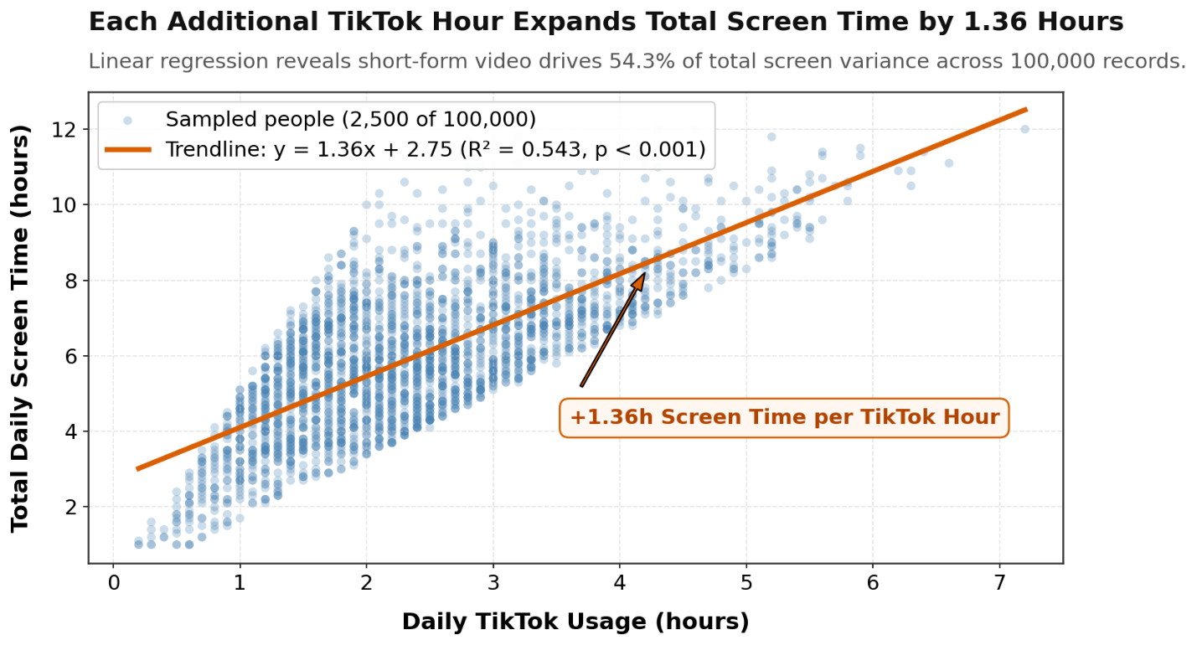
Source: Author’s own visualisation based on data from Dave (n.d.).

Figure 1 indicates that TikTok use is positively correlated with total daily screen time. Linear regression suggests that each additional hour of TikTok use is connected with an increase of about 1.36 hours in total screen time (R² = 0.543). But TikTok usage is already included in the total thus this association should not be taken to be causative.
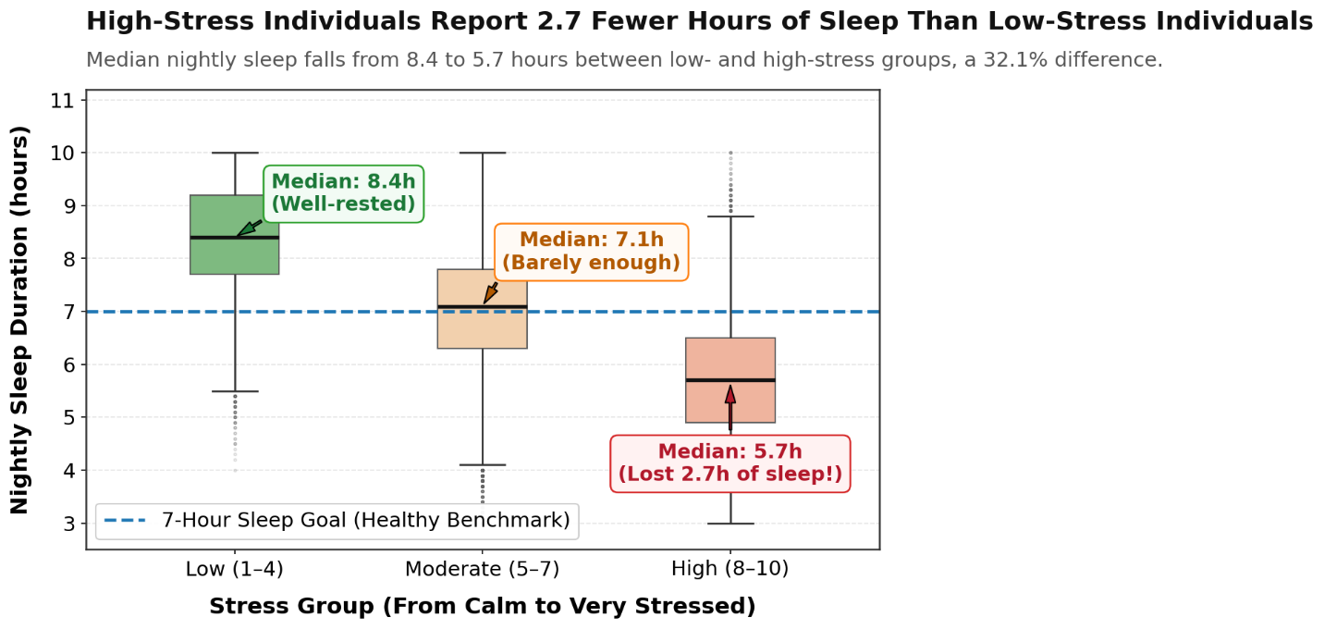
Source: Author’s own visualisation based on data from Dave (n.d.).

As we move from digital activity to wellbeing, we see a clear difference by stress group in sleep length (Figure 2). The median sleep in the low-stress group is 8.4 hours whereas the high-stress group had a median of 5.7 hours, a difference of 2.7 hours. The boxplots also indicate variability within each group, demonstrating that individual sleep patterns are not uniform.

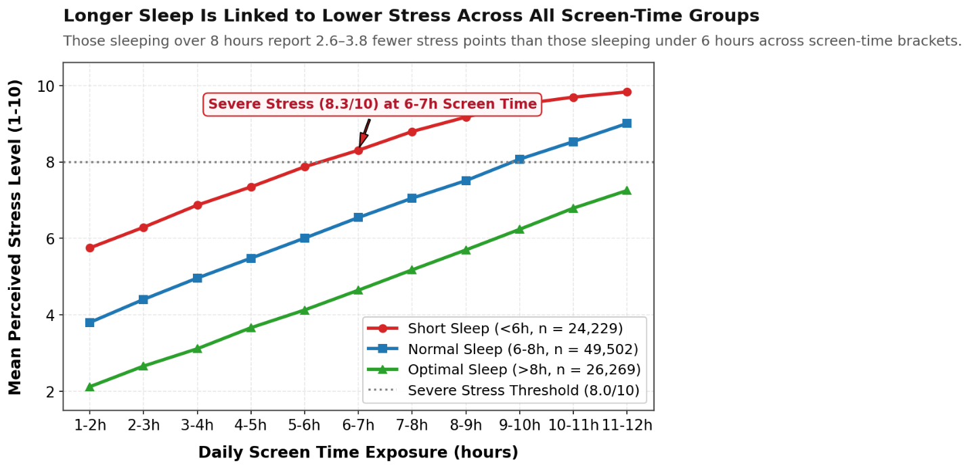
Source: Author's own visualisation based on data from Dave (n.d.).

Figure 3 extends this comparison by examining stress across similar screen-time ranges. Participants represented by records with at least eight hours of sleep consistently show lower average stress than those with under six hours. The difference ranges from approximately 2.6 to 3.8 points, suggesting that sleep duration provides useful additional information when interpreting stress patterns.

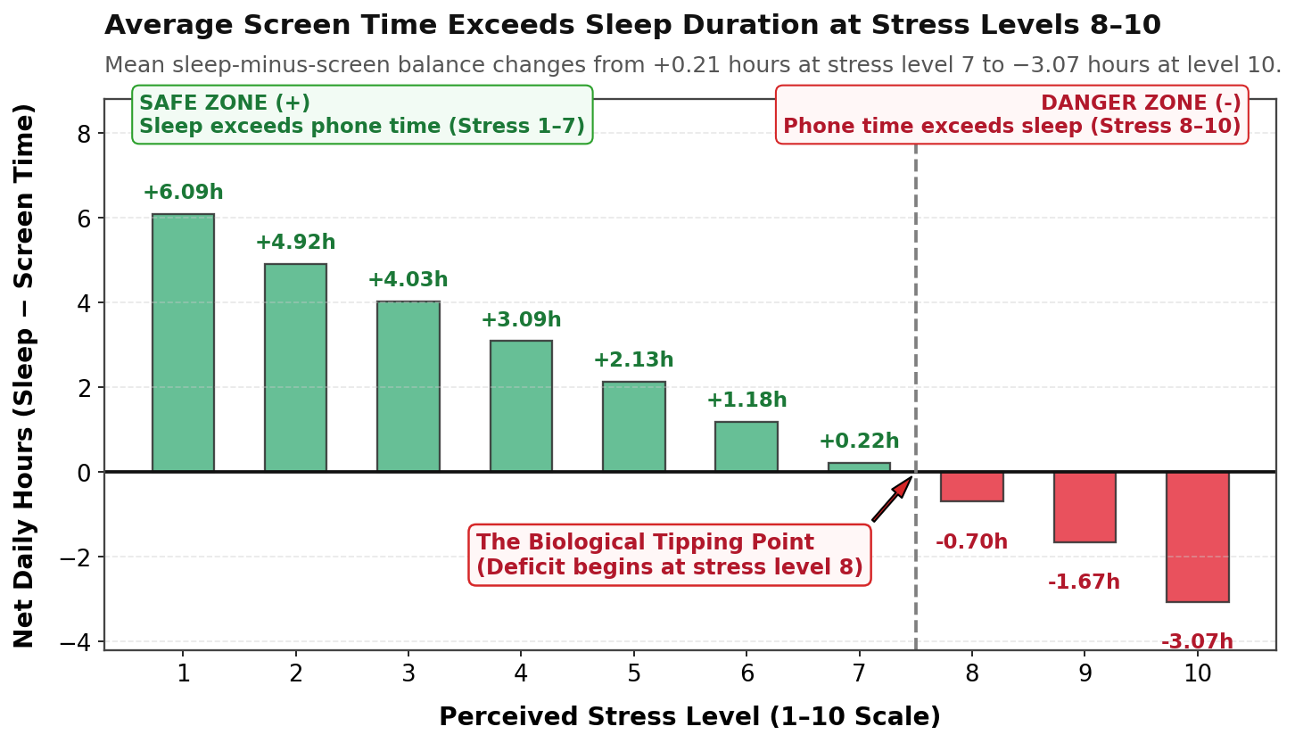
Source: Author's own visualisation based on data from Dave (n.d.).

Finally, Figure 4 summarises the difference between sleep and screen time across stress levels. The average balance becomes negative at stress level 8 (−0.70 hours) and reaches −3.07 hours at level 10. Together, these visualisations suggest that screen habits and sleep duration are associated with reported stress, although they cannot establish cause and effect.

4. Conclusion:
In general the data indicates clear connections with digital behaviors, sleep length and felt stress. More TikTok use is connected with higher overall screen time. Less sleep is consistently associated with more reported stress. The combined visualizations reveal that sleep duration provides extra insight beyond screen time alone. The dataset is synthetic, however, and hence these findings cannot be taken to show causation or be directly generalized to real-world populations.

References:
Dave, A. (n.d.) Screen Time Impact on Mental Health [Dataset]. Kaggle. Available at: https://www.kaggle.com/datasets/abhishekdave9/digital-habits-vs-mental-health-dataset (Accessed: 2 November 2026).

