MH4510 GROUP PROJECT
SMS Spam Classification
Team: Pattern Miners
Members: Teng Pei Si Adele(U2240156B), Clarrance Seah Jing Xiong(U2140255A), Wong Zi Xun(U2240117A), Kevin Lee Zhi Hong(U2140142L)
Division of Mathematical Sciences, School of Physical and Mathematical Sciences
Nanyang Technological University

Introduction
Spam detection for short message services (SMS) remains an important practical problem in natural language processing and cybersecurity. The objective of this project is to develop, compare, and critically evaluate several machine learning and deep learning approaches for classifying SMS messages as either ham (legitimate) or spam (unsolicited and often malicious). We use a popular SMS spam corpus and implement a complete pipeline that includes preprocessing, feature engineering, model training, and evaluation. The project aims to demonstrate differences in performance between classical models (e.g. XGBoost), sparse logistic methods (LASSO on TF-IDF), embedding-based linear models (GloVe + LASSO), and deep sequence models (GloVe + LSTM).

Contributions
This report documents the data cleaning, exploratory data analysis (EDA), feature engineering, model selection, results, and conclusions. The models implemented are:
- Extreme Gradient Boosting (XGBoost) on Bag-of-Words features (DTM).
- LASSO logistic regression trained on TF-IDF features.
- LASSO logistic regression trained on sentence embeddings from GloVe.
- LSTM network trained on GloVe-based representations.

Literature Review
Automatic spam filtering is a long-studied problem in machine learning and information retrieval. Early systems relied heavily on Naïve Bayes classifiers and simple rule-based filters. Later work introduced more sophisticated feature engineering (TF-IDF, n-grams) and ensemble methods such as gradient boosted trees (XGBoost) . Word embeddings such as word2vec and GloVe capture semantic relationships between words and have been used to generate dense sentence representations for downstream classification tasks . Recurrent neural networks, especially LSTM variants, are useful when sequential information (word order) is believed to be important .
Recent surveys emphasize that hybrid approaches which combine classical feature-based models and neural embeddings often yield robust performance on text classification benchmarks . Additionally, L1-regularized logistic regression (LASSO) is a popular and interpretable method to select a sparse set of predictive terms .

Exploratory Data Analysis

Dataset description
The dataset used is a public SMS spam collection containing labelled SMS messages. Each row contains the message text and a label indicating ham or spam. After removing duplicates, the dataset used in this project consists of approximately 5,169 messages.

Data cleaning and preprocessing
Preprocessing steps applied to the raw text include:
- Lowercasing text.
- Removing non-alphabetic characters (preserving “@” temporarily to mark emails).
- Replacing “@” with a token (e.g., twacc) to retain email occurrences.
- Lemmatization to reduce words to their base forms.
- Stopword removal via standard English stopword lists.
- Tokenization for embedding and n-gram processing.

Example R code (data cleaning)
sms_data <- read.csv("C:/Users/65881/Downloads/spam.csv")
sms_data <- sms_data[!duplicated(sms_data), ] %>%
select(v2, v1) %>%
rename(text = v2, label = v1) %>%
mutate(label = factor(label, levels = c("ham", "spam"),
labels = c(0,1)))
data <- sms_data %>%
mutate(text = text %>%
str_replace_all("[^A-Za-z@]", " ") %>%
str_squish() %>%
str_to_lower() %>%
str_replace_all("@", "twacc") %>%
lemmatize_strings() %>%
removeWords(stopwords("en")))

Summary statistics and class imbalance
Table 3.1 shows basic dataset statistics and class distribution.
Dataset summary (after cleaning)
Statistic | Value
Total messages | 5,169
Ham proportion | 0.8848
Spam proportion | 0.1152
Unique tokens (DTM cutoff $≥$10) | $≈$706
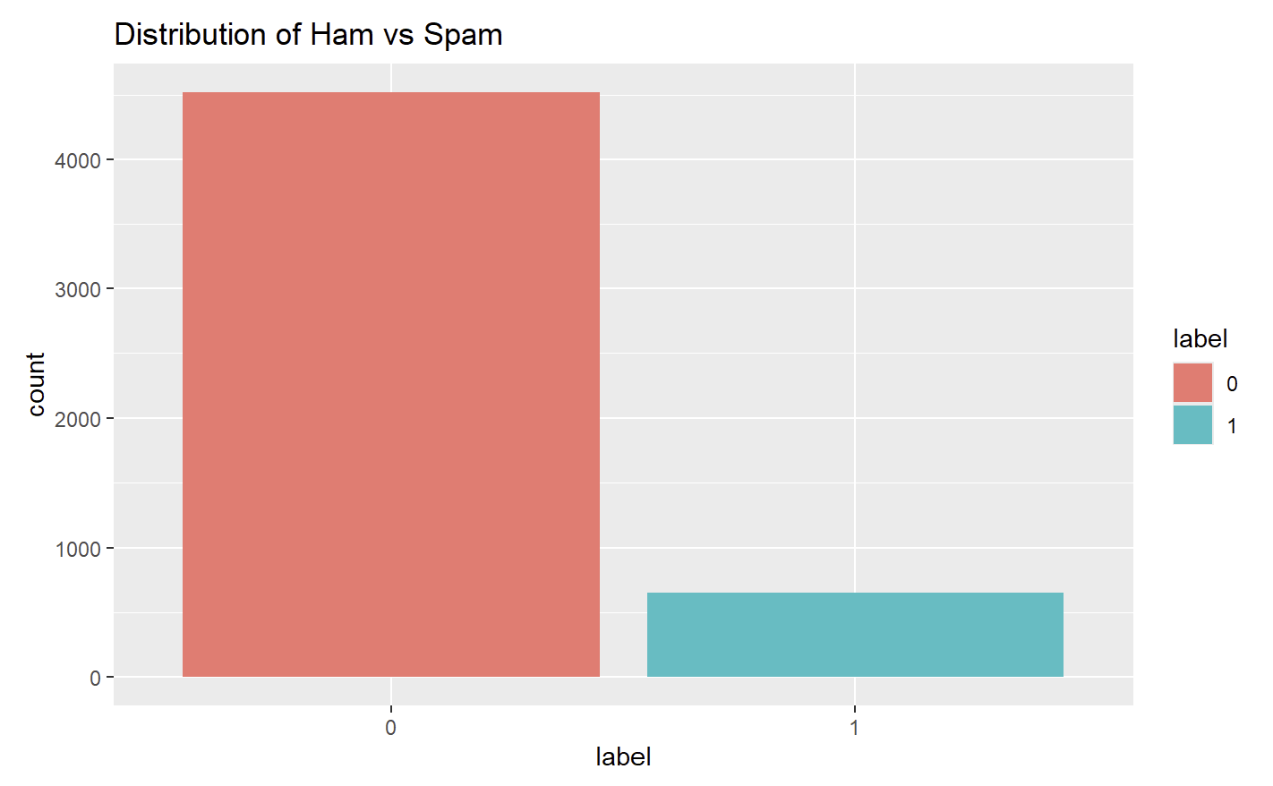
Figure 1: Class Distribution
Figure 1 displays the class distribution.

Word frequency and word clouds
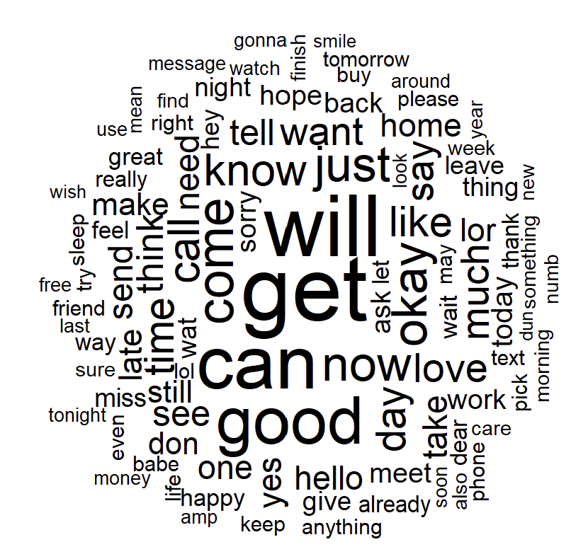
Figure 2: Ham Word Cloud
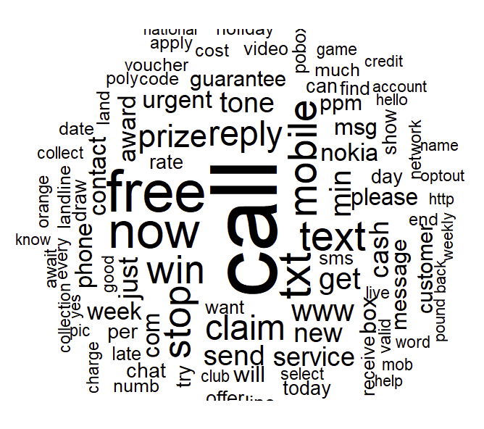
Figure 3: Spam Word Cloud

Feature Engineering

Document-Term Matrix, Bag-of-Words and Term Frequency-Inverse Document Frequency
A Document-Term Matrix (DTM) is constructed from the cleaned corpus. To reduce sparsity, terms appearing fewer than 10 times are removed. Bag-of-Words representation is created in the DTM to get the term frequency of the words in it. Term Frequency-Inverse Document Frequency (TF-IDF) score is computed for this representation by adjusting the weight of each word in accordance to its rarity across the entire corpus. This score is later used in LASSO logistic regression experiments.

Code: DTM and TF-IDF
corpus <- VCorpus(VectorSource(data$text))
DTM <- DocumentTermMatrix(corpus)
# keep terms with frequency >= 10
freq_words <- termFreq(data$text)
freq_words <- freq_words[freq_words >= 10]
DTM <- DTM[, names(freq_words)]
# TF-IDF
tfidf <- weightTfIdf(DTM)
tfidf_matrix <- as.matrix(tfidf)

GloVe embeddings and sentence representations
GloVe is trained on the tokenized corpus to produce dense word vectors. Sentence-level embeddings are formed by averaging the word vectors for words present in each message. A pre-trained GloVe embedding was not used as the embeddings by Stanford were only trained on Wikipedia, Twitter, and Common Crawl, all of which fail to capture the extremely informal language that is often used in messages.

Code: GloVe training and sentence embeddings
tokens <- word_tokenizer(data$text)
it <- itoken(tokens, progressbar = FALSE)
vocab <- create_vocabulary(it)
vectorizer <- vocab_vectorizer(vocab)
tcm <- create_tcm(it, vectorizer, skip_grams_window = 5)
glove <- GlobalVectors$new(rank = 50, x_max = 10)
wv_main <- glove$fit_transform(tcm, n_iter = 20)
word_vectors <- wv_main + t(glove$components)
sent_embedding <- t(sapply(tokens, function(x) {
w <- word_vectors[x, , drop = FALSE]
if (nrow(w) == 0) rep(0, 50) else colMeans(w)
}))

Model Selection
This section describes the models implemented, their motivations, and training details.

Extreme Gradient Boosting (XGBoost)
XGBoost is used with a binary logistic objective and DTM features. Early stopping is applied using a held-out validation set. The model parameters and tuning choices are detailed below.

Model specification
The XGBoost objective is logistic loss applied to a tree ensemble. If $f_{k}$ denotes the $k$-th tree, predictions are:
$${\hat{y}}_{i}=σ​\left(\sum_{k=1}^{K}{f_{k}}\left(x_{i}\right)\right), σ\left(z\right)=\frac{1}{1+e^{-z}}$$

Code: XGBoost training
labels <- as.numeric(as.character(data$label))
dataset <- cbind(label = labels, DTM_df)
set.seed(123)
train_idx <- createDataPartition(dataset$label, p = 0.8, list = FALSE)
train <- dataset[train_idx, ]
test <- dataset[-train_idx, ]
dtrain <- xgb.DMatrix(as.matrix(train[,-1]), label = train$label)
dtest <- xgb.DMatrix(as.matrix(test[,-1]), label = test$label)
params <- list(objective = "binary:logistic", eval_metric = "error",
max_depth = 6, eta = 0.3, subsample = 0.8, colsample_bytree = 0.8)
xgb_model <- xgb.train(params, dtrain, nrounds = 100,
watchlist = list(train = dtrain, eval = dtest),
early_stopping_rounds = 10, verbose = 1)

LASSO logistic regression with BoW+TF-IDF
LASSO (L1-penalized) logistic regression is applied to TF-IDF features to yield sparse predictive terms. Cross-validation is used to select the regularization parameter $λ$.

Code: LASSO on TF-IDF
tfidf_df <- as_tibble(tfidf_matrix) %>% mutate(Y = data$label)
set.seed(156)
ind <- runif(nrow(tfidf_df)) < 0.7
train_data <- tfidf_df[ind,]
test_data <- tfidf_df[!ind,]
lambda_seq <- 10^seq(-4, 0, length = 20)
lasso <- caret::train(Y ~ ., data = train_data, method = "glmnet",
trControl = caret::trainControl("cv", number = 5),
tuneGrid = expand.grid(alpha = 1, lambda = lambda_seq),
preProcess = c("scale"))

LASSO with GloVe embeddings
Sentence embeddings from GloVe are fed into LASSO logistic regression as a low-dimensional representation of each message. This approach captures semantic similarity among words while maintaining interpretability through L1 regularization.

Code: GloVe + LASSO
idx <- createDataPartition(data$label, p = 0.8, list = FALSE)
train_x <- sent_embedding[idx, ]
test_x <- sent_embedding[-idx, ]
train_y <- data$label[idx]
test_y <- data$label[-idx]
lasso_embed <- cv.glmnet(train_x, train_y, family = "binomial", alpha = 1)

LSTM with GloVe embeddings
An LSTM network is trained on document embeddings where each of the 100 GloVe-derived features is treated as a separate timestep. This sequence representation (100 timesteps × 1 feature per timestep) allows the LSTM to process feature dimensions sequentially. The network includes dropout regularization and dense layers to reduce overfitting risks.

Model and loss
Let $x_{t}$ denote the input feature vector at time step $t$. The LSTM computes a state update and produces an output $h_{t}$. For binary classification the final output is passed through a sigmoid and trained with binary cross-entropy loss:
$$L=-\sum_{i=1}^{N}{[}y_{i}log\left({\hat{y}}_{i}\right)+\left(1-y_{i}\right)log\left(1-{\hat{y}}_{i}\right)].$$

Code: LSTM training (keras3)
X_train_reshaped <- array(X_train, dim = c(nrow(X_train), ncol(X_train), 1))
X_test_reshaped <- array(X_test, dim = c(nrow(X_test), ncol(X_test), 1))
model <- keras_model_sequential() %>%
layer_lstm(units = 50, input_shape = c(ncol(X_train),1),
dropout = 0.2, recurrent_dropout = 0.2) %>%
layer_dense(units = 32, activation = "relu") %>%
layer_dropout(rate = 0.2) %>%
layer_dense(units = 1, activation = "sigmoid")
model %>% compile(optimizer = optimizer_adam(0.001),
loss = "binary_crossentropy", metrics = "accuracy")
history <- model %>% fit(X_train_reshaped, y_train, epochs = 50, batch_size = 32)

Results and Discussion
This section summarizes model performance and compares classifiers using accuracy, AUC, and confusion matrices. The metrics reported here are those obtained when running the consolidated R notebook on the dataset.

XGBoost performance
XGBoost achieved an accuracy of approximately 0.973 and AUC $≈$ 0.977 on the held-out test set. Table 6.1 shows the confusion matrix obtained.
XGBoost confusion matrix (test set)
 | Predicted 0 | Predicted 1
Actual 0 | 910 | 24
Actual 1 | 4 | 95

LASSO (TF-IDF) performance
LASSO on TF-IDF features produced accuracy $≈$ 0.961 and strong balanced accuracy. Confusion matrix is shown in Table 6.2.
LASSO (TF-IDF) confusion matrix (test set)
 | Predicted 0 | Predicted 1
Actual 0 | 1348 | 37
Actual 1 | 25 | 173

GloVe + LASSO performance
GloVe sentence embeddings paired with LASSO achieved accuracy $≈$ 0.935. The model trades some sensitivity for lower dimensionality; see Table 6.3.
GloVe + LASSO confusion matrix (test set)
 | Predicted 0 | Predicted 1
Actual 0 | 886 | 50
Actual 1 | 17 | 80

GloVe + LSTM performance
The LSTM model achieved test accuracy $≈$ 0.944 (see Table 6.4). Note that an LSTM trained on averaged embeddings will not leverage word order strongly; similar performance could often be obtained with a dense network on the sentence embeddings.
GloVe + LSTM confusion matrix (test set)
 | Predicted 0 | Predicted 1
Actual 0 | 901 | 45
Actual 1 | 13 | 74

Model comparison and discussion
Overall, XGBoost perform best in accuracy and AUC. TF-IDF + LASSO offers a competitive, highly interpretable baseline; the nonzero coefficients directly indicate important terms. GloVe embeddings reduce feature dimensionality and capture semantic information but may lose fine-grained frequency signals important for spam detection (e.g., rare tokens).

Limitations
- Dataset is relatively small and strongly imbalanced (ham >> spam). Models may overfit to the majority class; additional resampling strategies (SMOTE, class-weighting) could be considered.
- LSTM is trained on averaged embeddings here to capture sequential effects properly you would usually feed sequences of token indices and use an embedding layer.
- External validity: model trained on one dataset might not generalize to other SMS datasets (different countries, languages, or spam campaigns).
- GloVe embedding was derived from the dataset instead of using a pre-trained GloVe embedding.

Conclusion and Future Work
This project implemented and compared four modeling strategies for SMS spam detection. Key findings are:
- XGBoost on carefully preprocessed DTM features provides strong accuracy and AUC with efficient training and good interpretability.
- Sparse logistic regression (LASSO) on TF-IDF provides interpretable predictors and strong baseline performance.
- GloVe embeddings enable lower-dimensional, semantic-aware representations; when paired with LASSO they are effective but less accurate than XGBoost in this setting.
- LSTM achieved high accuracy in the implemented pipeline, but the result should be interpreted cautiously since the LSTM input collapsed temporal structure into a single vector.
Future directions include:
- Training contextual embeddings (e.g., BERT) and fine-tuning for spam detection.
- Building an end-to-end sequence model with token indices and pretrained embeddings.
- Evaluating robustness across datasets and imbalanced learning strategies.

References
Androutsopoulos, I., Metsis, V., Paliouras, G. (2006). Spam filtering with naive Bayes – which naive Bayes? CEAS.
Chen, T., Guestrin, C. (2016). XGBoost: A scalable tree boosting system. Proceedings of the 22nd ACM SIGKDD International Conference on Knowledge Discovery and Data Mining.
Hochreiter, S., Schmidhuber, J. (1997). Long short-term memory. Neural Computation, 9(8), 1735–1780.
Manning, C. D., Pennington, J., Socher, R. (2014). GloVe: Global vectors for word representation. Proceedings of the 2014 Conference on Empirical Methods in Natural Language Processing (EMNLP).
SMS Spam Collection Dataset. (n.d.). [Dataset]. https://www.kaggle.com/datasets/uciml/sms-spam-collection-dataset
Tibshirani, R. (1996). Regression shrinkage and selection via the lasso. Journal of the Royal Statistical Society: Series B (Methodological), 58(1), 267–288.
Wallace, B,Zhang, Y. (2018). A sensitivity analysis of (and practitioners’ guide to) convolutional neural networks for sentence classification. Proceedings of the 8th International Joint Conference on Natural Language Processing (IJCNLP).
Appendix
Consolidated R Code for the report [https://www.dropbox.com/scl/fi/ve1iy38s6ecdwyn0vzu1e/sms-project-Consolidated.Rmd?rlkey=p9t9jnngc4pmztu7k26zed0ph&st=m3stoei7&dl=0]

