Database Design
Employee Management System — Entity Relationship Diagram & Normalized Schema

1. Purpose
This document specifies the relational database design for the Employee Management System: the entity relationship diagram, the normalized schema, and the referential-integrity rules enforced by the application. It corresponds to schema.sql in the source repository, which is the executable source of truth — this document explains and justifies it.

2. Entity Relationship Diagram
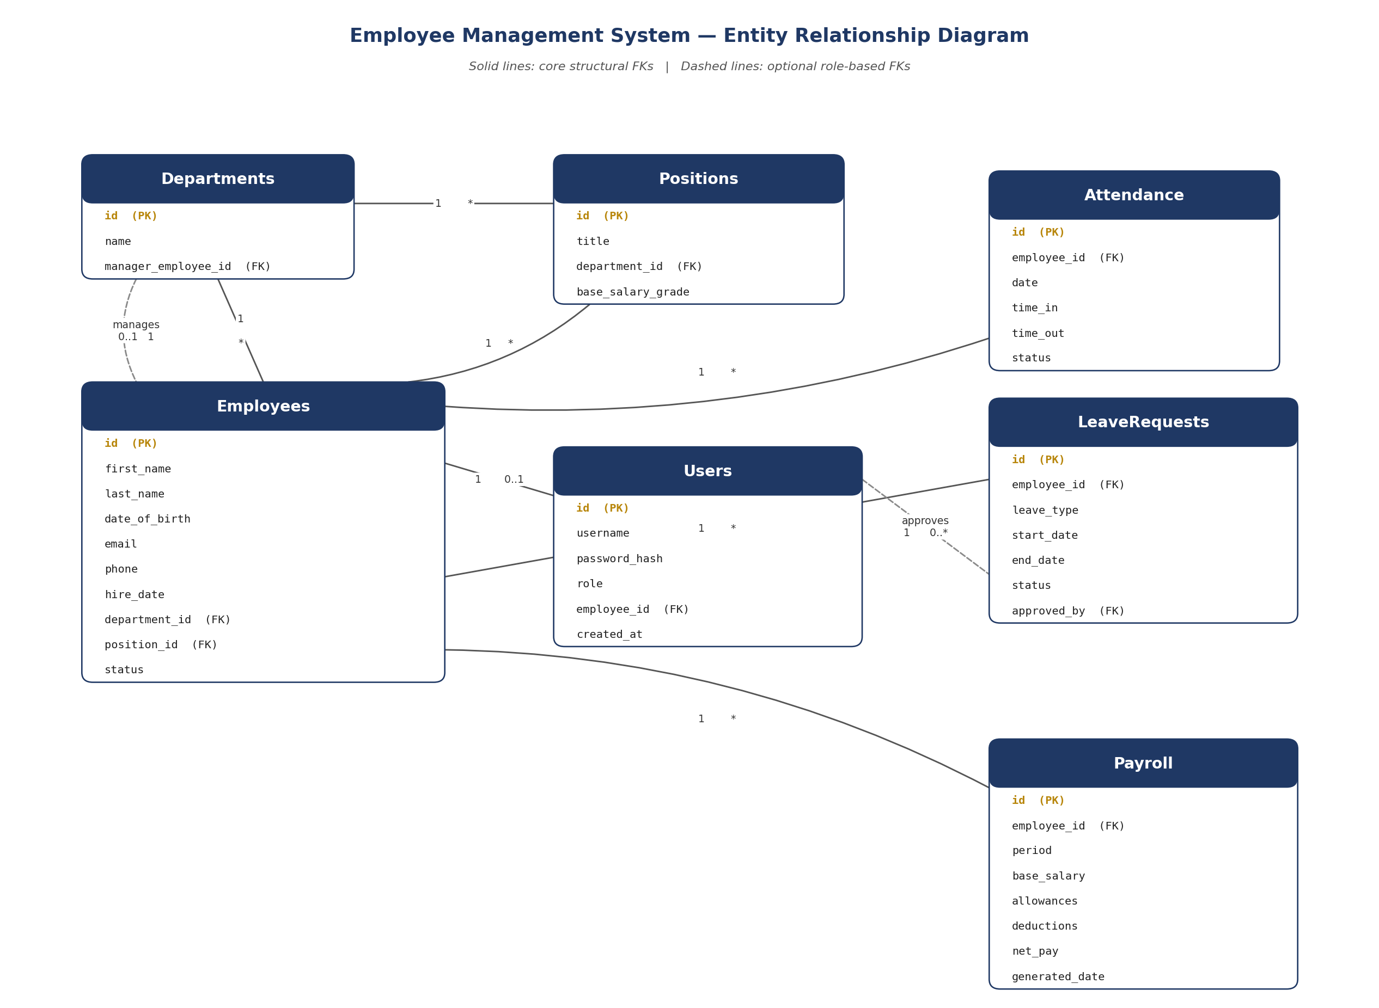
Seven entities, four of which (Attendance, LeaveRequests, Payroll, and the Positions/Departments pair) exceed the assessment's minimum of four related tables. Solid lines are the core structural foreign keys created at insert time; dashed lines are optional role-based references that may be null (a department may have no manager yet; a leave request may be pending with no approver yet).

3. Normalization
The schema is in Third Normal Form (3NF):
- 1NF: every column holds a single atomic value — no repeating groups (e.g., an employee's leave history is a separate LeaveRequests row per request, not a delimited list in one column).
- 2NF: every table uses a single-column surrogate primary key (id), so there are no composite keys and therefore no partial-key dependencies to violate.
- 3NF: no non-key column depends on another non-key column. For example, Employees stores department_id and position_id (foreign keys) rather than duplicating the department name or salary grade on every employee row — those live once each in Departments and Positions and are looked up via the FK.

4. Table Definitions

4.1 departments
Column | Type | Key | Notes
id | INTEGER | PK | Autoincrement
name | TEXT | UNIQUE, NOT NULL | Department name
manager_employee_id | INTEGER | FK → employees.id | Nullable — set once a manager is assigned

4.2 positions
Column | Type | Key | Notes
id | INTEGER | PK | Autoincrement
title | TEXT | NOT NULL | Job title
department_id | INTEGER | FK → departments.id, NOT NULL | Every position belongs to one department
base_salary_grade | REAL | NOT NULL | Feeds Payroll.base_salary at payroll-run time

4.3 employees
Column | Type | Key | Notes
id | INTEGER | PK | Autoincrement
first_name / last_name | TEXT | NOT NULL
date_of_birth | TEXT | nullable | ISO date string (YYYY-MM-DD)
email | TEXT | UNIQUE, nullable | Enforced unique so duplicate hires are caught at the DB level too
phone | TEXT | nullable
hire_date | TEXT | NOT NULL | ISO date string
department_id | INTEGER | FK → departments.id, nullable | Nullable so an employee can be created before assignment
position_id | INTEGER | FK → positions.id, nullable
status | TEXT | CHECK IN (active, inactive, terminated) | Default 'active'

4.4 users
Column | Type | Key | Notes
id | INTEGER | PK | Autoincrement
username | TEXT | UNIQUE, NOT NULL | Login identifier
password_hash | TEXT | NOT NULL | PBKDF2-HMAC, salt embedded in the stored string
role | TEXT | CHECK IN (ADMIN, HR_STAFF)
employee_id | INTEGER | FK → employees.id, nullable | Links a system account to an employee record, if applicable
created_at | TEXT | NOT NULL | ISO timestamp

4.5 attendance
Column | Type | Key | Notes
id | INTEGER | PK | Autoincrement
employee_id | INTEGER | FK → employees.id, NOT NULL
date | TEXT | NOT NULL | ISO date string
time_in / time_out | TEXT | nullable
status | TEXT | CHECK IN (present, absent, late) | Default 'present'

4.6 leave_requests
Column | Type | Key | Notes
id | INTEGER | PK | Autoincrement
employee_id | INTEGER | FK → employees.id, NOT NULL
leave_type | TEXT | NOT NULL | e.g. annual, sick, unpaid
start_date / end_date | TEXT | NOT NULL | ISO date strings
status | TEXT | CHECK IN (pending, approved, rejected) | Default 'pending'
approved_by | INTEGER | FK → users.id, nullable | Set when an Administrator actions the request

4.7 payroll
Column | Type | Key | Notes
id | INTEGER | PK | Autoincrement
employee_id | INTEGER | FK → employees.id, NOT NULL
period | TEXT | NOT NULL | e.g. '2026-08'
base_salary / allowances / deductions / net_pay | REAL | NOT NULL | net_pay = base_salary + allowances − deductions
generated_date | TEXT | NOT NULL | ISO timestamp of the payroll run

5. Referential Integrity Rules
- Foreign keys are enforced at the connection level (PRAGMA foreign_keys = ON in DatabaseConnection) — SQLite ignores them by default, so this is set explicitly on every connection.
- Deleting a Department or Position that still has dependent rows raises a SQLite IntegrityError, which the repository layer catches and re-raises as a clear EMSException ("Cannot delete this department — employees or positions are still assigned to it") rather than letting a raw database error reach the user.
- All INSERT/UPDATE/DELETE statements use parameterised queries (?) exclusively — no string-concatenated SQL anywhere in the codebase, closing off SQL injection.
- Multi-step writes (e.g., create-then-fetch) run inside DatabaseConnection.transaction(), which commits on success and rolls back automatically if any statement in the block raises.

6. Design Rationale
- SQLite over MySQL: zero server setup for a 7-week team project, while still exercising the full SQL/transaction/FK feature set the brief requires.
- Surrogate integer primary keys (id) throughout, rather than natural keys (e.g., email as PK), so identifiers never need to change if a person's details do.
- users is a separate table from employees rather than a boolean/role flag on employees, because not every employee needs a login, and not every login (in principle) needs to correspond to an employee.
- Departments.manager_employee_id and LeaveRequests.approved_by are both nullable FKs pointing at people, kept optional deliberately: a new department has no manager yet, and a pending leave request has no approver yet.

