User Manual
Employee Management System — End-User Guide

1. Introduction
This manual explains how to run and use the Employee Management System (EMS) as an end user — an Administrator or HR Staff member. It covers everything currently built: logging in, and managing employees, departments, and positions. It will be extended as the Attendance, Leave, Payroll, and Reports modules are completed.

2. Getting Started

2.1 Requirements
- Python 3.11 or later installed
- No other setup needed — the database and dependencies used so far are all in Python's standard library

2.2 Running the application
From the project's root folder:
cd src
python main.py
The first time the application runs, it creates the database automatically and prints a generated administrator username and password to the console — write this down, it is only shown once:

3. Logging In
Enter your username, then your password (characters are hidden as you type). You have 3 attempts before the application exits for security.
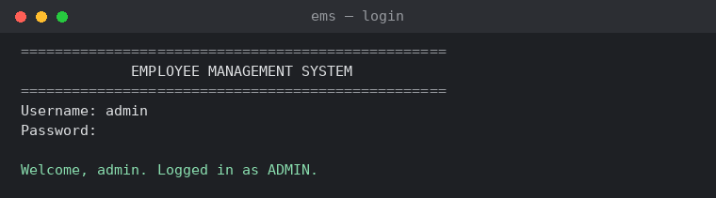
Figure 1 — Successful login
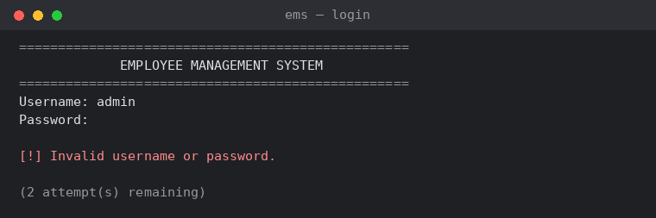
Figure 2 — An incorrect password is rejected, with attempts remaining shown

4. The Main Menu
After logging in you see the main menu. The options shown depend on nothing today — both roles see the same menu — but which actions succeed inside each module depends on your role (see Section 7).
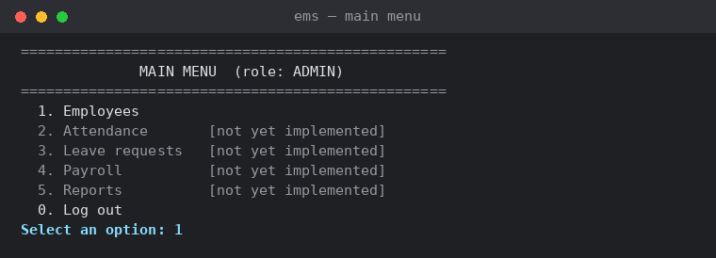
Figure 3 — Main menu after login

5. Managing Employees
Select “1. Employees” from the main menu to open the Employee Management screen.
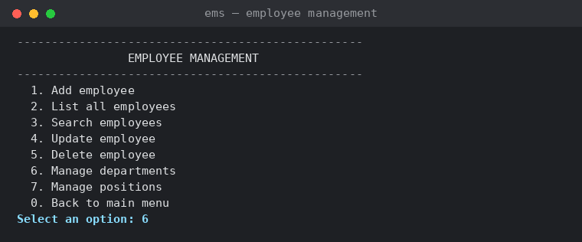
Figure 4 — Employee management menu

5.1 Add a department and position first
A new installation has no departments or positions yet. Use options 6 and 7 to create at least one of each before adding employees — an employee can be created without either, but you won't be able to assign one until it exists.
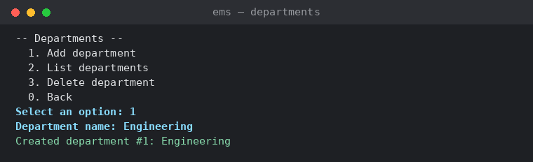
Figure 5 — Adding a department
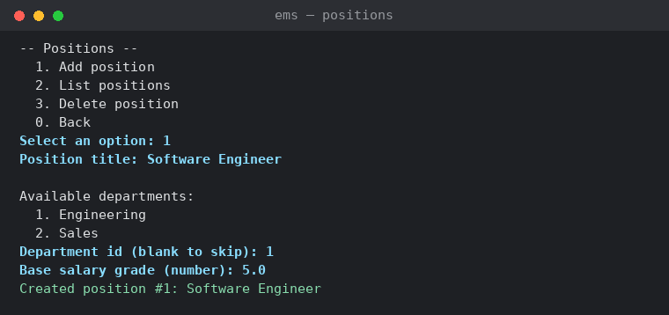
Figure 6 — Adding a position (choosing its department first)

5.2 Add an employee
Select “1. Add employee”. Date of birth and phone are optional — press Enter to skip them. You'll be shown the available departments and positions to choose from by id.
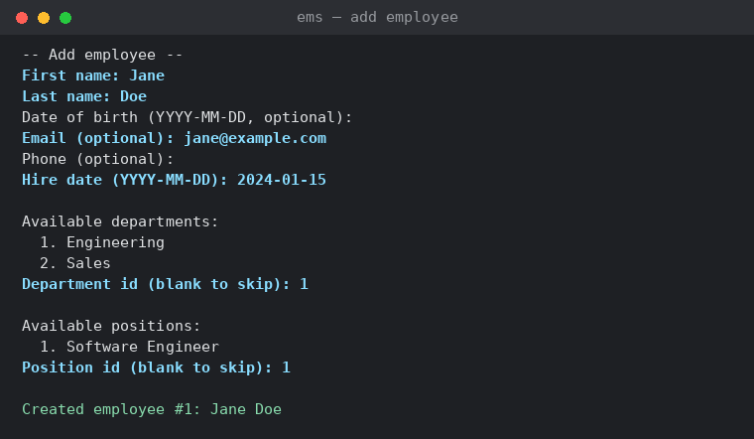
Figure 7 — Adding an employee

5.3 List and search employees
“2. List all employees” shows every record. “3. Search employees” lets you filter by name, status, and/or department — leave any prompt blank to skip that filter.
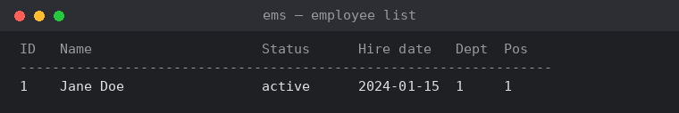
Figure 8 — Employee list

5.4 Update an employee
Select “4. Update employee” and enter the employee's id. Each field shows its current value in brackets — press Enter to keep it, or type a new value to change it.
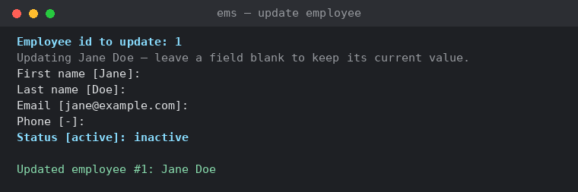
Figure 9 — Updating an employee's status

5.5 Delete an employee
Select “5. Delete employee”, enter the id, and type yes to confirm. This cannot be undone.
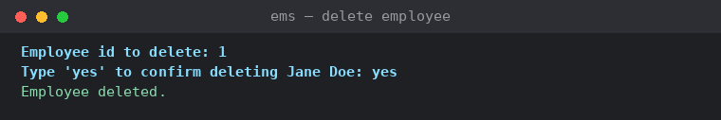
Figure 10 — Deleting an employee

6. Understanding Error Messages
The system validates everything you enter and explains what went wrong rather than crashing.
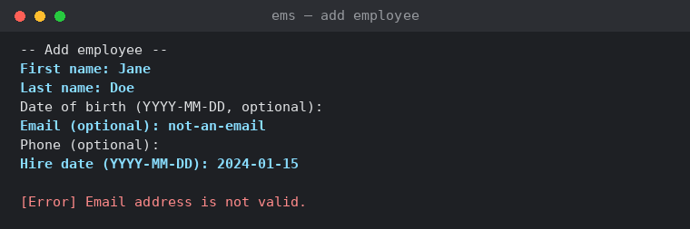
Figure 11 — An invalid email address is rejected before anything is saved

7. User Roles
There are two roles. What you can do depends on which one your account has:
Role | Can do
Administrator | Everything: create/edit/delete employees, departments, and positions
HR Staff | Create and edit employees; view departments and positions; cannot delete employees or manage departments/positions
If you try to do something your role doesn't allow, the system tells you clearly rather than letting it happen silently:
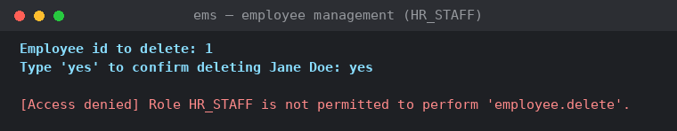
Figure 12 — HR Staff is blocked from deleting an employee

8. Logging Out
Select “0. Log out” from the main menu at any time. This ends your session; you'll need to log in again to continue.

9. Getting Help
If something goes wrong that isn't explained on screen, check logs/app.log in the project folder — every action and error is recorded there with a timestamp, which is the first thing to check before asking your Database Engineer or Lead Developer for help.

