Technical Documentation
Employee Management System — Architecture, Modules & Setup

1. Introduction
This document is the technical reference for developers working on or marking the Employee Management System (EMS). It covers the system architecture, the entity-relationship design, a module-by-module reference of the source code, setup instructions, and the current build status against the assessment's technical requirements.
Current scope: the application foundation (database, authentication, login) and a complete Employee CRUD vertical slice (Employees, Departments, Positions) are built and verified end-to-end. Attendance, Leave, Payroll, and Reports are not yet implemented — see Section 7.

2. Architecture
The system follows a layered Model–View–Controller (MVC) architecture. Data flows one direction per request: View captures input, Controller validates and orchestrates, Model/Repository executes business logic and persistence, Controller returns results, View renders output. A Services & Utilities layer provides authentication, logging, validation, and exception handling to every other layer.
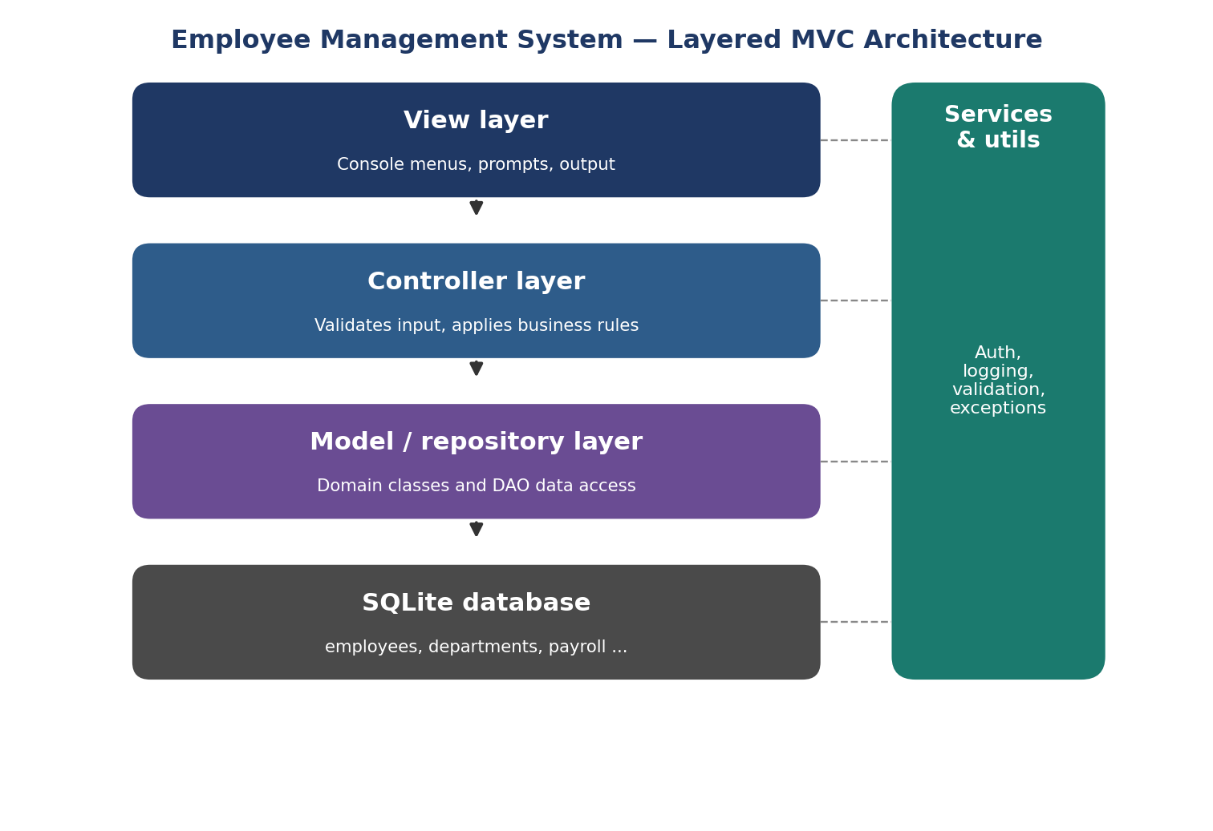
Layer | Responsibility
Model | Domain classes and Repository/DAO classes reading and writing the database. No console I/O.
View | All console/menu presentation. No business logic or direct database access.
Controller | Coordinates View and Model: validates input, applies business rules, enforces permissions.
Service / Utility | Cross-cutting concerns: authentication, logging, custom exceptions, validation helpers.

3. Database Design
Full detail (normalization discussion, column-level constraints, referential-integrity rules) is in the separate Database Design deliverable. Summary ERD:
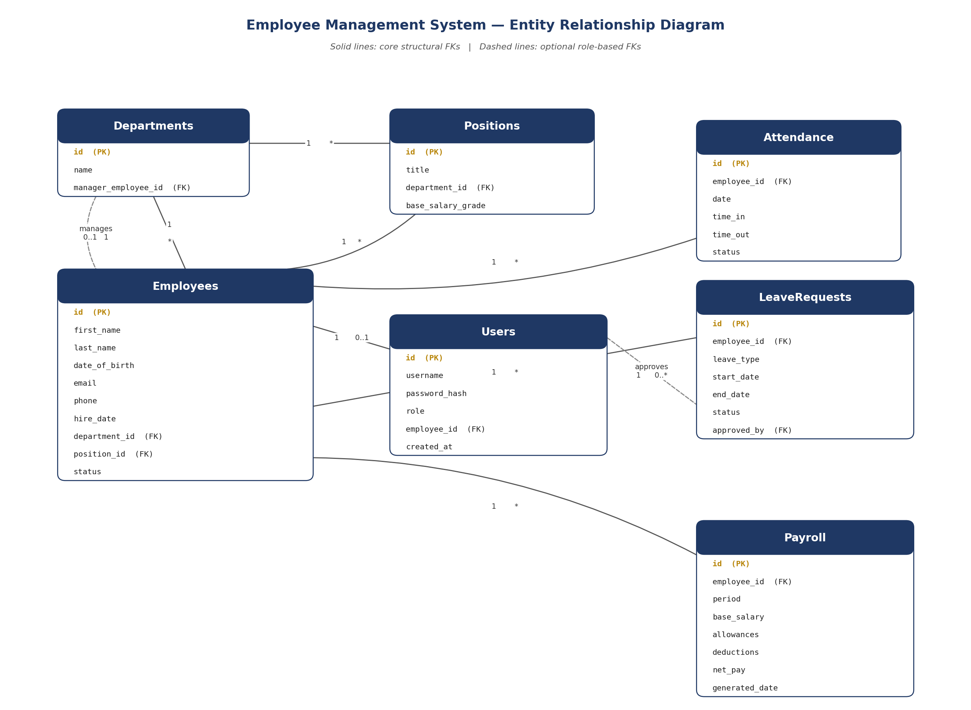

4. Module Reference
Every module below exists as working, executed code — not a placeholder. Method counts are exact (measured via static analysis of the source), not estimates.

4.1 Foundation
File | Class(es) | Methods | Purpose
config.py | — | — | Paths, constants, role codes
utils/logger.py | — | 2 fn | App-wide logging setup (file + console handlers)
utils/validators.py | Validator | 6 | Shared input-validation helpers
exceptions/custom_exceptions.py | 5 exception classes | 3 | EMSException hierarchy
repositories/database.py | DatabaseConnection, _Transaction | 12 | Connection, parameterised queries, transactions
models/user.py | User, Administrator, HRStaff | 14 | Abstract auth model + role subclasses + permissions
repositories/user_repository.py | UserRepository | 6 | User CRUD (DAO)
services/auth_service.py | AuthService | 4 | Password hashing (PBKDF2-HMAC) and login
controllers/auth_controller.py | AuthController | 6 | Session state, permission checks
views/login_view.py | LoginView | 6 | Login console prompts
views/main_menu_view.py | MainMenuView | 2 | Role-aware main menu
main.py | — | 4 fn | Entry point: bootstrap, login loop, menu loop

4.2 Employee CRUD vertical slice
File | Class(es) | Methods | Purpose
models/person.py | Person (abstract) | 14 | Base class: validated name/contact properties
models/employee.py | Employee(Person) | 7 | Adds hire_date, department/position, status
models/department.py | Department | 4 | Domain model
models/position.py | Position | 4 | Domain model
repositories/employee_repository.py | EmployeeRepository | 9 | Full CRUD + search/filter
repositories/department_repository.py | DepartmentRepository | 7 | Full CRUD, FK-violation handling
repositories/position_repository.py | PositionRepository | 7 | Full CRUD, FK-violation handling
controllers/employee_controller.py | EmployeeController | 7 | Validation, FK checks, permissions
controllers/department_controller.py | DepartmentController | 5 | Validation, permissions
controllers/position_controller.py | PositionController | 5 | Validation, permissions
views/employee_view.py | EmployeeView | 13 | All employee/department/position console menus
Totals across both slices: 26 classes, 141 class methods, and 7 module-level functions — comfortably above the assessment's minimums of 10 classes and 25 methods/functions.

5. Installation & Setup

5.1 Requirements
- Python 3.11 or later
- No external packages required for the code built so far (standard library only)

5.2 Running the application
cd src
python main.py
First run creates database/app.db from database/schema.sql automatically and prints a generated administrator password once.

5.3 Running the tests
pip install pytest
pytest tests/ -v
Note: pytest could not be installed in the offline sandbox this scaffold was built in. Every test file was syntax-checked, and the same logic was manually exercised end-to-end (see Test Report). Run the suite for real on a networked machine before relying on it as evidence of correctness.

6. Requirements Traceability
How the built code maps to the assessment's Section 6 technical requirements:
Requirement | Status | Where
≥10 classes | Met (26) | See Section 4
≥4 related tables with FKs | Met (7) | database/schema.sql
≥25 methods/functions | Met (148) | See Section 4
MVC architecture | Met | Section 2
Inheritance, polymorphism, encapsulation, abstraction, overriding, properties, dunders | Met | Person→Employee, User→Administrator/HRStaff
≥2 custom exceptions | Met (5) | exceptions/custom_exceptions.py
try/except/finally | Met | main.py, all views, database.py
Parameterised queries, transactions, DAO layer | Met | repositories/
Hashed login credentials | Met (PBKDF2-HMAC, not bcrypt — see note) | services/auth_service.py
≥2 roles, different permissions | Met | models/user.py
Search/filter ≥1 entity | Met | EmployeeRepository.search()
Logging (logging module) | Met | utils/logger.py, logs/app.log
CSV/JSON/text file handling | Not yet built | Planned for Reports/import module
pandas, matplotlib, requests libraries | Not yet used | Planned for Reports/Payroll module
Summary reports/charts | Not yet built | Planned Reports module
Attendance, Leave, Payroll entities | Schema exists; CRUD not yet built | database/schema.sql has the tables
pytest suite | Written, not yet run on a networked machine | tests/

7. Known Limitations & Planned Work
- Password hashing uses stdlib hashlib/PBKDF2-HMAC rather than bcrypt, because the environment this was built in has no network access to install packages. Swapping in bcrypt only touches services/auth_service.py.
- Attendance, Leave, and Payroll have database tables but no Model/Repository/Controller/View code yet.
- The core transactional workflow described in the SRS (approved leave → payroll deduction) depends on both the Leave and Payroll modules and is not yet implemented.
- No CSV/JSON import/export, no pandas/matplotlib reporting, and no requests-based external HTTP call yet — all required by Section 6.2.7 of the brief and planned for the Reports module.
- pytest was not executed in a networked environment; the test suite exists and was logic-verified manually, but a real pytest run with coverage should be captured before the Test Report is finalised.

