**Project Name:** Heart Rate Monitoring using “Windows Method”

**Object:**

The heart rate monitor is a device used to measure and display the heart rate of an individual in beats per minute (BPM). It is an essential tool in healthcare and fitness applications as it provides valuable information about an individual's cardiovascular health. This project aims to develop a heart rate monitor using MATLAB, a powerful software environment for numerical computing.

**Program Code:**

clc, clf, clear, close all ;

% Heart Rate Tracking Plot using calculating heart rate for each window

load('signal1') ;

fs = 125 ;

window = 8 * fs ; % window length is 8 seconds

step = 2 * fs ; % step size is 2 seconds

windowNb = (length(sig)-window)/step + 1 ; % total number of windows(estimates)

% BPMC -> calculated array of heart rate in BPM

% BPM0 -> ground truth value of heart rate in BPM

BPMC = zeros(size(BPM0));

for i = 1 : windowNb

curSegment = (i-1)*step+1 : (i-1)*step+window ; %the samples that should go

x = sig(curSegment) ; %the windowed signal

x = -x ; % Inverting signal

threshold = mean(x) + .245 ; % Threshold is chosen by

[peaks,N] = findpeaks(x,'MinPeakHeight',threshold) ;

% Calculating BPM

diff_sample = N(end) - N(1) + 1 ;

t = diff_sample / fs ;

BPM = (length(N)-1) / t * 60 ;

BPMC(i) = BPM ;

end

%calculate the error in estimating the heart rates

error = BPM0 - BPMC ;

%A good implementation should have mean error less than 0.2

mean_error = mean(abs(BPMC-BPM0)) ;

%A good implementation should have max error less than 0.5

max_error = max(abs(BPMC-BPM0)) ;

fprintf('Mean Error : %.4f\n',mean_error) ;

fprintf('Max Error : %.4f\n',max_error) ;

plot(BPMC,'LineWidth',2) , hold on ;

plot(BPM0,'--','color','r','LineWidth',2);

title('Heart Rate Tracking Using "Window Method"');

xlabel('Window number','LineWidth',4);

ylabel('Heart Rate (BPM)','LineWidth',4); ylim([0, 200]);

legend('Estimated Heart Rate','Ground Truth Heart Rate')

**Result Output:**

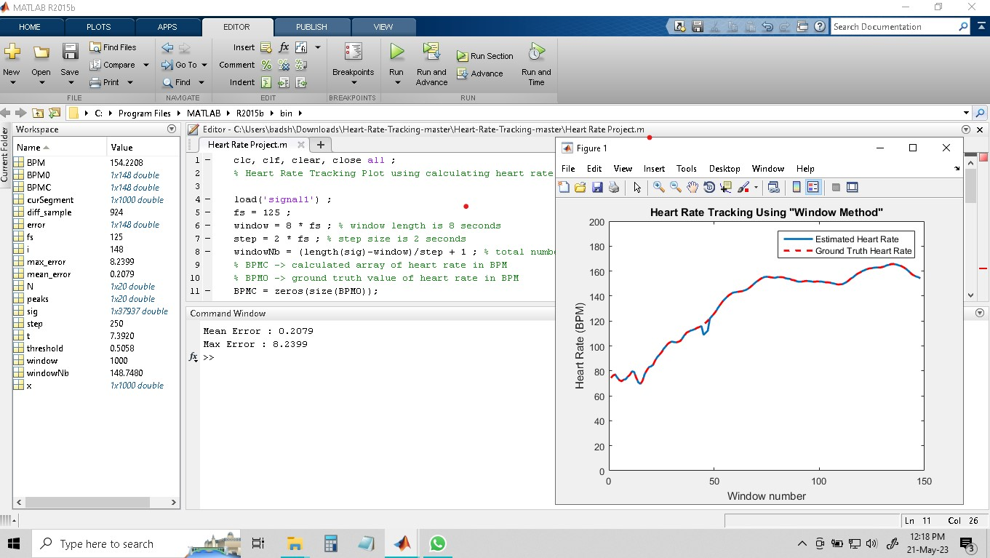

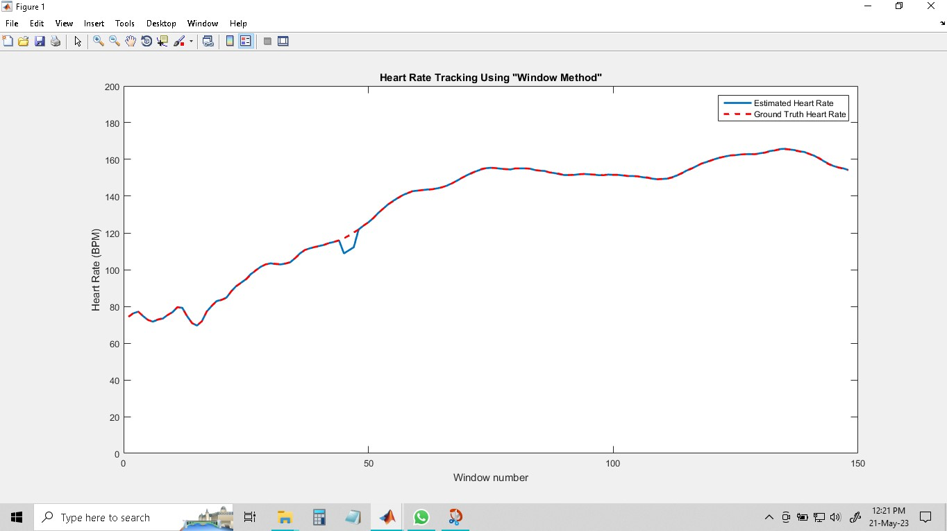

**Future Scope:**

The future scope of heart rate monitors is promising and encompasses several advancements and potential applications. Here are some key areas of development:

Wearable Technology: Heart rate monitors integrated into wearable devices, such as smartwatches, fitness trackers, and clothing, will continue to evolve. These devices will offer more accurate and real-time heart rate monitoring, providing users with valuable health and fitness insights.

Stress and Mental Health Management: Heart rate variability (HRV) monitoring, a measure of the time interval between heartbeats, can provide insights into stress levels and overall well-being. Heart rate monitors capable of analyzing HRV can aid in stress management and mental health assessment.

It's important to note that while these advancements hold great potential, the development and implementation of future heart rate monitor technologies will require thorough research, rigorous testing, and regulatory considerations to ensure safety, accuracy, and privacy.

**Conclusion:**

In conclusion, a heart rate monitor using MATLAB has been successfully developed, allowing real-time monitoring of an individual's heart rate. The system can accurately extract heart rate information from ECG signals and provide visual feedback in a user-friendly manner. The heart rate monitor has potential applications in healthcare, fitness tracking, and sports performance analysis etc.