Computer Vision and Smoke Sensor Based Fire Detection System

Nahid Chowdhury   
*Department of Computer Science*American International University – BangladeshDhaka, Bangladesh  
nahid.chowdhury1995@gmail.comDewan Ruhul Mushfiq   
*Department of Computer Science*American International University – BangladeshDhaka, Bangladesh  
mushfiq20@gmail.com  
AZM Ehtesham Chowdhury  
*Department of Computer Science*American International University – BangladeshDhaka, Bangladesh  
ehtesham@aiub.edu

*Abstract*— Unwanted fire causes many disasters. Thus, fire detection has been an important phenomenon to save human life. In this paper, we proposed a hybrid model that incorporates computer vision and smoke sensor-based fire detection into a single system to devise a more accurate and smart fire detection system. Our vision-based fire detection model utilizes color and motion attributes of fire combustion. Rule-based color segmentation is performed for classifying fire color regions and a modified image difference technique is used for detecting the motion of fire regions in consecutive frames. The proposed dynamic threshold technique is used for mitigating the false positive rate of the vision-based model. After performing a vision-based analysis, the proposed algorithm uses the MQ-2 smoke sensor to detect environment smoke and gas caused by fire combustion. Our implemented system raises a fire alarm in the form of remote notification after analyzing vision and smoke sensor-based model data. Real life experimental data shows that our system can detect fire with 86.67% of accuracy. In addition, the proposed system can be incorporated in existing surveillance systems at an adequately low extra expense.

Keywords—Fire flame detection, Fire color pixel segmentation, Fire region estimation, Dynamic threshold, Motion rate.

# Introduction

Ensuring safety for the people and goods are one of the major challenges of 21st century. Among other causes one extremely dangerous cause that can ruin lives is fire. According to the National Fire Protection Association's (NFPA) report published on April 23, 2013 the United States fire department had to respond to an estimated annual average of 366,600 home structure fires from 2007-2011 [1]. And estimated 7 people died each day! One of the primary reasons for so many fire deaths is not immediately being aware of the fire hazard.

In the context of 21st century, surveillance cameras are extremely common. It is used in homes, offices, shops, industries and everywhere. Vision based fire detection that can be done with existing surveillance cameras can go a long way to reduce the amount of severe fire accidents. Even though only smoke based fire alarms are most popular but a lot of times they do not necessarily work the way they are intended. An integrated system that can check smoke as well as recognize the fire flame using existing surveillance cameras and immediately notify the authorized persons can reduce the fire loss immensely.

Fire has shown to have diverse, multispectral marks, a few of which have been used to devise diverse strategies for its detection. The vast majority of the techniques can be classified into smoke, heat, or radiation detection. According to Wikipedia “Fire detectors sense one or more of the products or phenomena resulting from fire, such as smoke, heat, infrared and/or ultraviolet light radiation, or gas” [2]. However, each of the fire detection technique is better suited for a distinct scenario and it is quite difficult to devise a solution which can detect all the phenomena caused by fire. Therefore, we implemented a hybrid model which utilize computer vision as well as traditional smoke sensors for devising a more accurate and modern solution for fire detection in different environment. The objective of this work is to provide a fire detection model that utilize existing infrastructure but way more accurate and smarter than existing sensor based fire detection techniques.

The rest of the paper is organized as follows. The following section highlights some related works of sensor and computer vision based fire detection. Section III describes the proposed fire detection method as a whole. Section IV presents the architecture and the layout of our fire detector prototype. Section V describes the proposed vision based fire detection algorithm. It also discusses the methods in details. Section VI discuss about smoke sensor configuration in our prototype. Section VII shows the experimental data analysis in various real life environments and summarizes their result. Section VIII sheds light on why this system is beneficial for the detection of fire. Finally the last section IX concludes the paper.

# Related Work

Despite the growing interest in the field of automation, in the surveillance sector specially in fire detection, there is still lack of sufficient number of research conducted in the field of automated fire detection using real life scenarios. The authors [3] proposed a decent color analysis based fire detection method using HSI color space. They used image difference and color masking based approach for getting rid of spurious fire like region and also proposed a simple fire degree estimation technique. But the research only used color based distinctive feature of fire which is more error prone in real life scenarios.

Wireless sensor network based fire detection algorithm in video sequences is proposed by the authors [4]. They used motion and color feature of fire. For background extraction in image mixture of Gaussian is used and color based algorithm had been utilized for foreground extraction. The color detection algorithm is performed in RGB color space. Change map and blob’s area of consecutive binary frames is computed for motion detection in fire region. But spurious fire color objects can also be detected as fire by the algorithm because the authors did not addresses the smoke based distinctive feature of fire.

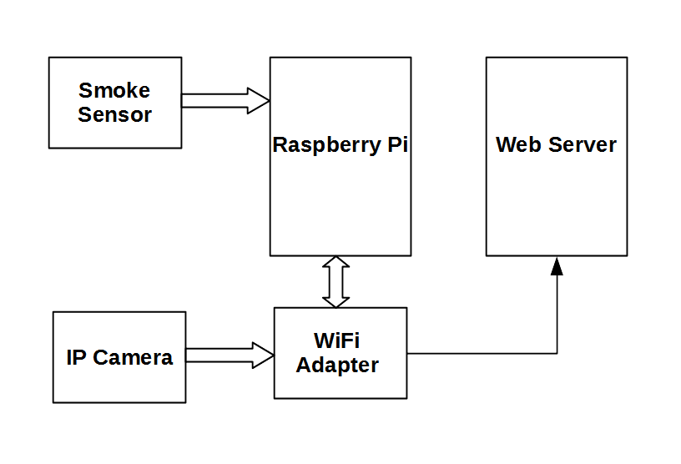

Fig. 2. Block diagram of the fire detector

A decent and architecturally complete fire alarm system is proposed by the authors [5] using raspberry pi, Arduino Uno and smoke sensors. The embedded system detects fire using presence of smoke in the air and generates a SMS notification with an image of surroundings. Thus it incorporates human intervention for confirming a notification to the fire fighters and mitigate false alarm. The shortcomings of this approach are it does not fully automate the fire alarm system and did not analyze the image captured by the system. A vision based model for analyzing surrounding image could be used for eliminating human intervention.

Therefore, a complete fire detection system which incorporates vision and smoke sensor based fire detection in a single system is proposed for real life fire detection. This paper also provides a complete architectural design of a fire alarm system in great detail.

# Approach

Detection of fire using automated system is complex because fire has many distinctive features and all the feature cannot be detected using single type of fire detector. Therefore, false positive rate of existing fire detection systems are very high.

Color, motion, shape, growth, heat, smoke and flame rays are some of the distinguishing feature of fire. In this paper we focused on features such as flame color, flame motion, generated smoke by fire and we hope to include additional features in our prototype in future work.

As mentioned earlier our algorithm is designed to work in static environment like CCTV surveillance areas therefore the first step of our algorithm is to dynamically define a threshold for the environment. After initializing the threshold the algorithm takes each frame from image source after T time and classifies fire like pixels using our color segmentation module.

In our prototype we have used IP camera as live image source and defined T = 2 sec. If the result of color segmentation find any fire like region then the algorithm proceed for motion detection of fire like region. After successful detection of motion in the fire like region, the algorithm use the estimated amount of fire in the image and collect the data of smoke sensor for ensuring the presence of fire. If all the steps give positive results then our algorithm raises fire alarm in a form of remote notification.

# Architecture Of Fire Detector Prototype

“Fig 1” shows the components used in our prototype fire detector. “Fig 2” shows the architecture and full block diagram of the system. The structure of out fire detection system composed of five core components which are Raspberry Pi 2 Model B single board computer for data processing, MQ-2 smoke sensor for sensing gas or smoke, IP camera for capturing the image from the environment, WIFI adapter for accessing internet from Raspberry Pi and a web server for sending real time fire alarm. As a web server and backend API we have used IIS server and ASP.NET MVC as well.

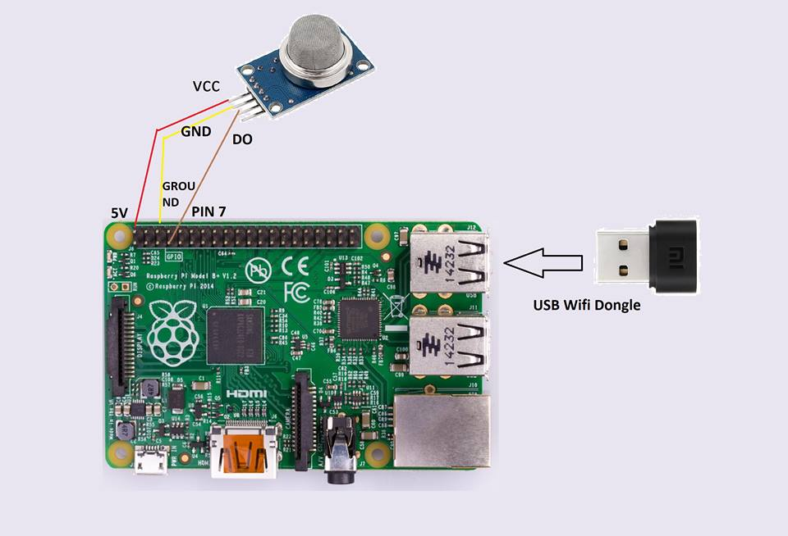

Fig. 1. Component diagram of the fire detector

# Proposed Fire Flame Detection Method

The proposed fire flame detection method is based on RGB color space because the targeted hardware to run our algorithm is IOT boards like Raspberry PI or Arduino and for extracting fire colored pixels, RGB color space require less computation compared to other color space. The algorithm consists of three sub algorithms: fire like color pixels segmentation for extracting only fire color pixels from the image, fire like region estimation for estimating the amount of fire in the environment image and motion detection in fire like regions. But in real life scenarios we also need to define a threshold dynamically for each distinct environment for decreasing false positive rate. The following sections will describe the steps in more details

## Fire like Color Pixels Segmentation

According to the literature review and based on our own experiments we noticed that fire has very distinctive color characteristics. It is a very powerful distinguishing feature of fire and almost every computer vision-based fire detection research used fire color feature extensively. The color of hydrocarbon flames which are the most common type of flame seen in nature belongs to red-yellow [6]. As mentioned earlier we used RGB color space for segmenting fire like color pixels from image. The authors [4, 7, 8, 9] also used RGB color space for aiding their fire color segmentation. For segmenting fire like pixels in RGB color space the two most commonly used rules shown in “(1)” and “(2)”

|  |  |
| --- | --- |
|  | (1) |

|  |  |
| --- | --- |
|  | (2) |

Where x and y are the spatial coordinates of a frame at time *t*. In “(1)”, *R(x, y)* is the intensity value of red channel at *x* and *y* location and *Rmean* “(1)” is the mean of red channel intensity values. In “(2)”, *G(x, y)* and *B(x, y)* are the intensity values of green and blue channel at x and y location respectively. So, to classify a pixel as fire color pixel, the value of red channel should be greater than the mean value of the red channel and the value of red channel supposed to be greater than the value of green channel and the value of green channel supposed to be greater than the value of blue channel.

But in our color segmentation algorithm we modified the first rule “(1)” for decreasing false positive rate in the real-life environment. So, the modified version of Rule “(1)” shown in the following Rule “(3)”.

|  |  |
| --- | --- |
|  | (3) |

Pixels that satisfy “(2): and “(3)” are considered to be fire like colored pixels in our color segmentation algorithm. The resulted image after performing the color segmentation can be represented as “(4)”.

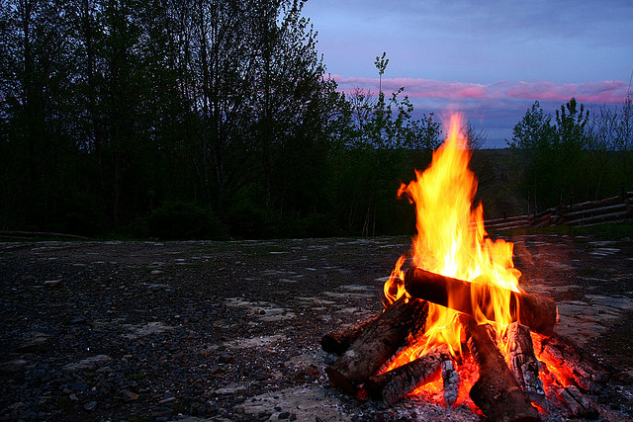

Fig. 3. Fire image

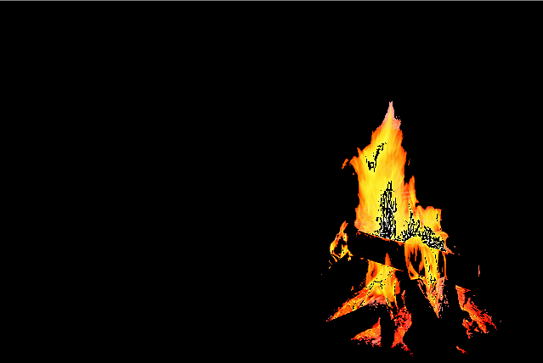

Fig. 4. Same fire image after color segmentation

|  |  |
| --- | --- |
|  | (4) |

As illustrated in “Fig. 3” and “Fig. 4”, the fire areas are almost completely extracted. But only color segmentation is not sufficient for fire flame detection because “Fig. 3” and “Fig. 4” illustrates only the best-case scenario where there is no fire colored object in the background. Notice “Fig. 5” which is a non-fire image, but after color segmentation “Fig. 6” some areas are extracted because the pixels color belongs. to the range of hydrocarbon flame colors. So, the fire detection algorithms based on only color feature will be resulted in very high false positive rate.

## Fire like Region Estimation

After color segmentation an approach is needed for estimating the burning degree of fire flames in the resulted image. A simple approach is proposed for roughly estimating the burning degree of fire flames which is similar to the approach of author [3]. In simple pseudo code, fire flame burning degree estimation can be expressed as,

*counter* = 0

**for** *x* = 0 to *image.rows* **do**

**for** *y* = 0 to *image.cols* **do**

**if** “(2)” **and** “(3)” **equals** *true* **then**

*counter++*

**end if**

**end for**

**end for**

*percentage* = (*counter* / (*image.rows* * *image.cols*)) * 100

The percentage is used as the parameter of measuring the amount of fire in the image. Where 0 percent means there is no fire found in the image and 100 percent means the whole area is covered in fire.

## Motion Detection

Motion detection algorithm runs on the result of color segmentation algorithm. The purpose of this sub algorithm is to remove static fire like colored object from the result and also gives a rough estimation of flame motion rate.



Fig.. 5. Non fire image

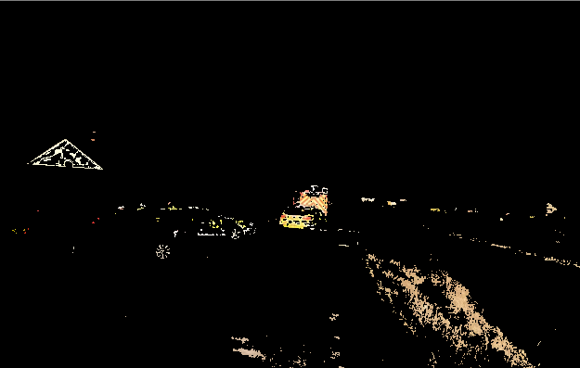

Fig. 6. Same non fire image after color segmentation

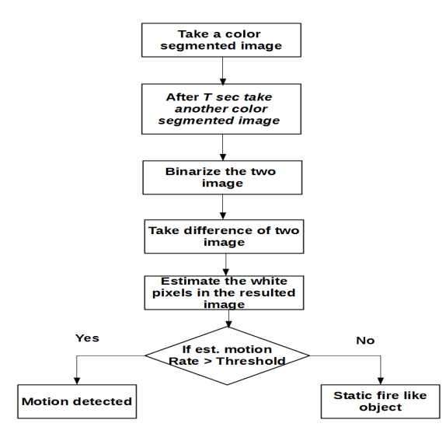

Fig. 7. Motion detection process

“Fig. 7” shows that the motion detection algorithm takes two fire-color segmented images. The second frame should be taken after *T* sec of first frame. The next step is to binarize the images. The rule for binarization is if *P(x, y)* is greater than zero then the *P(x, y)* becomes white (255pt) otherwise the *P(x, y)* becomes black (0pt). After binarization the absolute difference of two binarized frame is taken as resulted image. The result of motion detection algorithm is called motion rate which is nothing but the percentage of white pixels in the resulted image.

## Dynamic Threshold

Despite of the higher false positive rate of color-based fire detection algorithms, color-based approach is more popular because of its low false negative rate. Other vision-based fire detection algorithms that use color feature [3, 4, 7 - 13] also need to use other methods to decrease the higher false positive rate of color segmentation algorithm. Motion detection method can reduce the false positive rate of color segmentation but we also define a threshold at the very beginning of our fire flame detection algorithm. This method is also based on an assumption that when our algorithm first initializes the surrounding or the environment, it does not have any fire. On the basis of this assumption our algorithm takes a color segmented image of the environment and saves its estimated fire pixel rate for using as threshold. So, whenever the algorithm estimates the fire pixel rate for any frame it deducts the threshold from its estimation. However, this technique is not applicable for dynamic environments where the background changes frequently. But this technique surprisingly decreases the false positive rate of the algorithm for static environment like surveillance camera’s environment.

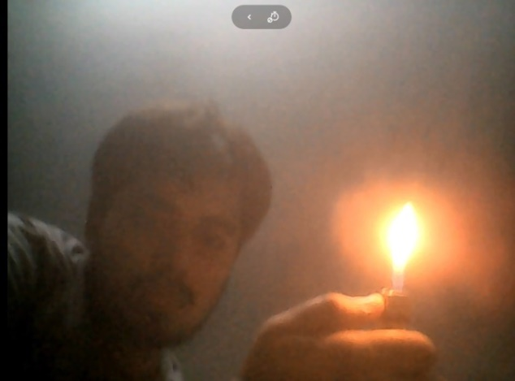

(a)

# Smoke Detection

Smoke and gas are two other important distinctive phenomenon caused by fire combustion. The gas produced during fire combustion highly dependent on combustion materials. Carbon monoxide is produced in quantity at most building fires because most organic materials contain carbon in their chemical structure. Materials that contain nitrogen, such as acrylic fiber, nylon, wool and urea-formaldehyde foam, could produce dangerous quantities of HCN in addition to CO [14]. Therefore, in our prototype we used MQ-2 smoke sensor which can sense smoke, LPG, Alcohol, Propane, Hydrogen, CO and even methane.

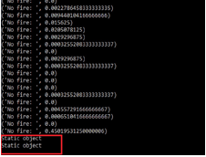

(c)

In our fire detection algorithm, the last step of verification of fire is smoke detection. After successful detection of fire flame by proposed fire flame detection algorithm, smoke detection takes place. If smoke detection method gives positive result then our algorithm sends a strong fire alert to the web server otherwise it gives a mild fire alert because there is no smoke or gas in the air caused by fire combustion. The following section shows some experimental result of our fire detector in real life scenarios and a finally gives a verdict about its accuracy.

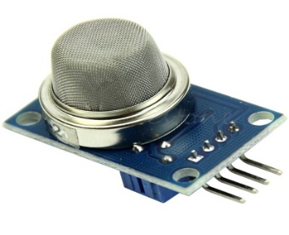

Fig. 8. MQ-2 smoke sensor

# Experimental Results

The proposed fire detection method was tested 60 times in variety of environments including indoor and outdoor. Some of the distinct scenarios are mentioned here.

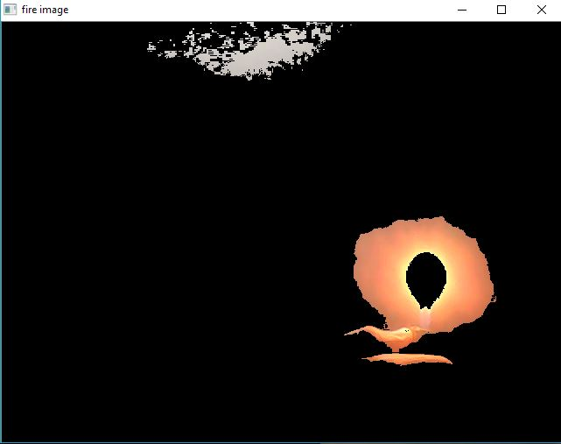

(b)

Fig. 9. Test scenario with fire and smoke

In “Fig. 9” (a) we have created some artificial fire and smoke. The fire detector successfully detected the flame area (b) and smoke and it sent a strong fire alert to the web server.

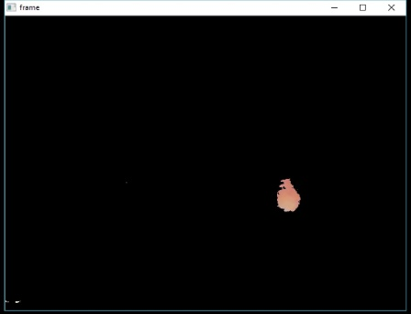

(b)

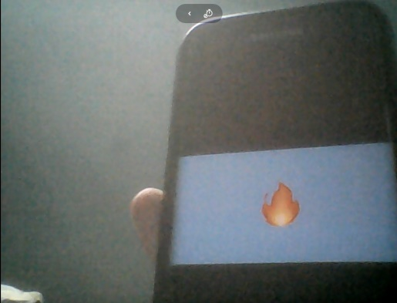

(a)

Fig. 10. Static fire like object test

In “Fig. 10” (a) we tested our algorithm with static fire like object, at first it successfully segmented the fire color object as shown in (b) but due to absence of motion attribute of fire the fire detector classified it as a static fire like object.

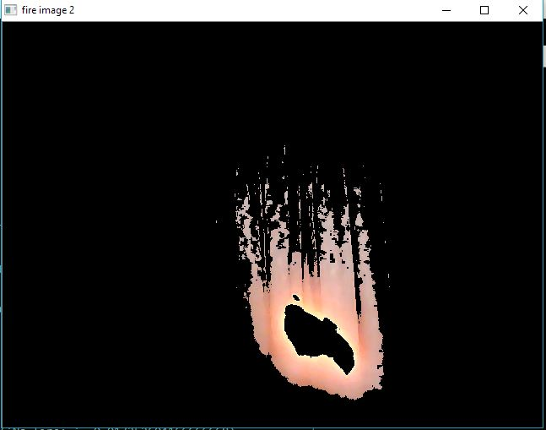

(b)

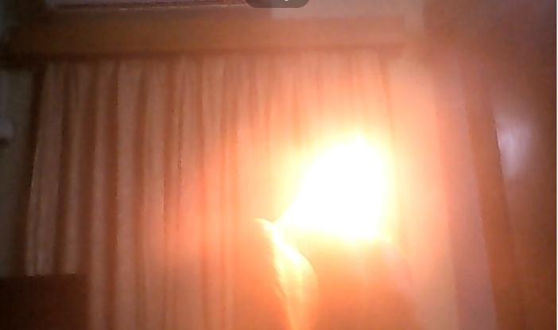

(a)

##### Fig. 11. Test scenario with fire

“Fig. 11” (a) shows an environment where we created artificial fire with match stick without artificial smoke. Our fire detector successfully detected the fire as shown in (b) but due to absence of smoke in the environment the smoke detector does not sense any smoke therefore the system sent a mild fire alert to our web server.

As mentioned earlier we conduct 60 tests in different environments and among 60 test cases 44 test cases contain actual fire and smoke and 16 test cases contain fake fire like objects without smoke. “Tab. I” shows the confusion matrix of experimental results where TP (true positive) means test cases where fire and smoke was present and algorithm detected it, FP (false positive) means test cases where fire wasn’t supposed to be detected but the algorithm detected fire, FN (false negative) means test cases where fire was present but algorithm failed to detect it, and TN (true negative) means test cases where there was no fire and algorithm did not detect any.

1. Confusion matrix of experimental data

|  |  |  |  |
| --- | --- | --- | --- |
|  | | Predicted Class | |
| + | - |
| Actual class | + | 41 | 3 |
| - | 5 | 11 |

According to “Tab. I” the predictive accuracy of our proposed algorithm is about 86.67%. The result is quite promising because all the test cases were done in real life environment. The author [4] achieved 92.8% of correct classification result by their algorithm but all the test cases were on previously captured video sequences. Therefore, in real life scenarios 86.67% of accuracy is quite sufficient in most of the cases.

# Advantages Over Existing Systems

The primary benefit of our proposed system over existing fire detection systems is the fact that whereas traditional fire detection system uses the smoke sensor to detect fire, our system not only detects the smoke but also can recognize fire combustion using computer vision. So, the detection is faster and more accurate than the traditional systems. The usability of our system is higher because of the real-time and two-step verification process. And the system is even more convenient since most offices and streets already have surveillance systems these days and our system can easily be integrated with those cameras that are already in place.

# Conclusion

In this paper, we proposed a hybrid fire detection system which incorporates computer vision and smoke sensor-based fire detection technique in a single system. Vision based algorithm uses color and motion feature of fire combustion and MQ-2 smoke sensor detects smoke and gas produced by combustion. Our algorithm analyzes all the data produced by the vision and sensor-based model and raises alarm in the form of remote Realtime notification. Our proposed system extends beyond fire detection and proposes a complete architectural reference of a fire alarm system. Our tests demonstrate that the proposed system distinguishes fire with high precision in real life CCTV surveillance environment. But the proposed system is not designed for the dynamic environment where the background changes frequently and the system is also not intelligent. So, in our future work we will endeavor to replace existing vision-based algorithm with deep learning based intelligent algorithm that will work equally in static and dynamic environment with better accuracy.

##### Acknowledgment

We would like to thank Mir Riyanul Islam, Faculty of Science and Information Technology, American International University Bangladesh for helping us optimize our algorithm.

##### References

1. M. Ahrens, “Vehicle fire trends and patterns,” Jun-2010. [Online]. Available: www.nfpa.org/News-and-Research/Fire-statistics-and-reports/Fire-statistics/Vehicle-fires/Vehicle-fire-trends-and-patterns. [Accessed: 15-Jul-2018].
2. “Fire Detection,” 23-Aug-2016. [Online]. Available: en.wikipedia.org/wiki/Fire_detection. [Accessed: 15-Jul-2018].
3. W.-B. Horng and J.-W. Peng, “A Fast Image-Based Fire Flame Detection Method Using Color Analysis,” *Tamkang Journal of Science and Engineering,* vol. 11, No. 3, pp. 273-285, 2008
4. Y.-H. Kim, A. Kim, and H.-Y. Jeong, “RGB Color Model Based the Fire Detection Algorithm in Video Sequences on Wireless Sensor Network,” *International Journal of Distributed Sensor Networks,* vol. 10, no. 4, p. 923609, 2014.
5. M. S. B. Bahrudin, R. A. Kassim, and N. Buniyamin, “Development of Fire alarm system using Raspberry Pi and Arduino Uno,” *2013 International Conference on Electrical, Electronics and System Engineering (ICEESE),* 2013
6. C. E. Baukal, The John Zink combustion handbook, 1st ed. Boca Raton: CRC Press, 2001.
7. X. Qi and J. Ebert, “A Computer Vision-Based Method for Fire Detection in Color Videos,” Semantic Scholar, 01-Jan-1970. [Online]. Available: https://www.semanticscholar.org/paper/A-Computer-Vision-Based-Method-for-Fire-Detection-Qi Ebert/067f553df16650f7433a6e5b36207670cb16ab42. [Accessed: 12-Apr-2019].
8. P. V. K. Borges and E. Izquierdo, “A Probabilistic Approach for Vision-Based Fire Detection in Videos,” *IEEE Transactions on Circuits and Systems for Video Technology,* vol. 20, no. 5, pp. 721–731, 2010.
9. Turgay Celik , Hasan Demirel, Huseyin Ozkaramanli, and Mustafa Uyguroglu, “Fire detection using statistical color model in video sequences,” *Proceedings of the International Conference on Acoustics, Speech, and Signal Processing,* Jun 2006.
10. P. Gomes, P. Santana, and J. Barata, “A Vision-Based Approach to Fire Detection,” *International Journal of Advanced Robotic Systems,* vol. 11, no. 9, p. 149, 2014.
11. N. True, “Computer Vision Based Fire Detection.” [Online]. Available: pdfs.semanticscholar.org/46f6/63bd1d32cdbec9b7ba206d471f94b9bbc03f.pdf. [Accessed: 22-Jul-2018].
12. T. Çelik, H. Özkaramanlı, and H. Demirel, “Fire and Smoke Detection without Sensors: Image Processing Based Approach,” *15th European Signal Processing Conference*, Sep. 2007.
13. C.-B. Liu and N. Ahuja, “Vision based fire detection,” *Proceedings of the 17th International Conference on Pattern Recognition*, 2004. ICPR 2004., 2004.
14. “Toxic Gases and Vapours Produced at Fires,” 01-Dec-1971. [Online]. Available:http://web.mit.edu/parmstr/Public/NRCan/CanBldgDigests/cbd144_e.html. [Accessed: 21-Jul-2018]