MMU-Based Cache Control Architecture for Multi-Core Processors

Student: Ovidiu-Alexandru Lates
Structure of Computers System
Technical University of Cluj-Napoca

Introduction

  - Context
The aim of this project is to offer a Memory Management Unit (MMU) that can be used to manage cache memory in multi-core processors. The MMU manages data exchange between main memory and the cache and delivers data most likely to be required again for rapid access. It will fetch the data required from the main memory and replace the least recently used blocks of memory with the cache, optimizing system and memory performance.
Cache memory is accountable for the overall speed of a computer since it accommodates a much lower data access time compared to main memory. With efficient management of cache operations using a special-purpose MMU, the system is able to contribute better performance, reduced latency, and better sharing of resources among several processor cores.

  - Objectives
The MMU will be designed in VHDL and

2.Bibliographic Research
2.1 Associative cache memory
A fully associative cache in computer architecture is a cache organization containing a single set with B ways, where B is the number of blocks, allowing any memory address to map to any block in the cache. This structure is also described as a B-way set associative cache with one set, meaning all blocks reside in a single set and any block can store any memory address. Caches maintain copies of data stored elsewhere, typically in main memory. Since caches are smaller than main memory, only a subset of the data can be stored, and bookkeeping data is maintained to track the origin of the data. Cache associativity describes how cache blocks are organized and how memory addresses map to cache locations. The fully associative cache is the most flexible, as any address can be stored in any block, functionally equivalent to a set-associative cache with a single set containing all blocks. This flexibility results in the fewest conflict misses for a given cache capacity but requires more hardware for additional tag comparisons, making it best suited for relatively small caches due to the large number of comparators needed.
To determine whether a block is present in the cache, the tag is compared with the tags stored in all cache lines. If a match is found, it is a cache hit, and the data is retrieved from that cache line. If no match is found, it's a cache miss, and the required data is fetched from main memory.

2.2 Snoopy cache protocols
Snoopy cache protocols are very popular in shared bus multiprocessors due to their relative simplicity. They have both write-update and write-invalidate policy versions. Write-invalidate snoopy cache protocols resemble this protocol in many ways and therefore are also easy to understand after studying a write-update protocol.
The definition of transmission routes of commands can be omitted in snoopy cache protocols since the commands are uniformly broadcasted on the shared bus. The protocol applies both the write-back and the write-through update policies. The former is used for private blocks, the latter for shared blocks.

2.3 Write-back
The data is updated only in the cache and updated into the memory at a later time. Data is updated in the memory only when the cache line is ready to be replaced.
Dirty Bit: Each Block in the cache needs a bit to indicate if the data present in the cache was modified(Dirty) or not modified(Clean). If it is clean there is no need to write it into the memory. It is designed to reduce write operation to a memory. If Cache fails or if the System fails or power outages the modified data will be lost. Because it's nearly impossible to restore data from cache if lost.
2.4 State of the blocks
MESI Protocol -
It is the most widely used cache coherence protocol. Every cache line is marked with one the following states:
- Modified -
This indicates that the cache line is present in current cache only and is dirty i.e its value is different from the main memory. The cache is required to write the data back to main memory in future, before permitting any other read of invalid main memory state.
- Exclusive -
This indicates that the cache line is present in current cache only and is clean i.e its value matches the main memory value.
- Shared -
It indicates that this cache line may be stored in other caches of the machine.
- Invalid -
It indicates that this cache line is invalid.

2.5 Rules cache write-back
- A write can only be done if the cache line is in the Modified or Exclusive state. If it is in the Shared state, all other cached copies must be invalidated first. A write moves the line into the Modified State.
- A cache can discard a Shared line at any time, changing to the Invalid state. A Modified line is written back first.
- If a cache holds a line in the Modified state, reads from other caches in the system will get the updated data from the cache. Conventionally, this is done by first writing the data to main memory and then changing the cache line to the Shared state, before performing a read.
- A cache that has a line in the Exclusive state must move the line to the Shared state when another cache reads that line.
- The Shared state might not be precise. If one cache discards a Shared line, another cache might not be aware that it could now move the line to Exclusive status.
All possibilities

MESI Local Read Hit
- Line must be in one of MES
- This must be correct local value (if M it must have been modified locally)
- Simply return value
- No state change

MESI Local Read Miss
- No other copy in caches
  - Processor makes bus request to memory
  - Value read to local cache, marked E
- One cache has E copy
  - Processor makes bus request to memory
  - Snooping cache puts copy value on the bus
  - Memory access is abandoned
  - Local processor caches value
  - Both lines set to S
- Several caches have S copy
  - Processor makes bus request to memory
  - One cache puts copy value on the bus (arbitrated)
  - Memory access is abandoned
  - Local processor caches value
  - Local copy set to S
  - Other copies remain S
- One cache has M copy
- Processor makes bus request to memory
- Snooping cache puts copy value on the bus
- Memory access is abandoned
- Local processor caches value
- Local copy tagged S
- Source (M) value copied back to memory
- Source value M -> S

MESI Local Write Hit
Line must be one of MES
- M
  - line is exclusive and already ‘dirty’
  - Update local cache value
  - no state change
- E
  - Update local cache value
  - State E -> M
- S
  - Processor broadcasts an invalidate on bus
  - Snooping processors with S copy change S->I
  - Local cache value is updated
  - Local state change S->M

MESI Local Write Miss
Detailed action depends on copies in other processors
- No other copies
- Value read from memory to local cache
- Value updated
- Local copy state set to M
- Other copies, either one in state E or more in state S
- Value read from memory to local cache -bus transaction marked RWITM (read with intent to modify)
- Snooping processors see this and set their copy state to I
- Local copy updated & state set to M
- Another copy in state M
  - Processor issues bus transaction marked RWITM
  - Snooping processor sees this
● Blocks RWITM request
● Takes control of bus
● Writes back its copy to memory
● Sets its copy state to I

- Another copy in state M (continued)
- Original local processor re-issues RWITM request
- Is now simple no-copy case
● Value read from memory to local cache
● Local copy value updated
● Local copy state set to M

2.6 Replacement policy
When the cache hits its capacity limit, the Least Recently Used (LRU) cache eviction policy is designed to eliminate the item that has been accessed the least recently. Items that have not been accessed for a longer period of time are assumed to be less likely to be used in the near future. When the cache is full, LRU evicts the item that hasn't been accessed in the longest time since it keeps track of the order in which items are accessed.
The basic idea behind implementing an LRU (Least Recently Used) cache using a key-value pair approach is to manage element access and removal efficiently through a combination of a doubly linked list and a hash map.
- When adding a new key-value pair, insert it as a new node at the head of the doubly linked list. This ensures that the newly added key-value pair is marked as the most recently used.
- If the key is already present in the cache , get the corresponding node in the doubly linked list using hashmap , update its value and move it to the head of the list, and update its position in the hashmap also. This operation ensures that the accessed key-value pair is considered the most recently used.
- The priority of nodes in the doubly linked list is based on their distance from the head . Key-value pairs closer to the head are more recently used and thus have higher priority . Also, key-value pairs closer to the tail are considered less recently used and have lower priority.
- When the cache reaches its maximum capacity and a new key-value pair needs to be added, remove the node from hashmap as well as from the tail in the doubly linked list . Tail node represents the least recently used key-value pair and is removed to make space for the new entry.

3. Design
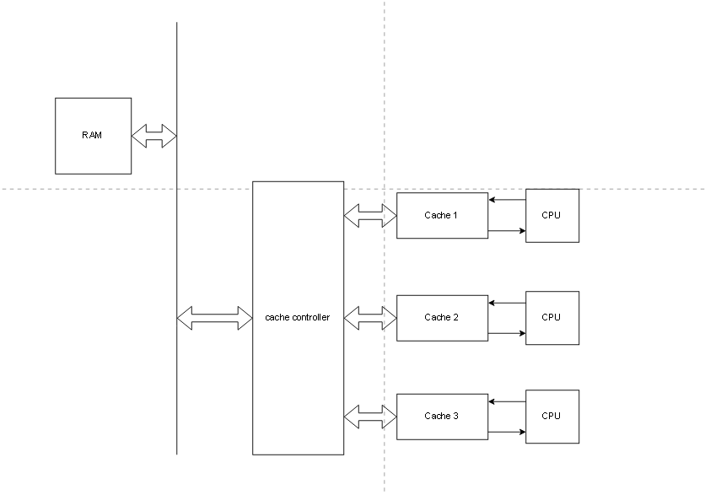

3.1 Main memory
I decided to use a main memory with $2^{16}$addresses, and each block has a size of 1 byte.
Main memory
Data 8 bits

The read signal indicates that there is a read request on the data bus, while the write signal indicates that a write operation is requested.
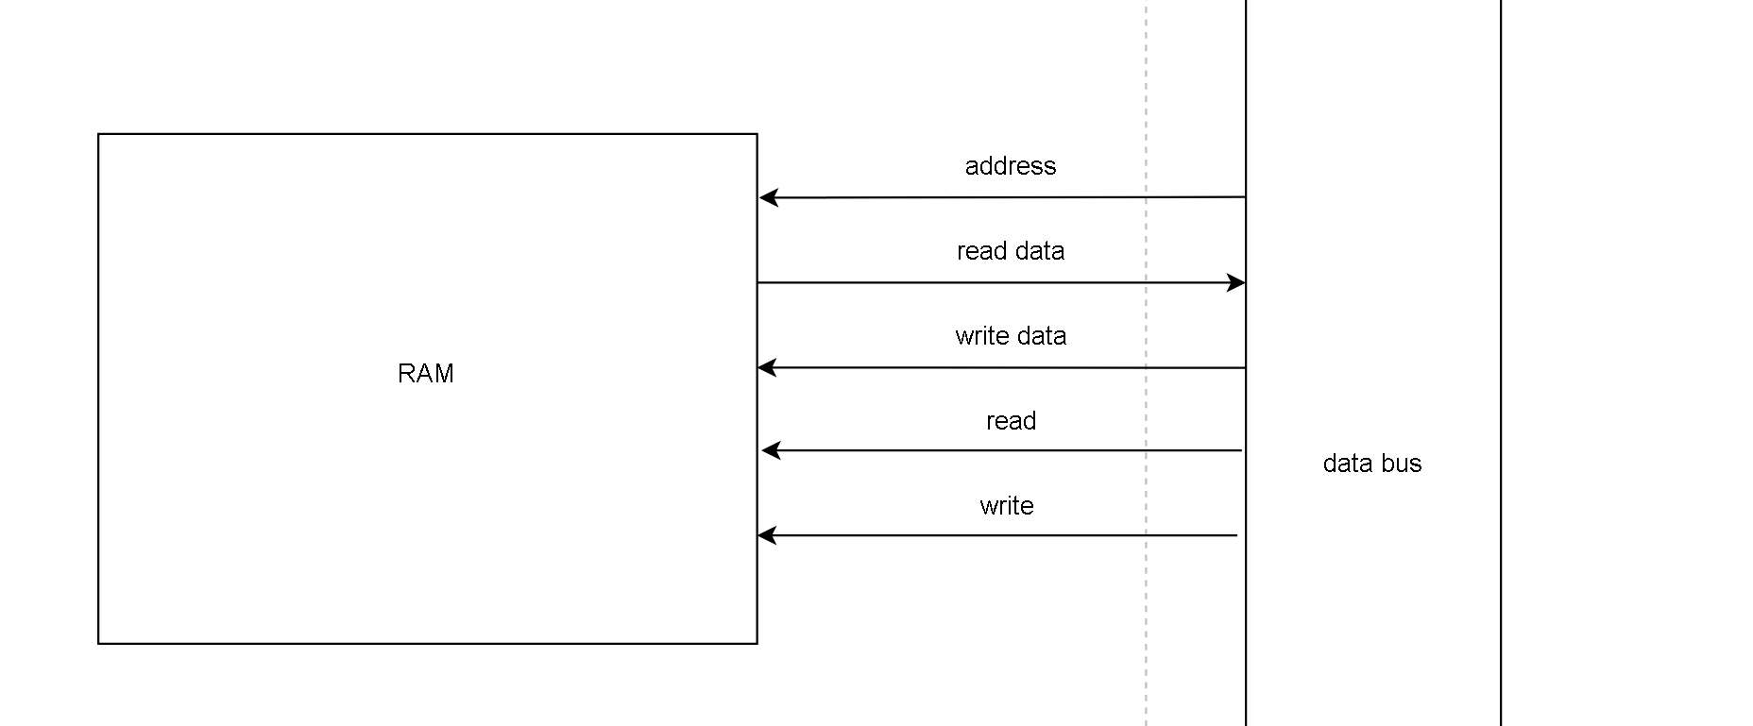
It reads 4 addresses at a time to prepare the data to be wrote in the cache.

address – 16 bits
read data – 32 bits
write data – 32 bits
read, write – 1 bit
The signal address represent were the data will be accessed, the signals read, write represent the requests from the data bus either for a read operation either for a write operation.
if it is a read request the signal read becomes 1 and the address is the data where is the data that is needed and then the signal read data becomes the content that is needed.
3.2 Cache
I have 3 cache memories, each cache line is 47 bits. I am using 16 lines for both caches. Of the 47 bits, 14 are for the tag, 2 for the MESI protocol, and 32 for the data.
Tag 14 bits | MESI 2bits | Data 00 8 bits | Data 01  8 bits | Data 10  8 bits | Data 11  8 bits

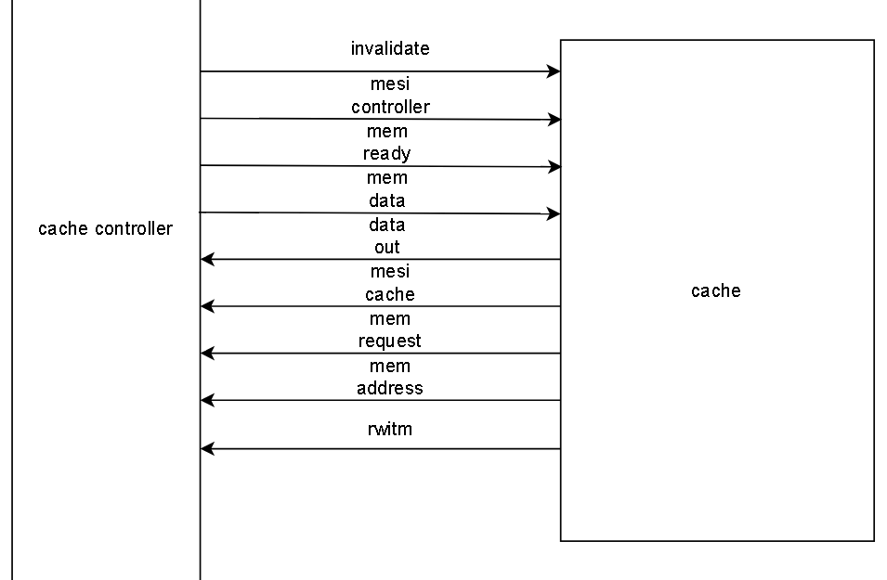
i_address_cpu – the 16-bit address of the memory location requested by the CPU.
i_write_data_cpu – the byte the CPU wants to write into the cache/memory.
i_read – read signal issued by the CPU (active ‘1’).
i_write – write signal issued by the CPU (active ‘1’).
i_address_cc – the 16-bit address received from the cache controller for checking the existence or invalidation of a line.
i_invalidate – signal requesting the invalidation of the line corresponding to the address in i_address_cc.
i_mesi_cc – the MESI state sent by the cache controller for the line fetched from memory.
i_mem_ready – signal indicating that external memory has supplied the requested data.
i_mem_data – the 32-bit data returned by the main memory (one line/word).
i_data_request – signal indicating that the cache controller requests to check/send data to the other caches.
o_rwitm – signal indicating a Read With Intent To Modify (RWITM) for the MESI protocol.
o_invalidate – broadcast signal used to invalidate the same line in other caches.
o_data_broadcast – the 32-bit data line sent to other caches upon the controller’s request.
o_data_out – the 48-bit evicted line when an entry is removed from the cache.
o_mesi_cache – the MESI state of the line found in the cache.
o_read_data_cpu – the byte returned to the CPU for a read operation.
o_mem_request – signal requesting access to the main memory (cache miss).
o_mem_address – the address sent to main memory for the requested data.
o_hit – signal indicating whether a cache hit occurred.

3.3 MESI Protocol bits
Modified | 00
Exclusive | 01
Shared | 10
Invalid | 11

3.4 Data Bus
The data bus checks the MESI protocol bits that it gets from all the caches if there are any copyes in the cache and it process the data according to section 2.5.
It sends read and write requests to the memory and transfers 32 bits of data at a time, corresponding to 4 memory blocks.

7.Bibliography
fully associative cache - https://www.sciencedirect.com/topics/computer-science/fully-associative-cache
snoopy protocols - https://www.tutorialspoint.com/what-are-snoopy-cache-protocols-in-computer-architecture
least recently used(cache eviction policy) - https://www.geeksforgeeks.org/system-design/cache-eviction-policies-system-design/
least recently used (implementation) - https://www.geeksforgeeks.org/system-design/lru-cache-implementation/
MESI protocol - https://www.geeksforgeeks.org/computer-organization-architecture/cache-coherence-protocols-in-multiprocessor-system/,https://www.csd.uoc.gr/~hy425/2016f/lectures/Lec15_snoop_coherence.pdf

Define the multi-core architecture with caches, MMU, and shared bus
implement and simulate the cache subsystem with LRU and hit/miss tests
integrate MMU and snoopy protocol for inter-core coherence
assemble all components (MMU, Cache, Bus, Memory) and run multi-core simulations to verify consistency, latency, and hit ratio
finalize and present complete VHDL simulation results showing correct cache behavior and coherence.

