106CR: DESIGNING FOR USABILITY

COURSEWORK

Group:

* Ovidiu Mitroi
* Plamen Atanasov
* Piotr Brycko
* Shazeb Dawood

Contents

Hierarchical Task Analysis…………………………………………………………………..p. 3

Group Report on HTA………………………………………………………………………...p. 5

Group Report on Digital Prototype……………………………………………………..p.6

Group Report on User Test……………………………………………………………...…p.9

INDIVIDUAL WORK: HOMEWORK 3…………………………………………………..p.20

PERSONAL REFLECTIONS

HOMEWORK 3………………………………………………………………………..p.21

HOMEWORK 7………………………………………………………………………..p.22

HOMEWORK 8……………………………………………………………………..…p.23

HOMEWORK 9………………………………………………………………………..p.24

1.Hierarchical Task Analysis and Diagram

**Done by:**

* **Plamen Atanasov**
* **Mitroi Ovidiu**
* **Shahzed Dawood.**
* **Piotr Brycko**

1. **Hierarchical Task Analysis Diagram:**

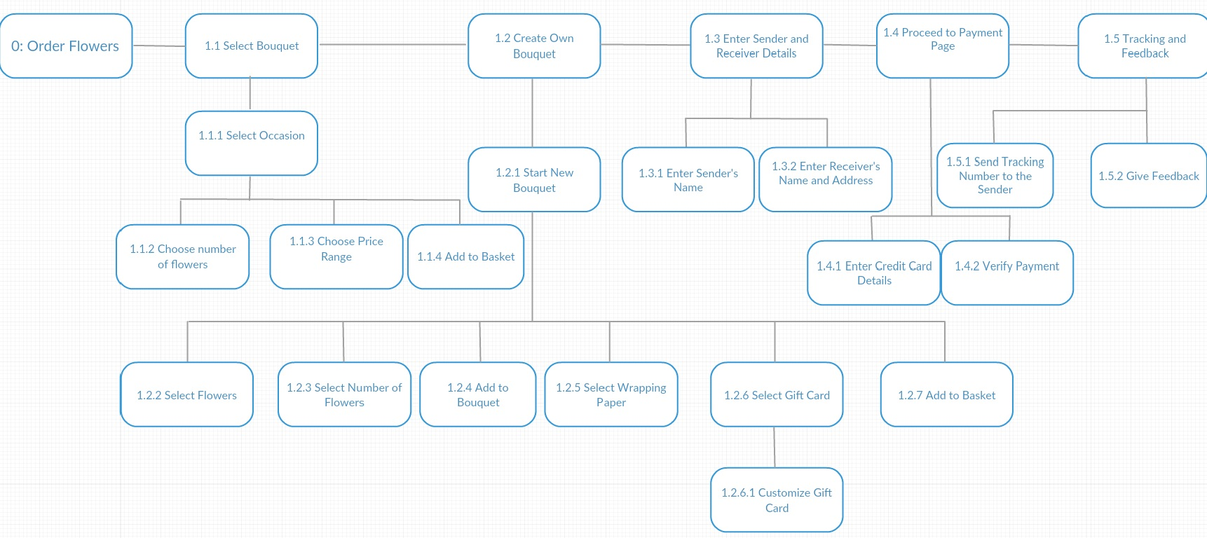

1. **Hierarchy Description:**
2. Order Bouquet/s

1.1. Select Bouquet

1.1.1 Select Occasion

1.1.2 Choose Number of Flowers

1.1.3 Choose Price Range

1.1.4 Add to Basket

1.2. Create Own Bouquet

1.2.1 Start New Bouquet

1.2.2 Select Flowers

1.2.3 Select Number of Flowers

1.2.4 Add to Bouquet

1.2.5 Select Wrapping Paper

1.2.6 Select Gift Card

1.2.6.1 Customize Gift Card

1.2.7 Add to Basket

1.3. Enter Sender and Receivers Details

1.3.1 Enter Sender’s Name

1.3.2 Enter Receiver’s Name and Address

1.4. Proceed to Payment Page

1.4.1 Enter Credit Card Details

1.4.2 Verify Payment

1.5. Tracking and Feedback

1.5.1 Send Tracking Number to the Sender

* + 1. Give Feedback

**3)Hierarchy Plans:**

**Plan 0: Order Bouquet**

Do **1.1** (mandatory), **1.2.5** and **1.2.6** (optional and in any order), then **1.2.6.1** (optional), **1.2.6** mandatory. Repeat this cycle as many times as you wish and then do **1.3**, **1.4** and **1.5** in that order. **1.5** is optional.

**Plan 1: Create Own Bouquet**

Do **1.2.1** (mandatory), **1.2.2, 1.2.3, 1.2.4** (optional cycle), **1.2.5**(mandatory), **1.2.6** and **1.2.6.1**(both optional) and **1.2.7**(mandatory) in that order. Do **1.3** and **1.4**(mandatory), **1.5**(optional).

**For both plans (0 and 1):**

**Plan 1.3: Enter Address Details**

Do 1.3.1(optional) and 1.3.2 (mandatory) in any order.

**Plan 1.4: Payment Page**

Do 1.4.1 and 1.4.2 in that order.

**Plan 1.5:**  Do 1.5.1 and 1.5.2 in any order (both optional).

2.Group report of homework 7: HTA Analysis

Our HTA describes the sequence of tasks a customer would have to take in order to buy flowers online. We determined that the customer should not be asked for any personal details or payment details before he made up his mind about whether or not he is going buy something (simulating a customer going to the checkout with his items).

When the user searches for bouquets, we determined he should be able to filter the list of available items by certain categories (occasion, size, colour etc.) We determined that the user can buy more than one bouquet, so he should not be prompted to the checkout process until he decides to do so, therefore selecting bouquets would optionally be a cycle, the user doing it as many times as he wants. We assessed that once the user has made up his mind, he should be able to add extras to the bouquet, like changing the wrapping paper, adding gift cards or balloons.

The checkout process starts with entering receiver’s details. This is a mandatory task, customer can enter his address or the address of the intended receiver. Sender’s details is an optional task (sometimes a customer may want to send anonymous flowers). The customer would then be prompted to the payment screen, which represents a sequential series of tasks which have to be done in order. At the end, the customer has the option of giving feedback or tracking his order.

We took some of these ideas and used them to shape the functionality of our prototype. While some things changed from the HTA to the prototype implementation, the HTA was definitely the foundation of this project.

3. Group report of homework 8: Digital Prototype

Our app is called **Flower Boutique TM.** The prototype was done using the Proto.io software. The functionality of the prototype is highlighted in the following youtube link:

<https://www.youtube.com/watch?v=1HTbqFC-HAc>

We have also implemented an application for making your own bouquet. One of our group member has coded it using a high level language. The app is basically 3 overlayed screens. The main screen(middle) has a grid list of all the available flower choices. The top screen has rows of filters, based on which the flower grid changes its components to match the set of filters chosen by the user. The bottom screen contains your basket and bouquets. To create a new bouquet, the user would have to simply drag a flower to a new slot in the basket. To add flowers to an existing bouquet, the user would drag a flower to the icon of an existing bouquet in the basket.

One of our group members demonstrates this functionality by doing a specific task, namely creating a bouquet containing two roses and two lillies. The art used was very simple due to inaccessibility of better images and illustrations. Access the following link to preview the demonstration:

<https://www.youtube.com/watch?v=uZoQRb1C5-o&feature=youtu.be>

Now let’s take a closer look to the actual design of the prototype. I will attempt to highlight the use of the C.R.A.P in a set of videos, as well as briefly explaining what each one means.

C.R.A.P stands for Contrast, Repetition, Alignment, Proximity. These are basic principles that apply to the visual design of an interface. These help guide the user when using your interface, helping him to get a better feel about how the interface works and what each element does and how it works.

CONTRAST helps with the aesthetics of the interface as well as with improving the perception of the user. It represents a guidebook for designers on what elements to include on a page. According to this principle, if two elements do two very different things, then it’s best to use different shapes, colors, borders or other visual elements so that the user can differentiate. Also, if two things work in a similar fashion, then it is best to use the same patterns of visual elements to incorporate the elements onto the screen. The following video illustrates how CONTRAST was used in our prototype:

<https://www.youtube.com/watch?v=-HPqwiEsZqk>

REPETITION helps the user to create a mind model of how he can interact with the different elements in your interface. For example, a designer should use the same kind of visual style for navigation buttons throughout the entire set of screens. This helps the user quickly understand the functionality of a button. Using the same pattern of colors for menus, for buttons, for dropdown elements etc. is a great way of reminding the user how these elements are used. The following video illustrates how REPETITION was used in our prototype:

<https://www.youtube.com/watch?v=y3xPTicT8XA>

ALIGNMENT is the principle of visually grouping the elements on the screen together. Basically nothing on your screen should be placed arbitrarily, there must be some sort of visual connection between elements. The following video illustrates how ALIGNMENT is used in our prototype:

<https://www.youtube.com/watch?v=wwy3E20XZjw>

PROXIMITY states that items that relate to each other should be grouped together. Follow the link to see how PROXIMItY is used in our prototype.

<https://www.youtube.com/watch?v=cTJiidbCt6c>

I have used the principle of CLOSURE a lot in the prototype. This is also about creating boundaries between related items. Here is the link:

<https://www.youtube.com/watch?v=oQ8b4pXd5qg>

The prototype has been designed with the user test in mind. It is only capable of taking this one specific task from beginning to the end. However, every button is interactive and there are actually several ways of performing the task. We implemented some solution path redundancy and a screen which informs the user that a feature he tried to access has not been implemented.

The full prototype is available for other users to test:

<https://pr.to/8PVUJP/>

(if you cannot access it, please contact me at [mitroio@uni.coventry.ac.uk](mailto:mitroio@uni.coventry.ac.uk) and I will re-upload it)

4. Group report on homework 9: User test

Task:

The task was to purchase 1 Oriental Bouquet, add a Teddy Bear as extra and go through the entire checkout process. The task finishes once the user has been generated a tracking number.

Method:

The user has been asked to sit comfortably at a desk or table. He was presented with consent form and participant instruction, then asked if he had any additional questions. The user was reminded that this is a teset of the software design, and not of his skill.

An Android phone was provided to the user. We used the Proto.io app to access the prototype. We used an online stopwatch to measure the time and used another phone to take pictures.

Baselines and Expert Input:

|  |  |  |  |
| --- | --- | --- | --- |
|  | **Completion time**  (Make sure every member starts from the same place. Then count the time in minutes and seconds it takes the member to get to the solution) | **User challenge**  (Ask the member to think aloud as they go through. Every time they say something like ‘I don’t know what I’m supposed to do’, ‘what’s this?’, ‘what do I do next’, or any other expression of confusion, count it as ‘1’; then the challenge count is the sum of 1s you record.) | **Actions**  (number of actions required to achieve the task. Scrolling, selecting, dropdown access all consider as actions) |
| Ovidiu Mitroi | 01:25 minutes | 0 | 12 |
| Plamen Atanasov | 01:45 minutes | 0 | 15 |
| Piotr Brycko | 02:12 minutes | 1 | 18 |
| Shazheb Dawood | 01:50 minutes | 1 | 17 |
| **AVERAGE** | 01:48 minutes | 0.5 | 15.5 |

The baseline analysis says that it takes an expert about 1:48 minutes and 15.5 actions to accomplish this task. However, we also performed a heuristic evaluation of the task, in order to better asses the baselines we are going to use. We have discovered a few issues:

* The ‘Shop’ button can be hard for a novice to access. There are 2 ways of accessing it, either by clicking on the top-left menu icon and selecting Shop from the list, or by clicking on the first picture in the first carousel(the one on top), both options from the home screen. We decided that this subtask could pose some problems at the beginning, but decided not to change it, because it will be overcome by a user after their first use. Severity rating: 2
* The ‘Add a Teddy Bear’ feature can be problematic. After the user reads the task, he will start searching for the teddy bear on the shop screen after adding the bouquet to cart, instead of accessing the basket first. One of our expert users also did that, so we determined this could be a problem. However, we believe this is a problem only because the user is extremely focused on adding the teddy bear to complete the task. A real user would have the patience to check the basket first. Severity Rating: 2
* Text entry is available, however it does not affect the functionality of the prototype. We determined that users might try to fill in text entries, increasing the completion time severely. Severity Rating: 1

Judging by the issues discovered in the heuristic evaluation, we decided to increase our baselines to cater for the possible errors. Our final baselines are:

**Completion Time: 3 minutes**

**Actions: 20**

We also decided to include in the Participant instructions that text entry is optional and in no way they should give out private details.

Documents used:

|  |  |
| --- | --- |
| Flower Boutique TM  **Informed Consent form** |  |
|  |  |

Are you happy to participate in my designing for usability project? To preserve your anonymity I will not issue names or information below to anyone. Data will not be published or disseminated in any way. I will need to use data in any / all of the following ways. Please delete as appropriate:

a I consent to being video-recorded **Yes / No**

b I consent to video footage being used in coursework **Yes / No**

c I consent to anonymous video images / transcripts being used in coursework **Yes / No**

d I consent to anonymous video footage / images / transcripts possibly being used on web pages **Yes / No**

e I consent to use of interview data for coursework **Yes / No**

Please complete:

Name of participant:

Address:

Email:

Signature:

Date:

Many thanks!

Participant Instructions:

Flower Boutique TM

Usability Test

**PARTICIPANT INSTRUCTIONS**

The application will be opened by the researcher and you will be presented with the home screen of the app.

Your **task** is to purchase 1 **Oriental Bouquet**, add a **Teddy Bear** as extra and go through the checkout process. The task is finished once you have been generated a tracking number.

When you have your tracking number displayed, please tell the researcher you have finished and show the researcher your result.

While you are carrying out this task, the researcher will discreetly observe you.

**NOTE:** Text entry works and you will be prompted to enter text, however it is not mandatory and in no way you should give out private details.

You are free to withdraw from this test at any time for any reason on request.

The test is not a test of you, but a test of the system. The purpose is to find out if the system is usable. If there are any problems, it is not a reflection of your ability, but may indicate some problem with the system design.

Researcher Instructions:

**RESEARCHER INSTRUCTIONS**

Please take a minute to read through this sheet; also have a look at the participant instructions.

1 Give your participant the participant instructions and ask him / her to read   
 them. Allow two minutes, and answer any questions they have.

2 Provide an Android Phone with Proto.io app installed and open the prototype provided by the lead researcher.

3 Make sure you have the data capture sheet and when the user is ready to begin, start (a) timing and (b) filling in the sheet. To capture the completion time you will need a stopwatch. You can use your phone for this, or a watch, or an online stopwatch.

4 When the user has finished, get a picture of their result, or write it down.

Results:

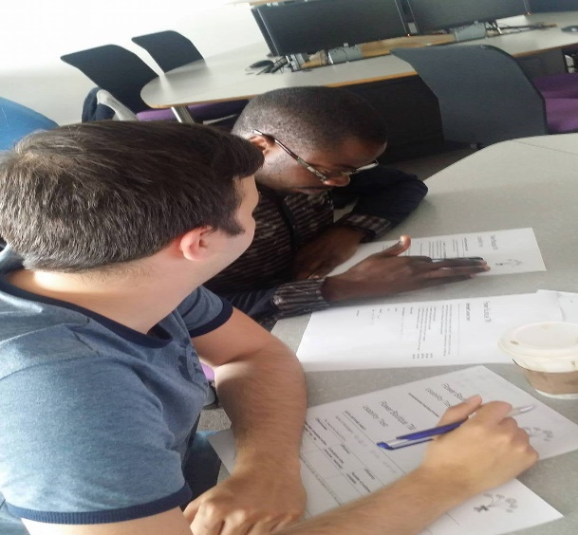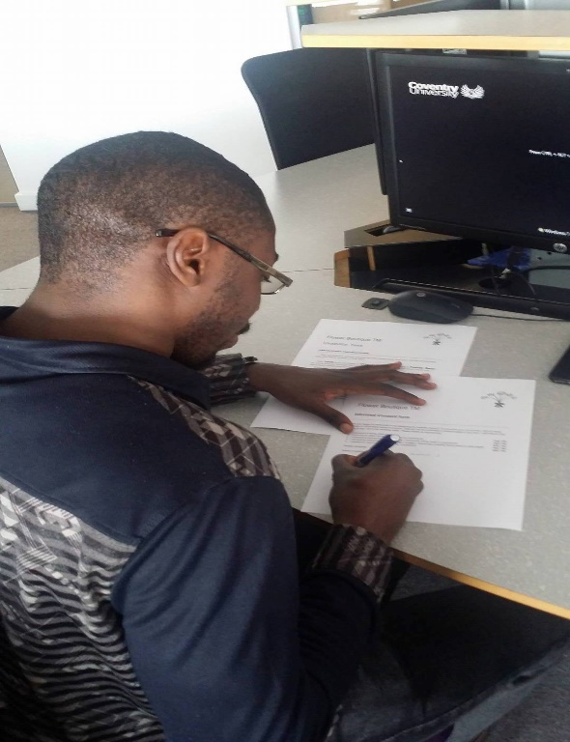

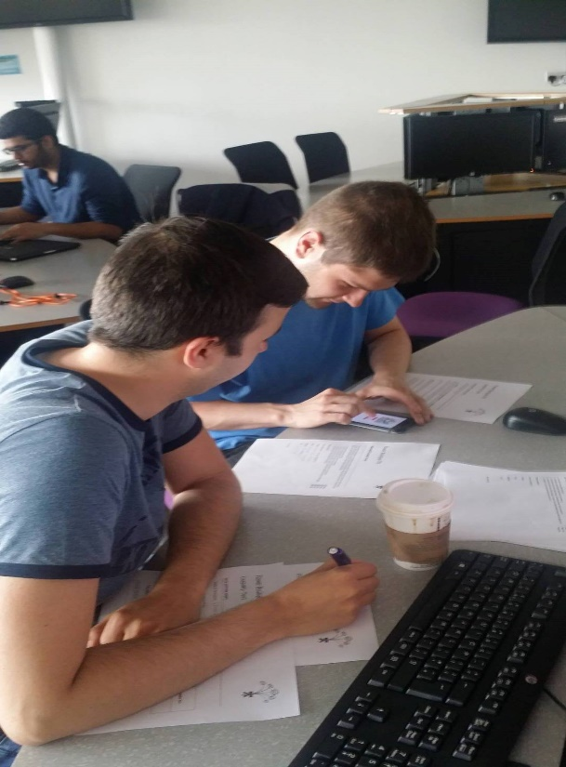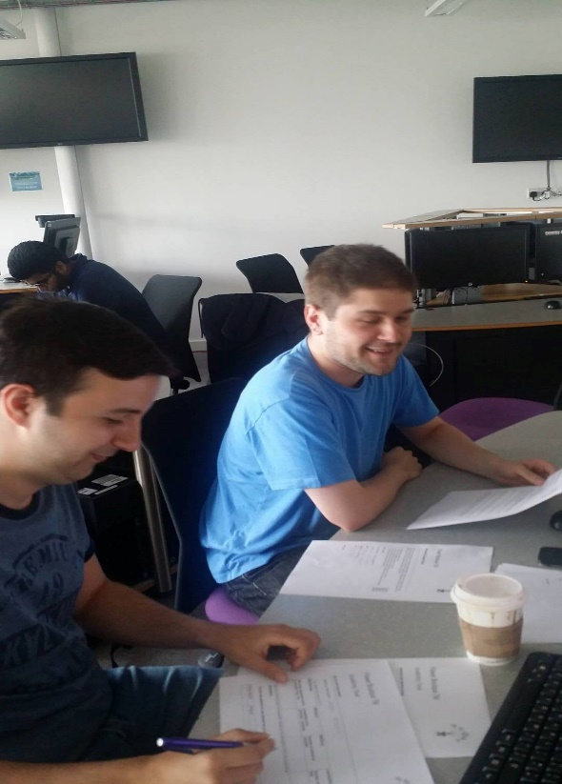

Here, Akindele and Genaro signing the consent form and doing the test.

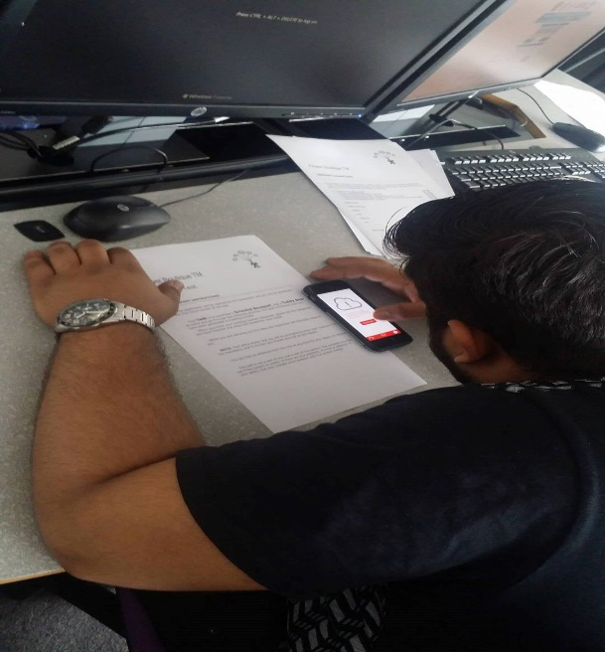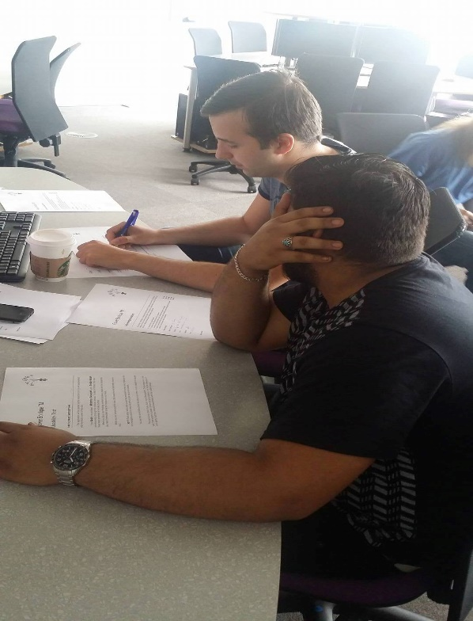

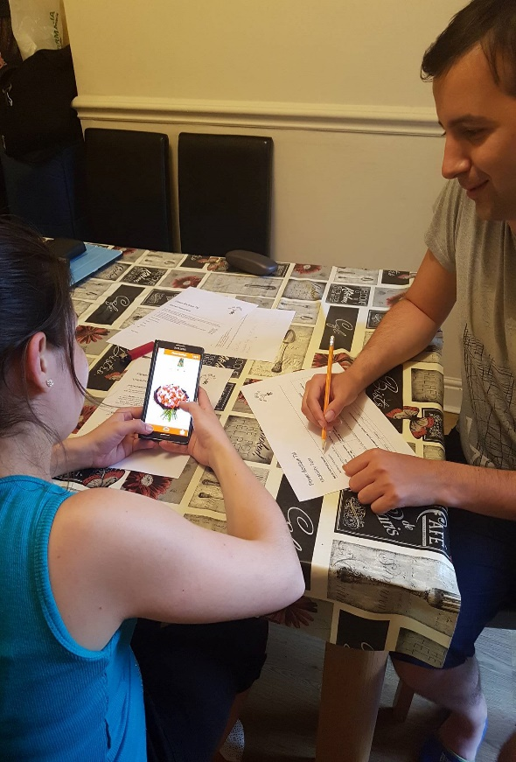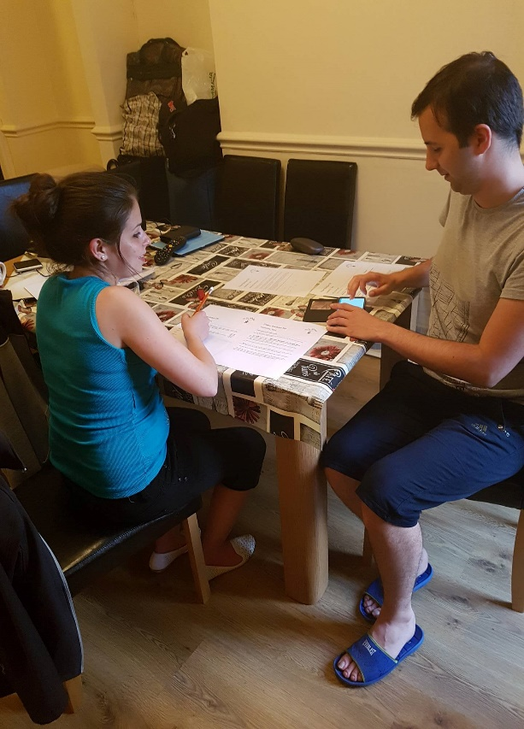

Data Capture:

|  |  |  |  |  |  |
| --- | --- | --- | --- | --- | --- |
| Name | Strongly disagree | Disagree | Undecided | Agree | Strongly agree |
| Akindele |  |  |  | X |  |
| Irfan |  |  |  |  | X |
| Genaro |  |  |  | X |  |
| Mihaela |  |  |  | X |  |

Conclusion:

The user test has been highly helpful to evaluate the design. Some of the users struggled with the issues found in the heuristic evaluation and that caused their completion time to be higher, as anticipated. Users have said that it would make sense for adding extras to be available before going to the basket. Everything else went well. We have decided that the implementation of a function to add extras to a selected bouquet before going to the basket would be very helpful to the functionality of our site.

|  |  |  |  |  |
| --- | --- | --- | --- | --- |
| **Name of Participant** | **Effectiveness**  **Was task completed within 3 minutes? Yes / No** | **Efficiency**  **Completion time (minutes / seconds)** | **Efficiency**  **Number of actions to complete** | **Learnability**  **Number of requests for help** |
| Akindele | Yes | 02:01 | 16 | 0 |
| Irfan | Yes | 02:22 | 21 | 1 |
| Genaro | Yes | 01:43 | 15 | 0 |
| Mihaela | Yes | 02:45 | 22 | 1 |

**INDIVIDUAL WORK**

**HOMEWORK 3: DESIGN PRINCIPLES**

**Homework 3:**

Youtube video explaining my analysis of a toaster by looking at design principles:

[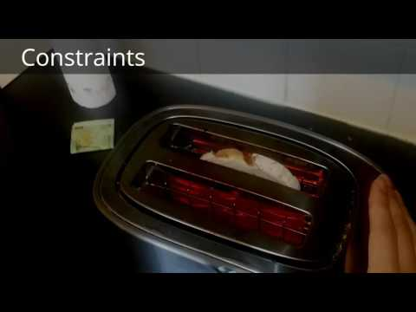](https://www.youtube.com/watch?v=8i5lnRduNUs)

**PERSONAL REFLECTIONS**

**HOMEWORK 3: DESIGN PRINCIPLES**

In this homework I find myself analysing a toaster from a designer’s point of view. I look at the 4 main design principles (Affordances, Mappings, Constraints and Conventions) and also others, like Contour Bias, Cost-Benefit effect. The reason for this homework was to get familiar with design analysis and learn how to critically reflect on a design, based on design principles. Design principles can guide the designer during the design process and can be used to evaluate and critique prototype design ideas(Benyon, 2014) . What I got out of this small project was better understanding of how to analyse an item and what to look at. This helped me spot good and bad design around the world.

I can say I have learned many things out of this homework. I have improved the way I think about an item, its usability and design, learned how to spot bad design and good, and how to critically reflect on designs I see around the world. It was also the first time I posted a video ono youtube, so I had to learn how that process takes place. The fact I did a video helped my presentation skills. I admit it felt a bit out of place, but it did teach me valuable lessons about presentation.

Difficulties I encountered started with choosing the right item to analyse. I was constantly looking around for things and thinking to myself if there is anything to say about it. Another difficulty was doing it by myself, filming and analysing at the same time. I struggled not to shake the camera and keep it steady, while also trying to rotate the item around to film the stuff I was talking about.

Overall, it was a fun and interesting task. I learned valuable lessons and produced a video I am quite proud of.

REFERENCES:

Benyon, D. (2014) *Designing Interactive Systems*, 3rd Ed. Harlow, England: Pearson (p. 86)

**HOMEWORK 7: HTA TASK ANALYSIS**

In this group task, we did a hierarchical task analysis (HTA) for the process of buying flowers on an ecommerce platform. Besides doing the diagram, we have laid down all the plans we thought were relevant to the task.

Task analysis is essential to any design. It is imperative to understand the mental model users have when they think about the task you want to design, so that your design breaks the task down in similar steps as encountered in the real world. “Task analysis is a key technique in interactive system design. The focus may be on the logical structure of tasks, or the cognitive demands made by tasks procedurally or structurally. Task analysis encompasses task design and it is here that it is probably most useful, as an analysis of a future design is undertaken to reveal difficulties.” (Benyon, 2014)

The HTA we developed was used intensively throughout the design process and it guided us into developing the protoype , as closely as possible to the experience of buying flowers from a real shop.

My role on this homework was simply of coordination and advice. Another group member was in charge of this task, while I have given advice on some steps that were not included(like Give Feedback, Select Wrapping Paper Style) and also kept close to the task leader in case he needed help or more advice. The most valuable lesson I learned was patience. I must admit I was not very confident in how the diagram is going to shape up, but I was astounded when I saw the final sketch. It looked impeccable and very well thought out. In the future, I will give more credit to people in charge of a task, even when it doesn’t look like it is going in the right direction. Patience and support are very important when working as part of a team.

As stated above, the challenge was not being able to properly see earlier prototypes or sketches of the diagram, simply because the diagram was done very late in the program. I had to overcome frustration, which paid off in the end and I am happy I didn’t decide to overcome the task leader’s work and do it myself. His work was very good and I am proud of it.

REFERENCES:

Benyon, D. (2014) *Designing Interactive Systems*, 3rd Ed. Harlow, England: Pearson (part II.11 p. 252)

**HOMEWORK 8: DIGITAL PROTOTYPE**

In this part of the task, we were concerned with the digital prototype. The final product is a functional prototype that is capable of running the user test and also has some other functions. We did the prototype using Proto.io, which had its challenges.

Prototypes are an essential part of designing. Prototypes stimulate reflections, and designers use them to frame, refine, and discover possibilities in a design space(Benyon, 2014). In other words, it’s what designers use as the basis of iteration. They succumb a prototype to user tests and based on feedback, a new, better prototype is created.

We received extremely good feedback on our prototype. Our users were impressed with the look and feel of it, when trialing it on a smartphone. The prototype also helped us identify the problems it has and come up with a plan on how to improve.

I was the task leader on this particular homework. I have faced many challenges during this task, one of them being the scope of the homework. We came up with lots of great ideas, but we didn’t think about the time it took to implement. We started working on them and eventually had to give up a chunk of them because there was not enough time. I struggled to learn the software Proto.io, I spent significant time to learn how it works and how I can improve the look of my prototype. Another challenge was the group report. As much as I wanted to divide the task evenly among all 4 members, I didn’t feel like I could properly explain all the concepts I used in the prototype and decided to do the group task myself, which again put a huge time constraint on me and made me feel under pressure.

I learned many valuable things in this task. One of the most important things is scoping adequately. It is very important to filter through all the many ideas that initially come up in a brainstorming session and choose the most realistic ones. Another important thing I learned about is time management. If I had started a bit earlier with the group report, I could have avoided the pressure not to let down my team.

I feel like I can apply all the lessons I learned during this task to every future group task I will be a part of.

REFERENCES: Benyon, D. (2014) *Designing Interactive Systems*, 3rd Ed. Harlow, England: Pearson(ii.8 p. 175)

**HOMEWORK 9: USABILITY TEST**

In this homework we were concerned with running our usability tests, performing heuristic evaluations and analysing data collected.

Usability tests are a great tool to get feedback from users on your design and learn where and how it can be improved. Even if you are both designer and evaluator, you need an organized list of findings so that you can prioritize redesign work.(Benyon, 2014) Iteration is based on feedback, which is the main result of running a usability test.

We received immense value from our usability test. The test outlined the potential problems our design might have and highlighted the strengths of our design. This data is valuable in case we decided to do a reiteration.

I designed the usability test and prepared the required documents. Other group members found the users and took photos and videos during the tests. I collected the data, tabulated them and performed analysis and the group report.

The main challenge in this task was the lack of big sample of users. We ended up with 4, I had to ask my girlfriend to be a user to reach this number. Not enough people were around in the classroom and we didn’t feel very comfortable to ask other people to do a usability test. Lack of self-confidence led to a very small sample of user data.

I learned a great deal out of this homework. I had to rush it a bit because we were out of time, which helped my focusing. I was completely focused on the task and managed to finish it quickly, while doing a good job. This is a valuable time since in life you will find yourself in situations where good work has to be done quickly.

REFERENCES:

Benyon, D. (2014) *Designing Interactive Systems*, 3rd Ed. Harlow, England: Pearson (ii.10 p. 228)