ENSF-381: Full Stack Web Development Laboratory
Lab03

Group information:
Unas Khalid (30141707)
David Onofeghara (30214188)

GitHub Link:
https://github.com/ovie-d/ENSF-381

Exercise 1 Output:
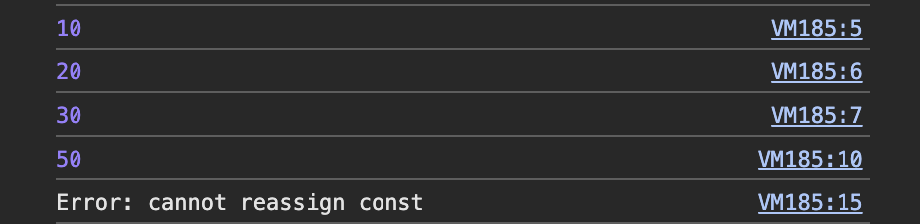
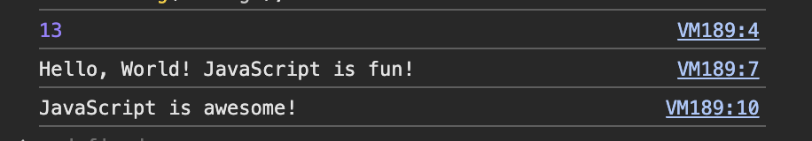

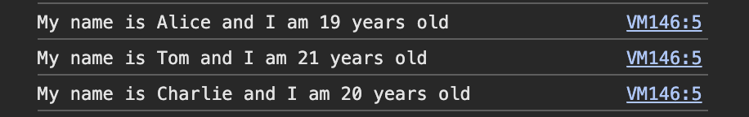
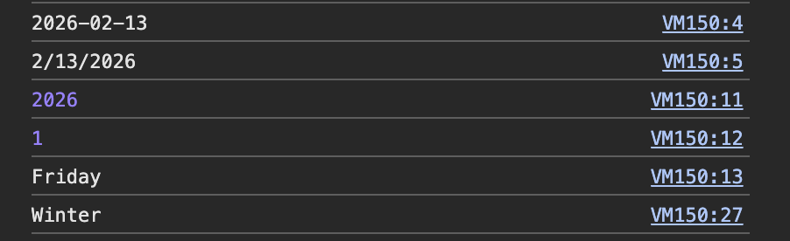
Exercise 2 Output:

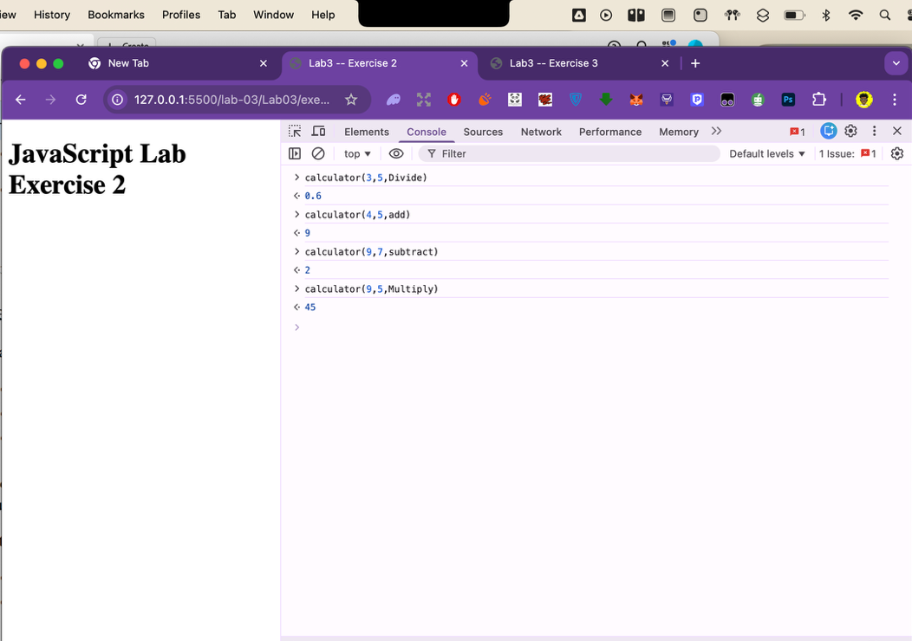
Exercise 3 Output:
